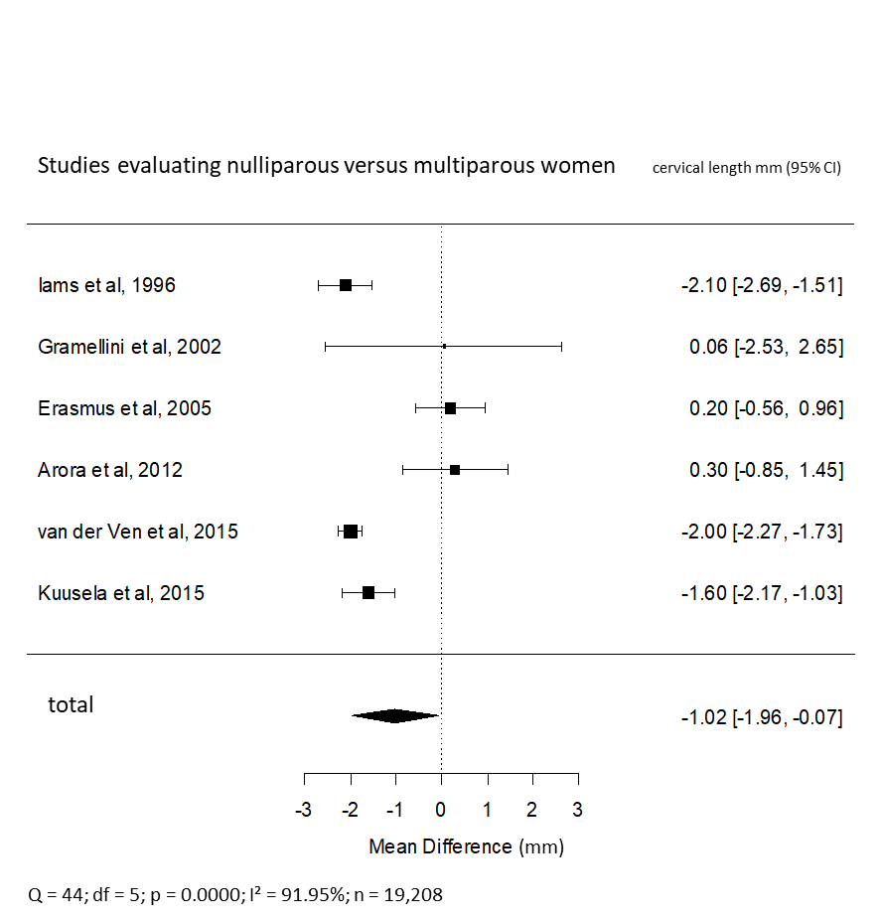
S2 Fig - Nulliparous versus multiparous
Difference of mean of cervical length between nulliparous versus parous women

