S3 Fig - Adolescents versus adults
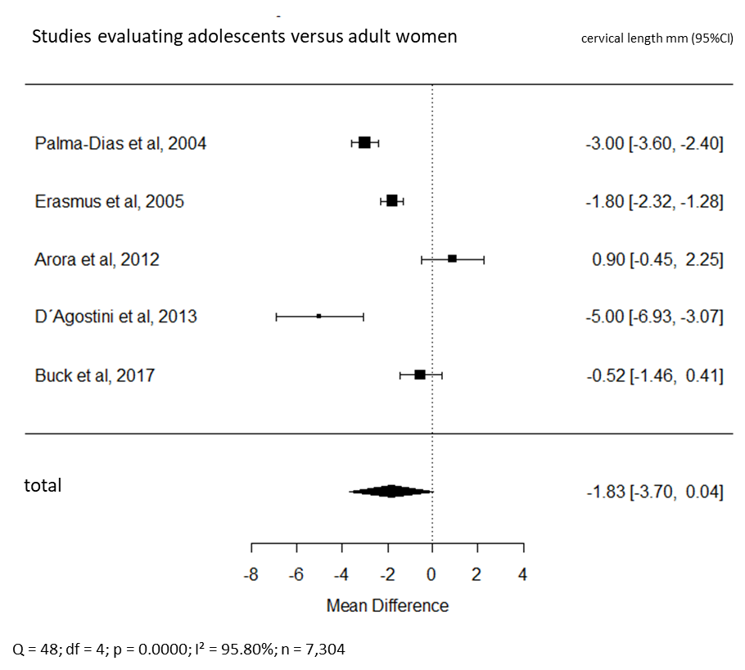
Comparison of cervical length measurements in adolescents and adults.

