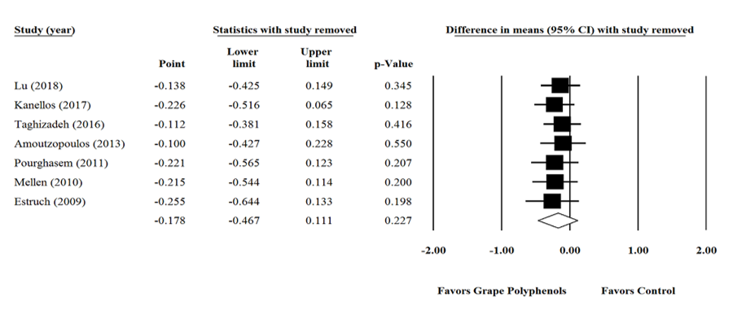

Supplementary figure 10. Sensitivity analysis was performed using a random effect model for impact of grape products containing polyphenols (GPCP) and Malondialdehyde.

