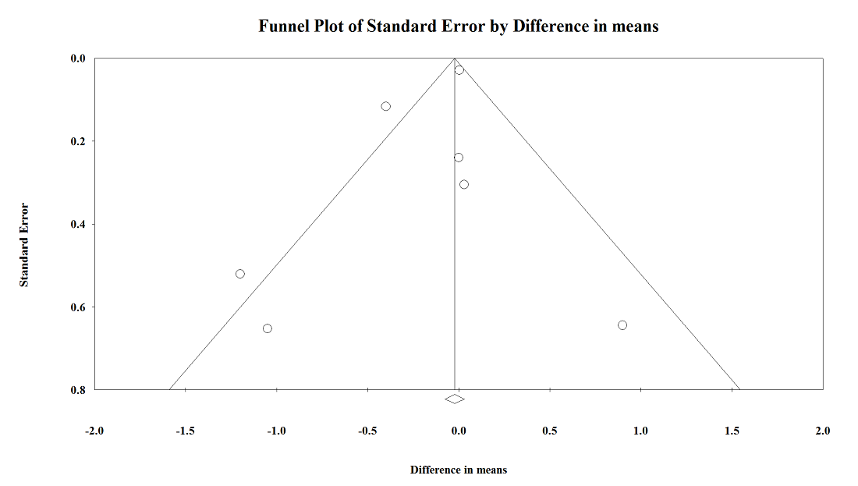
Supplementary figure 11. Funnel plot of Standardized mean differences Malondialdehyde concentration with grape products containing polyphenols (GPCP).

