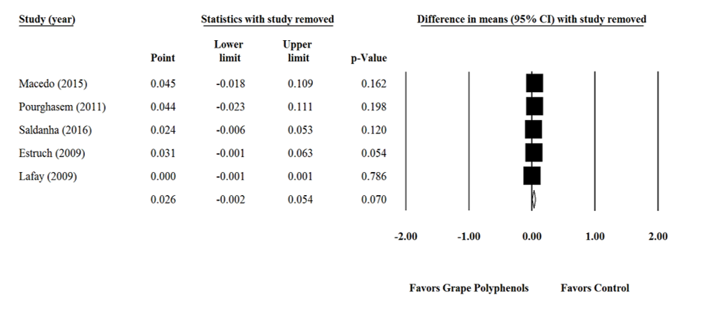
Supplementary figure 13. Sensitivity analysis was performed using a random effect model for grape products containing polyphenols (GPCP) and glutathione peroxidase levels.

