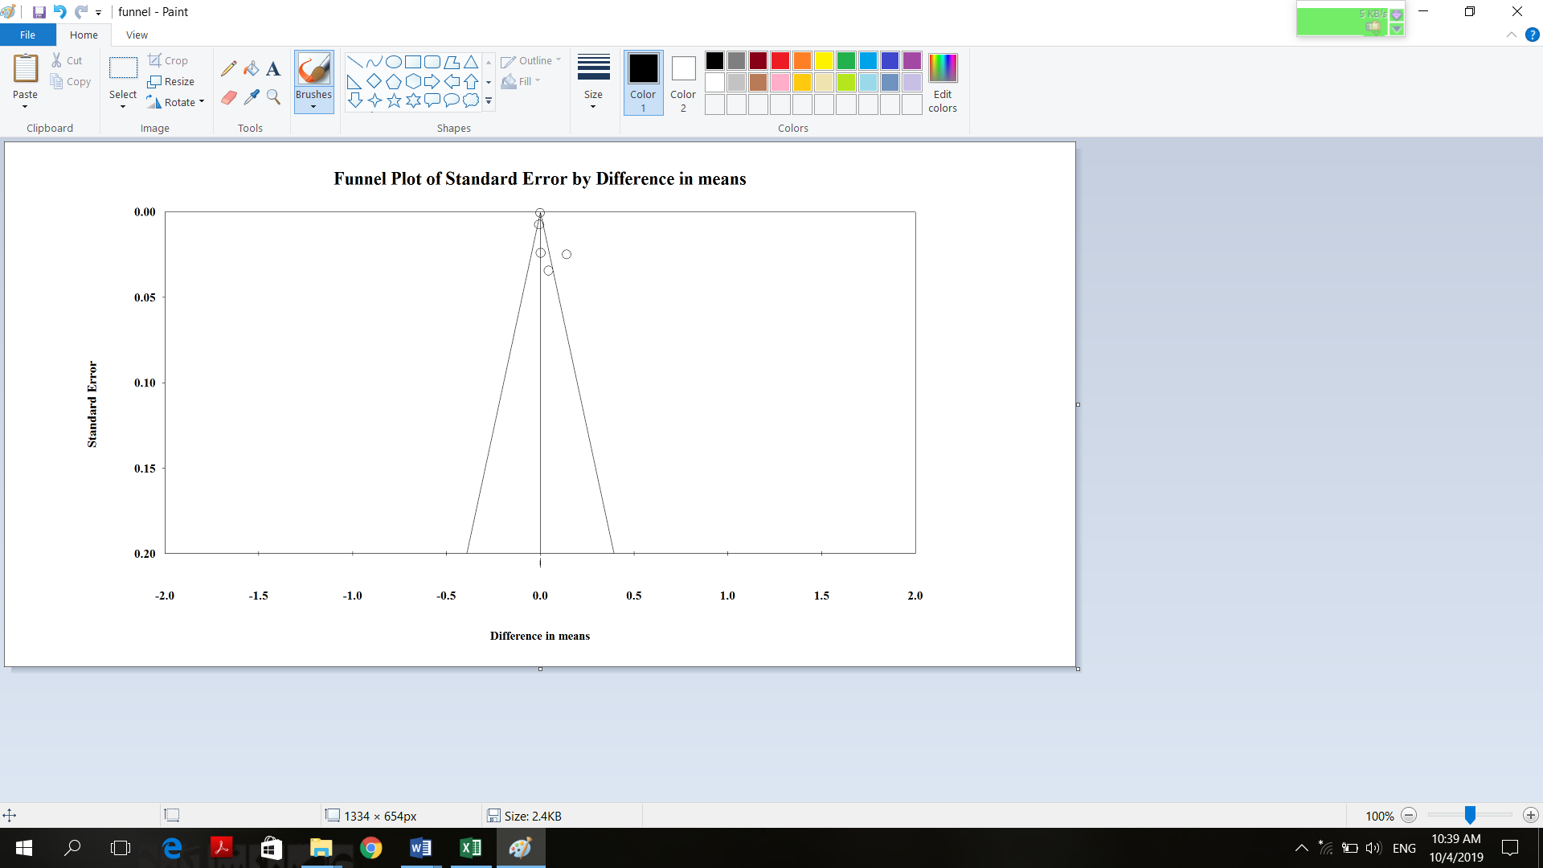
Supplementary Figure 14. Funnel plot of weighted mean differences glutathione peroxidase concentration with grape products containing polyphenols (GPCP).

