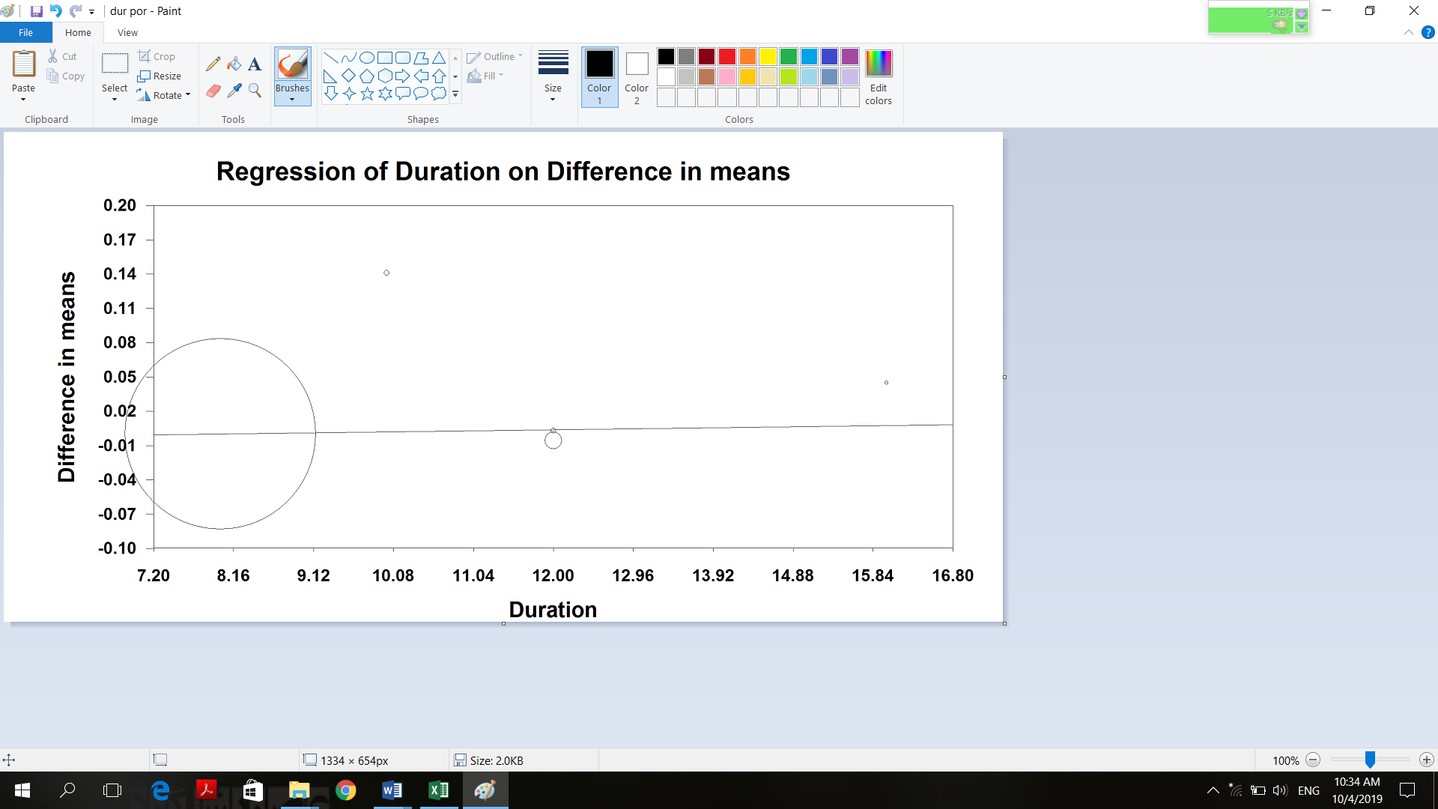
A

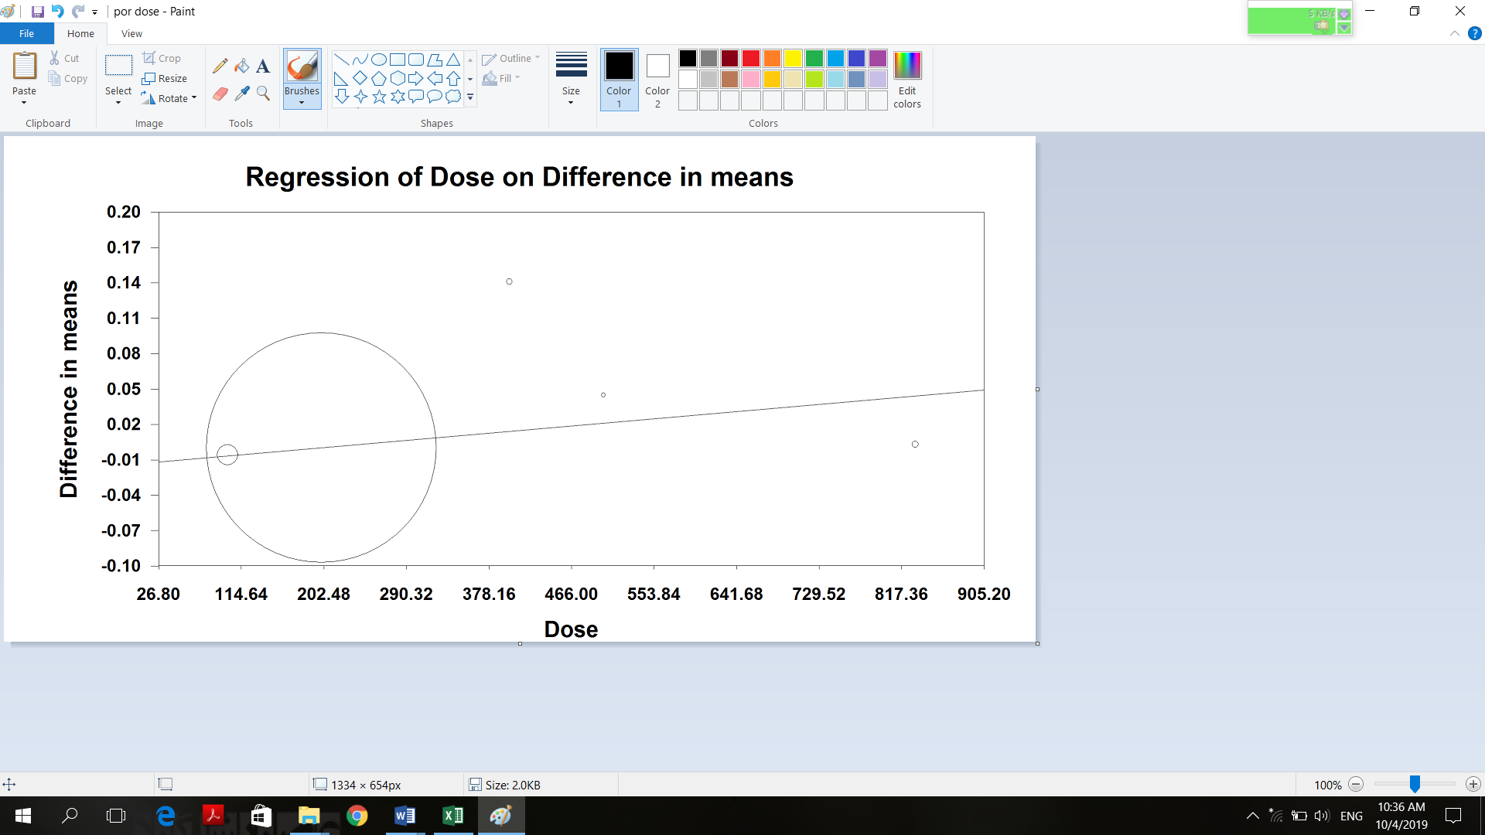
B

Supplementary Figure 13. Meta-regression plots of the association between Standardized mean difference in plasma glutathione peroxidase concentrations values after grape products containing polyphenols (GPCP) intake with duration (A) and dose (B) of intake. The size of each circle is inversely proportional to the variance of change.

