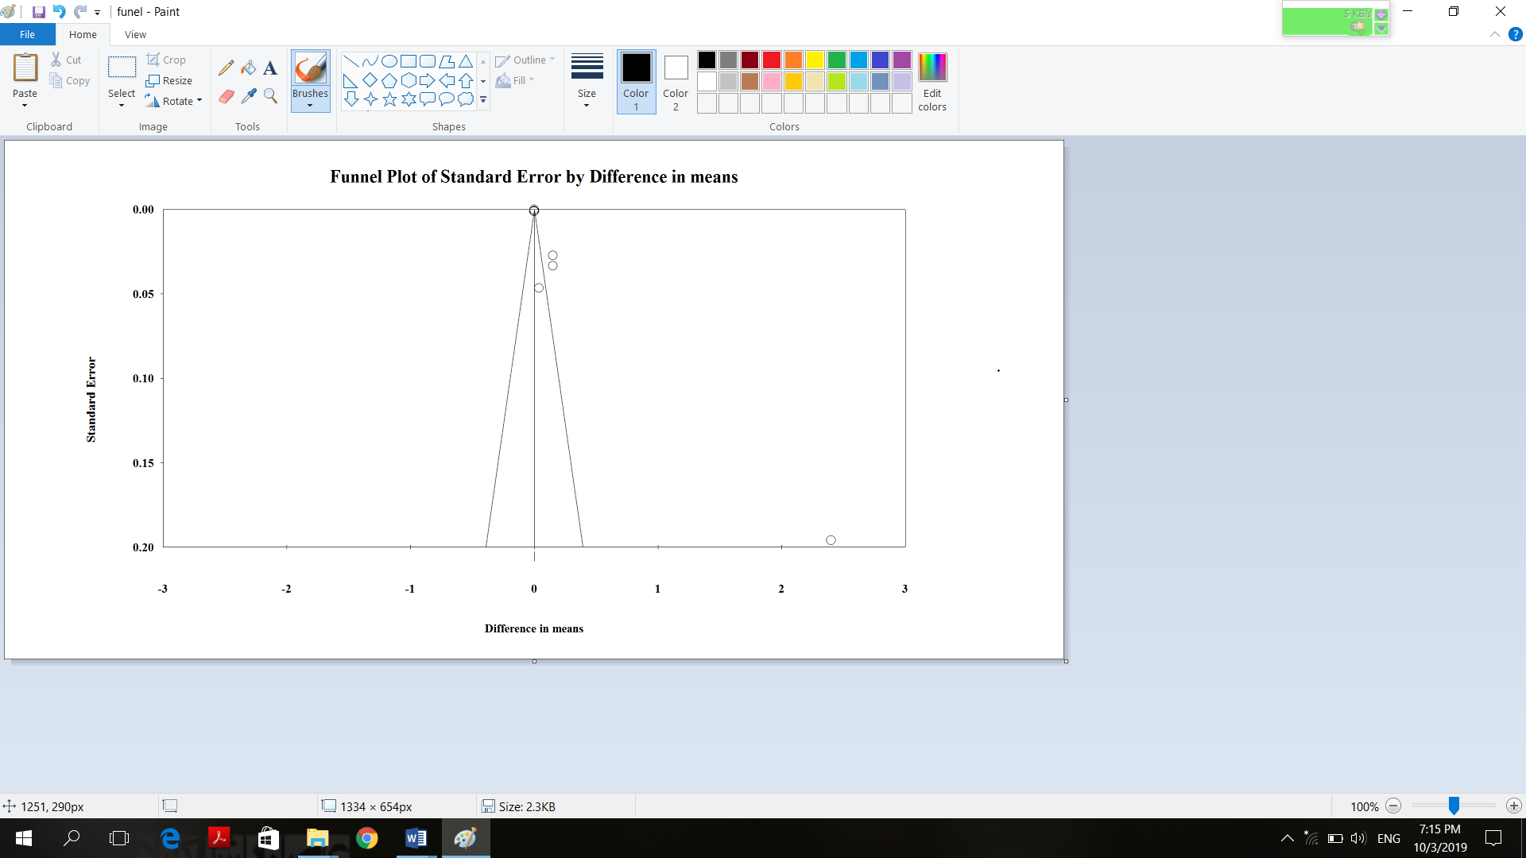
Supplementary Figure 2. Funnel plot of weighted mean differences Superoxide Dismutase concentration with grape products containing polyphenols (GPCP).

