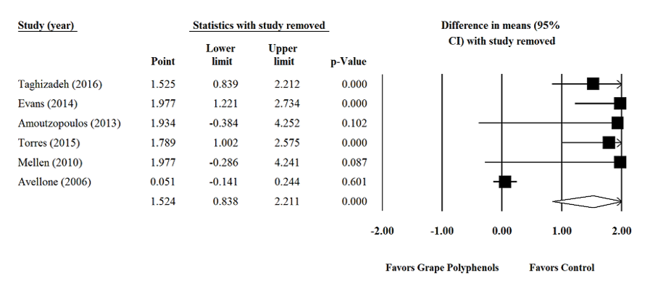

Supplementary figure 4. Sensitivity analysis was performed using a random effect model for impact of grape products containing polyphenols (GPCP) and total antioxidant capacity levels.

