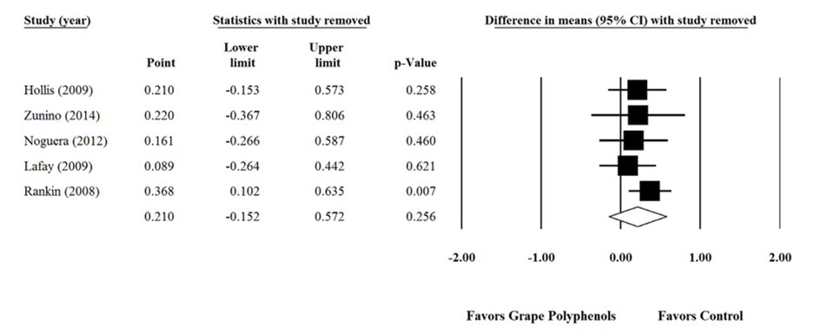

Supplementary figure 7. Sensitivity analysis was performed using a random effect model for impact of grape products containing polyphenols (GPCP) and oxygen radical absorbance capacity levels.

