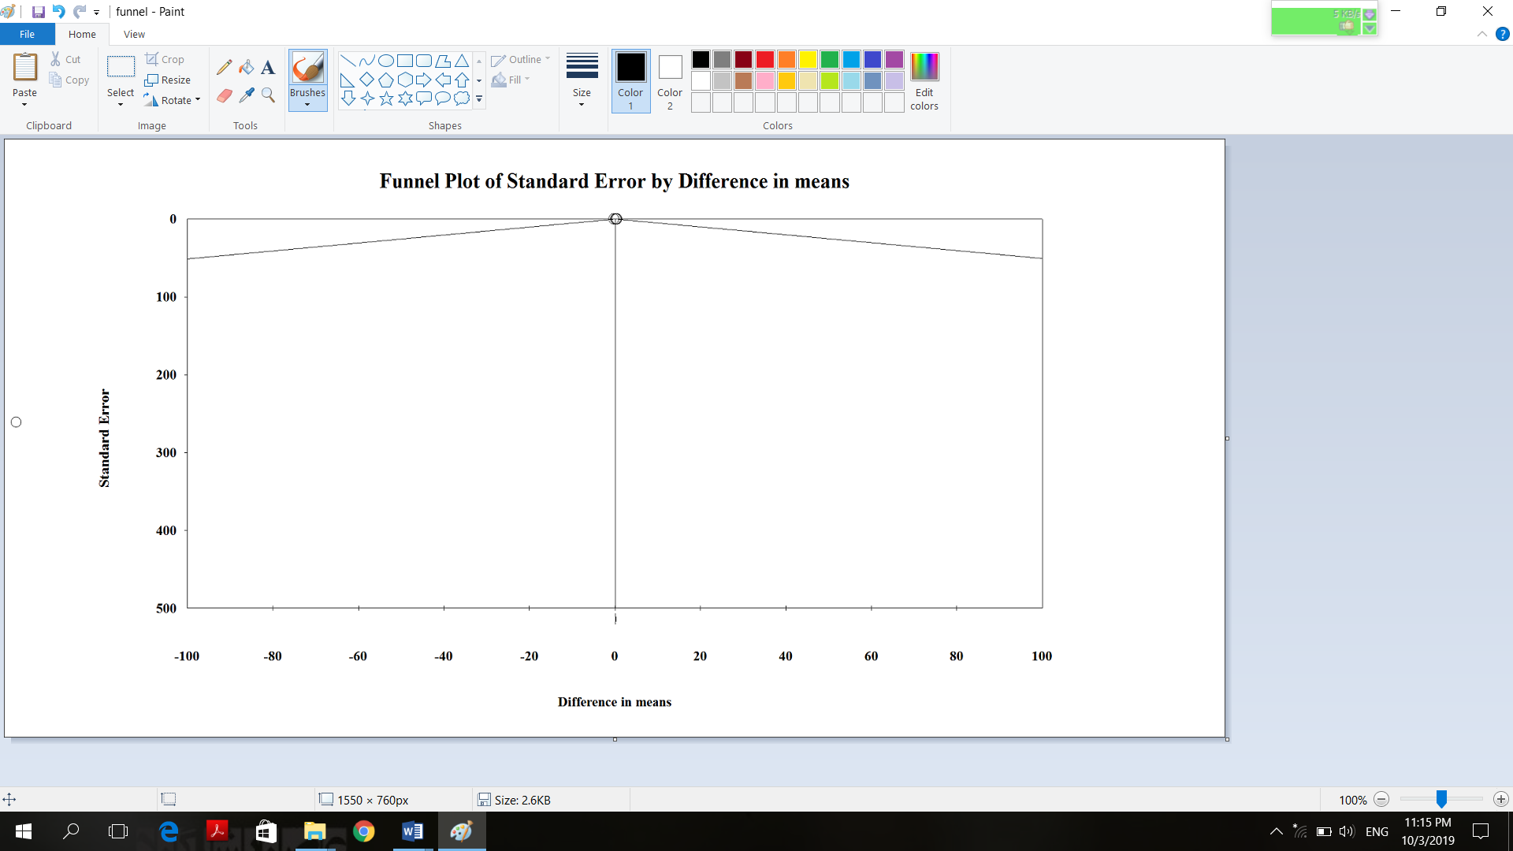
Supplementary figure 8. Funnel plot of weighted mean differences oxygen radical absorbance capacity concentration with grape products containing polyphenols (GPCP).

