Ms. No. IJCHY-D-20-00101
The effect of remote ischaemic conditioning on blood pressure response: A systematic review and meta-analysis
Biggie Baffour-Awuahª, MSc; Gudrun Dieberg^{b}, PhD, Melissa J Pearsonª, PhD and Neil A Smartª, PhD

SUPPLEMENTARY FILES

Table S1: Search strategy (PubMed)
Items | Query
#7 | Search ((((((remote ischaemic preconditioning) OR remote ischaemic conditioning) OR physiological ischaemia training) OR limb occlusion) OR cuff inflation)) AND blood pressure Filters: Clinical Trial; Randomized Controlled Trial; Humans
#6 | Search ((((((remote ischaemic preconditioning) OR remote ischaemic conditioning) OR physiological ischaemia training) OR limb occlusion) OR cuff inflation)) AND blood pressure Filters: Clinical Trial; Humans
#5 | Search ((((((remote ischaemic preconditioning) OR remote ischaemic conditioning) OR physiological ischaemia training) OR limb occlusion) OR cuff inflation)) AND blood pressure Filters: Randomized Controlled Trial; Humans
#4 | Search ((((((remote ischaemic preconditioning) OR remote ischaemic conditioning) OR physiological ischaemia training) OR limb occlusion) OR cuff inflation)) AND blood pressure Filters: Humans
#3 | Search ((((((remote ischaemic preconditioning) OR remote ischaemic conditioning) OR physiological ischaemia training) OR limb occlusion) OR cuff inflation)) AND blood pressure
#2 | Search blood pressure
#1 | Search ((((remote ischaemic preconditioning) OR remote ischaemic conditioning) OR physiological ischaemia training) OR limb occlusion) OR cuff inflation

This search strategy was repeated for all data bases used; Web of science, EMBASE, and Cochrane library of controlled trails

Table S2: JADAD assessment for included acute RIC exposure randomised controlled trials
Study author, year | Randomization | Randomization described and appropriate | Blinding | Blinding described and appropriate | An account of all participants included | Total score
Chotiyarnwong 2020 | 1 | 1 | 1 | 0 | 1 | 4
Incognito 2017 | 1 | 1 | 0 | 0 | 1 | 3
Kepler 2019 | 1 | 1 | 1 | 1 | 1 | 5
Kuusik 2019 | 1 | 1 | 1 | 1 | 1 | 5
Li 2013 | 1 | 1 | 1 | 1 | 1 | 5
Li 2014 | 1 | 1 | 1 | 1 | 1 | 5
Muller 2019 | 1 | 1 | 1 | Not described | 1 | 4
Xu 2018 | 1 | 1 | 0 | 0 | 1 | 3
Zagidullin 2016 | 1 | 1 | 1 | Not described | 1 | 4
Median score |  |  |  |  |  | 4

Table S3: JADAD assessment for included repeat RIC exposure randomised controlled trials
Study author, year | Randomization | Randomization described and appropriate | Blinding | Blinding described and appropriate | An account of all participants included | Total score
Chen 2019 | 1 | 1 | 0 | 0 | 1 | 3
Herrod 2019 | 1 | Not described | 1 | Not described | 1 | 3
Jones 2015 | 1 | 1 | 1 | 1 | 1 | 5
Kimura 2007 | 1 | Not described | 1 | 0 | 1 | 3
Maxwell 2019 | 1 | 1 | 1 | 1 | 1 | 5
Pryds 2017 | 1 | 1 | 1 | 1 | 1 | 5
Median score |  |  |  |  |  | 4

A | 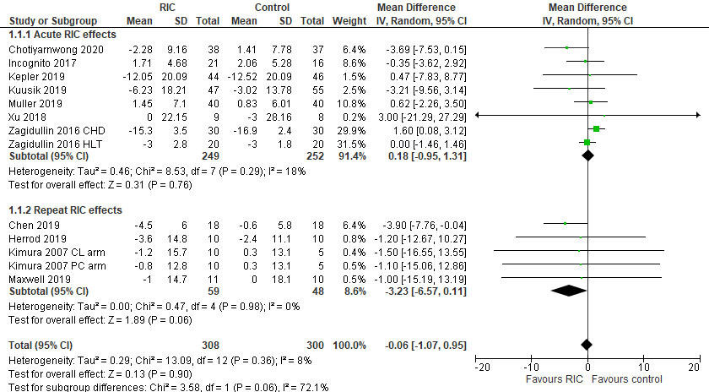
B | 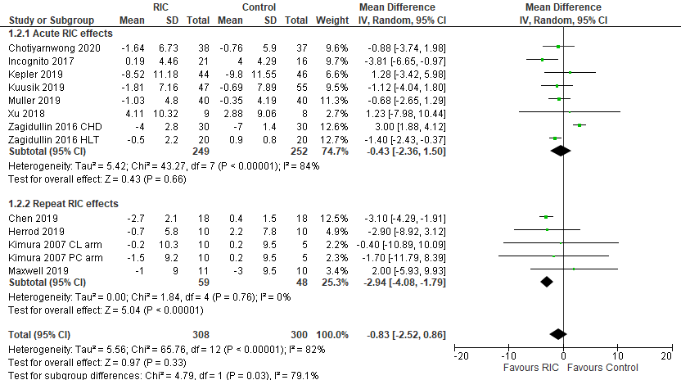
C | 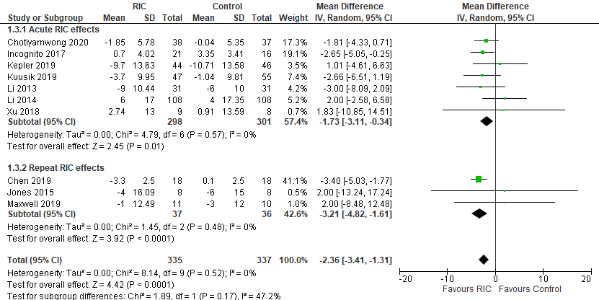
D | 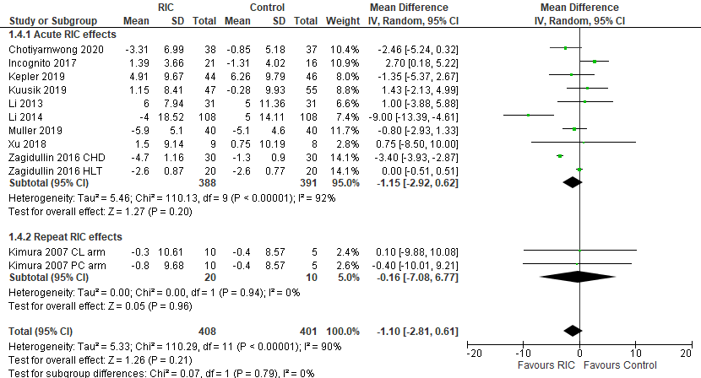

Figure S1: Sub-analysis of acute and repeat RIC exposure (all studies combined) - Changes in systolic and diastolic BP, MAP and HR.
Forest plots showing the combined effects of acute and repeat RIC exposure on systolic BP (A), diastolic BP (B), MAP (C) and HR (D). A p-value < 0.05 represents a significant pooled mean difference of overall effect. Horizontal lines across each present 95% CI for each study. The diamond represents the 95% CI for pooled estimates of effect of mean difference. CHD: chronic heart disease group; HLT: healthy group; IV: inverse variance; RIC: remote ischaemic conditioning; SD: standard deviation; Total: number of participants.

A | 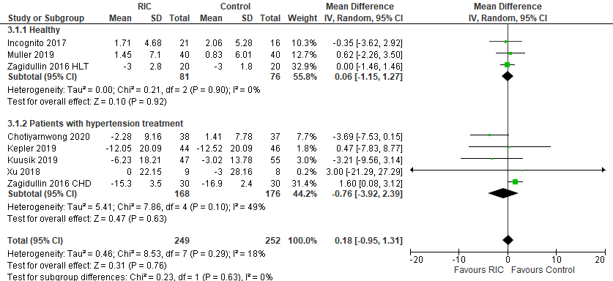
B | 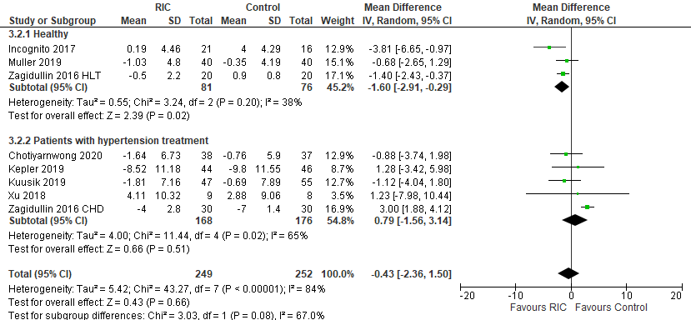
C | 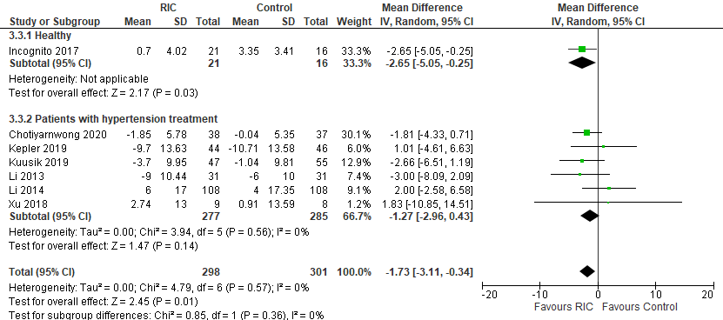
D | 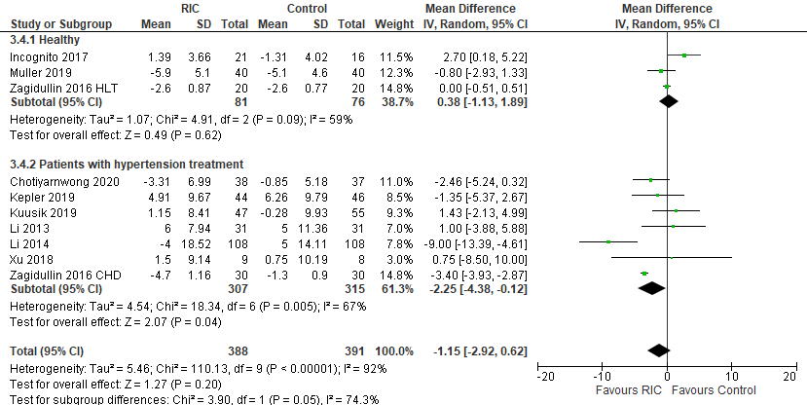

Figure S2: Sub-analysis of healthy versus patients receiving hypertension treatment - Changes in systolic and diastolic BP, MAP and HR after acute RIC exposure.
Forest plots showing the effects of acute RIC exposure on systolic BP (A), diastolic BP (B), MAP (C) and HR (D). A p-value < 0.05 represents a significant pooled mean difference of overall effect. Horizontal lines across each present 95% CI for each study. The diamond represents the 95% CI for pooled estimates of effect of mean difference. CHD: chronic heart disease group; HLT: healthy group; IV: inverse variance; RIC: remote ischaemic conditioning; SD: standard deviation; Total: number of participants.

A | 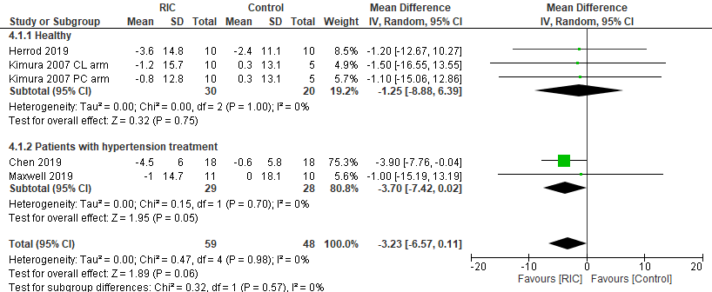
B | 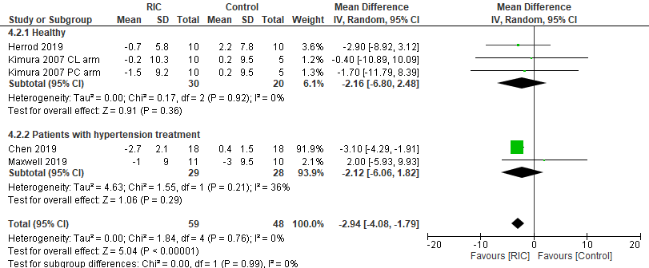
C | 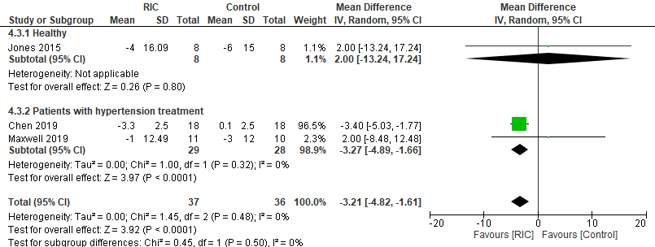
Figure S3: Sub-analysis of healthy versus patients receiving hypertension treatment - Changes in systolic and diastolic BP, and MAP after repeat RIC exposure. (please note, there was insufficient data for sub-analysis on HR)
Forest plots showing the effects of repeat RIC exposure on systolic BP (A), diastolic BP (B), MAP (C) and HR (D). A p-value < 0.05 represents a significant pooled mean difference of overall effect. Horizontal lines across each present 95% CI for each study. The diamond represents the 95% CI for pooled estimates of effect of mean difference. CHD: chronic heart disease group; HLT: healthy group; IV: inverse variance; RIC: remote ischaemic conditioning; SD: standard deviation; Total: number of participants.

A  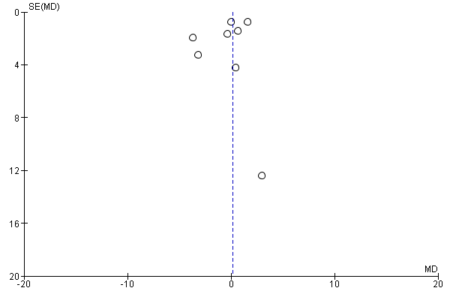  Systolic BP analysis | B  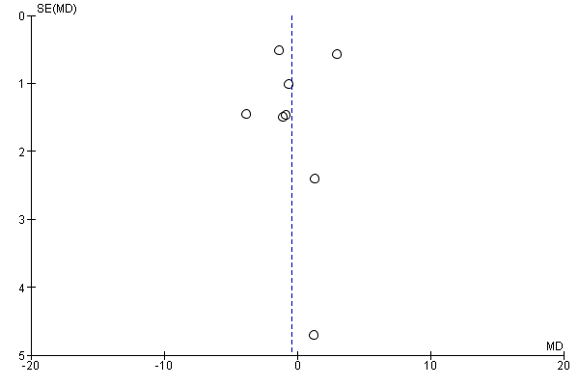  Diastolic BP analysis
C  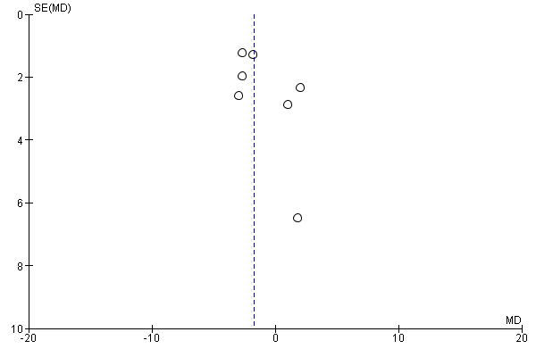 | D  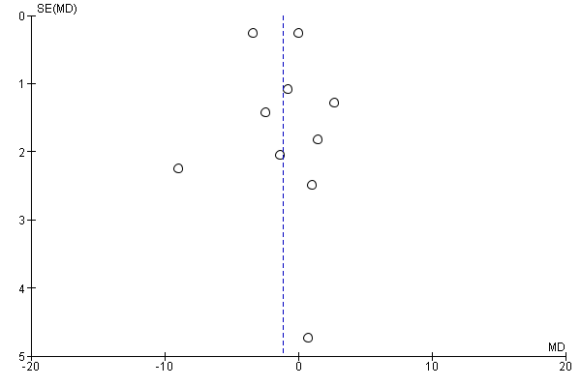
MAP analysis HR analysis
Figure S4: Egger Plot of systolic BP, diastolic BP, MAP and HR analysis following acute RIC exposure

A | 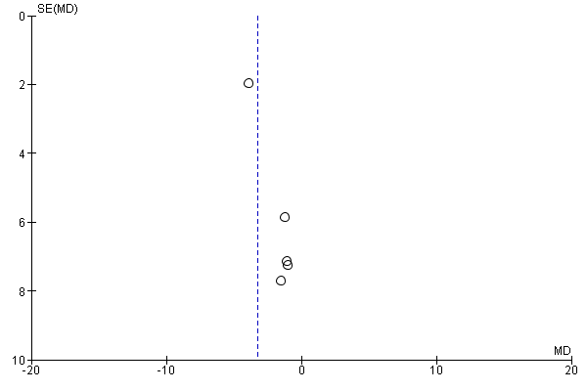  Systolic BP analysis | B | 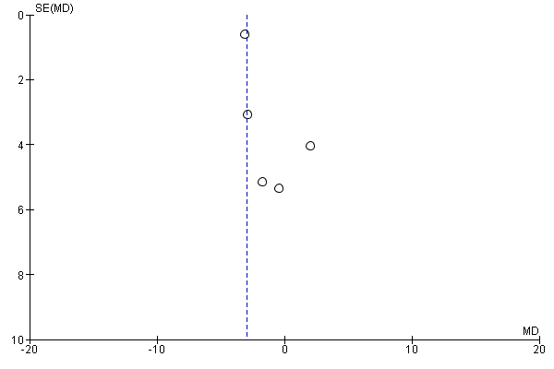  Diastolic BP analysis
C | 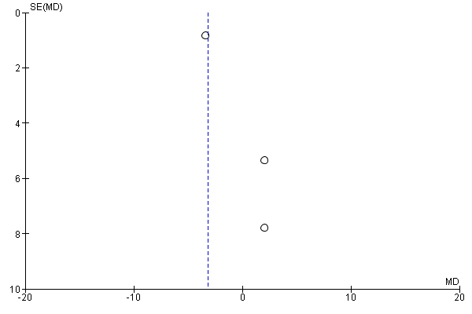  MAP analysis | D | 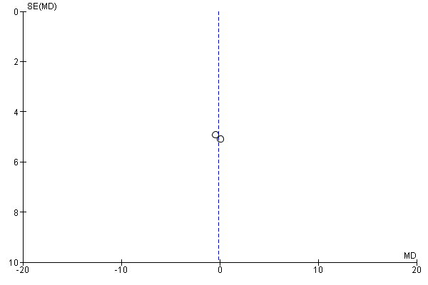  HR analysis

Figure S5: Egger Plot of systolic BP, diastolic BP, MAP and HR analysis following repeat RIC exposure

