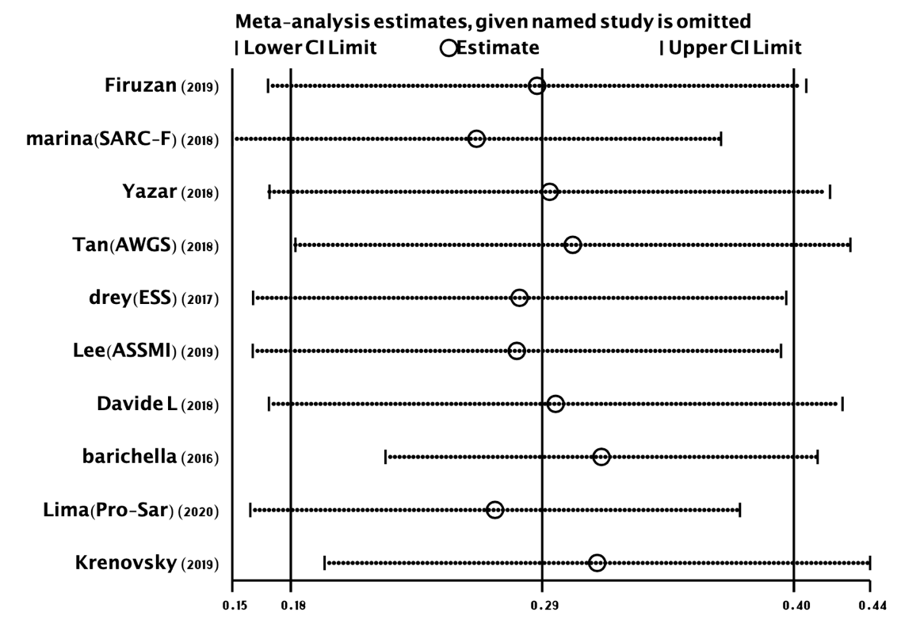
Appendix 1. Meta-analysis estimates, given named study is omitted

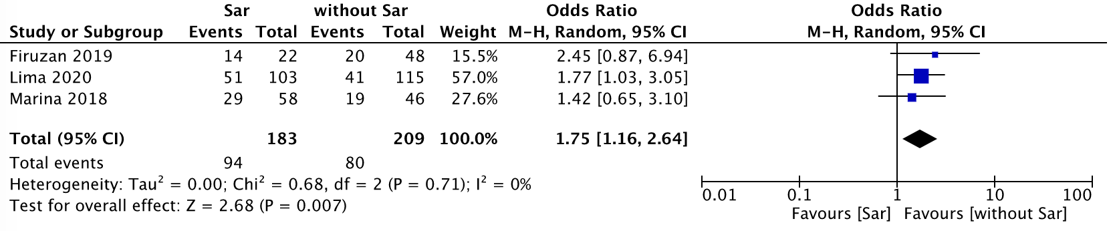
Appendix 2. PD with Sarcopenia vs. PD without Sarcopenia: %Fall

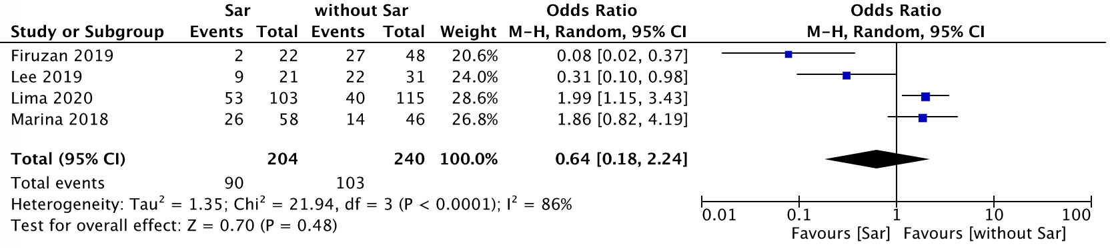

Appendix 3. PD with Sarcopenia vs. PD without Sarcopenia: %Female

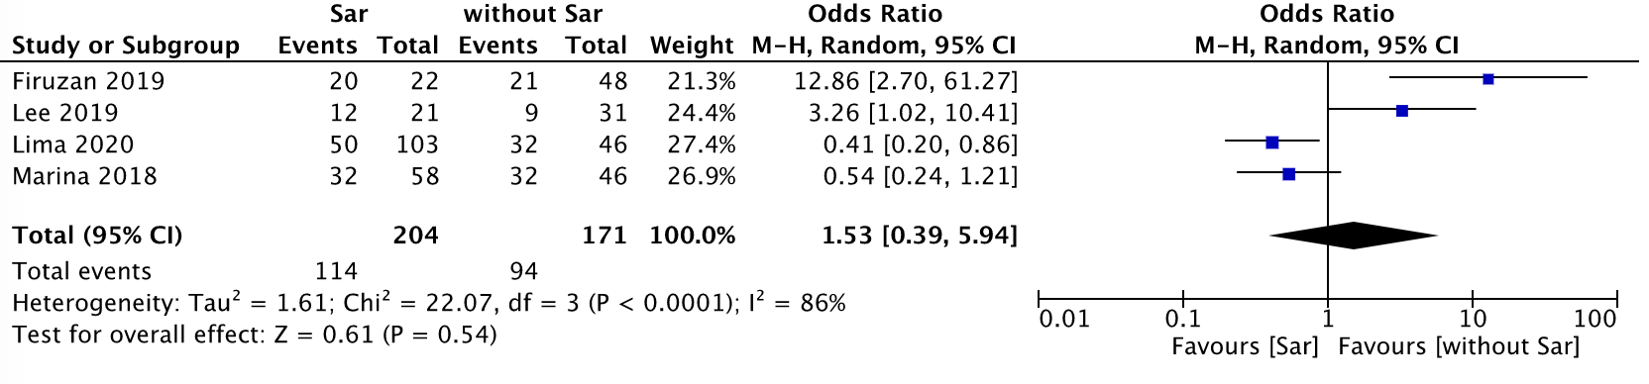

Appendix 4. PD with Sarcopenia vs. PD without Sarcopenia: %male

Appendix 5. Funnel graph prevalence (%) of sarcopenia in subjects with PD

