Supplement 3 Collated forests plots for troglitazone and rosiglitazone

The forest plots are presented for five liver related outcomes ALT, AST, ALP, total bilirubin and liver weight. Results are presented first for troglitazone, then for rosiglitazone. For each drug, results are presented first for studies on mice, then rats followed by non-human primates and finally for human studies.

ALT troglitazone
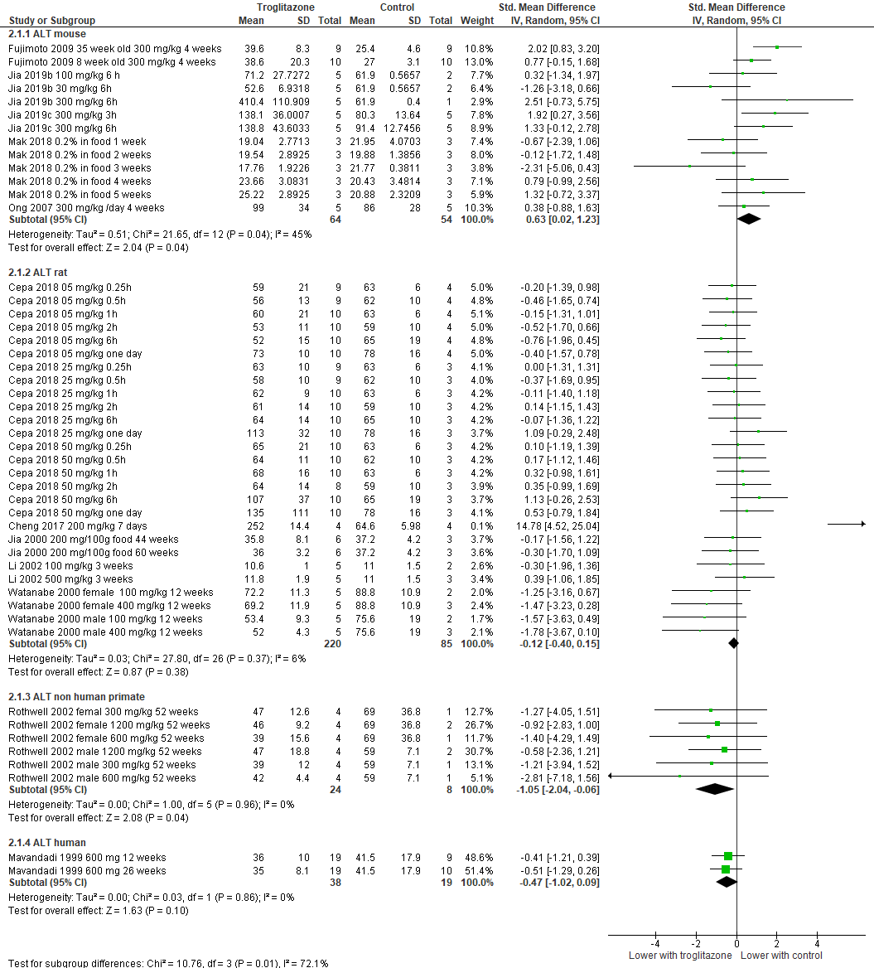

AST troglitazone
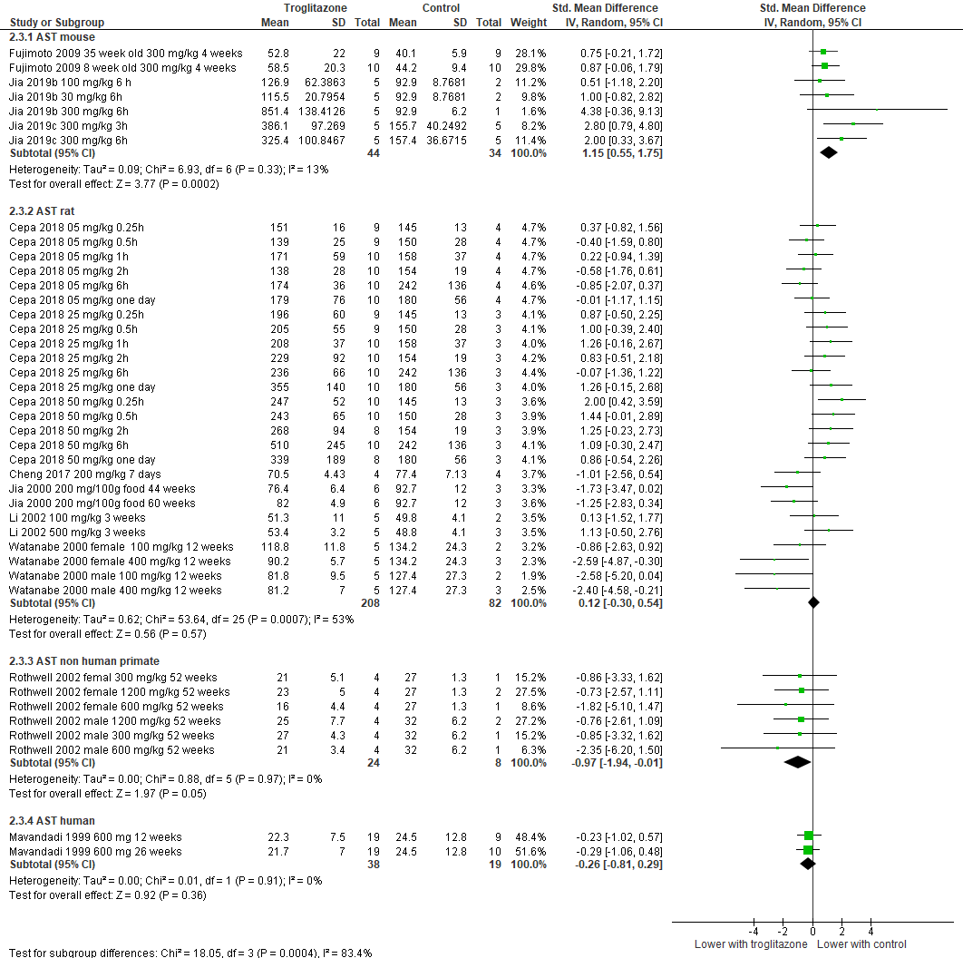

Elevated liver tests troglitazone
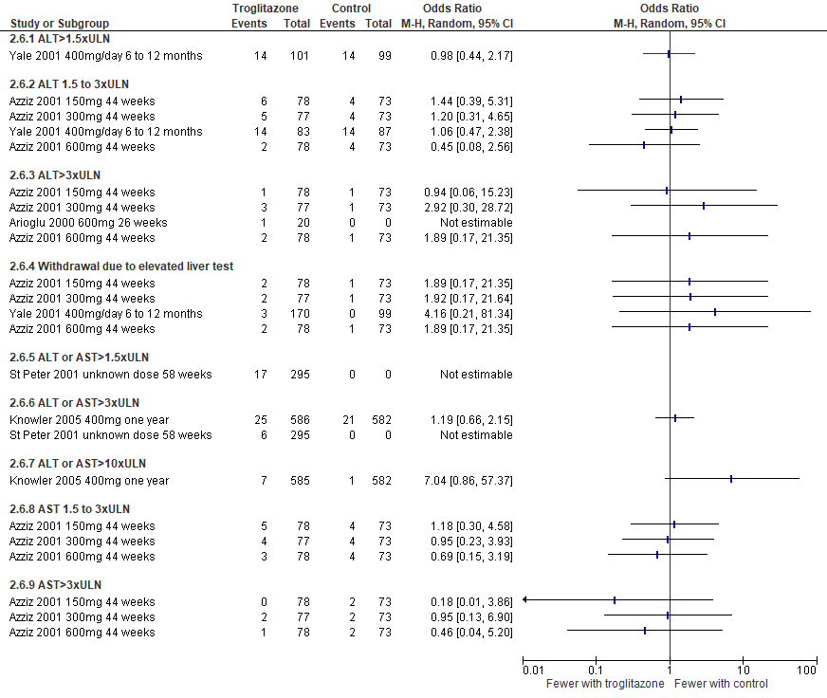

ALP troglitazone
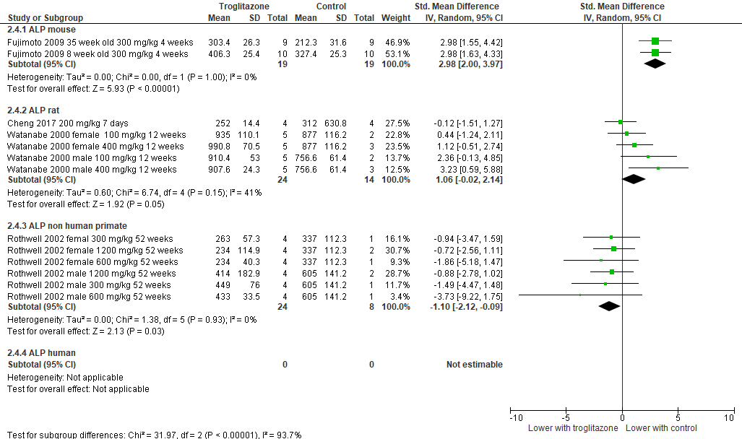

Total bilirubin troglitazone
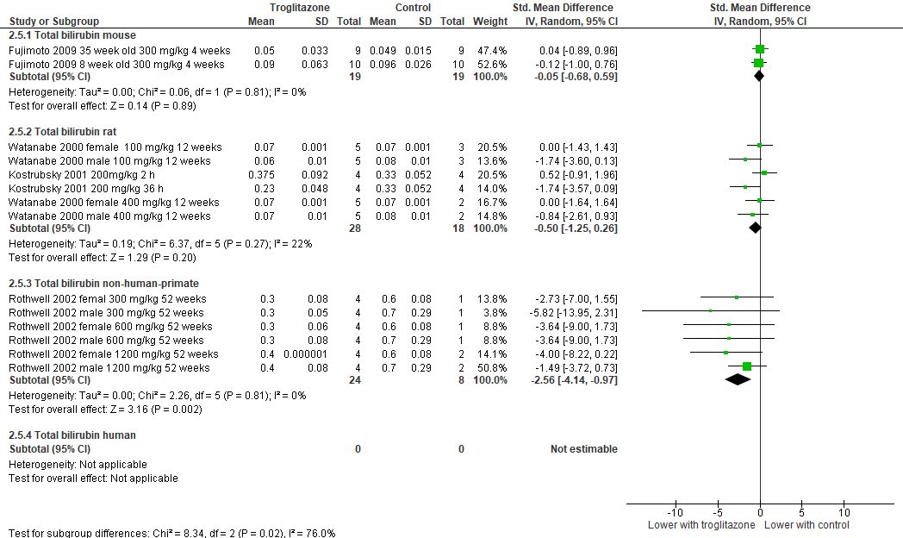

Liver weight troglitazone
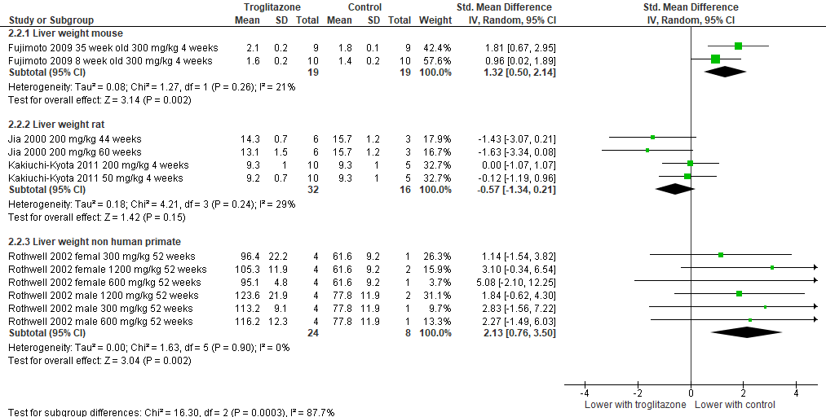

---------------------------

ALT rosiglitazone
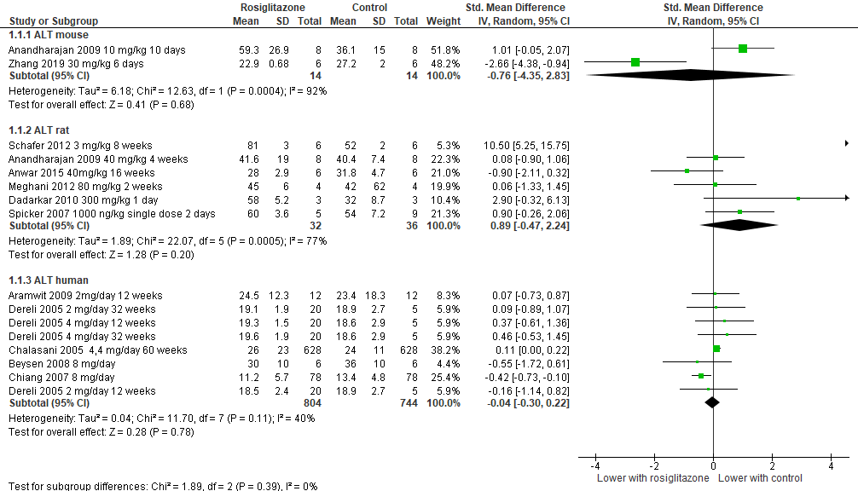

AST rosiglitazone
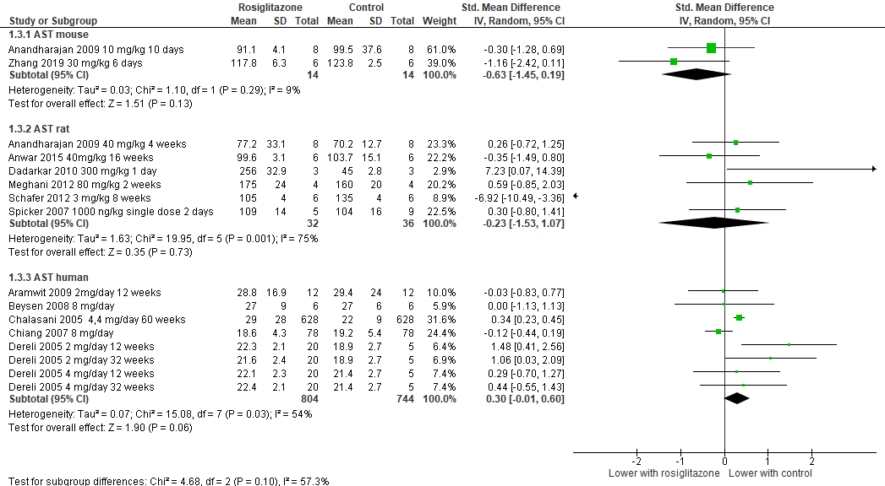

Elevated liver tests rosiglitazone
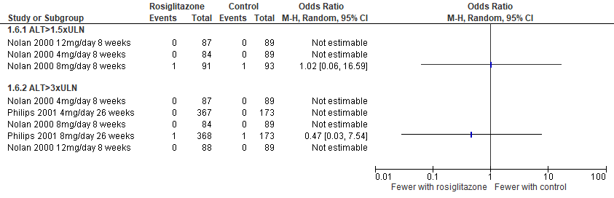

ALP rosiglitazone
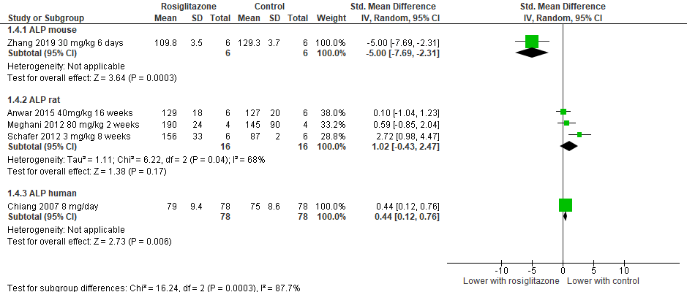

Total bilirubin rosiglitazone
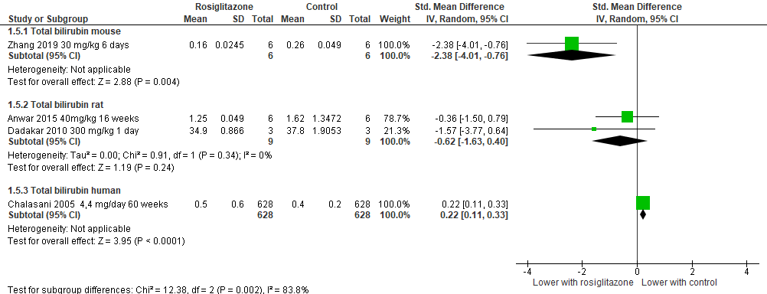

Liver weight rosiglitazone


