Search strategy
PubMed search, January 21, 2021:
(heart failure) AND (SGLT2 OR "sodium-glucose co-transporter-2" OR canagliflozin OR dapagliflozin OR empagliflozin OR sotagliflozin OR ertugliflozin)
1,002 results

Supplementary figure 1. Urgent visits for HF were significantly lower in the SGLT2 inhibitor group.
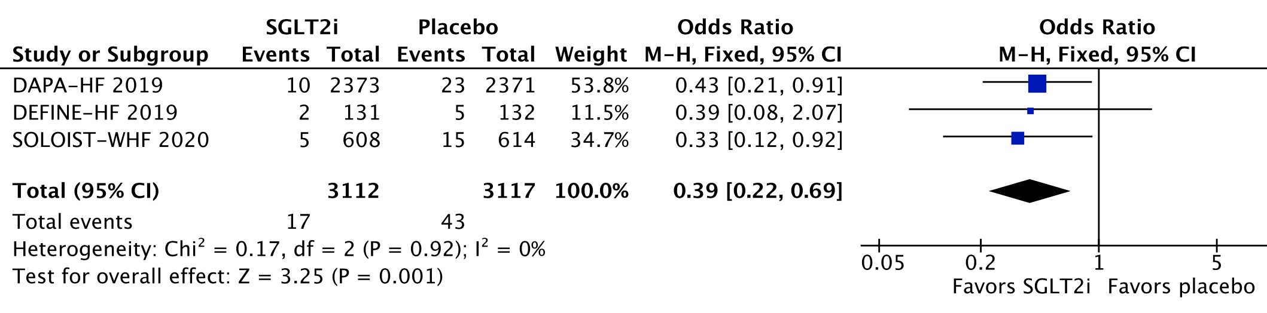
There was a significantly lower incidence of HF-related urgent visits in those treated with SGLT2 inhibitors (HR 0·39; 95% CI 0·22-0·69).

Supplementary figure 2A. There was no significant difference between groups in amputations.
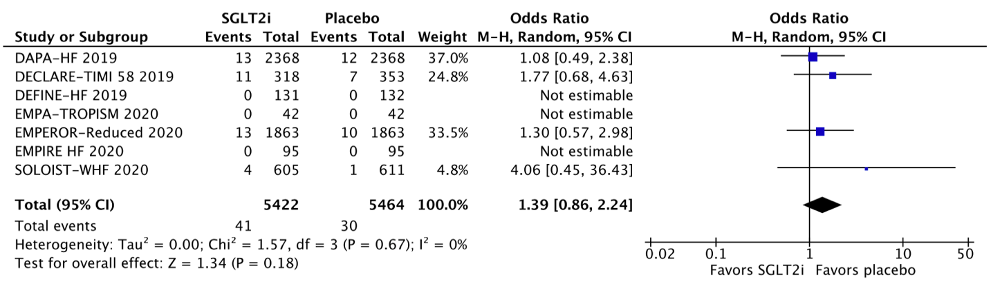
Patients treated with SGLT2 inhibitors (0·75%) and placebo (0·55%) had a similar incidence of amputations (HR 1·39; 95% CI 0·86-2·24).
Supplementary figure 2B. There was no significant difference between groups in bone fractures.
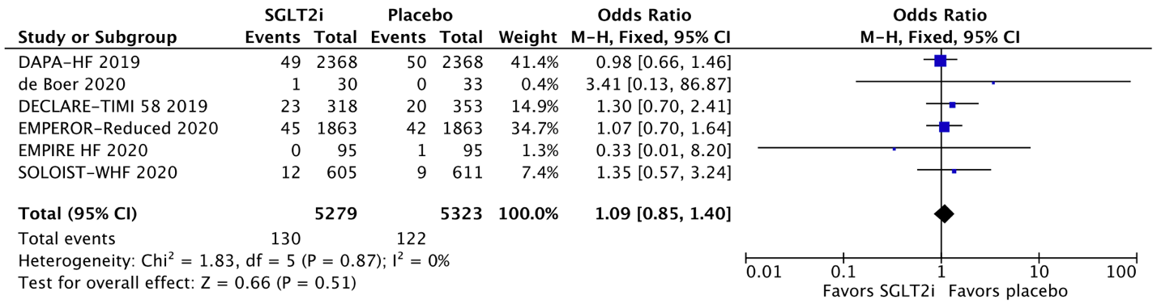
Patients treated with SGLT2 inhibitors (2·5%) and placebo (2·3%) had a similar incidence of amputations (HR 1·09; 95% CI 0·85-1·40).

Supplementary figure 3. Weight loss was significantly higher in the SGLT2 inhibitor group.
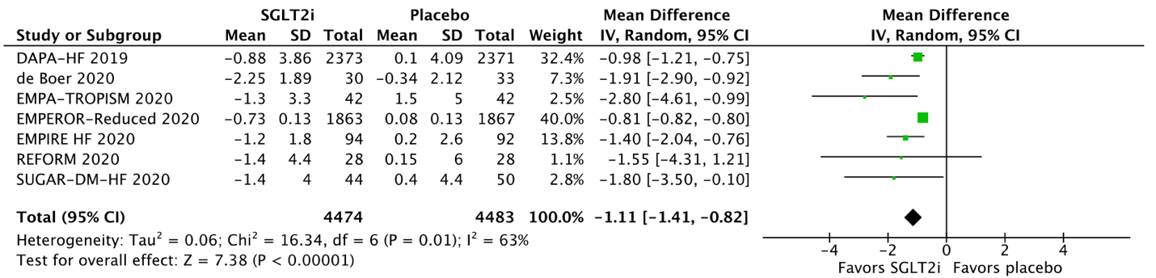
Patients treated with SGLT2 inhibitors had a significantly higher mean weight loss compared with those treated with placebo. The mean difference between groups was 1.11 Kg (95% CI 0.82-1.41 Kg).

Supplementary figure 4A. Cardiovascular death or HF hospitalizations/urgent visits in men.
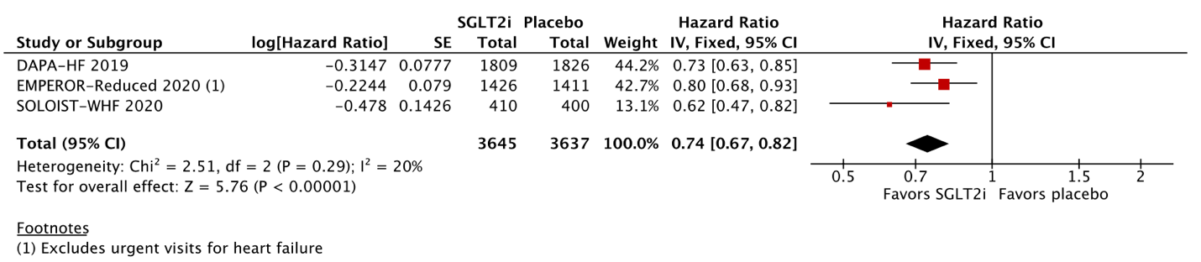In men with HF, there was a significant 26% relative risk reduction in the composite endpoint of cardiovascular death or HF hospitalizations/urgent visits among those treated with SGLT2 inhibitors compared with placebo (OR 0·74; 95% CI 0·67-0·82).

Supplementary figure 4B. Cardiovascular death or HF hospitalizations/urgent visits in women.
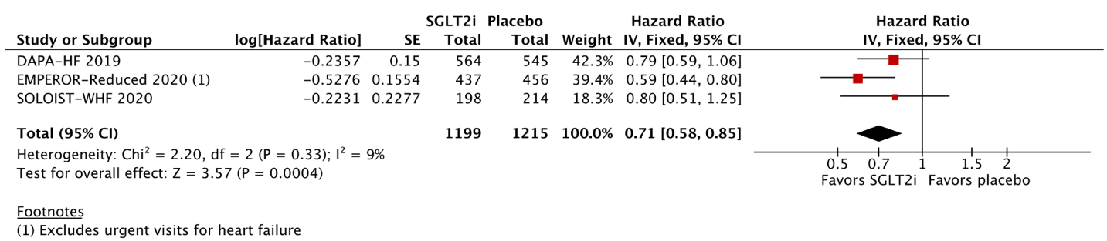In women with HF, there was a significant 29% relative risk reduction in the composite endpoint of cardiovascular death or HF hospitalizations/urgent visits among those treated with SGLT2 inhibitors compared with placebo (OR 0·71; 95% CI 0·58-0·85).

Supplementary figure 5A. Cardiovascular death or HF hospitalizations/urgent visits in patients < 65 years old.

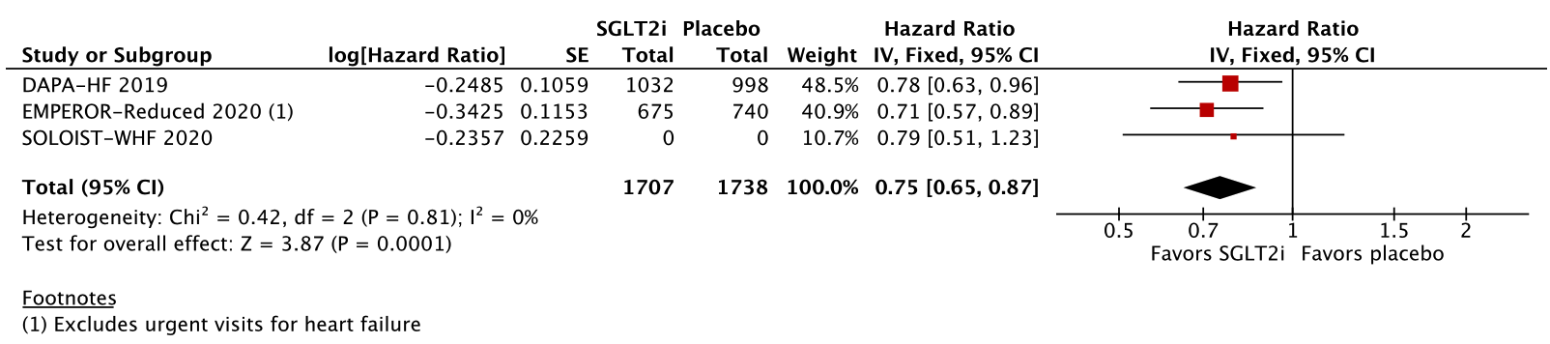
In patients with HF under the age of 65 years, there was a significant 25% relative risk reduction in the composite endpoint of cardiovascular death or HF hospitalizations/urgent visits among those treated with SGLT2 inhibitors compared with placebo (OR 0·75; 95% CI 0·65-0·87). The number of patients < 65 years old stratified between the SGLT2 inhibitor and placebo groups was not available in the SOLOIST-WHF trial.

Supplementary figure 5B. Cardiovascular death or HF hospitalizations/urgent visits in patients ≥ 65 years old.
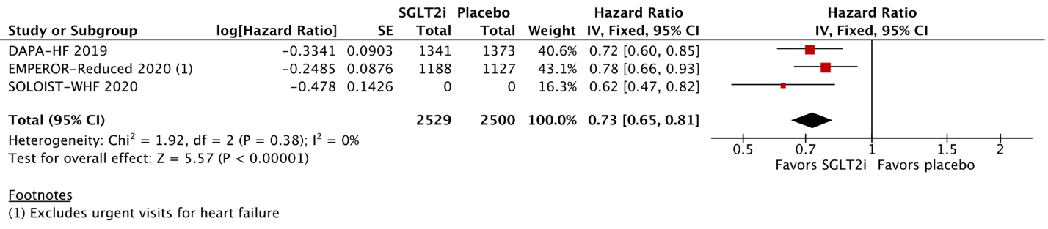In patients with HF aged 65 years or older, there was a significant 27% relative risk reduction in the composite endpoint of cardiovascular death or HF hospitalizations/urgent visits among those treated with SGLT2 inhibitors compared with placebo (OR 0·73; 95% CI 0·65-0·81). The number of patients ≥ 65 years old stratified between the SGLT2 inhibitor and placebo groups was not available in the SOLOIST-WHF trial.

Supplementary figure 6A. Cardiovascular death or HF hospitalizations/urgent visits in patients with an estimated glomerular filtration rate (eGFR) <60 mL/min/1.73m².
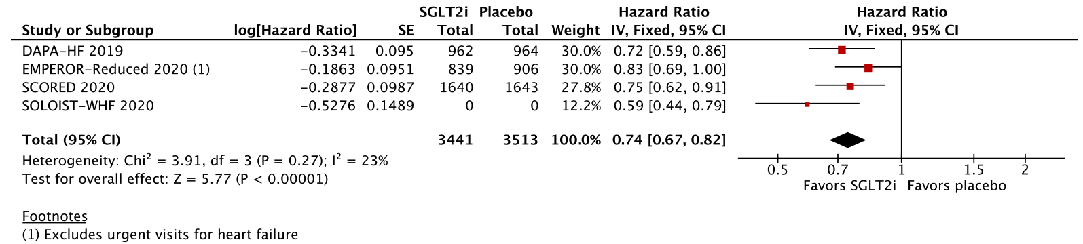
In patients with an eGFR < 60 mL/min/1.73m², there was a significant 26% relative risk reduction in the composite endpoint of cardiovascular death or HF hospitalizations/urgent visits among those treated with SGLT2 inhibitors compared with placebo (OR 0·74; 95% CI 0·67-0·82). The number of patients with eGFR < 60 mL/min/1.73m² stratified between the SGLT2 inhibitor and placebo groups was not available in the SOLOIST-WHF trial.

Supplementary figure 6B. Among patients with eGFR ≥60 mL/min/1.73m², cardiovascular death or HF hospitalizations/urgent visits was significantly lower in the SGLT2 inhibitor group.
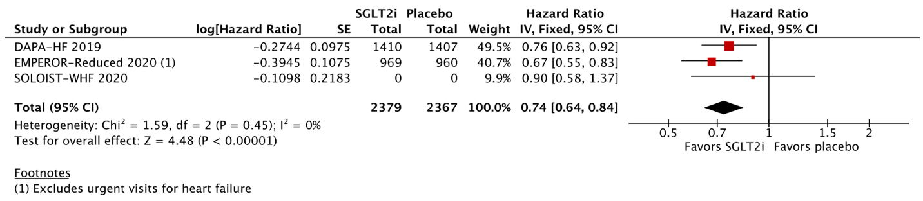In patients with an eGFR ≥ 60 mL/min/1.73m², there was a significant 26% relative risk reduction in the composite endpoint of cardiovascular death or HF hospitalizations/urgent visits among those treated with SGLT2 inhibitors compared with placebo (OR 0·74; 95% CI 0·64-0·84). The number of patients with eGFR ≥ 60 mL/min/1.73m² stratified between the SGLT2 inhibitor and placebo groups was not available in the SOLOIST-WHF trial.

Supplementary figure 7A. Cardiovascular death or HF hospitalizations/urgent visits in patients with New York Heart Association (NYHA) class II symptoms.
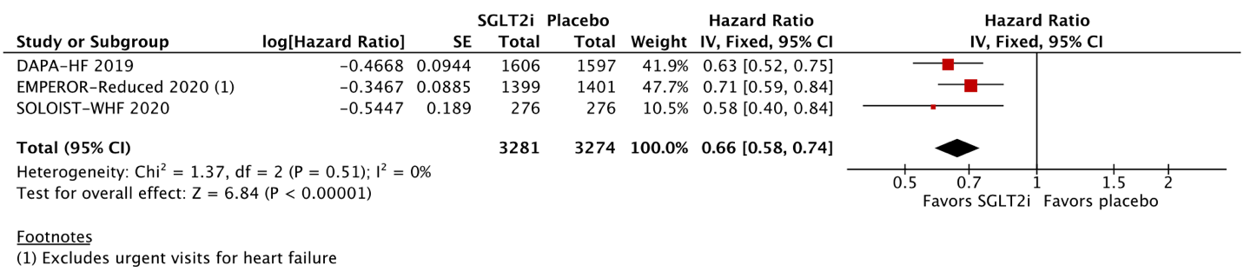
In patients with NYHA class II symptoms, there was a significant 34% relative risk reduction in the composite endpoint of cardiovascular death or HF hospitalizations/urgent visits among those treated with SGLT2 inhibitors compared with placebo (OR 0·66; 95% CI 0·58-0·74).

Supplementary figure 7B. Cardiovascular death or HF hospitalizations/urgent visits in patients with New York Heart Association (NYHA) class III or IV symptoms.
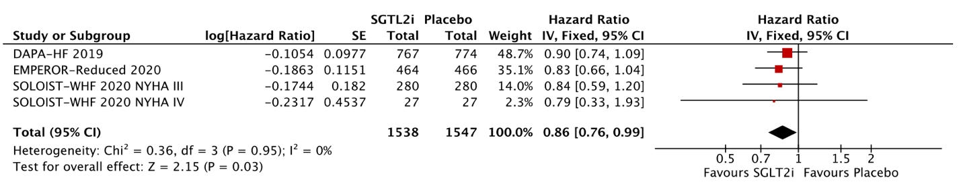
In patients with NYHA class III or IV symptoms, there was a significant 14% relative risk reduction in the composite endpoint of cardiovascular death or HF hospitalizations/urgent visits among those treated with SGLT2 inhibitors compared with placebo (OR 0·86; 95% CI 0·76-0·99).

Supplementary figure 8A. Cardiovascular death or HF hospitalizations/urgent visits in patients with diabetes.
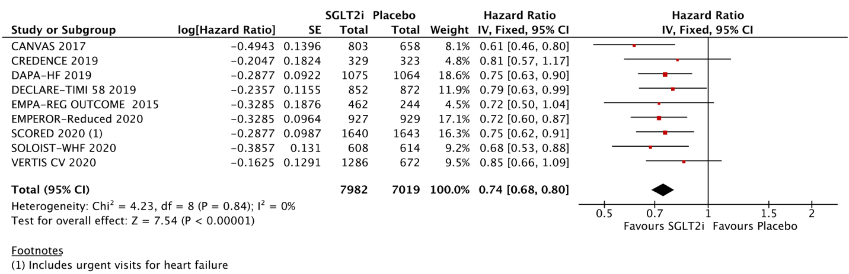
In patients with HF and diabetes, there was a significant 26% relative risk reduction in the composite endpoint of cardiovascular death or HF hospitalizations/urgent visits among those treated with SGLT2 inhibitors compared with placebo (OR 0·74; 95% CI 0·68-0·80).

Supplementary figure 8B. Cardiovascular death or HF hospitalizations/urgent visits in patients without diabetes.
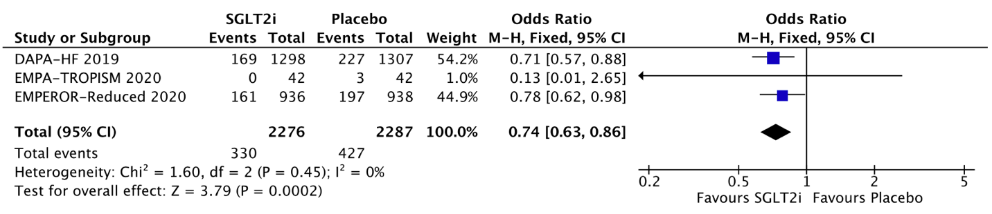
In patients with HF and no diabetes, there was a significant 26% relative risk reduction in the composite endpoint of cardiovascular death or HF hospitalizations/urgent visits among those treated with SGLT2 inhibitors compared with placebo (OR 0·74; 95% CI 0·63-0·86).

Supplementary figure 9A. Funnel plot for all-cause mortality
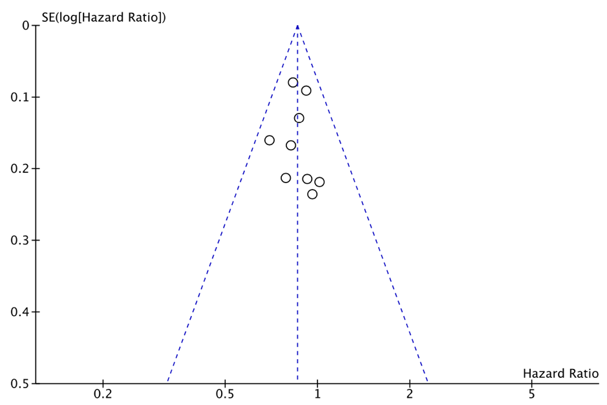
A symmetrical distribution of study weights and hazards ratios shows no evidence of publication bias.

Supplementary figure 9B. Funnel plot for cardiovascular mortality
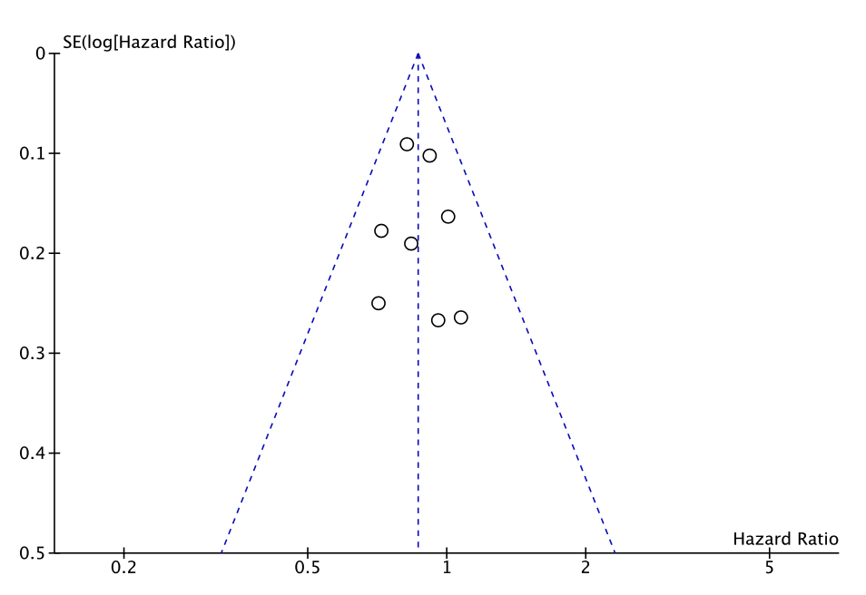
A symmetrical distribution of study weights and hazards ratios shows no evidence of publication bias

Supplementary Table 1. Critical appraisal according to the Cochrane Collaboration’s tool for assessing risk of bias in randomized trials.
Study | Selection bias | Performance bias | Detection bias | Attrition bias | Reporting bias
De Boer 2020 | Low | Low | Unclear | High | Low
CANVAS HF 2018 | Low | Low | Low | Low | Low
CREDENCE 2019 | Low | Low | Low | Low | Low
DAPA-HF 2019 | Low | Low | Low | Low | Low
DECLARE TIMI 2019 | Low | Low | Low | Low | Low
DEFINE-HF 2019 | Low | Low | Low | Low | Low
EMPA TROPISM 2020 | Low | Low | Low | Low | Low
EMPA-REG 2016 | Low | Low | Low | Low | Low
EMPEROR-Reduced 2020 | Low | Low | Low | Low | Low
REFORM 2020 | Low | Low | Low | Low | Low
SCORED 2020 | Low | Low | Low | Low | Low
SOLOIST-WHF 2020 | Low | Low | Low | Low | Low
VERTIS 2020 | Low | Low | Low | Low | Low

