Whether inhaled methoxyflurane implement the fast and efficient pain management in trauma patients: a systematic review and meta-analysis based on the clinically important differences
Hong Liu (M.Sc.),^{1*} Xi Fu (M.D.),^{1*} Yi-Feng Ren (M.D., Ph.D.),¹ Shi-Yan Tan (M.Sc.),¹ Si-Rui Xiang (M.Sc.),¹ Chuan Zheng (M.D., Ph.D.),¹ Feng-Ming You (M.D., Ph.D.),¹ Wei Shi (M.D.),² Lin-Jiong Li (M.D., Ph.D.)¹

Supplementary Online Content
Table of Contents
eMethods 1: PubMed Search Strategy Search strategy | Page 2- 5
eMethods 2: Web of Science Search Strategy Search strategy | Page 6
eMethods 3: EMBASE Search Strategy Search strategy | Page 6
eMethods 4: Cochrane Library Search Strategy Search strategy | Page 6
eMethods 5: Google Scholar Search Strategy Search strategy | Page 6
eTable 1: Risk of Bias Assessment | Page 7-10
eFigure 1A: Risk of Bias Summary | Page 11
eFigure 1B: Cross Tabulation Risk of Bias | Page 12
eTable 2: The definitions of pain relief in different studies | Page 13
eFigure 2: The forest plots of the adverse events | Page 14
eFigure 3: The incidence of TEAEs grouped by system organ classes | Page 15
eFigure 4: The incidence of remaining occasional symptoms | Page 16
eTable 3A: Sensitivity analyses for primary outcome by excluding high-risk bias trials | Page 17
eTable 3B: Predefined subgroup analyses for Primary outcome | Page 18-19
eTable 4A: Sensitivity analyses for secondary outcomes and safety results | Page 20-23
eTable 4B: Predefined subgroup analyses for secondary outcomes and safety results | Page 24-28

eMethods 1: PubMed Search Strategy Search strategy

PubMed (24)
Subject words: | Free words
Methoxyflurane | Methofluranum  Penthrane  Pentrane  Anecotan
Emergency department | Emergency Services, Hospital  Hospital Emergency Services  Services, Hospital Emergency  Emergency Hospital Service  Emergency Hospital Services  Hospital Service, Emergency  Hospital Services, Emergency  Service, Emergency Hospital  Services, Emergency Hospital  Hospital Service Emergency  Emergencies, Hospital Service  Emergency, Hospital Service  Hospital Service Emergencies  Service Emergencies, Hospital  Service Emergency, Hospital  Hospital Emergency Service  Emergency Units  Emergency Unit  Unit, Emergency  Units, Emergency  Service, Hospital Emergency  Accident and Emergency Department  Emergency Ward  Emergency Wards  Ward, Emergency  Wards, Emergency  Emergency Departments  Department, Emergency  Departments, Emergency  Emergency Department  Emergency Room  Emergency Rooms  Room, Emergency  Rooms, Emergency  Emergency Outpatient Unit  Emergency Outpatient Units  Outpatient Unit, Emergency  Outpatient Units, Emergency  Unit, Emergency Outpatient  Units, Emergency Outpatient

1. "methoxyflurane"[MeSH Terms] (2052)
2. (((methoxifluranum[Title/Abstract]) OR (Penthrane[Title/Abstract])) OR (penthrane[Title/Abstract])) OR (Anecotan[Title/Abstract]) (173)
3. ((((methoxyflurane[MeSH Terms]) OR (methoxifluranum[Title/Abstract])) OR (Penthrane[Title/Abstract])) OR (penthrane[Title/Abstract])) OR (Anecotan[Title/Abstract]) (2057)
4. trauma[Title/Abstract] (240615)
5. ((((((((((((((((((((((((((((((((((((((((emergency department[Title/Abstract]) OR (Emergency Services, Hospital[Title/Abstract])) OR (Hospital Emergency Services[Title/Abstract])) OR (Services, Hospital Emergency[Title/Abstract])) OR (Emergency Hospital Service[Title/Abstract])) OR (Emergency Hospital Services[Title/Abstract])) OR (Hospital Service, Emergency[Title/Abstract])) OR (Hospital Services, Emergency[Title/Abstract])) OR (Service, Emergency Hospital[Title/Abstract])) OR (Services, Emergency Hospital[Title/Abstract])) OR (Hospital Service Emergency[Title/Abstract])) OR (Emergencies, Hospital Service[Title/Abstract])) OR (Emergency, Hospital Service[Title/Abstract])) OR (Hospital Service Emergencies[Title/Abstract])) OR (Service Emergencies, Hospital[Title/Abstract])) OR (Service Emergency, Hospital[Title/Abstract])) OR (Hospital Emergency Service[Title/Abstract])) OR (Emergency Units[Title/Abstract])) OR (Emergency Unit[Title/Abstract])) OR (Unit, Emergency[Title/Abstract])) OR (Units, Emergency[Title/Abstract])) OR (Service, Hospital Emergency[Title/Abstract])) OR (Accident[Title/Abstract] AND Emergency Department[Title/Abstract])) OR (Emergency Ward[Title/Abstract])) OR (Emergency Wards[Title/Abstract])) OR (Ward, Emergency[Title/Abstract])) OR (Wards, Emergency[Title/Abstract])) OR (Emergency Departments[Title/Abstract])) OR (Department, Emergency[Title/Abstract])) OR (Departments, Emergency[Title/Abstract])) OR (Emergency Department[Title/Abstract])) OR (Emergency Room[Title/Abstract])) OR (Emergency Rooms[Title/Abstract])) OR (Room, Emergency[Title/Abstract])) OR (Rooms, Emergency[Title/Abstract])) OR (Emergency Outpatient Unit[Title/Abstract])) OR (Emergency Outpatient Units[Title/Abstract])) OR (Outpatient Unit, Emergency[Title/Abstract])) OR (Outpatient Units, Emergency[Title/Abstract])) OR (Unit, Emergency Outpatient[Title/Abstract])) OR (Units, Emergency Outpatient[Title/Abstract]) (119337)
6. pre-hospital [Title/Abstract] (4524)
7. ("methoxyflurane"[MeSH Terms] OR "methoxifluranum"[Title/Abstract] OR "Penthrane"[Title/Abstract] OR "Penthrane"[Title/Abstract] OR "Anecotan"[Title/Abstract]) AND ("trauma"[Title/Abstract] OR ("emergency department"[Title/Abstract] OR "emergency services hospital"[Title/Abstract] OR "hospital emergency services"[Title/Abstract] OR "services hospital emergency"[Title/Abstract] OR "emergency hospital service"[Title/Abstract] OR "emergency hospital services"[Title/Abstract] OR (("hospital s"[All Fields] OR "hospitalisation"[All Fields] OR "hospitalization"[MeSH Terms] OR "hospitalization"[All Fields] OR "hospitalised"[All Fields] OR "hospitalising"[All Fields] OR "hospitality"[All Fields] OR "hospitalisations"[All Fields] OR "hospitalizations"[All Fields] OR "hospitalize"[All Fields] OR "hospitalized"[All Fields] OR "hospitalizing"[All Fields] OR "hospitals"[MeSH Terms] OR "hospitals"[All Fields] OR "Hospital"[All Fields]) AND "service emergency"[Title/Abstract]) OR "hospital services emergency"[Title/Abstract] OR "service emergency hospital"[Title/Abstract] OR "services emergency hospital"[Title/Abstract] OR (("hospital s"[All Fields] OR "hospitalisation"[All Fields] OR "hospitalization"[MeSH Terms] OR "hospitalization"[All Fields] OR "hospitalised"[All Fields] OR "hospitalising"[All Fields] OR "hospitality"[All Fields] OR "hospitalisations"[All Fields] OR "hospitalizations"[All Fields] OR "hospitalize"[All Fields] OR "hospitalized"[All Fields] OR "hospitalizing"[All Fields] OR "hospitals"[MeSH Terms] OR "hospitals"[All Fields] OR "Hospital"[All Fields]) AND "service emergency"[Title/Abstract]) OR (("emerge"[All Fields] OR "emerged"[All Fields] OR "emergence"[All Fields] OR "emergences"[All Fields] OR "Emergencies"[MeSH Terms] OR "Emergencies"[All Fields] OR "Emergency"[All Fields] OR "emergent"[All Fields] OR "emergently"[All Fields] OR "emergents"[All Fields] OR "emerges"[All Fields] OR "emerging"[All Fields]) AND "hospital service"[Title/Abstract]) OR "emergency hospital service"[Title/Abstract] OR (("hospital s"[All Fields] OR "hospitalisation"[All Fields] OR "hospitalization"[MeSH Terms] OR "hospitalization"[All Fields] OR "hospitalised"[All Fields] OR "hospitalising"[All Fields] OR "hospitality"[All Fields] OR "hospitalisations"[All Fields] OR "hospitalizations"[All Fields] OR "hospitalize"[All Fields] OR "hospitalized"[All Fields] OR "hospitalizing"[All Fields] OR "hospitals"[MeSH Terms] OR "hospitals"[All Fields] OR "Hospital"[All Fields]) AND "service emergencies"[Title/Abstract]) OR (("Service"[All Fields] OR "service s"[All Fields] OR "serviced"[All Fields] OR "Services"[All Fields] OR "services s"[All Fields] OR "servicing"[All Fields]) AND "emergencies hospital"[Title/Abstract]) OR "service emergency hospital"[Title/Abstract] OR "hospital emergency service"[Title/Abstract] OR "emergency units"[Title/Abstract] OR "emergency unit"[Title/Abstract] OR "unit emergency"[Title/Abstract] OR "units emergency"[Title/Abstract] OR "service hospital emergency"[Title/Abstract] OR ("Accident"[Title/Abstract] AND "emergency department"[Title/Abstract]) OR "emergency ward"[Title/Abstract] OR "emergency wards"[Title/Abstract] OR "ward emergency"[Title/Abstract] OR "wards emergency"[Title/Abstract] OR "emergency departments"[Title/Abstract] OR "department emergency"[Title/Abstract] OR "departments emergency"[Title/Abstract] OR "emergency department"[Title/Abstract] OR "emergency room"[Title/Abstract] OR "emergency rooms"[Title/Abstract] OR "room emergency"[Title/Abstract] OR "rooms emergency"[Title/Abstract] OR "emergency outpatient unit"[Title/Abstract] OR "emergency outpatient units"[Title/Abstract] OR (("outpatient s"[All Fields] OR "outpatients"[MeSH Terms] OR "outpatients"[All Fields] OR "Outpatient"[All Fields]) AND "unit emergency"[Title/Abstract]) OR "outpatient units emergency"[Title/Abstract] OR ("Unit"[All Fields] AND "emergency outpatient"[Title/Abstract]) OR (("unit s"[All Fields] OR "Units"[All Fields]) AND "emergency outpatient"[Title/Abstract]) OR "pre-hospital"[Title/Abstract])) (24)

Web of Science (24)
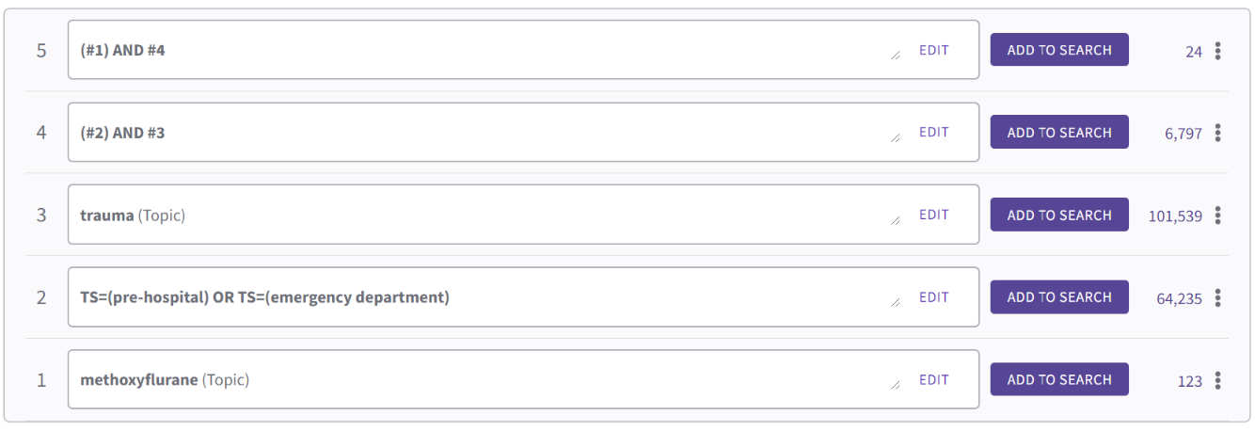

Embase (31)
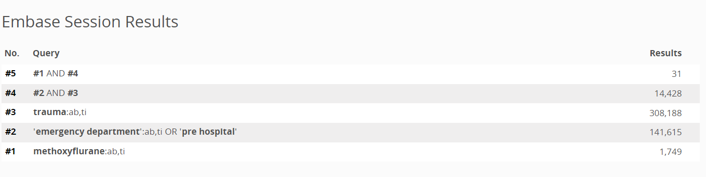

Cochrane Library (50)
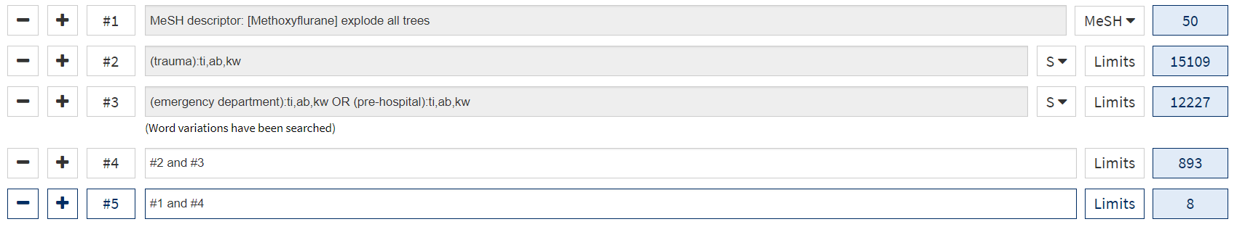

Google Scholar (100)
methoxyflurane AND (trauma or emergency department or pre-hospital) AND clinical trial (First ten pages of results (100 citations) included.
eTable 1: Risk of Bias Assessment
Study | Overall Assessment | Sequence generation | Allocation Concealment | Blinding:  Performance Bias | Blinding:  Detection Bias | Incomplete  Outcome Data | Selective Outcome Reporting | Other Sources  of Bias
Borobia 2020 |  | Randomization stratified by clinical center by SAS statistical software. | Randomization lists were used to generate sealed envelopes that were distributed to sites to perform randomization. | Open label | Open label | The primary analysis population was the intention-to-treat population. Efficacy results were similar for both the intention-to-treat and per-protocol populations. | Pre-specified outcomes reported. | No other sources of bias.
Risk of Bias | High | Low | Low | High | High | Low | Low | Low
Brichko 2020 |  | A simple computerised sequence generation randomisation method wasapplied with no stratification (Single center). | After screening and eligibility assessments, patients were randomised 1:1. | Open label | Open label | All outcome measures were assessed on an intention to treat basis (only one patient lost to follow-up). | Pre-specified outcomes reported. | No other sources of bias.
Risk of Bias | High | Low | Unclear | High | High | Low | Low | Low
Coffey 2014 |  | Randomisation sequences, stratified by center and age group (adolescent/adult) were prepared by an independent statistician. | The study medication was packaged according to the randomisation sequences. | The inhalers were visually indistinguishable, but as methoxyflurane has a characteristic odour, one drop of methoxyflurane was placed on the outside of the primed inhaler to support blinding. | The research nurse, the treating physician and the patient all remained blind to the treatment administered. | The intention-to-treat population was defined as those patients in the safety population who had at least one post-baseline efficacy assessment. Patients who received the wrong treatment in error were analysed as randomised. | Pre-specified outcomes reported. | No other sources of bias.
Risk of Bias | Low | Low | Low | Low | Low | Low | Low | Low
Coffey 2016 |  | Treatment randomization (using permuted block randomization), stratified by center and age group (adolescent/adult) was prepared by an independent statistician. | The study medication was packaged according to the randomisation sequences. | Placed each inhaler into a plastic bag, which was sealed, labeled with the patient randomization number and weighed. The placebo treatments were indistinguishable to the patient and treating physician upon opening. | The patient and all other personnel involved with the conduct and interpretation of the study, including the investigators, site personnel and the study team, were blinded to the treatment allocation. | Efficacy analyses were performed using the intention-to-treat population, defined as all randomized patients who received at least one dose of study medication and had at least one post-baseline efficacy assessment. | Pre-specified outcomes reported. | No other sources of bias.
Risk of Bias | Low | Low | Low | Low | Low | Low | Low | Low
Hartshorn 2019 |  | Randomization was performed by an independent statistician using permuted blocks and was stratified by center and age group. | Study medication was assembled and dispensed in a sealed plastic bag by an unblinded research team member. | The investigator, patient, and all site personnel (except the staff member responsible for dispensing study medication) were blinded to the treatment assignment. | The investigator, patient, and all site personnel (except the staff member responsible for dispensing study medication) were blinded to the treatment assignment. | The modified intention-to-treat (ITT) population (including all randomized patients who used the study medication and had at least one on-treatment efficacy assessment) was used for all efficacy analyses. | Pre-specified outcomes reported. | No other sources of bias.
Risk of Bias | Low | Low | Low | Low | Low | Low | Low | Low
Mercadante 2019 |  | Patients were randomised to study treatment via a centralized Interactive Web Response System. Randomisation was in a block randomisation scheme of four without stratification. | Guaranteed allocation concealment, set up within the electronic case report form. | Open label | Open label | All efficacy and safety analyses were performed using the intention-to-treat population. | Pre-specified outcomes reported. | No imputation of missing data was performed.
Risk of Bias | High | Low | Low | High | High | Low | Low | Unclear
Ricard-Hibon  2020 |  | Randomisation was stratified by gender, centre and baseline pain score. | Randomisation was stratified by gender, centre and baseline pain score. | The inhalers were supplied to the patient/study investigator/nurse with an identical external packaging. | To ensure that the patient, nurse and study investigator were blinded to treatment, inhalers were prepared immediately prior to the study drug intake by a single, trained nurse at each participating centre who was not involved in the trial. | Efficacy was analysed in the full analysis set, comprising all randomised patients who received at least one inhalation of study medication and provided at least one on-treatment efficacy evaluation. | Pre-specified outcomes reported. | No other sources of bias.
Risk of Bias | Low | Low | Low | Low | Low | Low | Low | Low
Serra 2020 |  | Non-stratified blocks of four were used for randomization, and the procedure started with the verification of the eligibility criteria. | Treatment allocation was concealed to investigators thanks to a centralized Interactive Web Response System integrated with the electronic case report form. | Open label | Open label | For efficacy variables, the intention-to-treat population approach was adopted, and no imputation of missing data was performed. Since in the total population the intention-to-treat and per-protocol results were similar. | Pre-specified outcomes reported. | No imputation of missing data was performed.
Risk of Bias | High | Low | Low | High | High | Low | Low | Unclear
Voza 2020 |  | Treatment randomization was performed in blocks of four, without stratification. | Once patient eligibility was confirmed, treatment allocation was performed via a centralized Interactive Web Response System set up within the electronic case report form. | Open label | Open label | Efficacy variables were analyzed using the intention-to-treat population. | Pre-specified outcomes reported. | No imputation of missing data was performed.
Risk of Bias | High | Low | Low | High | High | Low | Low | Unclear

eFigure 1A: Risk of Bias Summary

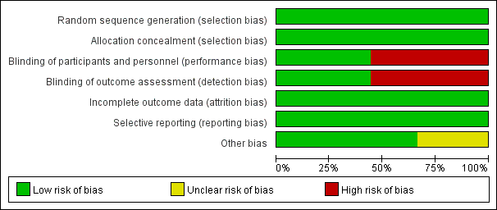

eFigure 1B: Cross Tabulation Risk of Bias
Green circle= low bias risk, yellow circle= unclear bias risk, red circle= high bias risk.

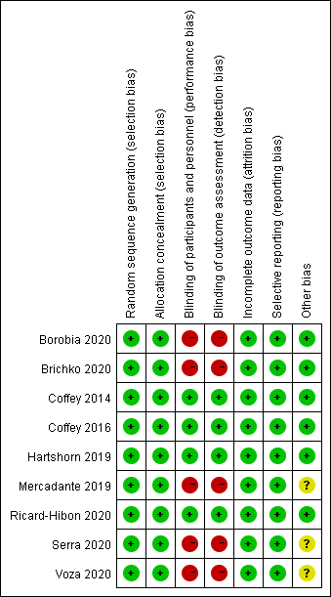
eTable 2: The definitions of pain relief in different studies
Study | The definitions of pain relief
Borobia 2020 | subjectively reported by the patient until their departure from the emergency department
Coffey 2016 | subjectively reported by the patient until their departure from the emergency department
Hartshorn 2019 | subjectively reported by the patient until their departure from the emergency department
Mercadante 2019 | subjectively reported by the patient up to 30 min after randomization
Ricard-Hibon 2020 | total pain relief determined by the patients on the electronic tablet device
Serra 2020 | from randomization to the onset of analgesic effect reported by the patient

eFigure 2: The forest plots of the adverse events. (A) the total incidence of TEAEs; (B) the most common TEAEs occurring with methoxyflurane (dizziness, somnolence, feeling drunk and headache). TEAE, treatment-emergent adverse events. M-H, the Mantel-Haenszel method; Chi², a test of significance for heterogeneity; I², a test for heterogeneity where highest level is 100%; Z, a significance test for the weighted average effect size. A low P value or large Chi² relative to its degree of freedom (df) provides evidence of heterogeneity of intervention effects. The squares and bars represent the mean values and 95% CIs of the effect sizes. The diamond represents the combined effect.

eFigure 3: The incidence of TEAEs grouped by system organ classes.
TEAE, treatment-emergent adverse events. M-H, the Mantel-Haenszel method; Chi², a test of significance for heterogeneity; I², a test for heterogeneity where highest level is 100%; Z, a significance test for the weighted average effect size. A low P value or large Chi² relative to its degree of freedom (df) provides evidence of heterogeneity of intervention effects. The squares and bars represent the mean values and 95% CIs of the effect sizes. The diamond represents the combined effect.

eFigure 4: The incidence of remaining occasional symptoms
TEAE, treatment-emergent adverse events. M-H, the Mantel-Haenszel method; Chi², a test of significance for heterogeneity; I², a test for heterogeneity where highest level is 100%; Z, a significance test for the weighted average effect size. A low P value or large Chi² relative to its degree of freedom (df) provides evidence of heterogeneity of intervention effects. The squares and bars represent the mean values and 95% CIs of the effect sizes. The diamond represents the combined effect.

eTable 3A: Sensitivity analyses for primary outcome by excluding high-risk bias trials
Deleted Studies | WMD [99% CI] | Model | P | I² test (%) | Number of studies
10 minutes
Borobia 2020, Mercadante 2019, Voza 2020 | -1.42 [-1.82, -1.02] | Fixed | < 0.00001 | 7 | 3
15 minutes
Borobia 2020, Mercadante 2019, Voza 2020 | -1.86 [-2.32, -1.40] | Fixed | < 0.00001 | 13 | 3
20 minutes
Borobia 2020, Mercadante 2019, Voza 2020 | -1.60 [-2.09, -1.10] | Fixed | < 0.00001 | 50 | 3
Abbreviation: WMD: weighted mean difference; CI: confidence interval.

eTable 3B: Predefined subgroup analyses for primary outcome
Subgroup | Subgroup category | Included studies | N studies | WMD [99% CI] | Model | P | I² test (%)
10 minutes
Age | Adolescents | Hartshorn 2019, Coffey 2014 | 2 | -1.30 [-1.80, -0.80] | Fixed | < 0.00001 | 9
Age | Adults | Borobia 2020, Coffey 2016, Mercadante 2019, Voza 2020 | 4 | -1.05 [-1.67, -0.43] | Random | < 0.0001 | 75
The intervention of control group | Normal saline inhaled | Hartshorn 2019, Coffey 2014, Coffey 2016 | 3 | -1.42 [-1.82, -1.02] | Fixed | < 0.00001 | 7
The intervention of control group | SAT | Borobia 2020, Mercadante 2019, Voza 2020 | 3 | -0.87 [-1.52, -0.22] | Random | 0.0005 | 70
15 minutes
Age | Adolescents | Hartshorn 2019, Coffey 2014 | 2 | -1.72 [-2.29, -1.15] | Fixed | < 0.00001 | 20
Age | Adults | Borobia 2020, Coffey 2016, Mercadante 2019, Voza 2020 | 4 | -1.06 [-2.08, -0.05] | Random | 0.007 | 89
The intervention of control group | Normal saline inhaled | Hartshorn 2019, Coffey 2014, Coffey 2016 | 3 | -1.86 [-2.32, -1.40] | Fixed | < 0.00001 | 13
The intervention of control group | SAT | Borobia 2020, Mercadante 2019, Voza 2020 | 3 | -0.73 [-1.78, 0.32] | Random | 0.07 | 87
20 minutes
Age | Adolescents | Hartshorn 2019, Coffey 2014 | 2 | -1.30 [-2.30, -0.30] | Random | < 0.00001 | 53
Age | Adults | Borobia 2020, Coffey 2016, Mercadante 2019, Voza 2020 | 4 | -1.04 [-1.90, -0.19] | Random | 0.002 | 82
The intervention of control group | Normal saline inhaled | Hartshorn 2019, Coffey 2014, Coffey 2016 | 3 | -1.60 [-2.09, -1.10] | Fixed | < 0.00001 | 50
The intervention of control group | SAT | Borobia 2020, Mercadante 2019, Voza 2020 | 3 | -0.77 [-1.60, 0.07] | Random | 0.02 | 75
Abbreviation: N, number; WMD: weighted mean difference; CI: confidence interval; SAT: standard analgesic treatment.

eTable 4A: Sensitivity analyses for secondary pain-related outcomes and other secondary outcomes
Time from the start of treatment to first pain relief by excluding high-risk bias trials
Deleted Studies | WMD [95% CI] | Model | P | I² test (%) | Number of included studies
Borobia 2020, Mercadante 2019, Voza 2020 | -4.63 [-7.68, -1.57] | Random | 0.003 | 100 | 3
Proportion of patients experiencing pain relief
By excluding high-risk bias trials
Deleted Studies | RR [95% CI] | Model | P | I² test (%) | Number of included studies
Borobia 2020, Mercadante 2019, Serra 2020 | 1.44 [1.13, 1.83] | Random | 0.003 | 80 | 3
By excluding the results of PenASAP
Deleted Studies | RR [95% CI] | Model | P | I² test (%) | Number of included studies
Ricard-Hibon 2020 | 1.37 [1.12, 1.67] | Random | 0.002 | 85 | 5
Proportions of patients, physicians or nurses who rated satisfaction as ‘Excellent’, ‘Very good’ or ‘Good’
The proportion of patients
By excluding high-risk bias trials
Deleted Studies | RR [95% CI] | Model | P | I² test (%) | Number of included studies
Borobia 2020, Mercadante 2019, Serra 2020, Voza 2020 | 1.67 [1.25, 2.25] | Random | <0.0006 | 82 | 3
By excluding the results of PenASAP
Deleted Studies | RR [95% CI] | Model | P | I² test (%) | Number of included studies
Ricard-Hibon 2020 | 1.28 [1.02, 1.61] | Random | 0.04 | 86 | 6
The proportion of physicians
By excluding high-risk bias trials
Deleted Studies | RR [95% CI] | Model | P | I² test (%) | Number of included studies
Mercadante 2019, Serra 2020, Voza 2020 | 1.77 [1.32, 2.36] | Random | 0.0001 | 70 | 3
By excluding the results of PenASAP
Deleted Studies | RR [95% CI] | Model | P | I² test (%) | Number of included studies
Ricard-Hibon 2020 | 1.48 [1.23, 1.77] | Random | <0.0001 | 62 | 5
The proportion of nurses
By excluding high-risk bias trials
Not Applicable
By excluding the results of PenASAP
Deleted Studies | RR [95% CI] | Model | P | I² test (%) | Number of included studies
Ricard-Hibon 2020 | 2.03 [1.01, 4.13] | Random | 0.04 | 91 | 2
The total incidence of treatment-emergent adverse events
By excluding high-risk bias trials
Deleted Studies | RR [95% CI] | Model | P | I² test (%) | Number of included studies
Borobia 2020, Mercadante 2019, Voza 2020 | 2.10 [1.19, 3.69] | Random | 0.01 | 88 | 4
By excluding the results of PenASAP
Deleted Studies | RR [95% CI] | Model | P | I² test (%) | Number of included studies
Ricard-Hibon 2020 | 2.90 [1.54, 5.46] | Random | 0.001 | 85 | 6
Abbreviation: WMD: weighted mean difference; RR, risk ratio; CI: confidence interval.

eTable 4B: Predefined subgroup analyses for secondary outcomes and safety results
Time from the start of treatment to first pain relief
Subgroup | Subgroup category | Included studies | N studies | WMD [95% CI] | Model |  | P |  |  | I² test (%)
Age | Adolescents | Hartshorn 2019, Coffey 2014 | 2 | -3.95 [-7.79, -0.12] | Random |  | 0.04 |  |  | 100
Age | Adults | Borobia 2020, Mercadante 2019, Serra 2020, Voza 2020 | 4 | -6.00 [-6.10, -5.90] | Fixed |  | < 0.0001 |  |  | 0
The intervention of control group | Normal saline inhaled | Hartshorn 2019, Coffey 2014 | 2 | -3.95 [-7.79, -0.12] | Random |  | 0.04 |  |  | 100
The intervention of control group | SAT | Borobia 2020, Mercadante 2019, Serra 2020, Voza 2020 | 4 | -6.00 [-6.10, -5.90] | Fixed |  | < 0.0001 |  |  | 0
Proportion of patients experiencing pain relief
Subgroup | Subgroup category | Included studies | N studies | RR [95% CI] | Model |  | P |  |  | I² test (%)
Age | Adolescents | Hartshorn 2019 | 1 | 1.20 [1.04, 1.39] | Random |  | / |  |  | /
Age | Adults | Borobia 2020, Coffey 2016, Mercadante 2019, Ricard-Hibon 2020, Serra 2020 | 5 | 1.47 [1.17, 1.85] | Random |  | 0.001 |  |  | 86
The intervention of control group | Normal saline inhaled | Coffey 2016, Hartshorn 2019, Ricard-Hibon 2020 | 3 | 1.44 [1.13, 1.83] | Random |  | 0.003 |  |  | 80
The intervention of control group | SAT | Borobia 2020, Mercadante 2019, Serra 2020 | 3 | 1.40 [0.99, 1.97] | Random |  | 0.04 |  |  | 90
Proportions of patients, physicians or nurses who rated satisfaction as ‘Excellent’, ‘Very good’ or ‘Good’
The proportion of patients
Subgroup | Subgroup category | Included studies | N studies | RR [95% CI] | Model |  | P |  |  | I² test (%)
Age | Adolescents | Hartshorn 2019 | 1 | 1.40 [1.14, 1.72] | Random |  | / |  |  | /
Age | Adults | Borobia 2020, Coffey 2016, Mercadante 2019, Ricard-Hibon 2020, Serra 2020, Voza 2020 | 6 | 1.29 [1.02, 1.63] | Random |  | 0.03 |  |  | 88
The intervention of control group | Normal saline inhaled | Coffey 2016, Hartshorn 2019, Ricard-Hibon 2020 | 3 | 1.67 [1.25, 2.25] | Random |  | 0.0006 |  |  | 82
The intervention of control group | SAT | Borobia 2020, Mercadante 2019, Serra 2020, Voza 2020 | 4 | 1.09 [1.00, 1.19] | Fixed |  | 0.04 |  |  | 16
The proportion of physicians
Subgroup | Subgroup category | Included studies | N studies | RR [95% CI] | Model |  | P |  |  | I² test (%)
Age | Adolescents | Hartshorn 2019 | 1 | 1.48 [1.18, 1.86] | Random |  | / |  |  | /
Age | Adults | Coffey 2016, Mercadante 2019, Ricard-Hibon 2020, Serra 2020, Voza 2020 | 5 | 1.51 [1.26, 1.82] | Random |  | <0.0001 |  |  | 66
The intervention of control group | Normal saline inhaled | Coffey 2016, Hartshorn 2019, Ricard-Hibon 2020 | 3 | 1.73 [1.49, 2.02] | Random |  | <0.0001 |  |  | 70
The intervention of control group | SAT | Mercadante 2019, Serra 2020, Voza 2020 | 3 | 1.36 [1.22, 1.52] | Fixed |  | <0.0001 |  |  | 0
The proportion of nurses
Age | Adolescents | Hartshorn 2019 | 1 | 1.50 [1.20, 1.88] | Random |  | / |  |  | /
Age | Adults | Coffey 2016, Ricard-Hibon 2020 | 2 | 2.16 [1.34, 3.50] | Random |  | 0.002 |  |  | 82
The intervention of control group | Normal saline inhaled | Not Applicable
The intervention of control group | SAT
The total incidence of treatment-emergent adverse events
Subgroup | Subgroup category | Included studies | N studies | RR [95% CI] |  | Model |  | P | I² test (%)
Age | Adolescents | Coffey 2014, Hartshorn 2019 | 2 | 1.39 [1.13, 1.71] |  | Fixed |  | 0.002 | 0
Age | Adults | Borobia 2020, Coffey 2016, Mercadante 2019, Ricard-Hibon 2020, Voza 2020 | 5 | 4.45 [3.30, 6.02] |  | Fixed |  | <0.00001 | 40
The intervention of control group | Normal saline inhaled | Coffey 2014, Coffey 2016, Hartshorn 2019, Ricard-Hibon 2020 | 4 | 2.10 [1.19, 3.69] |  | Random |  | 0.01 | 88
The intervention of control group | SAT | Borobia 2020, Mercadante 2019, Voza 2020 | 3 | 8.39 [4.12, 17.10] |  | Fixed |  | <0.00001 | 0
Abbreviation: N, number; WMD: weighted mean difference; RR, risk ratio; CI: confidence interval; SAT: standard analgesic treatment

