Supplemental data

Supplemental tables

Supplemental Table 1. Results of 8 studies included in the study
Study | Year | aICH | Dose of alteplase | HTGT
Broeg-Morvay¹⁹ | 2016 | √ | 0.9 mL/kg or  0.6 mL/kg | \
Wang²⁰ | 2017 | √ | 0.9 mL/kg | \
Bellwald¹⁸ | 2017 | √ | 0.9 mL/kg or  0.6 mL/kg | \
Balodis¹⁷ | 2019 | √ | 0.9 mL/kg | \
Gong³³ | 2019 | \ | unknown | \
Yang²⁵ | 2020 | √ | 0.9mg/kg | √
Zi²⁷ | 2021 | \ | 0.9mg/kg | √
Suzuki²⁶ | 2021 | \ | 0.6-mg/kg | √

Note: √, positive in the study; \, negative in the study; aICH, asymptomatic intracerebral hemorrhage; HTGT, mean time from hospital admission to groin puncture; superscript number indicate the reference number.

Supplemental Table 2. Quality of 9 studies evaluated with the Newcastle-Ottawa Scale
Study name  Year | Selection | Comparability | Outcome | Overall score
Broeg-Morvay et al, 2016¹⁹ | 3 | 2 | 3 | 8
Bellwald et al, 2017¹⁸ | 3 | 2 | 2 | 7
Wang et al, 2017²⁰ | 4 | 2 | 3 | 9
Balodis et al, 2018¹⁷ | 3 | 0 | 3 | 6
Gong et al, 2019³³ | 2 | 2 | 3 | 7
Casetta et al, 2019³¹ | 1 | 2 | 2 | 5
Yang et al, 2020²⁵ | 4 | 2 | 3 | 9
Suzuki et al, 2021²⁶ | 4 | 1 | 4 | 9
Zi et al, 2021²⁷ | 3 | 2 | 4 | 9
Note: Superscript number indicate the reference number. The study by Casetta et al, 2019³¹ was excluded due to low to a low quality score of 5 (less than 6).

Supplemental Table 3. Subgroup analysis on the effect of alteplase
Clinical outcome | A (OR(95%CI)) | B(OR(95%CI)) | Overall (OR(95%CI)) | P
Mortality at 90 days | 1.126(0.731,1.734) | 1.025(0.767,1.370) | 1.056(0.830,1.342) | 0.66
FI 90 days | 0.946(0.647,1.382) | 0.998(0.800,1.246) | 0.985(0.813,1.192) | 0.88
Recanalization | 0.768(0.470,1.254) | 1.075(0.791,1.461) | 0.975(0.753,1.263) | 0.85
sICH | 1.946(0.651,5.815) | 1.242(0.838,1.840) | 1.318(0.913,1.904) | 0.14
Note: A, patients received either 2/3 dose of altiplase or full dose of altiplase; B, studies using full dose of altiplase; FI, functional independence; sICH, symptomatic intracranial hemorrhage; OR, odds ratio; Overall, combination of groups A and B; CI, confidence interval.

Supplemental figures and legends
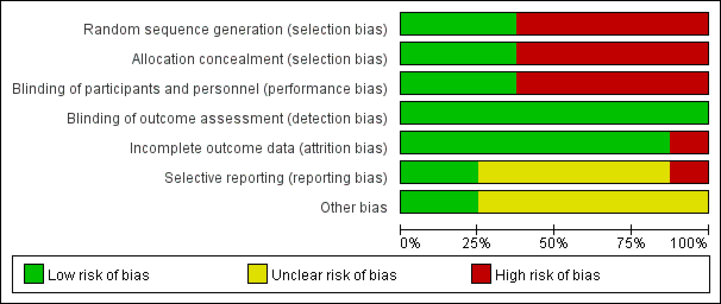
Supplemental Fig 1. Assessment of study bias.

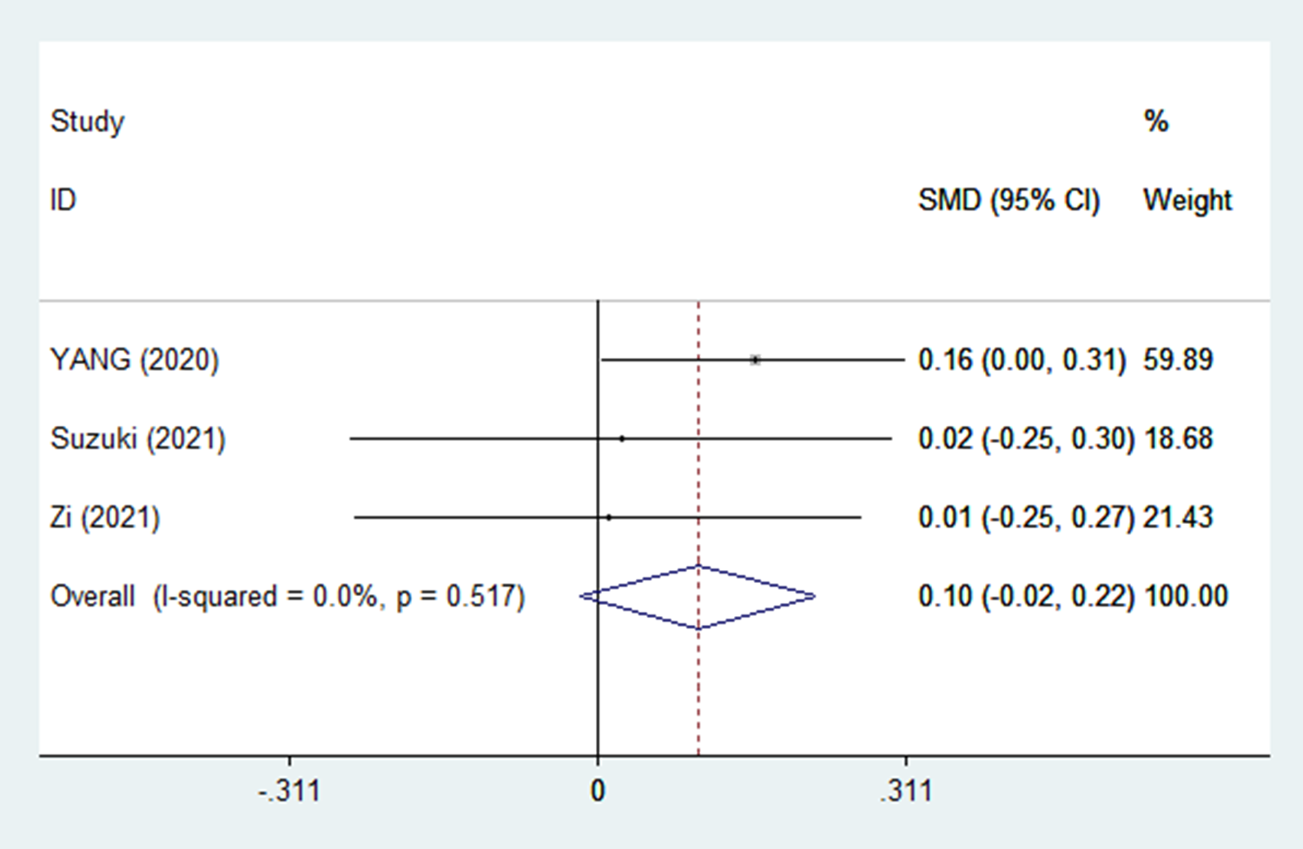
Supplemental Fig 2. From hospital admission to groin puncture.

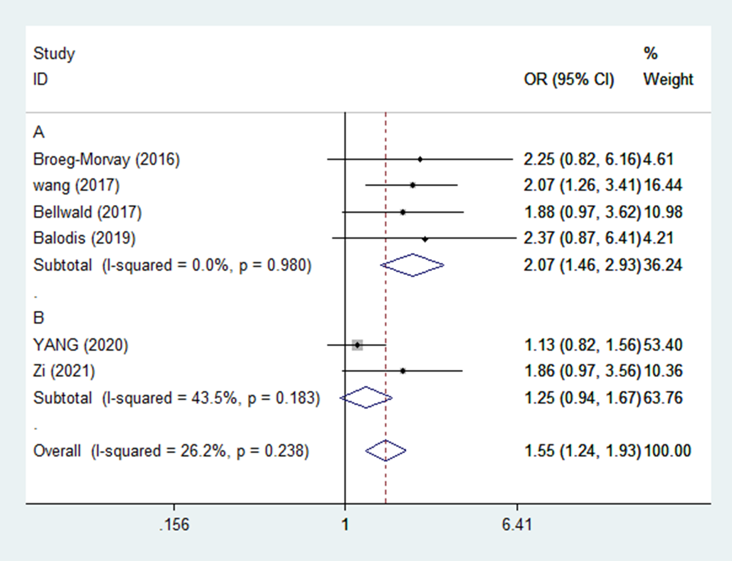
Supplemental Fig 3. asymptomatic intracerebral hemorrhage. A: non-RCT; B: RCT. RCT, randomized controlled trial.

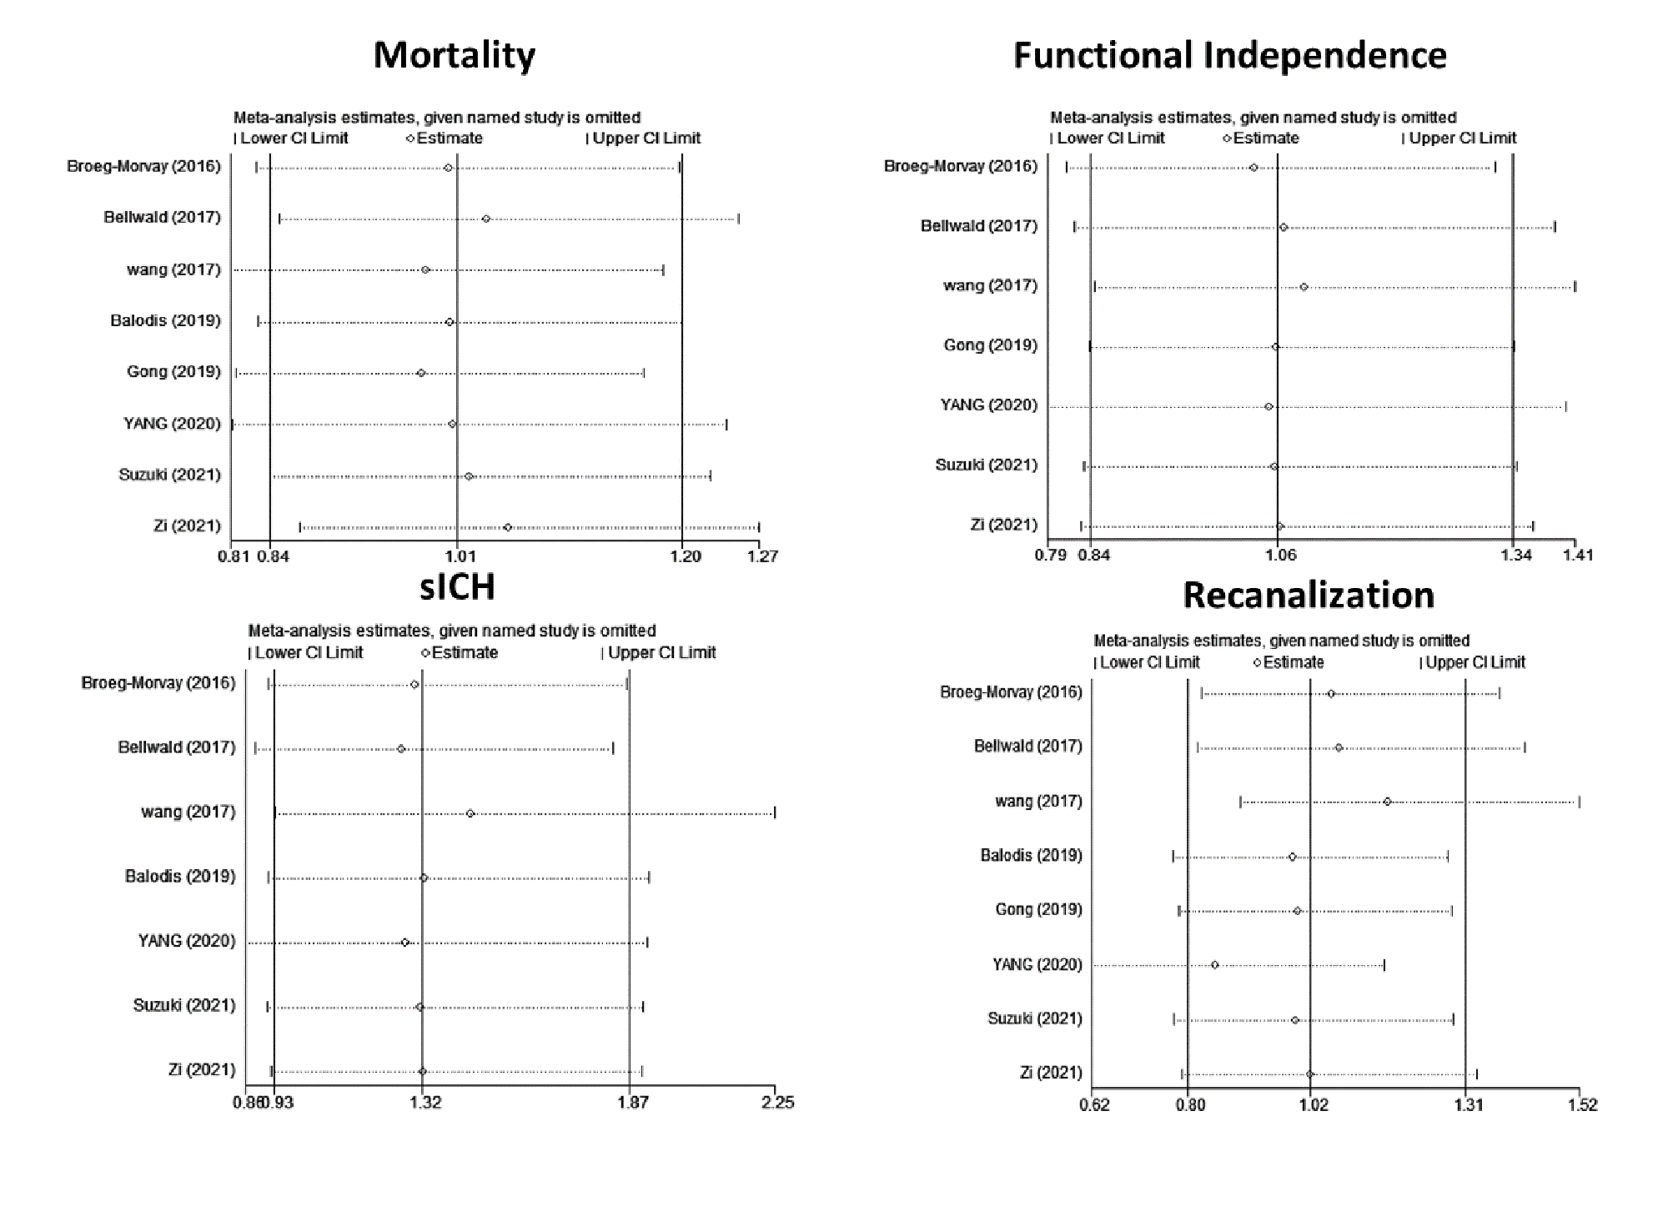
Supplementary Fig 4. Sensitivity Analysis

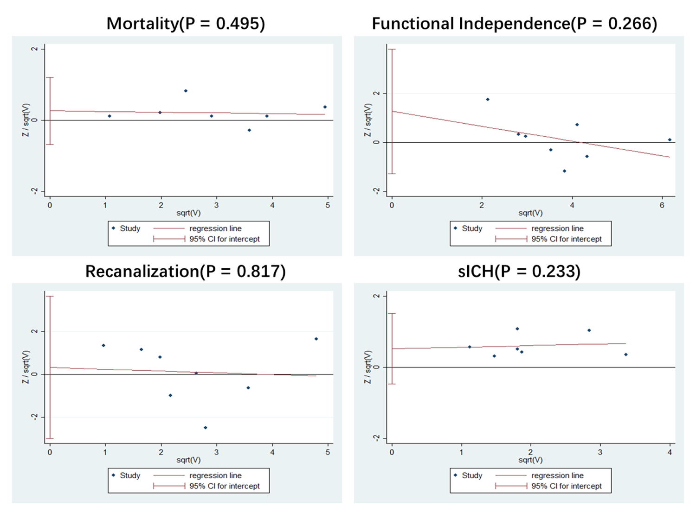
Supplemental Fig 5. Detection of the bias publication

