BJAN-D-21-00152 – Supplementary material

Appendix I - Search strategy
 | P | I
SciELO query | (((Outside operating room) OR (procedural sedation) OR (non-operating room anesthesia)) OR (procedural analgesia)) OR (fora do bloco) OR (sedação) OR (anestesia) OR (analgesia) | (Dexmedetomidine OR Dexmedetomidina) | October 4, 2020 | 103
LILACS query | tw:((tw:((((outside operating room) OR (procedural sedation) OR (non-operating room anesthesia)) OR (procedural analgesia)) OR (fora do bloco) OR (sedação) OR (anestesia) OR (analgesia) )) AND (tw:(((children OR infant OR pediatrics OR criança OR bebé OR pediatria))))) AND (db:(“LILACS”)) | (Dexmedetomidine OR Dexmedetomidina) | September 26, 2020 | 104
Scopus query | TITLE-ABS-KEY (“outside operating room” OR “procedural sedation” OR “non-operating room anesthesia” OR “procedural analgesia”) | TITLE-ABS-KEY (dexmedetomidine) | October 4, 2020 | 205 | 2245
ClinicalTrials.gov query | Operating room OR procedural OR sedation anesthesia OR analgesia AND (adults OR older adults) AND (with results) AND (terminated OR completed) | Dexmedetomidine | October 12, 2020 | 64 | Final
MEDLINE query | (((((outside operating room) OR procedural sedation) OR non-operating room anesthesia) OR (procedural analgesia)) NOT (Children OR Infant OR Pediatrics)) | Dexmedetomidine | October 4, 2020 | 1874 | 105
Framework | Adults + NORA setting: non-operating room anesthesia, outside of operating room sedation, procedural sedation and/or analgesia | Dexmedetomidine | Date | Total | Duplicates

Records identified through database searching
(n = 2350)

Screening

Included

Eligibility

Identification
Additional records identified through other sources
(n=1)
Records after duplicates removed
(n = 2118)
Records screened
(n = 172)
Records excluded after screening for relevance
(n = 1946)
Reasons for exclusion:
- Pediatric population (118)
- Not NORA (1094)
- Not RCT (735)
- No control or without DEX (11)
- Ongoing studies (2)

Full-text articles assessed for eligibility
(n = 97)
)
Full-text articles excluded (n = 61) Reasons for exclusion:
- Pediatric population (1)
- Not RCT (10)
- No control or without DEX (21)
- Not NORA (20)
- Without access to full text/data (3)
- Ongoing studies (1)
- Article published in Chinese and Russian (5)

Studies included in qualitative synthesis
(n = 97)
Studies included in quantitative synthesis (meta-analysis)
(n = 63)
Appendix II – Flowchart

Appendix III - Definition of Outcomes
Outcome | Definition of outcome | Used by which studies
Time until full recovery
Full recovery | Aldrete score ≥9 (n=3) | Wu (49), Lee, Sung (82), Candiotti, Bergese (84)
Full recovery | Modified Aldrete score ≥9 (n=11) | Goyal, Hasnain (19), Padiyara, Bansal (25), Pushkarna, Sarangal (26), Sethi, Sindhi (33), Sruthi, Mandal (37), Dere, Sucullu (60), Kilic, Sahin (63), Koruk, Koruk (64), Lee, Ryu (81), Alizadehasl, Sadeghpour (89), Eldesuky Ali Hassan (94)
Full recovery | Modified Aldrete score =10 (n=1) | Kim, Yoo (79)
Full recovery | Aldrete score =10 [76, 87, 94, 117] (n=4) | Akarsu Ayazoğlu, Polat (55), Zeyneloglu, Pirat (66), Cho, Shim (77), Elkalla and El Mourad (104)
Full recovery | Aldrete score >9 and an OAA/S score >4 (n=1) | Ramkiran, Iyer (27)
Full recovery | Modified post-anesthesia discharge scoring ≥9 (n=1) | Cheung, Qiu (39)
Full recovery | Modified post-anesthesia discharge scoring >9 (n=3) | Hiwarkar, Kshirsagar (17), Ryu, Lee (83), Jalowiecki, Rudner (108)
Full recovery | Without definition (n=3) | Ravipati, Reddy (29), Ren (47), Arpaci and Bozkirli (57)
Full recovery | Other definitions, such as, a RSS of 2 Cooper, Candiotti (85), were used in 36.6% of the studies.
Hemodynamic complications and adverse events
Hypotension | SBP <90mmHg (n=13) | Goneppanavar, Magazine (18), Karanth, Murali (20), Gu, Xu (40), Liao, Ma (41), Yuan, Fu (53), Tan, Miao (54), Akarsu Ayazoğlu, Polat (55), Sairaku, Yoshida (72), Lee, Ryu (81), Ryu, Lee (83), Alizadehasl, Sadeghpour (89), Mazanikov, Udd (103)
Hypotension | SBP <80mmHg (n=6) | Hashiguchi, Matsunaga (68), Kinugasa, Higashi (70), Togawa (75), Kim, Chang (80)
Hypotension | Decrease in SBP >20% of baseline value (n=2) | Samantaray (30), Samantaray, Hanumantha Rao (31)
Hypotension | Decrease in SBP >30% of baseline value (n=1) | Togawa (75)
Hypotension | Other SBP cut-offs (n=3) | Nooh, Sheta (15), Mukhopadhyay, Niyogi (24), Gunduz, Sakalli (61)
Hypotension | MAP <60 mmHg (n=11) | Goneppanavar, Magazine (18), Mukhopadhyay, Niyogi (24), Rasheed, Punera (28), Sethi, Sindhi (33), Liao, Ma (41), Wu, Zhang (50), Yuan, Fu (53), Kilic, Sahin (63), Cho, Shim (77), Cho, Soh (78), Khalil, Al-Agaty (97)
Hypotension | Decrease in MAP >20% of baseline value (n=8) | Sethi, Sindhi (33), Wu, Zhang (50), Kilic, Sahin (63), Lee, Ryu (81), Eldesuky Ali Hassan (94), Elnabtity and Selim (95), Elkalla and El Mourad (104), Salazar Merchán (106)
Hypotension | Other MAP cut-offs (n=6) | Goyal, Hasnain (19), Lu, Li (42), Kaygusuz, Gokce (62), Koruk, Koruk (64)
Hypotension | Decrease in BP >20% of baseline value (n=6) | Sriganesh, Reddy (36), Sruthi, Mandal (37), Yin, Hong (52), Kim, Yoo (79), Loh, Ariffin (109)
Hypotension | Decrease in BP ≥20% of baseline value (n=2) | Mukhopadhyay, Niyogi (24), Wu (49)
Hypotension | Decrease in BP >30% of baseline value (n=7) | Wang (48), Tan, Miao (54), Kuyrukluyıldız, Binici (65), Huncke, Adelman (86), Jalowiecki, Rudner (108)
Hypotension | Other BP cut-offs (n=6) | Wang (48), Takimoto, Ueda (73), Ryu, Lee (83), Prachanpanich, Apinyachon (100)
Hypotension | Without definition (n=2) | (Padiyara, Bansal (25), St-Pierre, Tanoubi (105)
Hypotension | Other definitions were used in 4.9% of the studies.
Hypertension | Increase in BP >20% of baseline value (n=4) | Samantaray, Hanumantha Rao (31), Sethi, Sindhi (33), Wu, Zhang (50), Yin, Hong (52)
Hypertension | Increase in BP ≥20% of baseline value (n=1) | Mukhopadhyay, Niyogi (24)
Hypertension | Increase in BP >30% of baseline (n=1)
Hypertension | MAP >150mmHg (n=2) | Sethi, Sindhi (33), Wu, Zhang (50)
Hypertension | MAP >100mmHg (n=1) | Mukhopadhyay, Niyogi (24)
Hypertension | Other definitions were used in 55.6% of the studies.
Bradycardia | HR <60bpm (n=6) | Nooh, Sheta (15), Liao, Ma (41), Yuan, Fu (53), Hashiguchi, Matsunaga (68), Ryu, Lee (83), Eldesuky Ali Hassan (94)
Bradycardia | HR <50bpm (n=23) | Goyal, Hasnain (19), Mukhopadhyay, Niyogi (24), Sethi, Sindhi (33), Sruthi, Mandal (37), Lu, Li (42), Wang (48), Wu (49), Wu, Zhang (50), Yin, Hong (52), Tan, Miao (54), Kilic, Sahin (63), Kuyrukluyıldız, Binici (65), Sairaku, Yoshida (72), Lee, Ryu (81), Amri, Nahrini (90), Elnabtity and Selim (95), Prachanpanich, Apinyachon (100), Elkalla and El Mourad (104), Salazar Merchán (106), Jalowiecki, Rudner (108), Loh, Ariffin (109)
Bradycardia | HR <45bpm (n=7) | Akarsu Ayazoğlu, Polat (55), Kaygusuz, Gokce (62), Togawa (75), Cho, Shim (77), Cho, Soh (78), Lee, Sung (82), St-Pierre, Tanoubi (105)
Bradycardia | HR <40bpm (n=7) | Karanth, Murali (20), Koruk, Koruk (64), Kinugasa, Higashi (70), Kim, Chang (80)
Bradycardia | Decrease in HR >20% from the baseline value (n=9) | Samantaray (30), Sethi, Sindhi (33), Sriganesh, Reddy (36), Wu, Zhang (50), Kilic, Sahin (63), Kim, Yoo (79), Elnabtity and Selim (95), Eberl, Preckel (107)
Bradycardia | Decrease in HR >30% from the baseline value (n=4) | Wang (48), Huncke, Adelman (86)
Bradycardia | Without definition (n=2) | Padiyara, Bansal (25), Riachy, Khayat (101)
Bradycardia | Other definitions were used in 15.1% of the studies.
Tachycardia | HR >100 bpm (n=4) | Mukhopadhyay, Niyogi (24), Yin, Hong (52), Yuan, Fu (53), Ryu, Lee (83)
Tachycardia | Increase in HR >20% of baseline value (n=2) | Wu, Zhang (50), Yuan, Fu (53)
Tachycardia | Other definitions were used in 75% of the studies.
Respiratory complications and adverse events
Respiratory depression or desaturation | RR ≤10cpm or desaturation <90% (n=1) | Lee, Ryu (81)
Respiratory depression or desaturation | RR ≤8cpm or desaturation <90% (n=2) | Sethi, Sindhi (33), Wu, Zhang (50)
Respiratory depression or desaturation | RR <8cpm or desaturation <92% (n=3) | Samantaray (30), Samantaray, Hanumantha Rao (31), Akarsu Ayazoğlu, Polat (55)
Respiratory depression or desaturation | RR <8cpm or desaturation <90% or apnea (cessation of breathing for more than 30 seconds) (n=3) | Arpaci and Bozkirli (57), Candiotti, Bergese (84), Alizadehasl, Sadeghpour (89)
Respiratory depression or desaturation | RR <6cpm or desaturation <90% or apnea (cessation of breathing for more than 20 seconds) (n=1) | Lee, Sung (82)
Respiratory depression or desaturation | Desaturation ≤92% or requiring administration of nasal oxygen (n=1)
Respiratory depression or desaturation | Desaturation ≤92% (n=8) | Nooh, Sheta (15), Sriganesh, Reddy (36), Cheung, Qiu (39), Koruk, Koruk (64), Togawa (75), Eldesuky Ali Hassan (94), El Mourad, Elghamry (96)
Respiratory depression or desaturation | Desaturation ≤92% for more than 10 seconds (n=1) | St-Pierre, Tanoubi (105)
Respiratory depression or desaturation | Desaturation ≤90% (n=1) | Takimoto, Ueda (73)
Respiratory depression or desaturation | Desaturation <90% (n=12) | Kundra, Velayudhan (21), Sruthi, Mandal (37), Lu, Li (42), Ma, Fang (46), Yin, Hong (52), Hashiguchi, Matsunaga (68), Kinugasa, Higashi (70), Cho, Shim (77), Kim, Yoo (79), Kim, Chang (80), Mazanikov, Udd (103), Elkalla and El Mourad (104)
Respiratory depression or desaturation | Desaturation <90% for more than 10 seconds (n=1) | Ryu, Lee (83)
Respiratory depression or desaturation | Desaturation <90% for more than 30 seconds (n=2) | Liao, Ma (41), Cho, Soh (78)
Respiratory depression or desaturation | Desaturation <90% for more than 120 seconds (n=1) | Akarsu Ayazoğlu, Polat (55)
Respiratory depression or desaturation | Without definition (n=14) | Nooh, Sheta (15), Hiwarkar, Kshirsagar (17), Padiyara, Bansal (25), Akça, Aydoğan-Eren (56), Demiraran, Korkut (59), Gunduz, Sakalli (61), Cooper, Candiotti (85), Taylor (88), Amri, Nahrini (90), Modir, Moshiri (92), Fan, Ti (98), Eberl, Preckel (107)
Respiratory depression or desaturation | Other definitions were used in 13.6% of the studies.
Pain/Discomfort
 | VAS score (0 no pain – 10 worst pain) (n=22) | Shetty and Aggarwal (16), Kundra, Velayudhan (21), Samantaray (30), Samantaray, Hanumantha Rao (31), Sivasubramani, Pandyan (34), Trivedi (38), Ma, Fang (46), Ren (47), Wang (48), Akça, Aydoğan-Eren (56), Demiraran, Korkut (59), Gunduz, Sakalli (61), Zeyneloglu, Pirat (66), Zor, Ozturk (67), Kinugasa, Higashi (70), Amri, Nahrini (90), Masoumi, Maleki (91), Modir, Moshiri (92), Alhashemi and Kaki (93), Yu, Li (99), St-Pierre, Tanoubi (105), Shariffuddin, Teoh (110)
 | VAS score (0 no pain – 100 worst pain) (n=5) | Kaygusuz, Gokce (62), Lee, Ryu (81), Huncke, Adelman (86), Elnabtity and Selim (95), Khalil, Al-Agaty (97)
 | NRS (0 no pain – 10 worst pain) (n=10) | Nooh, Sheta (15), Karanth, Murali (20), Magazine (22), Cheung, Ying (43), Cheung (44), Cheung (45), Wu (49), Cho, Shim (77), Kim, Chang (80), Jalowiecki, Rudner (108)
 | NRS (0 no discomfort - 10 severe discomfort) (n=4) | Pushkarna, Sarangal (26), Samantaray (30), Samantaray, Hanumantha Rao (31), Yuan, Fu (53)
 | Other definitions were used in 24.1% of the studies.
Amnesia and awareness of the procedure
 | Questionaries asking patients about events that occurred during the procedure (n=8) | Hiwarkar, Kshirsagar (17), Sivasubramani, Pandyan (34), Kawaai, Tomita (69), Taniyama (74), Togawa (75), Nolan, Delgadillo (87), St-Pierre, Tanoubi (105)
 | Showing photos to patients after infusion of the drug and asking for their details after the procedure (n=2) | Mishra, Birmiwal (23), Cheung, Ying (43)
 | 4-point Likert scale (n=1) | St-Pierre, Tanoubi (105)
Grade of conscious sedation
 | BIS (n=5) | Padiyara, Bansal (25), Koruk, Koruk (64), Taniyama (74), Togawa (75)
 | BIS in combination with RSS (n=10) | Mishra, Birmiwal (23), Ma, Fang (46), Akarsu Ayazoğlu, Polat (55), Kuyrukluyıldız, Binici (65), Cho, Shim (77), Lee, Ryu (81), Alizadehasl, Sadeghpour (89), Khalil, Al-Agaty (97), Shariffuddin, Teoh (110)
 | BIS in combination with OAA/S score (n=5) | Ramkiran, Iyer (27), Cheung (44), Bavullu, Aksoy (58), Cho, Soh (78), Fan, Ti (98)
 | RSS (n=24) | Goneppanavar, Magazine (18), Goyal, Hasnain (19), Kundra, Velayudhan (21), Magazine (22), Sivasubramani, Pandyan (35), Sriganesh, Reddy (36), Liao, Ma (41), Lu, Li (42), Cheung, Ying (43), Wu (49), Wu (51), Yin, Hong (52), Akça, Aydoğan-Eren (56), Dere, Sucullu (60), Kilic, Sahin (63), Takimoto, Ueda (73), Cooper, Candiotti (85), Modir, Moshiri (92), Eldesuky Ali Hassan (94), El Mourad, Elghamry (96), Salazar Merchán (106), Loh, Ariffin (109)
 | RASS (n=4) | Kawaai, Tomita (69), Sairaku, Yoshida (72), Muller, Borowics (102)
 | OAA/S score (n=22) | Shetty and Aggarwal (16), Hiwarkar, Kshirsagar (17), Karanth, Murali (20), Samantaray (30), Samantaray, Hanumantha Rao (31), Cheung, Qiu (39), Wang (48), Wu, Zhang (50), Yuan, Fu (53), Kaygusuz, Gokce (62), Zeyneloglu, Pirat (66), Kim, Yoo (79), Lee, Sung (82), Ryu, Lee (83), Candiotti, Bergese (84), Huncke, Adelman (86), Alhashemi and Kaki (93), Yu, Li (99), Prachanpanich, Apinyachon (100), St-Pierre, Tanoubi (105), Eberl, Preckel (107), (108)
 | Other definitions were used in 14.6% of the studies.

Appendix IV – Risk of bias by article
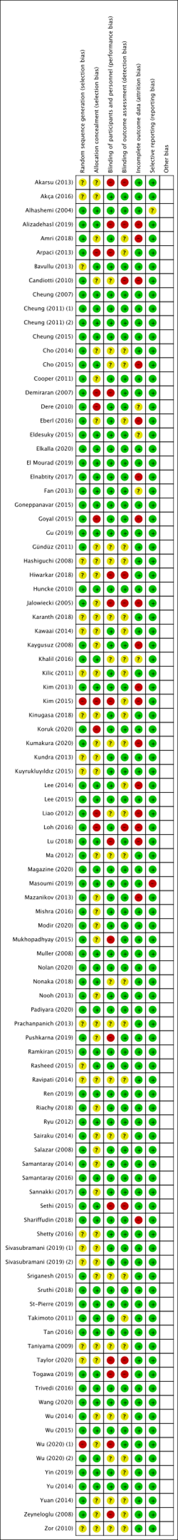
Figure 6 - Risk of bias summary: review authors' judgements about each risk of bias item for each included study.

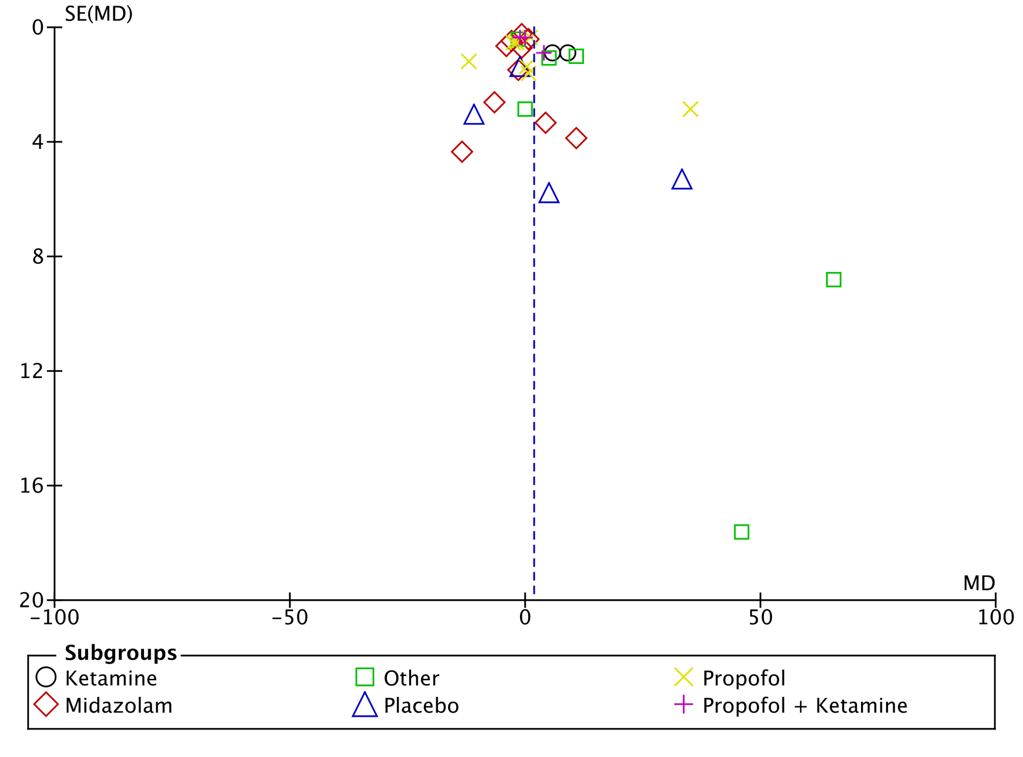
Figure 7 - Funnel plot of comparison: 1 Time until recovery, outcome: 1.2 Time until recovery by control.
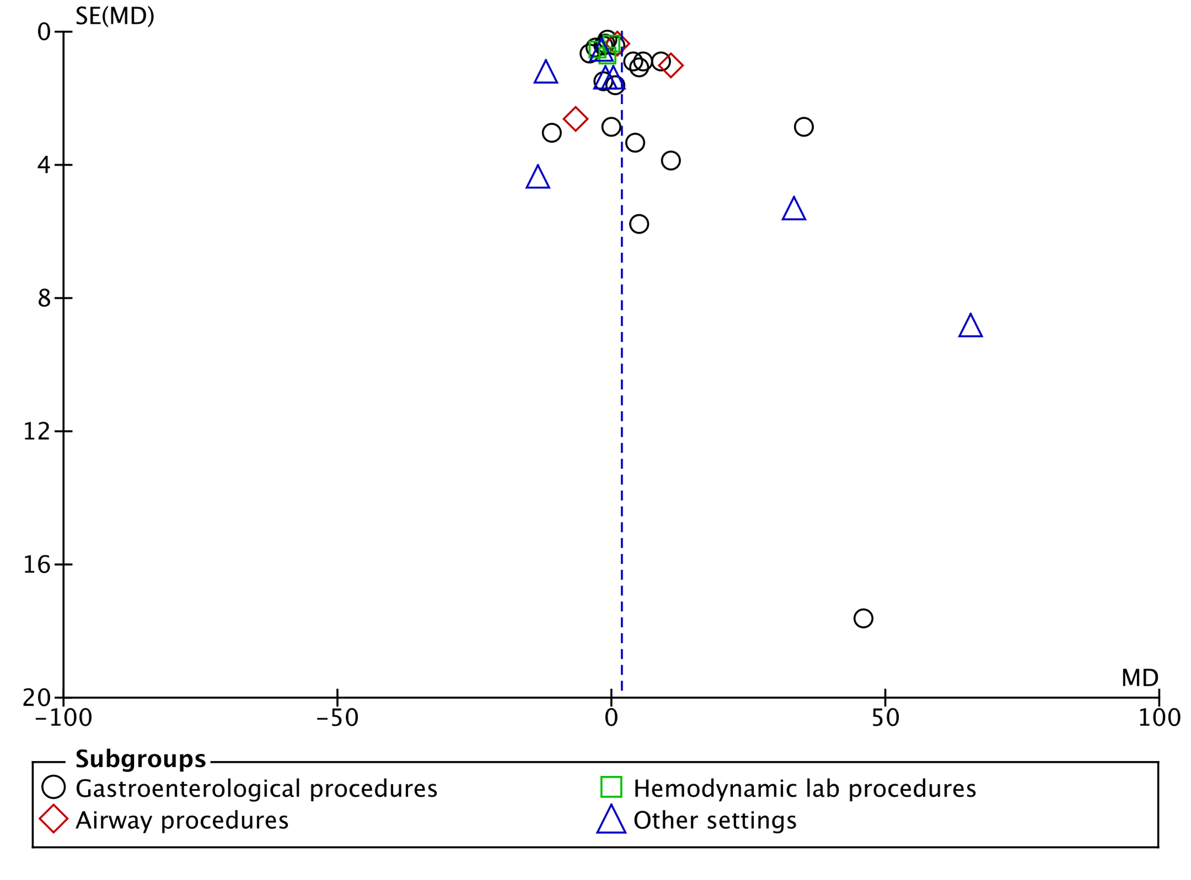
Figure 8 - Funnel plot of comparison: Time until recovery by setting.

Appendix V - Funnel plot of Outcomes
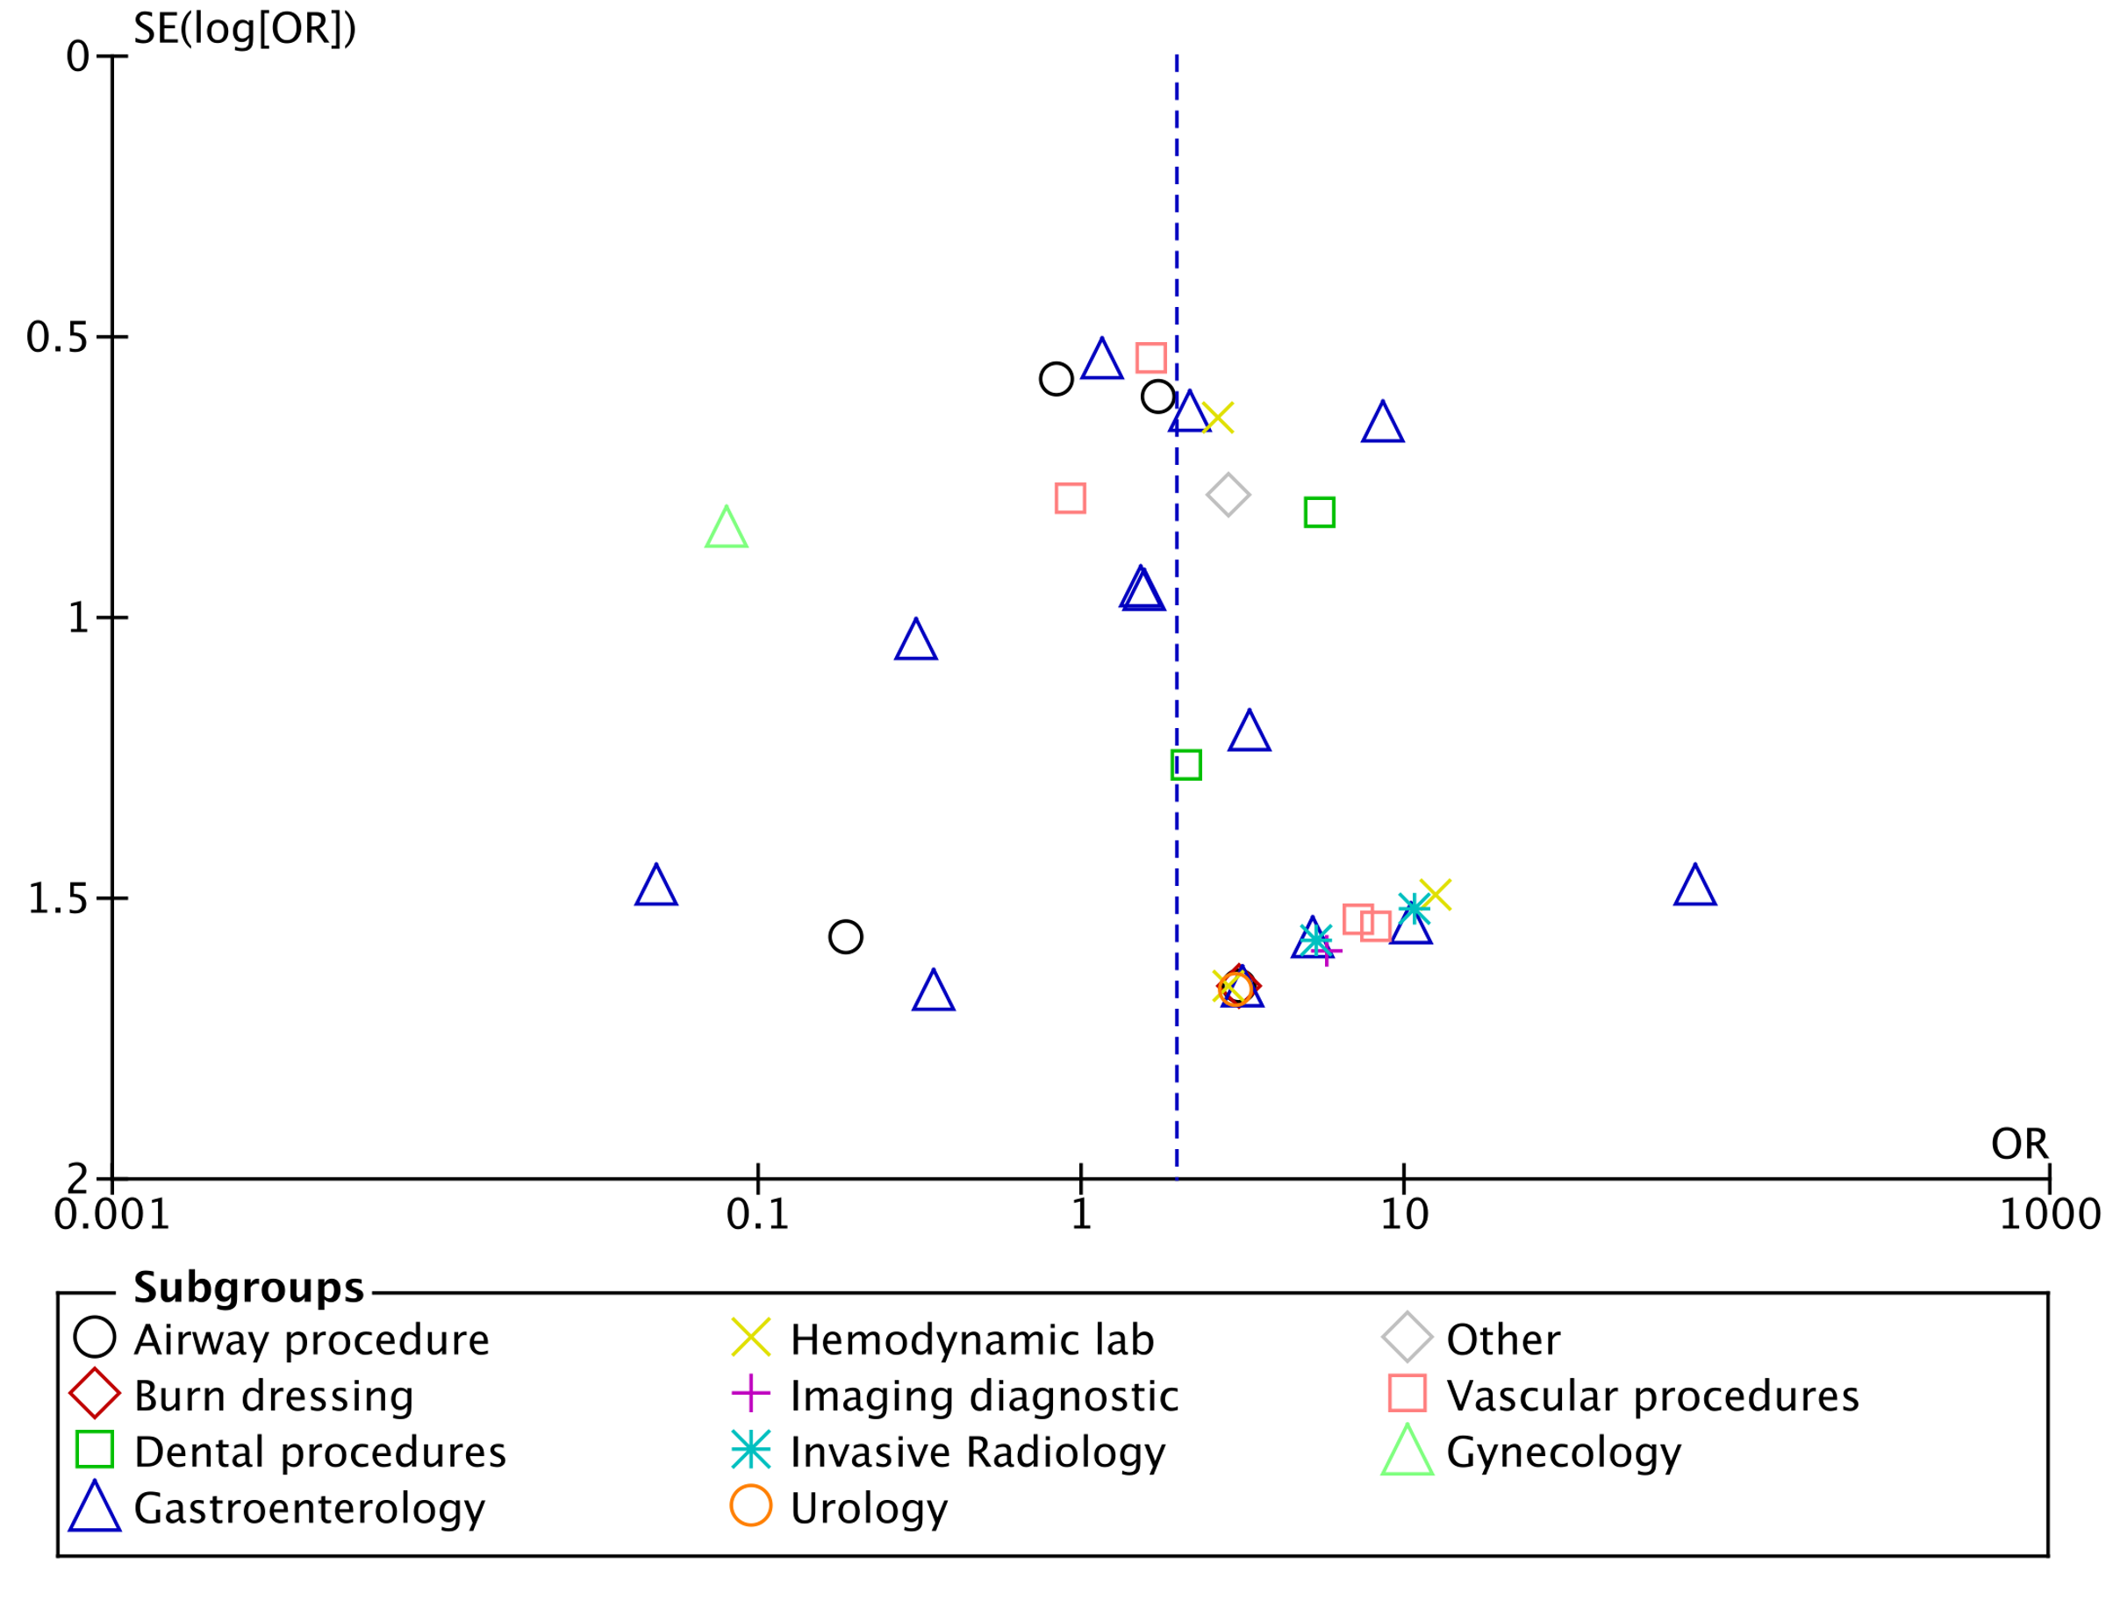
Figure 9 - Funnel plot of included in hypotension meta-analysis by setting.

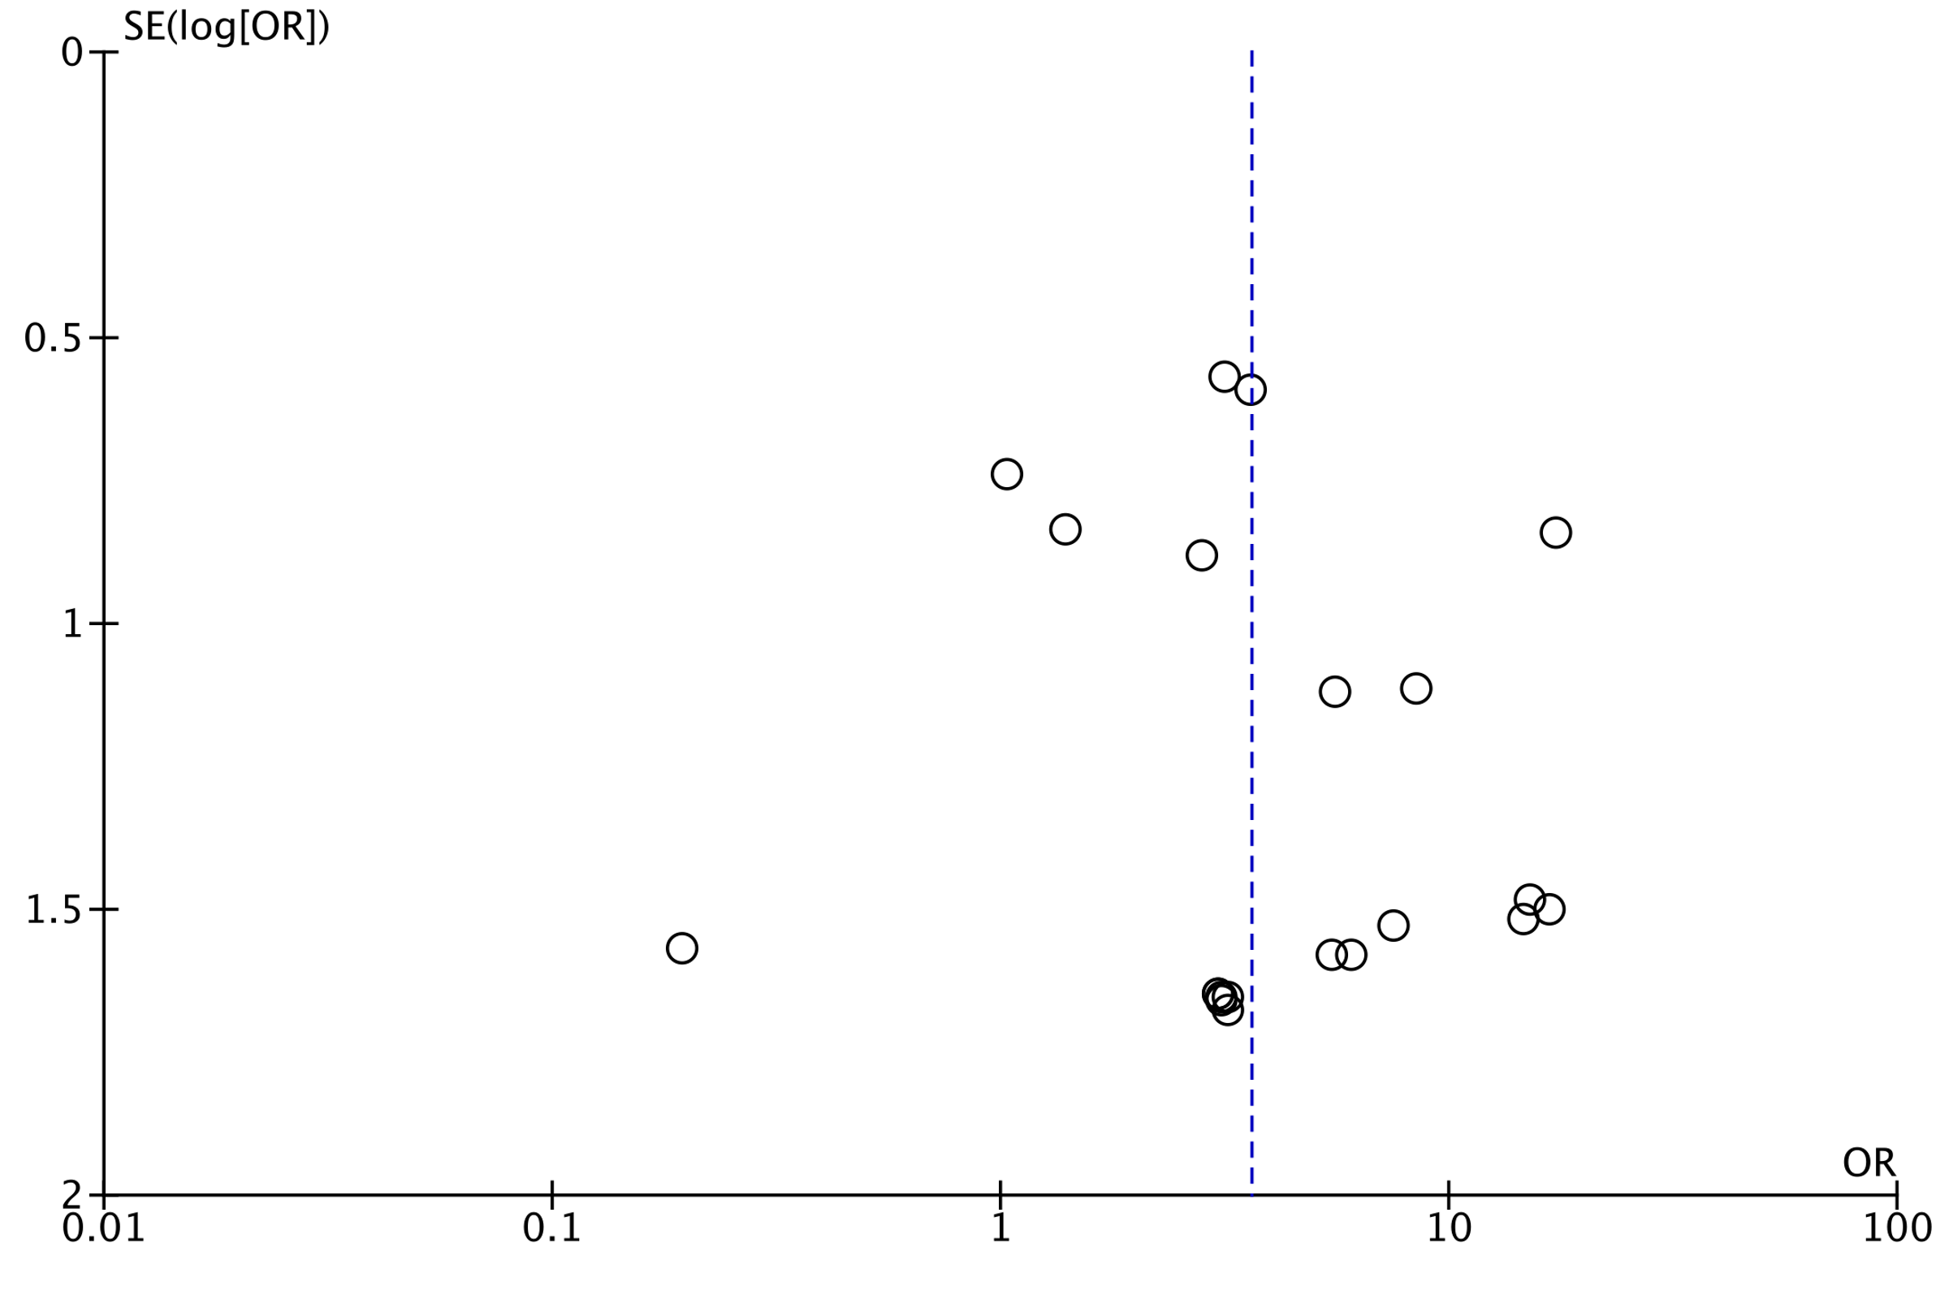
Figure 10 - Funnel plot of RCT included in bradycardia meta-analysis.

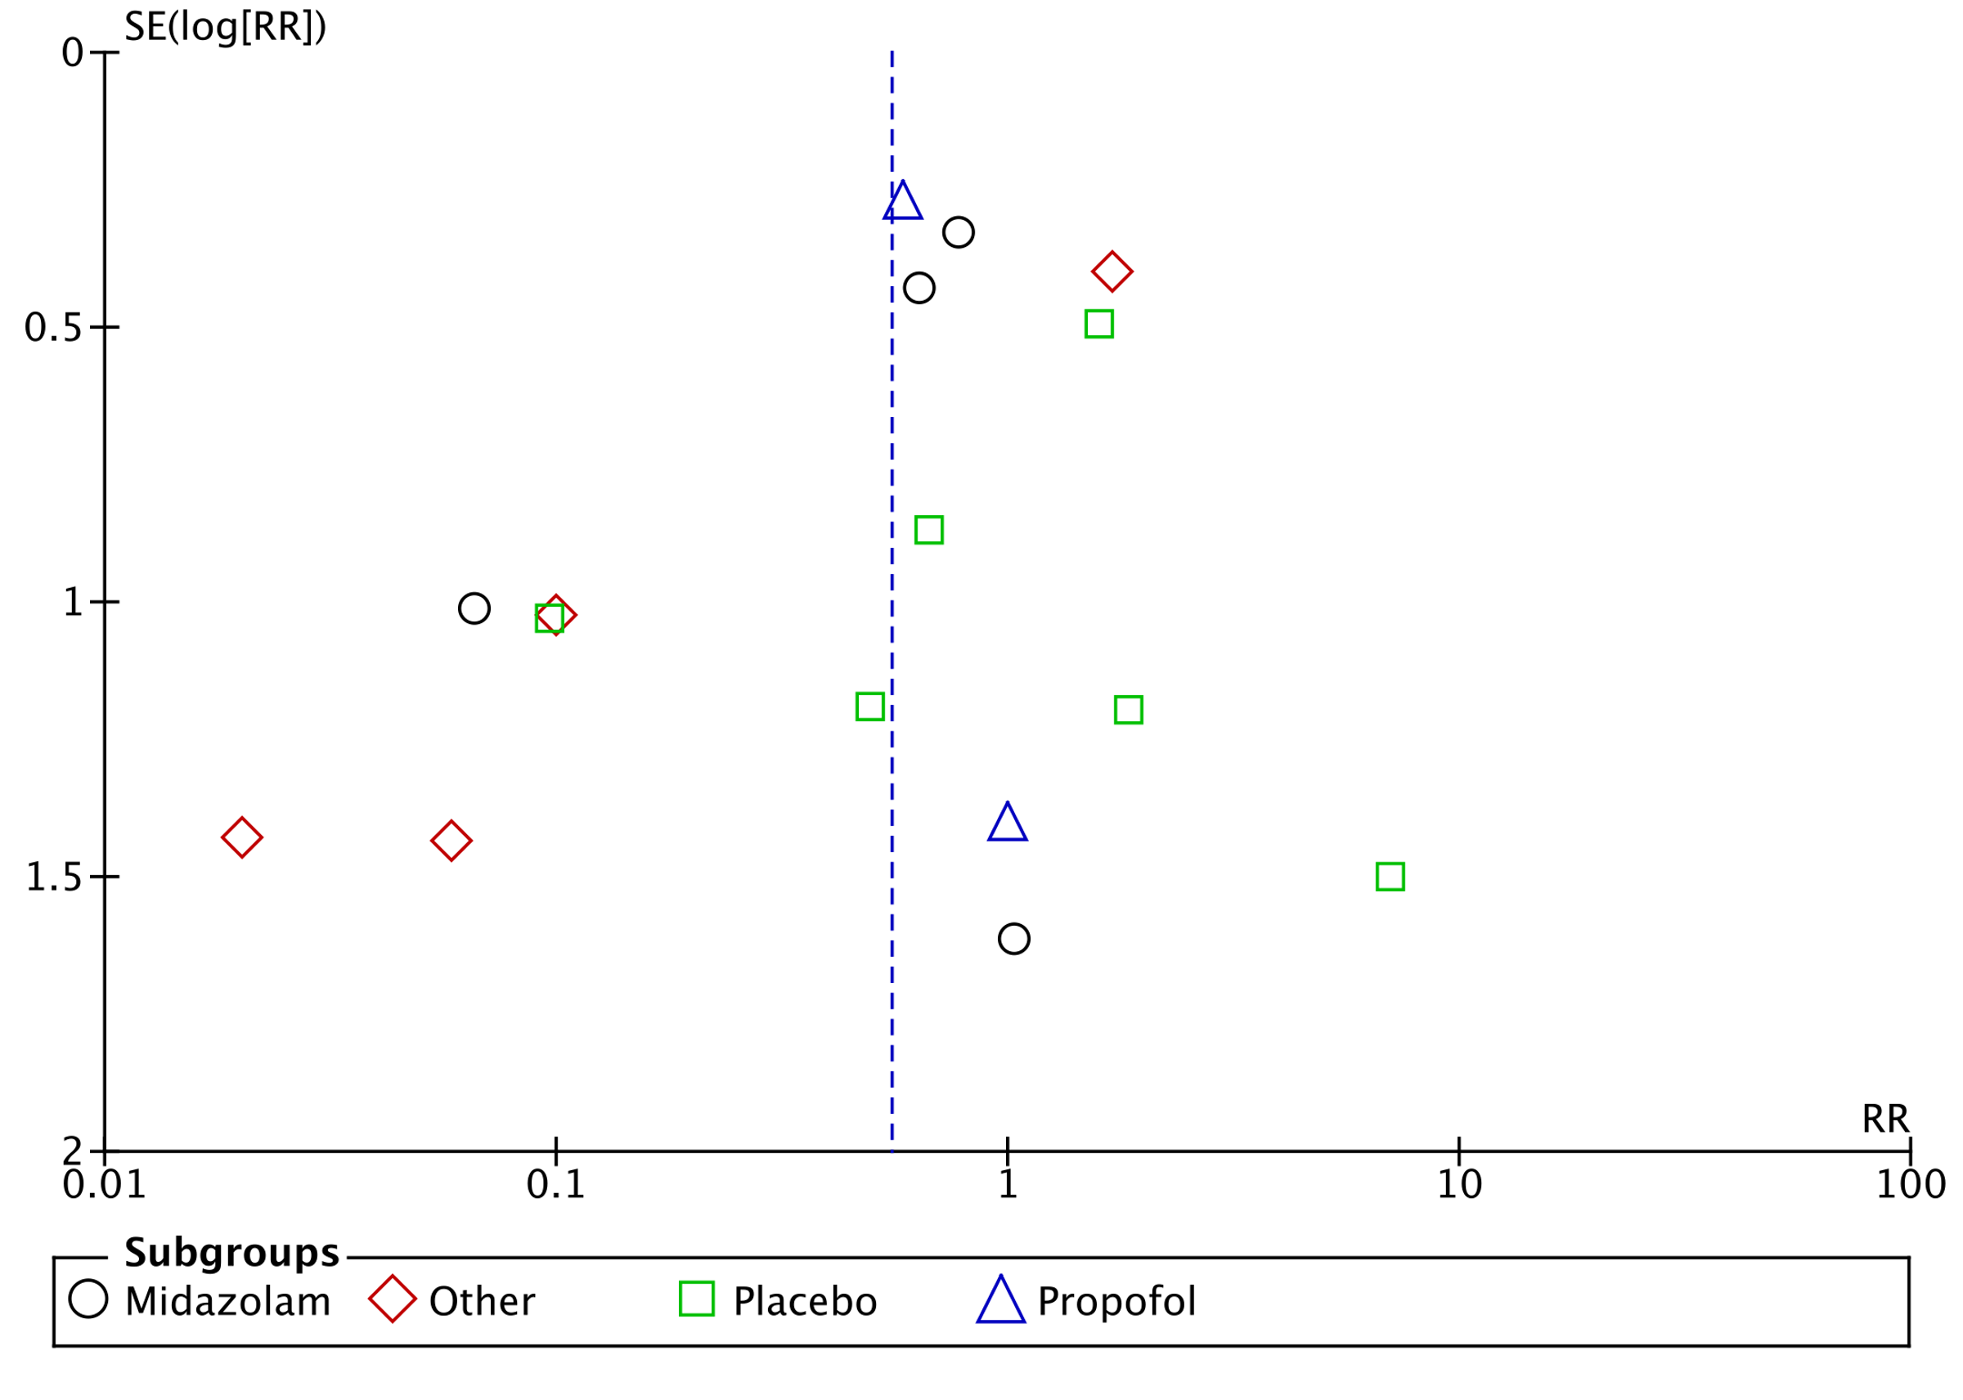
Figure 11 - Funnel plot of comparison: Desaturation by comparator.

OAA/S score - Observer’s Assessment of Alertness and Sedation scale; SBP - systolic blood pressure; MAP - mean arterial pressure; BP - blood pressure; BIS - bispectal index; RSS - Ramsay Sedation Score; RASS - Richmond Agitation and Sedation Score

