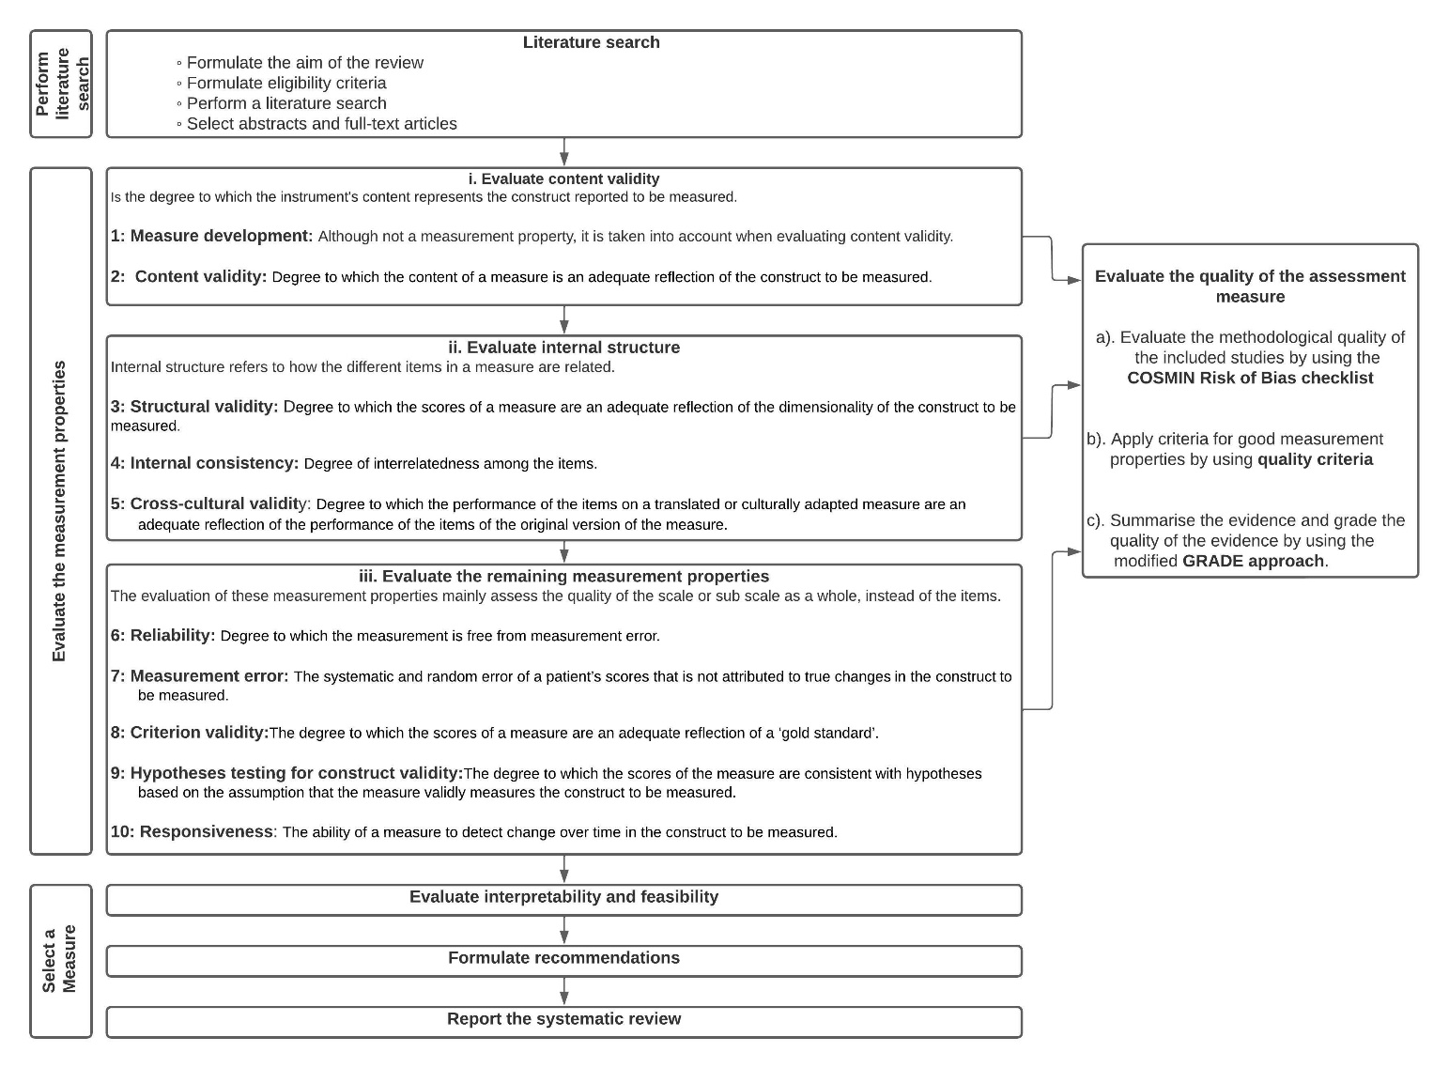

Figure S1: A flow diagram depicting our approach to using Consensus-based Standards for the selection of health Measurement INstruments (COSMIN) steps for conducting a systematic review of measures and COSMIN taxonomy and definitions (39)

