Supporting Information
Table of contents
  - Literature search 2
  - Search components 2
1.2.1 DGF search 2
1.2.2 AKI search 4
1.3 Data collection 5
1.4 Synthesis of results 5
1.5 Risk of bias and sensitivity analysis of results 5
1.6 Statistics 5
1.7 Other information 5

  - Literature search
Two separate systematic literature searches were performed in the databases of PubMed, EMBASE and Web of Science, in which the literature until December 2020 was examined.
Studies were excluded if 1) no preclinical (i.e. animal) model was applied; 2) only organs other than kidneys were examined; 3) only ischemia was applied, in the absence of reperfusion; 4) data was solely gathered after ischemia rather than after IR; 5) only metabolite levels of compounds that are not directly involved in energy metabolism were measured (e.g. phospholipids, drug metabolites); 6) metabolites were not measured (e.g. only enzyme activities); 7) kidney injury was due to other causes than IR (e.g. rejection, toxins); 8) it concerned a review, book section or case report; 9) language was other than English.
Altogether, 35 preclinical studies were included from the systematic searches (Supplementary Figure 1a and 1b) and were subsequently clustered according to their study population (i.e. species studied). Details of the searches in PubMed, EMBASE and Web of Science are given under Supplementary Data 1.2 Search components.
a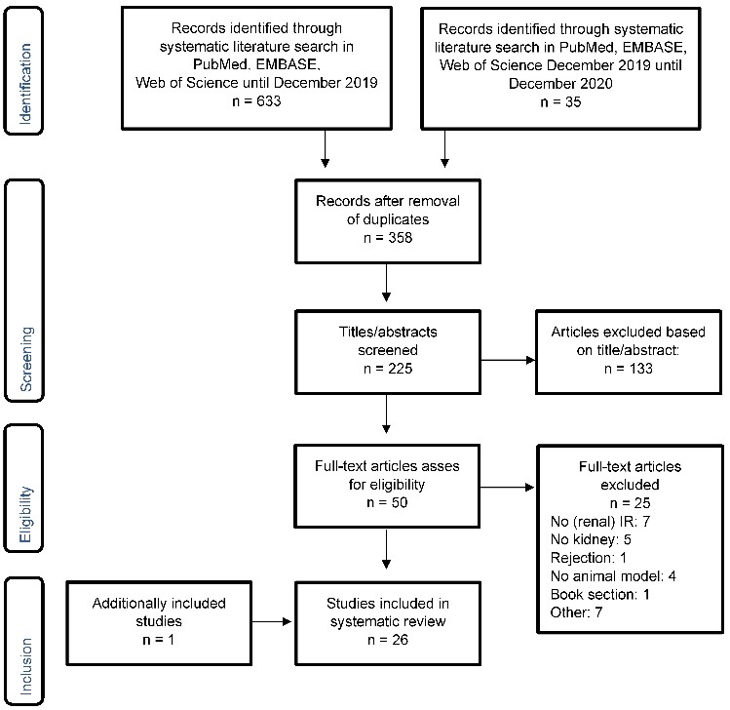b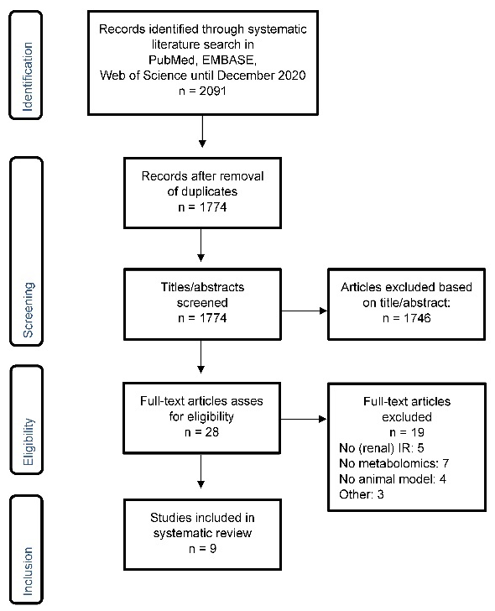
Supporting Figure 1. Flowchart of the systematic literature search performed to identify preclinical studies reporting metabolic data following renal ischemia reperfusion (IR) in the context of a) Delayed Graft Function (DGF) and b) Acute Kidney Injury (AKI).
  - Search components
    - DGF search
In total, 220, 15 and 88 unique references were found using systematic searches in respectively Pubmed, EMBASE and Web of Science on the 19th of December, 2019, excluding duplicates. Additionally, 22, 5 and 8 unique references were found using systematic searches in respectively Pubmed, EMBASE and Web of Science on the 1st of December, 2020, excluding duplicates as well as references identified by the DGF search from December 2019.
PubMed
(("ischemia-reperfusion"[tw] OR ischemia-reperfus*[tw] OR "ischaemia-reperfusion"[tw] OR ischaemia-reperfus*[tw] OR "Reperfusion Injury"[Mesh:noexp] OR "reperfusion injury"[tw] OR "reperfusion injuries"[tw] OR reperfusion injur*[tw] OR "reperfusion damage"[tw] OR reperfusion damag*[tw] OR "ischemic injury"[tw] OR "ischemic injuries"[tw] OR ischemic injur*[tw] OR "ischaemic injury"[tw] OR "ischaemic injuries"[tw] OR ischaemic injur*[tw] OR "Primary Graft Dysfunction"[mesh] OR "primary graft dysfunction"[tw] OR "primary graft failure"[tw] OR "Delayed Graft Function"[Mesh] OR "delayed graft function"[tw]) AND ("Kidney"[mesh] OR "kidney"[tw] OR "kidneys"[tw] OR "renal"[tw] OR "Kidney transplantation"[mesh] OR kidney transplant*[tw] OR "renal transplantation"[tw] OR renal transplant*[tw] OR kidney graft*[tw] OR renal graft*[tw] OR "renal injury"[tw] OR "renal injuries"[tw] OR "kidney injury"[tw] OR "kidney injuries"[tw]) AND ("Metabolomics"[Mesh] OR "Metabolome"[mesh] OR "metabonomics"[tw] OR "metabolomics"[tw] OR metabonom*[tw] OR metabolom*[tw] OR "metabolic profile"[tw] OR "metabolic profiles"[tw] OR "metabolites"[tw] OR "metabolite"[tw] OR "metabolic"[ti]) AND ("english"[la] OR "dutch"[la] OR "russian"[la]))
EMBASE
(("ischemia-reperfusion".ti,ab OR "ischemia-reperfus*".ti,ab OR "ischaemia-reperfusion".ti,ab OR ischaemia-reperfus*.ti,ab OR *"Reperfusion Injury"/ OR "reperfusion injury".ti,ab OR "reperfusion injuries".ti,ab OR "reperfusion injur*".ti,ab OR "reperfusion damage".ti,ab OR reperfusion damag*.ti,ab OR "ischemic injury".ti,ab OR "ischemic injuries".ti,ab OR ischemic injur*.ti,ab OR "ischaemic injury".ti,ab OR "ischaemic injuries".ti,ab OR ischaemic injur*.ti,ab OR *"Primary Graft Dysfunction"/ OR "primary graft dysfunction".ti,ab OR "primary graft failure".ti,ab OR *"Delayed Graft Function"/ OR "delayed graft function".ti,ab) AND (exp *"Kidney"/ OR "kidney".ti,ab OR "kidneys".ti,ab OR "renal".ti,ab OR exp "Kidney transplantation"/ OR kidney transplant*.ti,ab OR "renal transplantation".ti,ab OR renal transplant*.ti,ab OR kidney graft*.ti,ab OR renal graft*.ti,ab OR "renal injury".ti,ab OR "renal injuries".ti,ab OR "kidney injury".ti,ab OR "kidney injuries".ti,ab) AND (*"Metabolomics"/ OR *"Metabolome"/ OR "metabonomics".ti,ab OR "metabolomics".ti,ab OR metabonom*.ti,ab OR metabolom*.ti,ab OR "metabolic profile".ti,ab OR "metabolic profiles".ti,ab OR "metabolites".ti,ab OR "metabolite".ti,ab OR "metabolic".ti) AND ("english".la OR "dutch".la OR "russian".la))
Web of Science
(ti=("ischemia-reperfusion" OR "ischemia-reperfus*" OR "ischaemia-reperfusion" OR "ischaemia-reperfus*" OR "Reperfusion Injury" OR "reperfusion injury" OR "reperfusion injuries" OR "reperfusion injur*" OR "reperfusion damage" OR "reperfusion damag*" OR "ischemic injury" OR "ischemic injuries" OR "ischemic injur*" OR "ischaemic injury" OR "ischaemic injuries" OR "ischaemic injur*" OR "Primary Graft Dysfunction" OR "primary graft dysfunction" OR "primary graft failure" OR "Delayed Graft Function" OR "delayed graft function") AND ts=("Kidney" OR "kidney" OR "kidneys" OR "renal" OR exp "Kidney transplantation" OR "kidney transplant*" OR "renal transplantation" OR "renal transplant*" OR "kidney graft*" OR "renal graft*" OR "renal injury" OR "renal injuries" OR "kidney injury" OR "kidney injuries") AND (ts=("Metabolomics" OR "Metabolome" OR "metabonomics" OR "metabolomics" OR metabonom* OR metabolom* OR "metabolic profile" OR "metabolic profiles" OR "metabolites" OR "metabolite") OR ti="metabolic") AND la=("english" OR "dutch" OR "russian")) OR (ts=("ischemia-reperfusion" OR "ischemia-reperfus*" OR "ischaemia-reperfusion" OR "ischaemia-reperfus*" OR "Reperfusion Injury" OR "reperfusion injury" OR "reperfusion injuries" OR "reperfusion injur*" OR "reperfusion damage" OR "reperfusion damag*" OR "ischemic injury" OR "ischemic injuries" OR "ischemic injur*" OR "ischaemic injury" OR "ischaemic injuries" OR "ischaemic injur*" OR "Primary Graft Dysfunction" OR "primary graft dysfunction" OR "primary graft failure" OR "Delayed Graft Function" OR "delayed graft function") AND ti=("Kidney" OR "kidney" OR "kidneys" OR "renal" OR exp "Kidney transplantation" OR "kidney transplant*" OR "renal transplantation" OR "renal transplant*" OR "kidney graft*" OR "renal graft*" OR "renal injury" OR "renal injuries" OR "kidney injury" OR "kidney injuries") AND (ts=("Metabolomics" OR "Metabolome" OR "metabonomics" OR "metabolomics" OR metabonom* OR metabolom* OR "metabolic profile" OR "metabolic profiles" OR "metabolites" OR "metabolite") OR ti="metabolic") AND la=("english" OR "dutch" OR "russian"))
    - AKI search
In total, 1662, 92 and 20 unique references were found using systematic searches in respectively Pubmed, EMBASE and Web of Science on the 9th of December, 2020, excluding duplicates as well as references identified in the DGF search.
PubMed
(("Acute Kidney Injury"[majr] OR "Acute Kidney Injury"[ti] OR "Acute Kidney Injuries"[ti] OR "Acute Renal Injury"[ti] OR "Acute Renal Injuries"[ti] OR "Acute Kidney Failure"[ti] OR "Acute Kidney Insufficiency"[ti] OR "Acute Renal Failure"[ti] OR "Acute Renal Insufficiency"[ti] OR "AKI"[ti]) AND ("Metabolomics"[majr] OR "Metabolome"[majr] OR "metabonomics"[ti] OR "metabolomics"[ti] OR metabonom*[ti] OR metabolom*[ti] OR "metabolic profile"[ti] OR "metabolic profiles"[ti] OR "metabolites"[ti] OR "metabolite"[ti] OR "Metabolism"[majr:noexp] OR "metabolism"[ti] OR "metabo*"[ti] OR ("Acute Kidney Injury/metabolism"[majr] AND "metabolism"[Subheading:NoExp])) AND ("english"[la] OR "dutch"[la] OR "russian"[la]) NOT (("Cisplatin"[Mesh] OR "cisplatin"[tw] OR "Sepsis"[Mesh] OR "sepsis"[tw] OR "toxic kidney"[tw] OR "toxic renal"[tw] OR "nephrotox*"[tw]) NOT ("surgery"[subheading] OR "Surgical Procedures, Operative"[Mesh] OR "surgery"[tw] OR "surgical"[tw] OR "surgical*"[tw] OR "Perioperative Period"[Mesh] OR "Perioperative Care"[Mesh] OR "peri operative"[tw] OR "perioperative"[tw] OR "Postoperative Period"[Mesh] OR "Postoperative Complications"[Mesh] OR "post operative"[tw] OR "postoperative"[tw] OR "Endovascular Procedures"[Mesh] OR "endovascular"[tw] OR "endo vascular"[tw])) NOT (("Review"[ptyp] OR "review"[ti]) NOT ("Clinical Study"[ptyp] OR "trial"[ti] OR "RCT"[ti] OR "Case Reports"[ptyp] OR "case report"[ti])))
EMBASE
((*"Acute Kidney Failure"/ OR "Acute Kidney Injury".ti OR "Acute Kidney Injuries".ti OR "Acute Renal Injury".ti OR "Acute Renal Injuries".ti OR "Acute Kidney Failure".ti OR "Acute Kidney Insufficiency".ti OR "Acute Renal Failure".ti OR "Acute Renal Insufficiency".ti OR "AKI".ti) AND (exp *"Metabolomics"/ OR exp *"Metabolome"/ OR "metabonomics".ti OR "metabolomics".ti OR metabonom*.ti OR metabolom*.ti OR "metabolic profile".ti OR "metabolic profiles".ti OR "metabolites".ti OR *"metabolite"/ OR "metabolite".ti OR *"Metabolism"/ OR "metabolism".ti OR "metabo*".ti) AND ("english".la OR "dutch".la OR "russian".la) NOT ((exp *"Cisplatin"/ OR "cisplatin".ti OR exp "Sepsis"/ OR "sepsis".ti OR "toxic kidney".ti OR "toxic renal".ti OR "nephrotox*".ti) NOT (exp "surgery"/ OR "su".fs OR "surgery".ti,ab OR "surgical".ti,ab OR "surgical*".ti,ab OR exp "Perioperative Period"/ OR "peri operative".ti,ab OR "perioperative".ti,ab OR exp "Postoperative Period"/ OR exp "Postoperative Complication"/ OR "post operative".ti,ab OR "postoperative".ti,ab OR "Endovascular Surgery"/ OR "endovascular".ti,ab OR "endo vascular".ti,ab)) NOT ((exp "Review"/ OR "review".ti) NOT (exp "Clinical Study"/ OR exp "Clinical trial"/ OR "trial".ti OR "RCT".ti OR "Case Report"/ OR "case report".ti)))
Web of Science
(ti=("Acute Kidney Failure" OR "Acute Kidney Injury" OR "Acute Kidney Injuries" OR "Acute Renal Injury" OR "Acute Renal Injuries" OR "Acute Kidney Failure" OR "Acute Kidney Insufficiency" OR "Acute Renal Failure" OR "Acute Renal Insufficiency" OR "AKI") AND ti=("Metabolomics" OR "Metabolome" OR "metabonomics" OR "metabolomics" OR metabonom* OR metabolom* OR "metabolic profile" OR "metabolic profiles" OR "metabolites" OR "metabolite" OR "metabolite" OR "Metabolism" OR "metabolism" OR "metabo*") AND la=("english" OR "dutch" OR "russian") NOT (ti=("Cisplatin" OR "cisplatin" OR "Sepsis" OR "sepsis" OR "toxic kidney" OR "toxic renal" OR "nephrotox*") NOT ts=("surgery" OR "surgery" OR "surgical" OR "surgical*" OR "Perioperative Period" OR "peri operative" OR "perioperative" OR "Postoperative Period" OR "Postoperative Complication" OR "post operative" OR "postoperative" OR "Endovascular Surgery" OR "endovascular" OR "endo vascular")) NOT ((TI="Review" OR DT="review") NOT TI=("Clinical Study" OR "Clinical trial" OR "trial" OR "RCT" OR "Case Report" OR "case series")))
  - Data collection
One author collected data from the included studies. Extracted data included specifics concerning the study populations, control groups, intervention techniques, sampling techniques, measurement techniques, applied definitions of IR injury, as well as metabolic data (i.e. reported metabolite levels). If controls were missing, metabolic data was excluded. To present the metabolic data of the studies, reported means of measured metabolite levels in study groups and control groups within single studies were collected and compared. All extracted data is publicly available in the cited publications.
  - Synthesis of results
Studies were considered eligible for inclusion of outcomes if they reported metabolic aspects, which is also a prerequisite according to the inclusion criteria. The data (i.e. reported metabolite levels) were mapped along theoretical pathways (energetic status, redox, glycolysis, TCA cycle, β-oxidation, amino acid metabolism) to obtain insight into changes in the major metabolic routes. Absolute measures were converted to semi-quantitative data (i.e. dynamics of changes), which enabled direct comparisons between studies, despite great variety in applied methods. The studies were clustered according to their study population (i.e. type of animal studied). Altogether, this resulted in an illustrative overview in the form of a heatmap.
  - Risk of bias and sensitivity analysis of results
In this systematic review, we did not assess risk of bias of the included preclinical studies, as this is inherent to preclinical studies and their great heterogeneity (i.e. differences in species, strains, induction of injury). This excessive heterogeneity and concomitant granulated data also restricted the assessment of robustness of results, and results were therefore converted to qualitative aspects in a theoretical framework.
  - Statistics
This systematic review is a qualitative and descriptive study, and the reported quantitative data has already been statistically examined in the original publications. Therefore, further statistical tests were not applied.
  - Other information
The review was not registered. A review protocol was not prepared, as this study concerns an explorative meta-analysis. The PRISMA checklist for systematic reviews is given in Supplementary Table 1.
Supporting Table 1. PRISMA guidelines for systematic reviews checklist.
Section and Topic | Item # | Checklist item | Location where item is reported
TITLE
Title | 1 | Identify the report as a systematic review. | 1
ABSTRACT
Abstract | 2 | See the PRISMA 2020 for Abstracts checklist. | 3
INTRODUCTION
Rationale | 3 | Describe the rationale for the review in the context of existing knowledge. | 4
Objectives | 4 | Provide an explicit statement of the objective(s) or question(s) the review addresses. | 4
METHODS
Eligibility criteria | 5 | Specify the inclusion and exclusion criteria for the review and how studies were grouped for the syntheses. | Supp. Info 1.1
Information sources | 6 | Specify all databases, registers, websites, organisations, reference lists and other sources searched or consulted to identify studies. Specify the date when each source was last searched or consulted. | 5
Search strategy | 7 | Present the full search strategies for all databases, registers and websites, including any filters and limits used. | Supp. Info 1.2
Selection process | 8 | Specify the methods used to decide whether a study met the inclusion criteria of the review, including how many reviewers screened each record and each report retrieved, whether they worked independently, and if applicable, details of automation tools used in the process. | 5
Data collection process | 9 | Specify the methods used to collect data from reports, including how many reviewers collected data from each report, whether they worked independently, any processes for obtaining or confirming data from study investigators, and if applicable, details of automation tools used in the process. | Supp. Info 1.3
Data items | 10a | List and define all outcomes for which data were sought. Specify whether all results that were compatible with each outcome domain in each study were sought (e.g. for all measures, time points, analyses), and if not, the methods used to decide which results to collect. | Supp. Info 1.3
Data items | 10b | List and define all other variables for which data were sought (e.g. participant and intervention characteristics, funding sources). Describe any assumptions made about any missing or unclear information. | Supp. Info 1.3
Study risk of bias assessment | 11 | Specify the methods used to assess risk of bias in the included studies, including details of the tool(s) used, how many reviewers assessed each study and whether they worked independently, and if applicable, details of automation tools used in the process. | NA
Effect measures | 12 | Specify for each outcome the effect measure(s) (e.g. risk ratio, mean difference) used in the synthesis or presentation of results. | Supp. Info 1.3
Synthesis methods | 13a | Describe the processes used to decide which studies were eligible for each synthesis (e.g. tabulating the study intervention characteristics and comparing against the planned groups for each synthesis (item #5)). | Supp. Info 1.4
Synthesis methods | 13b | Describe any methods required to prepare the data for presentation or synthesis, such as handling of missing summary statistics, or data conversions. | Supp. Info 1.4
Synthesis methods | 13c | Describe any methods used to tabulate or visually display results of individual studies and syntheses. | Supp. Info 1.4
Synthesis methods | 13d | Describe any methods used to synthesize results and provide a rationale for the choice(s). If meta-analysis was performed, describe the model(s), method(s) to identify the presence and extent of statistical heterogeneity, and software package(s) used. | Supp. Info 1.4
Synthesis methods | 13e | Describe any methods used to explore possible causes of heterogeneity among study results (e.g. subgroup analysis, meta-regression). | Supp. Info 1.4
Synthesis methods | 13f | Describe any sensitivity analyses conducted to assess robustness of the synthesized results. | NA
Reporting bias assessment | 14 | Describe any methods used to assess risk of bias due to missing results in a synthesis (arising from reporting biases). | 10-14
Certainty assessment | 15 | Describe any methods used to assess certainty (or confidence) in the body of evidence for an outcome. | 10-14
RESULTS
Study selection | 16a | Describe the results of the search and selection process, from the number of records identified in the search to the number of studies included in the review, ideally using a flow diagram. | 6, Supp. Info 1.1-1.2
 | 16b | Cite studies that might appear to meet the inclusion criteria, but which were excluded, and explain why they were excluded. | Supp. Info Fig. 1
Study characteristics | 17 | Cite each included study and present its characteristics. | Table 2+3
Risk of bias in studies | 18 | Present assessments of risk of bias for each included study. | Supp. Info 1.5
Results of individual studies | 19 | For all outcomes, present, for each study: (a) summary statistics for each group (where appropriate) and (b) an effect estimate and its precision (e.g. confidence/credible interval), ideally using structured tables or plots. | Fig. 2
Results of syntheses | 20a | For each synthesis, briefly summarise the characteristics and risk of bias among contributing studies. | 10-14
Results of syntheses | 20b | Present results of all statistical syntheses conducted. If meta-analysis was done, present for each the summary estimate and its precision (e.g. confidence/credible interval) and measures of statistical heterogeneity. If comparing groups, describe the direction of the effect. | Supp. Info 1.6
Results of syntheses | 20c | Present results of all investigations of possible causes of heterogeneity among study results. | 6-9
Results of syntheses | 20d | Present results of all sensitivity analyses conducted to assess the robustness of the synthesized results. | Supp. Info 1.5
Reporting biases | 21 | Present assessments of risk of bias due to missing results (arising from reporting biases) for each synthesis assessed. | 10-14
Certainty of evidence | 22 | Present assessments of certainty (or confidence) in the body of evidence for each outcome assessed. | NA
DISCUSSION
Discussion | 23a | Provide a general interpretation of the results in the context of other evidence. | 10-14
Discussion | 23b | Discuss any limitations of the evidence included in the review. | 14
Discussion | 23c | Discuss any limitations of the review processes used. | 14
Discussion | 23d | Discuss implications of the results for practice, policy, and future research. | 10-14
OTHER INFORMATION
Registration and protocol | 24a | Provide registration information for the review, including register name and registration number, or state that the review was not registered. | Supp. Info 1.7
Registration and protocol | 24b | Indicate where the review protocol can be accessed, or state that a protocol was not prepared. | Supp. Info 1.7
Registration and protocol | 24c | Describe and explain any amendments to information provided at registration or in the protocol. | NA
Support | 25 | Describe sources of financial or non-financial support for the review, and the role of the funders or sponsors in the review. | 14-15
Competing interests | 26 | Declare any competing interests of review authors. | 14-15
Availability of data, code and other materials | 27 | Report which of the following are publicly available and where they can be found: template data collection forms; data extracted from included studies; data used for all analyses; analytic code; any other materials used in the review. | Supp. Info 1.3

