Supplemental Table 1. Comorbidities and medications of the included studies

 | Comorbid conditions(%) |  |  |  |  |  |  |  | Medications(%)
Included studies | Hypertension | Diabetes mellitus | Heart failure | Ischemic heart disease | Myocardial infarction | Chronic kidney disease | History of stroke or TIA | History of bleeding | Antiplatelet drugs | Beta-Blockers | Statins | ACEI or ARBs | Diuretics | Proton-pump inhibitors
Yang L-2020 | 91.08 | 46.15 | 50.82 | NA | 8.64 | 37.48 | 23.17 | 16.59 | 11.96 | NA | NA | NA | NA | NA
Seiffge DJ-2019 | 75.07 | 24.66 | NA | NA | NA | NA | 3.52 | NA | 38.60 | NA | 25.88 | NA | NA | NA
Xian Y-2019 | 81.03 | 25.78 | 12.73 | NA | 31.12 | NA | 8.09 | NA | 54.54 | NA | NA | NA | NA | NA
Larsen TB-2014 | 35.79 | 16.39 | 10.39 | NA | 18.27 | NA | 35.52 | 18.38 | NA | NA | NA | NA | NA | NA
Komen JJ-2019 | 65.10 | 16.80 | 16.30 | NA | 5.50 | 6.30 | 19.90 | 9.70 | 44.80 | 52.40 | 28.40 | 38.20 | 20.60 | NA
Park J-2019 | 89.75 | 32.98 | 43.39 | NA | 5.94 | NA | 100.00 | 20.63 | 44.56 | NA | NA | NA | NA | 34.32
Coleman CI-2017 | 78.05 | 32.76 | 18.52 | NA | NA | 9.92 | 100.00 | 4.79 | 34.52 | 57.78 | 58.36 | 54.58 | 31.49 | NA
Nielsen PB-2019 | 62.10 | 51.60 | 32.60 | NA | 11.60 | 11.40 | 100.00 | NA | NA | NA | NA | NA | NA | NA
Tsai C-2020 | 94.10 | 50.15 | 54.96 | NA | 10.40 | 25.00 | 74.74 | 100.00 | 11.20 | NA | NA | NA | NA | NA
Lee S-2020 | 90.10 | 32.20 | 41.80 | NA | 5.40 | 16.80 | 20.30 | NA | 34.20 | NA | NA | NA | NA | 30.90

ACEIs=angiotensin-converting enzyme inhibitors; ARBs=angiotensin receptor blockers; NA=not available
Supplemental Table 2. Dose of NOACs and TT of warfarin users in the included studies

Included studies | Dose of NOACs | TTR of warfarin users (%)
Yang L-2020 | 29.5% of rivaroxaban, 74.1% of dabigatran, 57.6% of apixaban, and 71.0% of edoxaban groups received low dose NOAC. Others received standard dose NOAC. | NA
Seiffge DJ-2019 | 2,656 patients received standard dose of NOACs, 33.10% of rivaroxaban, 36.10% of dabigatran, 0.4% of edoxaban. 27.2% of apixaban | NA
Xian Y-2019 | 4,041 patients received standard dose of NOACs, 45.58% of rivaroxaban, 30.66% of dabigatran, 23.90% of apixaban. | 58-68
Larsen TB-2014 | 2,398 patients received different dose of NOACs, 55.88% of low dose dabigatran, 44.12% of standard dose dabigatran. | NA
Komen JJ-2019 | 21,028 patients received standard dose of NOACs, 9.60% of rivaroxaban, 15.10% of dabigatran, 0.2% of Edoxaban, 75.2% of apixaban. | NA
Park J-2019 | 32,729 patients received standard dose of NOACs, 37.61% of rivaroxaban, 19.22% of dabigatran, 16.16% of Edoxaban, 27.00% of apixaban. | 49
Coleman CI-2017 | 6.2% of rivaroxaban, 17.7% of dabigatran, 57.6% of apixaban, and 71.0% of edoxaban groups received low dose NOAC. Others received standard dose NOAC. | NA
Nielsen PB-2019 | NA | NA
Tsai C-2020 | 3,493 patients received standard dose of NOACs, 48.26% of rivaroxaban, 40.94% of dabigatran, 16.16% of Edoxaban, 10.79% of apixaban. | NA
Lee S-2020 | 63.3% of rivaroxaban, 74.1% of dabigatran, 57.6% of apixaban, and 71.0% of edoxaban groups received reduced dose NOAC. Others received standard dose NOAC. | NA

NOACs=non-Vitamin K antagonist oral anticoagulants; VKAs=vitamin K antagonists;TTR=Time in the therapeutic range; NA=not available

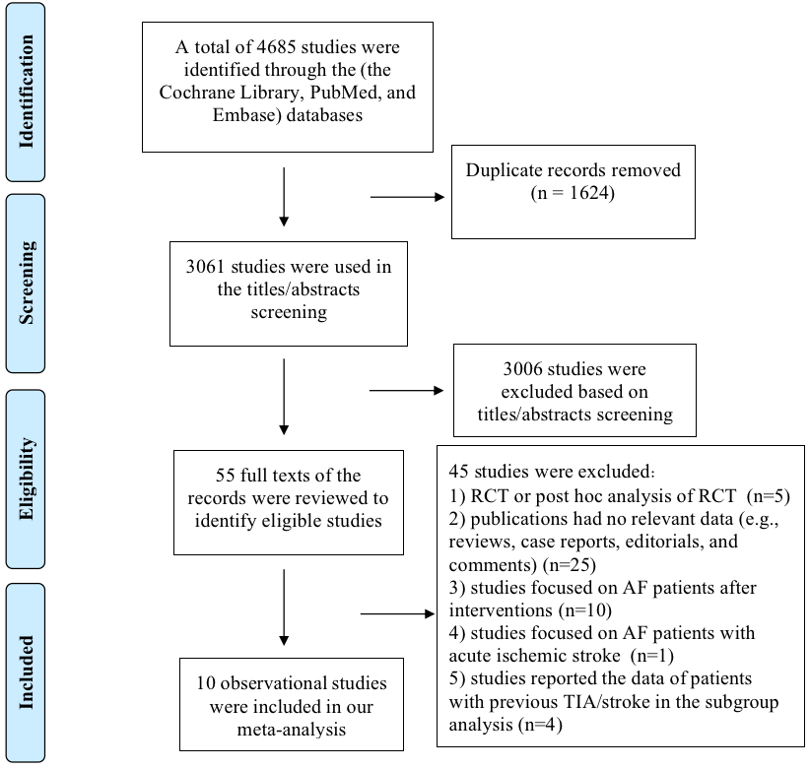
Supplemental Figure 1. The literature retrieval process of this meta-analysis

