Supplementary file 3. Additional analysis
Mortality till 6 months follow up
Excluding studies with sample less than 50 in each arm
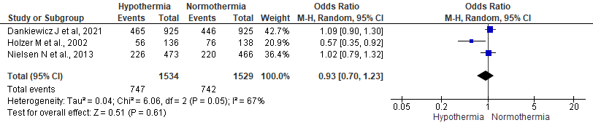
Figure 1. Forest plot comparing six month mortality across hypothermia and normothermia protocol using random effect model excluding studies with sample less than 50 in each arm
Excluding all the studies published before 2010 and pooling data from Nielsen N et al., and Dankiewicz J et al using fixed effect model
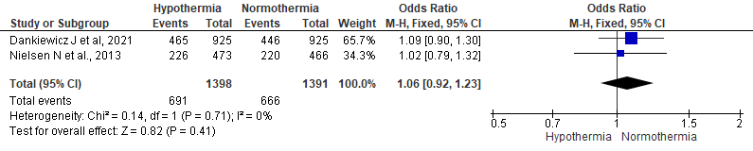
Figure 2. Forest plot comparing six month mortality across hypothermia and normothermia protocol using random effect model excluding all the studies published before 2010

Unfavorable neurological outcomes:
Unfavorable neurological outcome with CPC 3 or 4, or mRS of 4 or 5 using fixed effect model

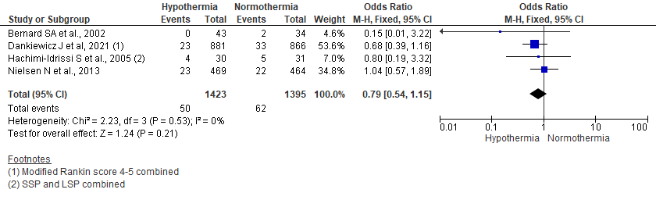
Figure 3. Forest plot comparing unfavorable neurological outcome six month following OHCA across hypothermia and normothermia protocol using fixed effect model

