Journal of Cachexia, Sarcopenia and Muscle
Association between skeletal muscle mass and quality of life in adults with cancer: a systematic review and meta-analysis
Lauren Hanna^{1,2}, Kay Nguo¹, Kate Furness^{2,3}, Judi Porter^{1,4}, Catherine E. Huggins¹
¹Department of Nutrition, Dietetics and Food, Monash University, Clayton, Victoria, Australia
²Department of Nutrition and Dietetics, Monash Health, Monash Medical Centre, Clayton, Victoria, Australia
³Department of Physiotherapy, School of Primary and Allied Health Care, Monash University, Frankston, Victoria, Australia
⁴Institute for Physical Activity and Nutrition, School of Exercise and Nutrition Sciences, Deakin University, Geelong, Victoria, Australia

Meta-analyses of HRQOL global and physical function domain scores, with studies grouped by cut point used by authors to stratify participants according to low or normal muscle mass stores.
The included studies used a range of different cut points to dichotomise people into groups of low or normal muscle mass. These cut points vary, and therefore result in a different classification of people with low muscle which adds heterogeneity to the analysis. In these forest plots, the studies have been grouped according to the cut point used by the authors to examine if there is any sign of systematic bias based on cut point classification.
‘Total’ refers to sample size of low or normal muscle mass groups in each study.

2A.
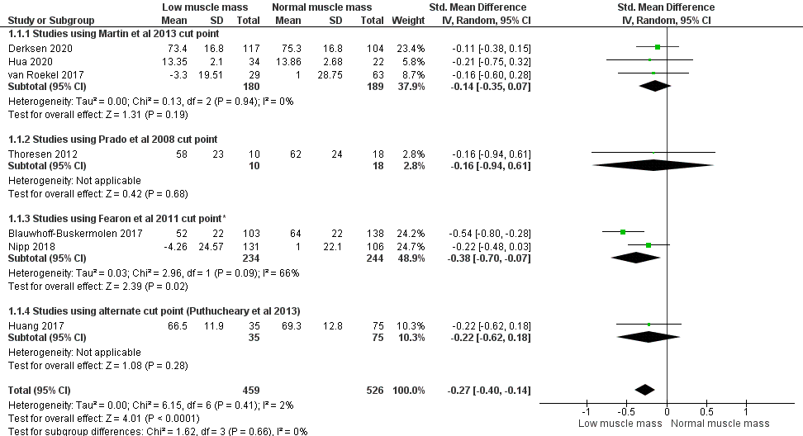

3A.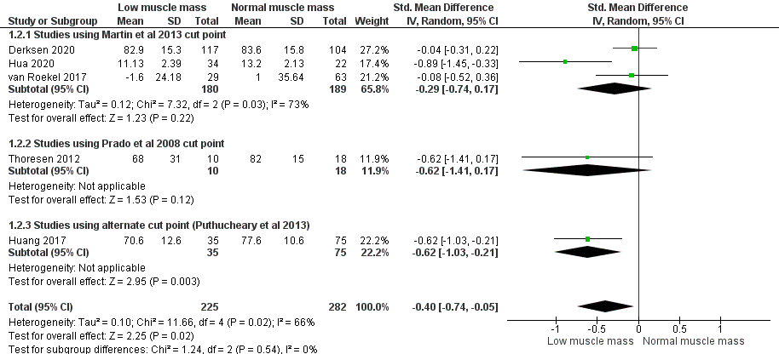

Supplementary Fig: 2A. Global HRQOL scores and 3A. Physical function domain scores Studies grouped according to cut point used to classify participants according to low muscle mass. *Study by Blauwhoff-Buskermolen et al 2017 used the cut point by Fearon et al 2011 for 155 participants (64%) with colorectal, breast or prostate cancers. For 86 participants with lung cancer (36%) where computed tomography (CT) imaging was conducted at the fourth thoracic vertebra (T4), an alternate cut point based on the Fearon et al 2011 cut point was used to identify low/normal skeletal muscle mass, produced from an unpublished study of participants with CT-derived skeletal muscle index data measured at both T4 and the third lumbar vertebra (L3).

