Journal of Cachexia, Sarcopenia and Muscle
Association between skeletal muscle mass and quality of life in adults with cancer: a systematic review and meta-analysis

Lauren Hanna^{1,2}, Kay Nguo¹, Kate Furness^{2,3}, Judi Porter^{1,4}, Catherine E. Huggins¹
¹Department of Nutrition, Dietetics and Food, Monash University, Clayton, Victoria, Australia
²Department of Nutrition and Dietetics, Monash Health, Monash Medical Centre, Clayton, Victoria, Australia
³Department of Physiotherapy, School of Primary and Allied Health Care, Monash University, Frankston, Victoria, Australia
⁴Institute for Physical Activity and Nutrition, School of Exercise and Nutrition Sciences, Deakin University, Geelong, Victoria, Australia

Meta-analyses of HRQOL domain scores, with participants grouped according to low or normal muscle mass stores. The studies in first subgroup reported only univariate data without adjustment for confounding factors. The study in the second subgroup reported multivariate data.
‘Total’ refers to sample size of low or normal muscle mass groups in each study.

Social functioning domain scores
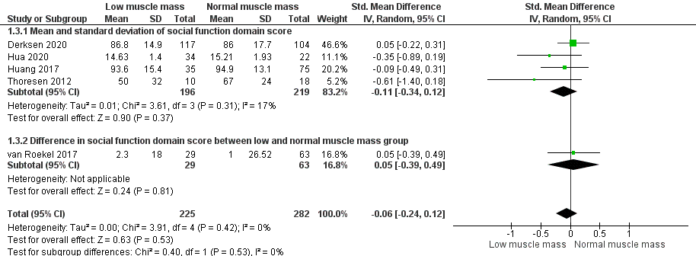

Role functioning domain scores
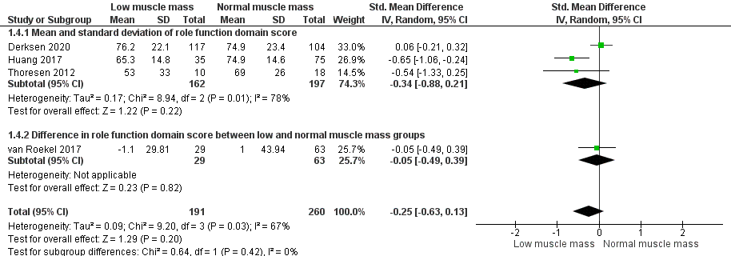
Emotional functioning domain scores
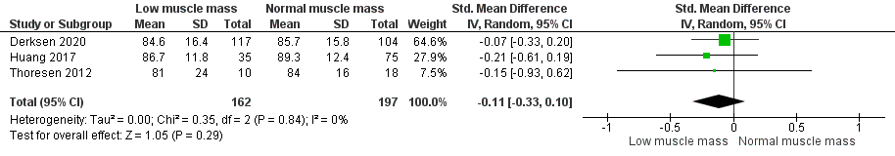

Cognitive functioning domain scores


