Manuscript: “Effect of locally-delivered adjunctive antibiotics during surgical periodontal therapy: A systematic review and meta‐analysis”
UNIVERSITÄTSKLINIKUM Schleswig-Holstein, Campus Kiel
Klinik für Zahnerhaltungskunde und Parodontologie, Direktor: Prof. Dr. C. Dörfer
Arnold-Heller-Str. 3, Haus B, D-24105 Kiel
Prof. Dr. Matthias Hannig
Direktor
Klinik für Zahnerhaltung, Parodontologie und Präventive Zahnheilkunde,
Universität des Saarlandes

Editor-in-Chief
Clinical Oral Investigations

UNIVERSITÄTSKLINIKUM
Schleswig-Holstein
Campus Kiel
Klinik für Zahnerhaltungskunde und Parodontologie
Ass. Prof. Dr. Karim M Fawzy El-Sayed
Oberarzt
Arnold-Heller-Str. 3, Haus 26, D-24105 Kiel
Tel: 0431 / 500-26210
Fax: 0431 / 500-26204
E-Mail: karim.fawzy@gmail.com

Dear Prof. Dr. Hannig,

Please find attached the revised manuscript “Effect of locally-delivered adjunctive antibiotics during surgical periodontal therapy: A systematic review and meta‐analysis” as a submission to Clinical Oral Investigations. This study systematically assesses for the first time the current evidence on effects of locally-delivered antibiotics during osseous periodontal surgery, compared to periodontal surgery alone on clinical periodontal parameters. All reviewers’ comments have been meticulously addressed and all required changes applied to the revised manuscript.

We affirm that the study is original and not presently under consideration for publication elsewhere. In consideration of the editors of Clinical Oral Investigations taking action in reviewing and editing this submission, the authors hereby transfer, assign or otherwise convey all copyright ownership to Clinical Oral Investigations in the event that such work is published in the Journal.

We hope you are interested in our study and are looking forward to hearing from you.

Yours Sincerely,
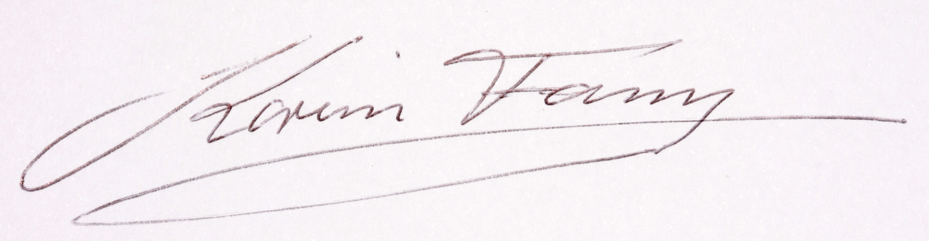
Dr. Karim Fawzy El-Sayed

