SUPPLEMENTARY DATA
Appendix
Cochrane Central Register of Controlled Trials (CCTR) via Ovid (1991+)):
# | Query | Results from 30 Aug 2021
1 | ((corona-vir* or coronavir* or covid* or ncov* or hcov* or cov19 or cov-19 or cov2019 or cov-2019) adj3 ("19" or "2019" or novel or new or nuevo or nouveau or wuhan or hubei or china or chinese or pneumon* or pandemic* or outbreak* or quarantin* or shut-down* or shutdown* or lockdown* or lock-down* or "stay-at-home" or "shelter-in-place" or survivor* or long-haul*)).ti,hw,ab. | 6,667
2 | (corona-virinae19 or corona-virinae2019 or corona-virus19 or corona-virus2019 or coronavirinae19 or coronavirinae2019 or coronavirus19 or coronavirus2019 or covid19 or covid2019 or ncov19 or ncov2019 or hcov19 or hcov2019).ti,hw,ab. | 370
3 | (sars* adj1 (corona-vir* or coronavir* or cov* or hcov* or ncov*)).ti,hw,ab. | 2,753
4 | (severe-acute-respiratory-syndrome adj1 (corona-vir* or coronavir* or cov* or hcov* or ncov*)).ti,hw,ab. | 626
5 | (betacoronavirus or sarscov* or sars-cov* or sars2 or covid or postcovid or longcovid or Wuhan-Seafood-Market-Pneumonia-Virus).ti,hw,ab. | 6,682
6 | 1 or 2 or 3 or 4 or 5 | 6,877
7 | ((bacteri* or lenta or infecti*) adj3 endocardi*).ti,hw,ab. | 459
8 | 6 and 7 | 0

Embase via Ovid (1974+):
# | Query | Results from 30 Aug 2021
1 | coronavirus disease 2019/ or exp severe acute respiratory syndrome coronavirus 2/ | 147,852
2 | ((corona-vir* or coronavir* or covid* or ncov* or hcov* or cov19 or cov-19 or cov2019 or cov-2019) adj3 ("19" or "2019" or novel or new or nuevo or nouveau or wuhan or hubei or china or chinese or pneumon* or pandemic* or outbreak* or quarantin* or shut-down* or shutdown* or lockdown* or lock-down* or "stay-at-home" or "shelter-in-place" or survivor* or long-haul*)).ab,kw,ti,dq,od. | 164,543
3 | (corona-virinae19 or corona-virinae2019 or corona-virus19 or corona-virus2019 or coronavirinae19 or coronavirinae2019 or coronavirus19 or coronavirus2019 or covid19 or covid2019 or ncov19 or ncov2019 or hcov19 or hcov2019).ab,kw,ti,dq,od. | 2,717
4 | (sars* adj1 (corona-vir* or coronavir* or cov* or hcov* or ncov*)).ab,kw,ti,dq,od. | 61,415
5 | (severe-acute-respiratory-syndrome adj1 (corona-vir* or coronavir* or cov* or hcov* or ncov*)).ab,kw,ti,dq,od. | 21,398
6 | (betacoronavirus or sarscov* or sars-cov* or sars2 or covid or postcovid or longcovid or Wuhan-Seafood-Market-Pneumonia-Virus).ab,kw,ti,dq,od. | 165,387
7 | 2 or 3 or 4 or 5 or 6 | 177,988
8 | exp endocarditis/ | 50,415
9 | ((bacteri* or lenta or infecti*) adj3 endocardi*).ab,kw,ti,dq,od. | 29,606
10 | 8 or 9 | 53,831
11 | 7 and 10 | 129
12 | limit 10 to covid-19 Ovid Embase filter | 139
13 | 11 or 12 | 143
14 | limit 13 to dc=20190901-20210830 | 138

LILACS (1982+)
Covid19 OR Covid-19 OR SARS-COV-2 OR Coronavirus [Words] AND endocarditis [Words]

MEDLINE via Ovid (1946+ and Epub Ahead of Print, In-Process & Other Non-Indexed Citations and Ovid MEDLINE(R) Daily):
# | Query | Results from 30 Aug 2021
1 | COVID-19/ or SARS-CoV-2/ | 100,810
2 | ((corona-vir* or coronavir* or covid* or ncov* or hcov* or cov19 or cov-19 or cov2019 or cov-2019) adj3 ("19" or "2019" or novel or new or nuevo or nouveau or wuhan or hubei or china or chinese or pneumon* or pandemic* or outbreak* or quarantin* or shut-down* or shutdown* or lockdown* or lock-down* or "stay-at-home" or "shelter-in-place" or survivor* or long-haul*)).ab,kf,ti. or (corona-virinae19 or corona-virinae2019 or corona-virus19 or corona-virus2019 or coronavirinae19 or coronavirinae2019 or coronavirus19 or coronavirus2019 or covid19 or covid2019 or ncov19 or ncov2019 or hcov19 or hcov2019).ab,kw,ti. | 92,982
3 | (sars* adj1 (corona-vir* or coronavir* or cov* or hcov* or ncov*)).ab,kf,ti. | 37,094
4 | (severe-acute-respiratory-syndrome adj1 (corona-vir* or coronavir* or cov* or hcov* or ncov*)).ab,kf,ti. | 12,376
5 | (betacoronavirus or sarscov* or sars-cov* or sars2 or covid or postcovid or longcovid or Wuhan-Seafood-Market-Pneumonia-Virus).ab,kf,ti. | 97,880
6 | or/1-5 | 106,484
7 | exp Endocarditis/ | 29,334
8 | ((bacteri* or lenta or infecti*) adj3 endocardi*).ab,kw,ti. | 17,520
9 | 7 or 8 | 32,775
10 | 6 and 9 | 32
11 | limit 9 to covid-19 Ovid Medline filter | 32
12 | 10 or 11 | 32
13 | limit 12 to dt=20190901-20210830 | 32

PubMed (1946+): *Note PubMed’s general Covid-19 filter was applied
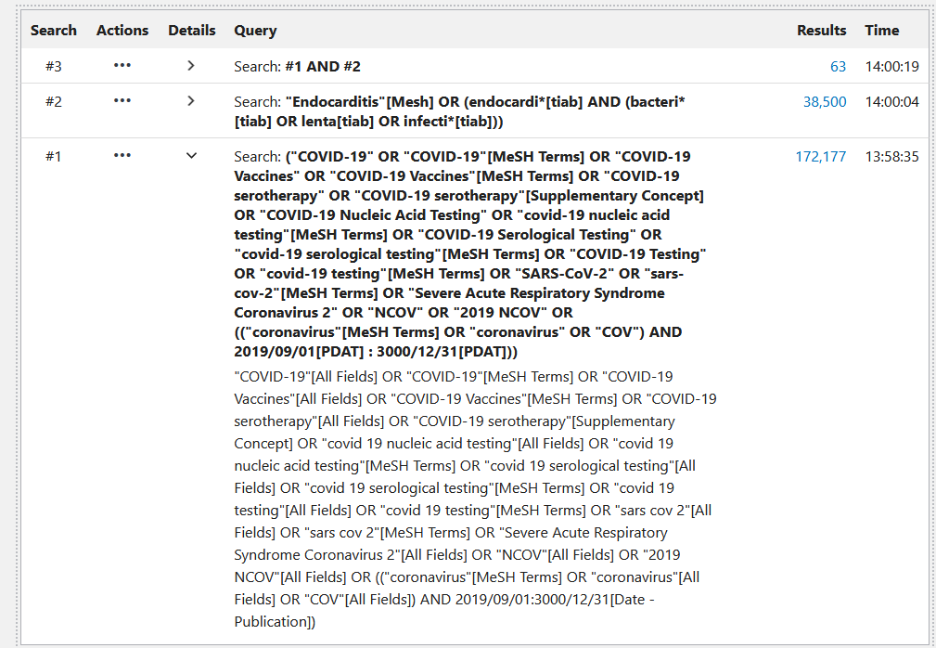

SciELO (1997+):
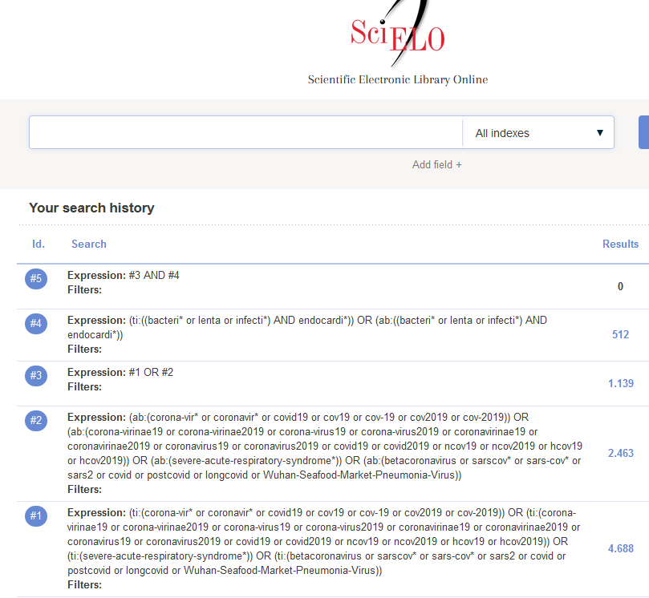

Scopus via Elsevier (1823+):
( ( TITLE-ABS-KEY ( ( corona-vir* OR coronavir* OR covid* OR ncov* OR hcov* OR cov19 OR cov-19 OR cov2019 OR cov-2019 ) W/3 ( "19" OR "2019" OR novel OR new OR nuevo OR nouveau OR wuhan OR hubei OR china OR chinese OR pneumon* OR pandemic* OR outbreak* OR quarantin* OR shut-down* OR shutdown* OR lockdown* OR lock-down* OR "stay-at-home" OR "shelter-in-place" OR survivor* OR long-haul* ) ) OR TITLE-ABS-KEY ( corona-virinae19 OR corona-virinae2019 OR corona-virus19 OR corona-virus2019 OR coronavirinae19 OR coronavirinae2019 OR coronavirus19 OR coronavirus2019 OR covid19 OR covid2019 OR ncov19 OR ncov2019 OR hcov19 OR hcov2019 ) OR TITLE-ABS-KEY ( sars* W/1 ( corona-vir* OR coronavir* OR cov* OR hcov* OR ncov* ) ) OR TITLE-ABS-KEY ( severe-acute-respiratory-syndrome W/1 ( corona-vir* OR coronavir* OR cov* OR hcov* OR ncov* ) ) OR TITLE-ABS-KEY ( betacoronavirus OR sarscov* OR sars-cov* OR sars2 OR covid OR postcovid OR longcovid OR wuhan-seafood-market-pneumonia-virus ) ) ) AND ( TITLE-ABS-KEY ( ( bacteri* OR lenta OR infecti* ) W/3 endocardi* ) ) AND ORIG-LOAD-DATE AFT 20190901

Web of Science Core Collection via Clarivate Analytics (Science Citation Index Expanded 1975+ & Emerging Sources Citation Index 2015+):


