Supplementary

Figures

Figure S1: Diagnostic Tests Forest Plot on Sensitivity and Specificity, SROC and Diagnostic OR for 1. NAAT, 2. NAAT (POC), 3. Sequencing, 4. Serology (IgG and/or IgM), 5. Serology (IgG and IgM), 6. Serology (IgG), 7. Serology (IgM), 8. Serology (Ab), 9. Serology (IgA), 10. Serology (POC, IgG and/or IgM), 11. Serology (POC, IgG and IgM), 12. Serology (POC, IgG), 13. Serology (POC, IgM), 14. Imaging, 15. Imaging (AI) and 16. Clinical Features and Laboratory Parameters Model

NAAT
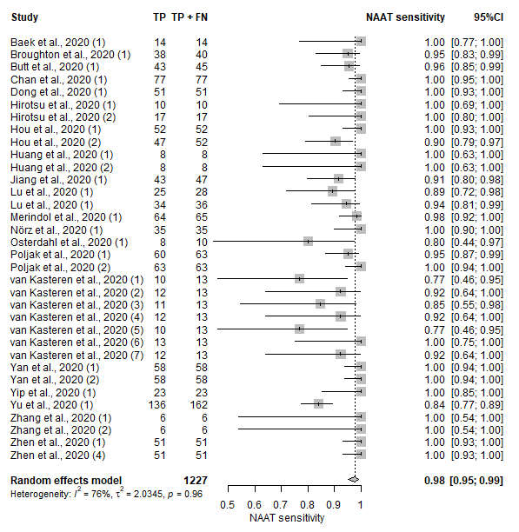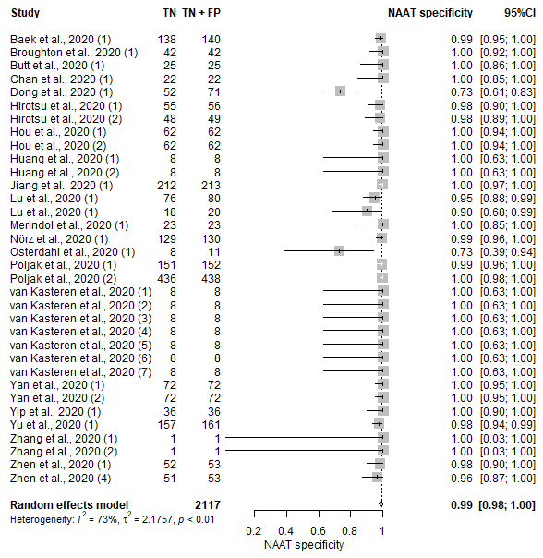
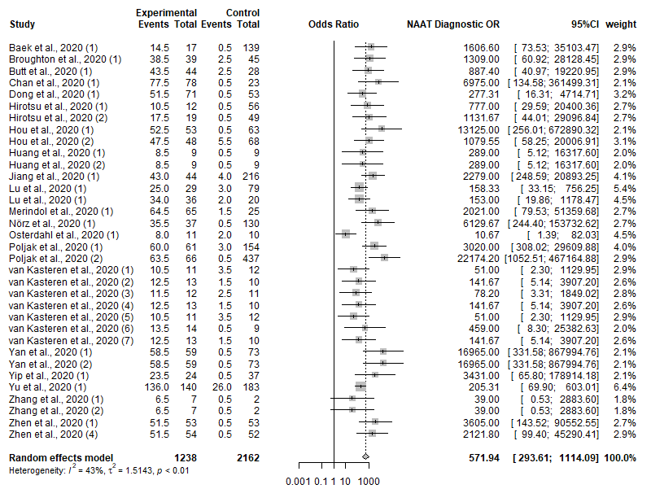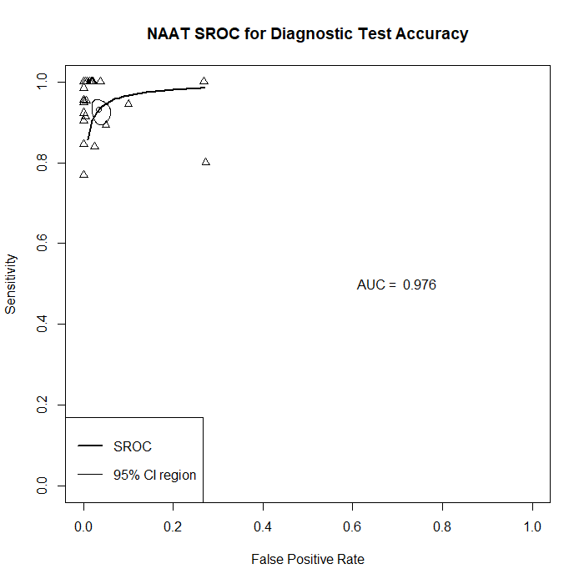

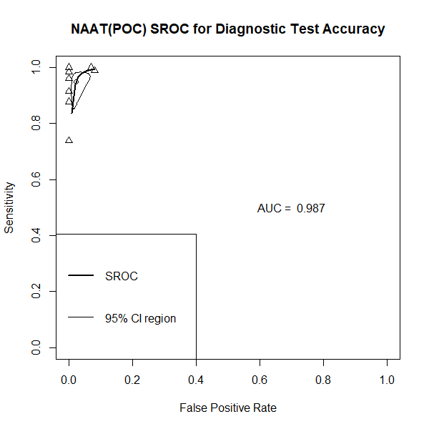
NAAT (POC)
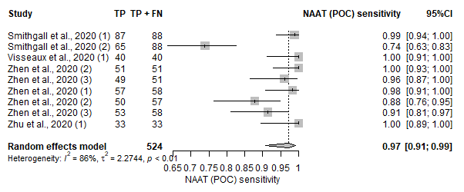
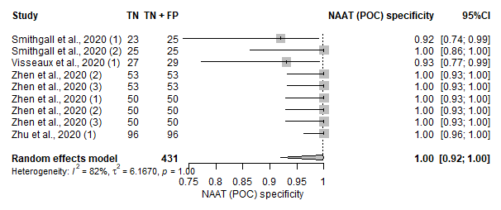
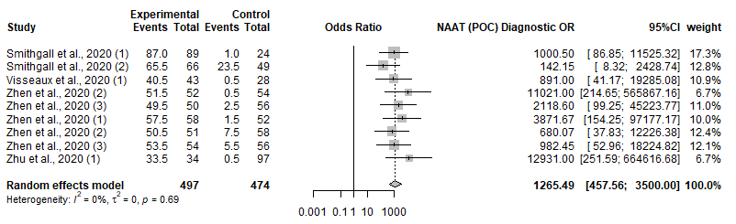

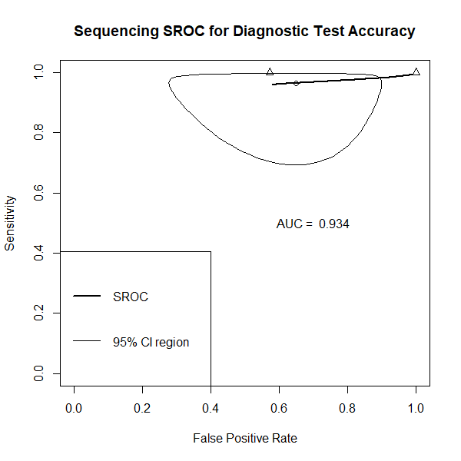
Sequencing
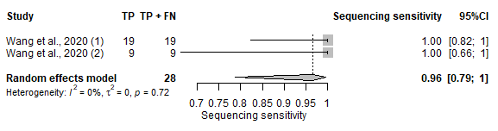
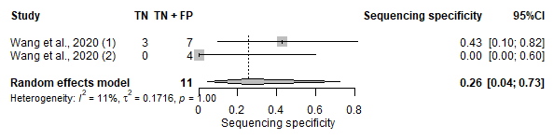
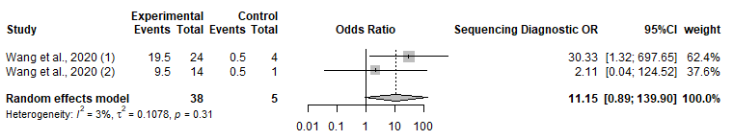

Serology (IgG and/or IgM)
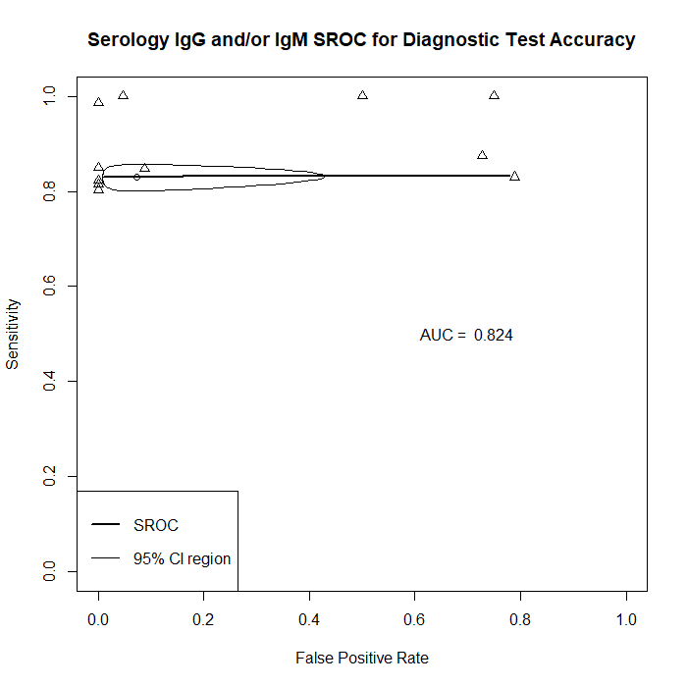
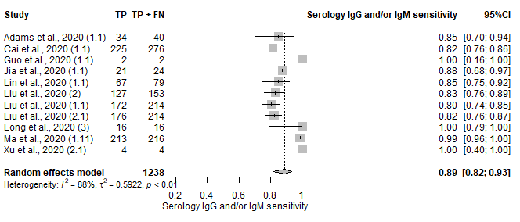
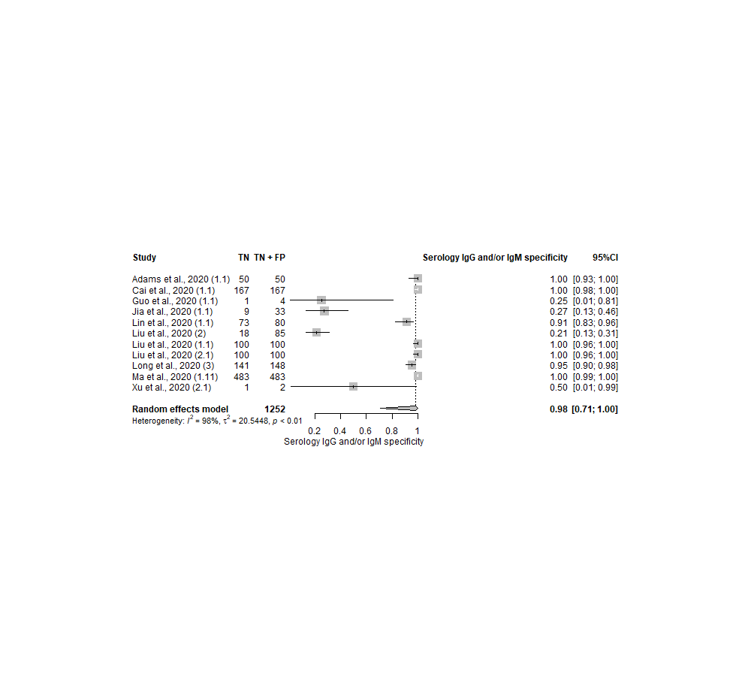
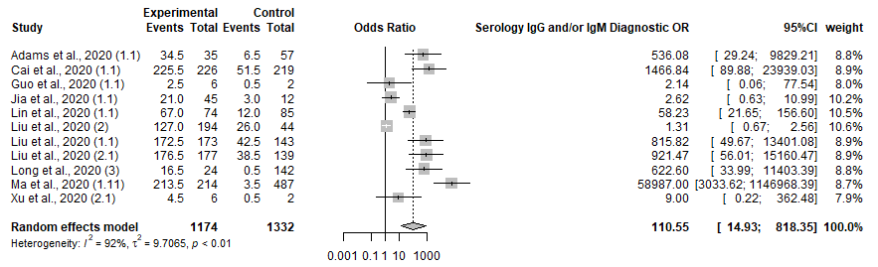

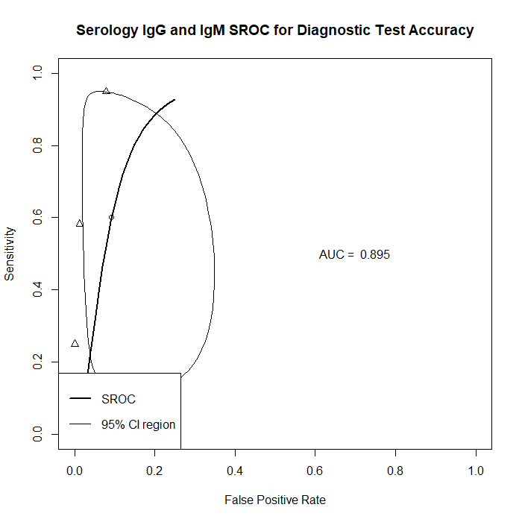
Serology (IgG and IgM)
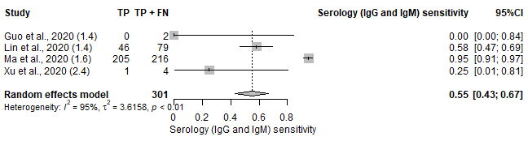
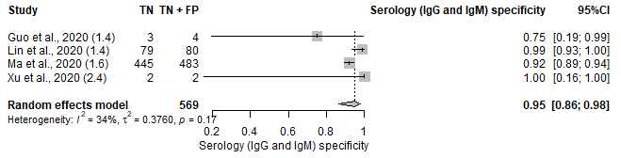
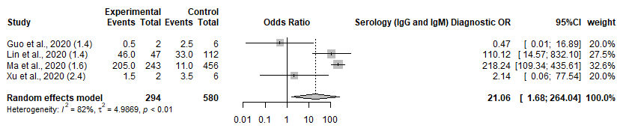

6. Serology (IgG)
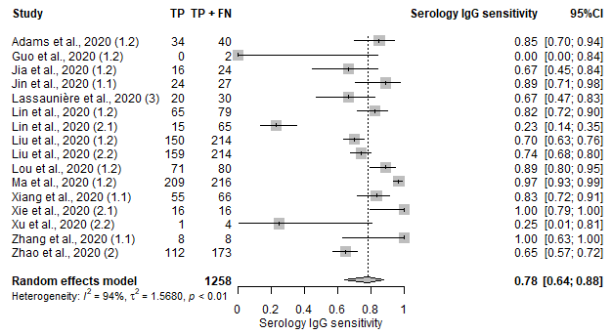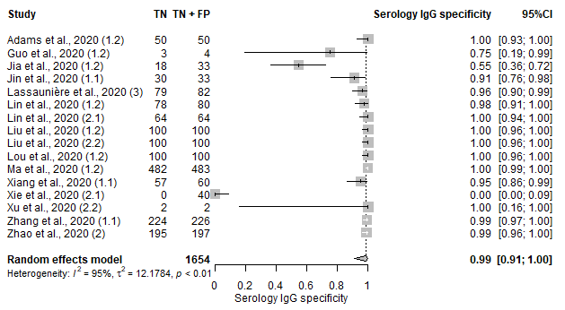
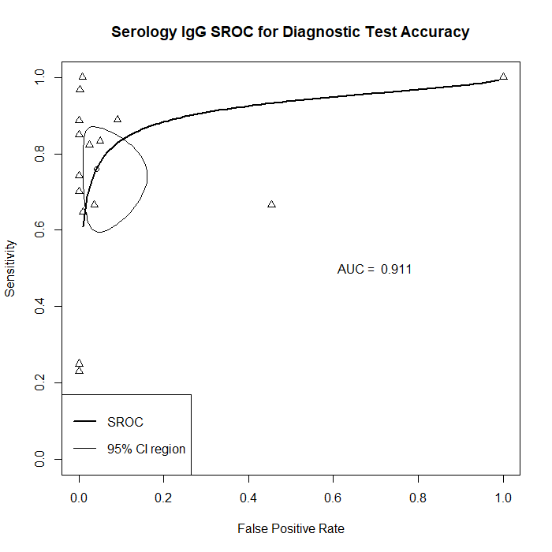
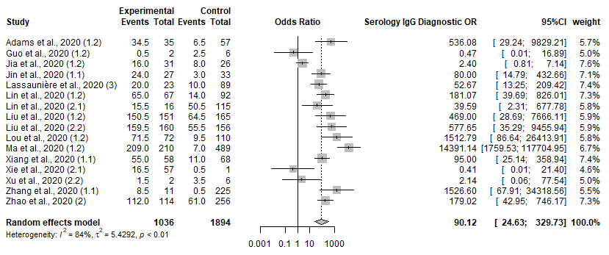

7. Serology (IgM)
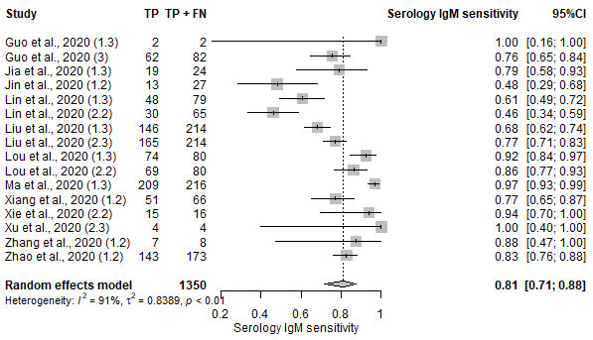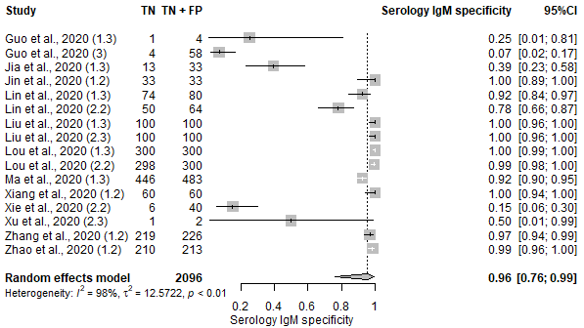
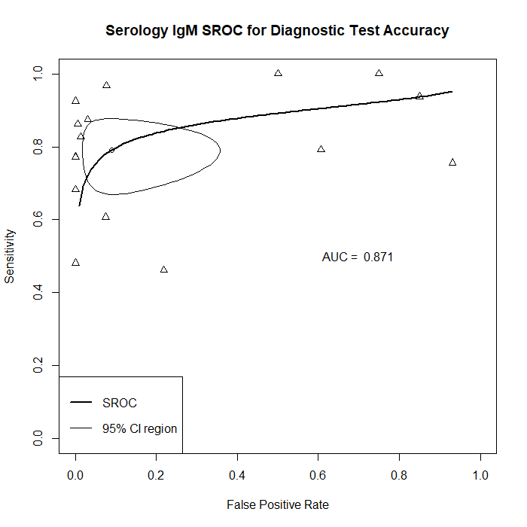
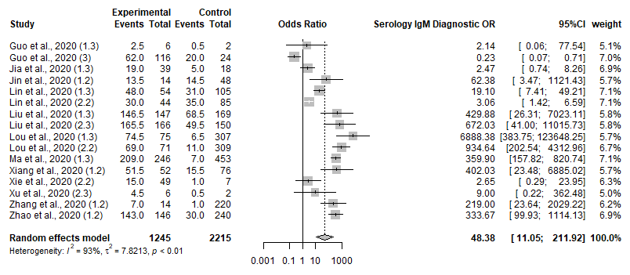

8. Serology (Ab)
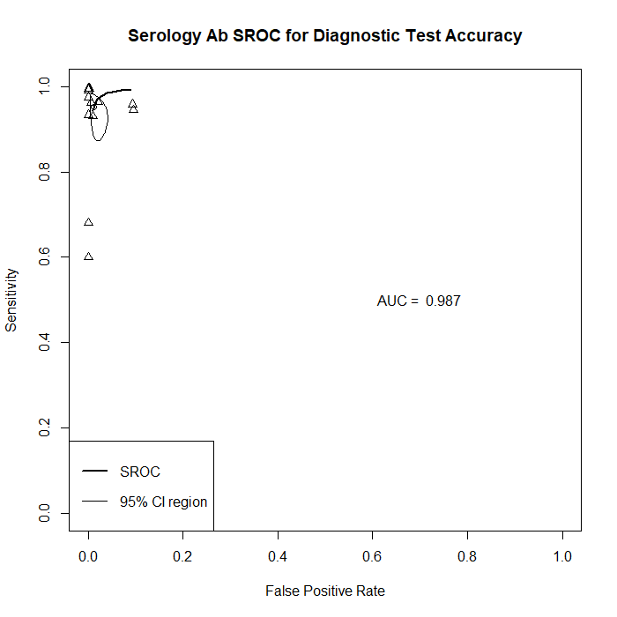
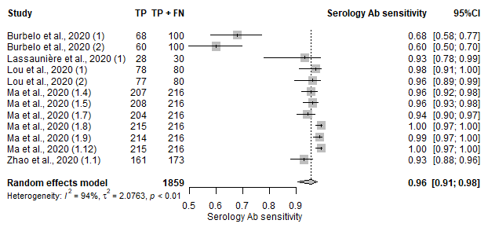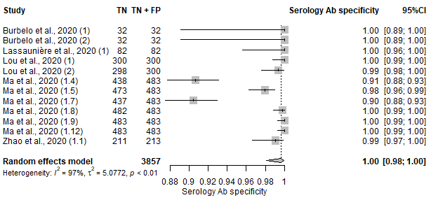
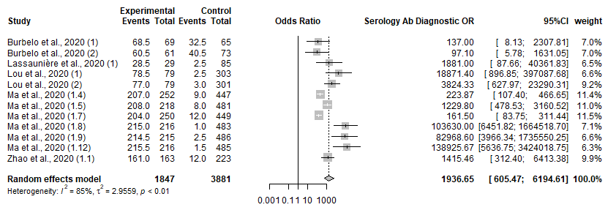

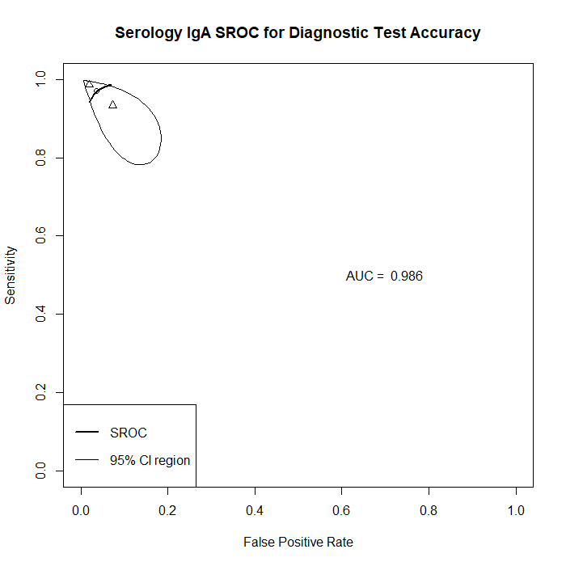
9. Serology (IgA)
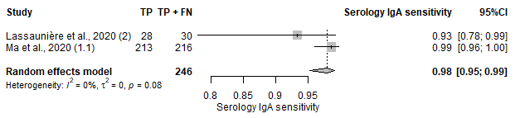
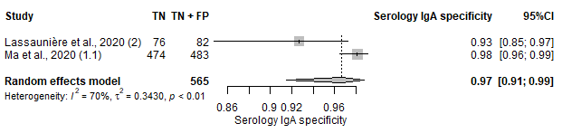
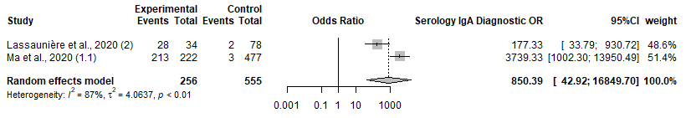

10. Serology-POC (IgG and/or IgM)
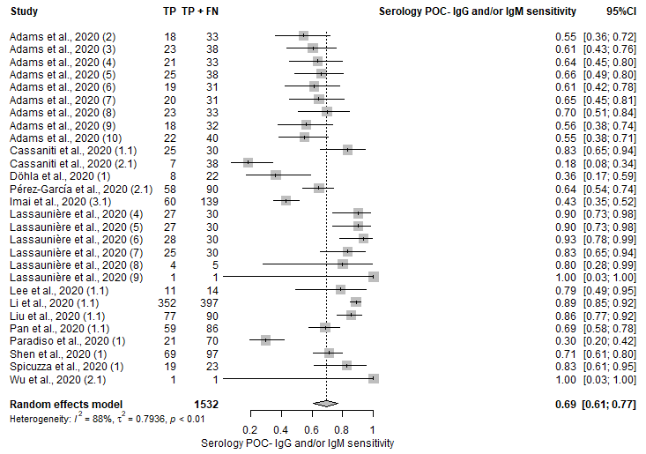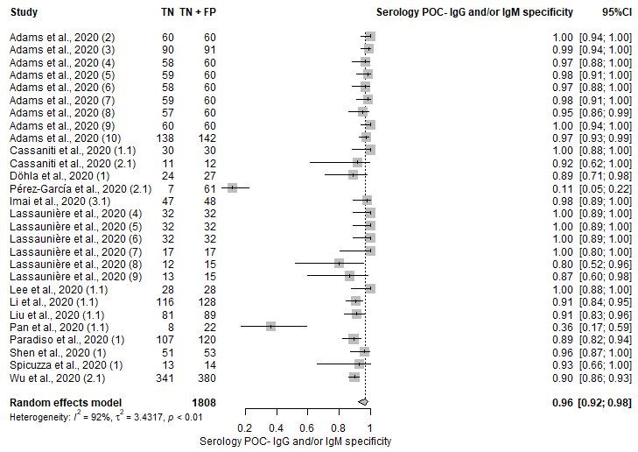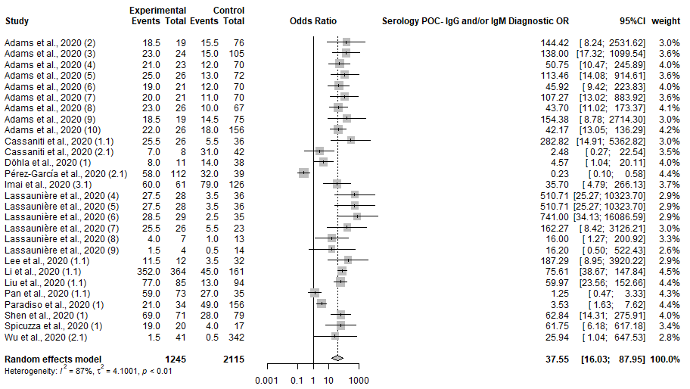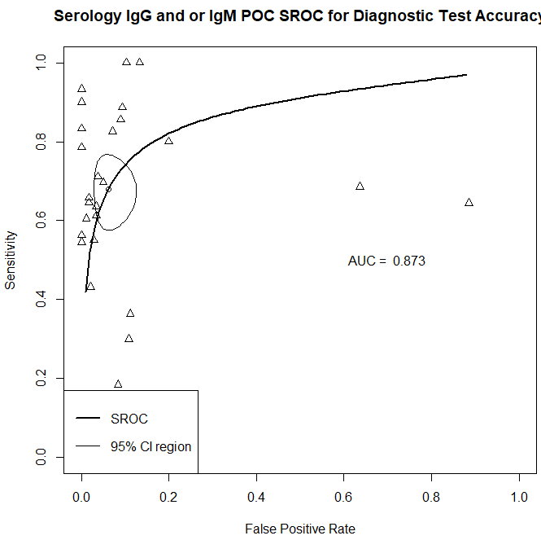

11. Serology-POC (IgG and IgM)
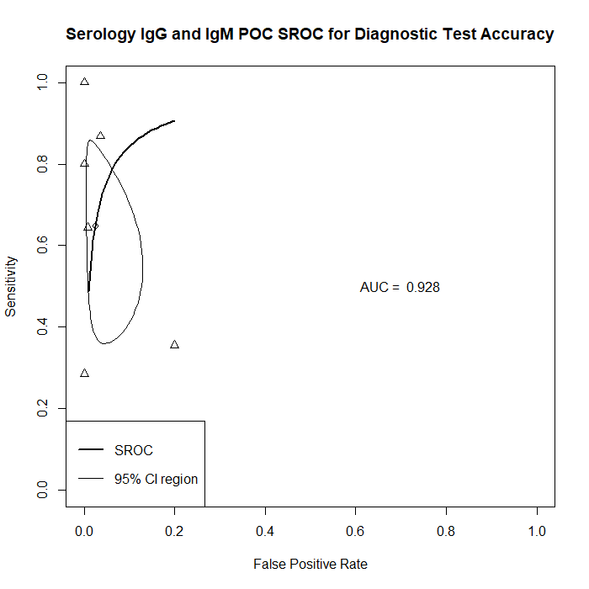
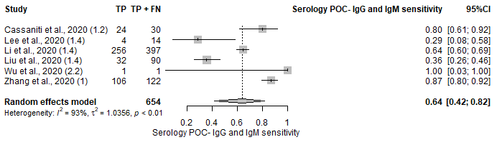
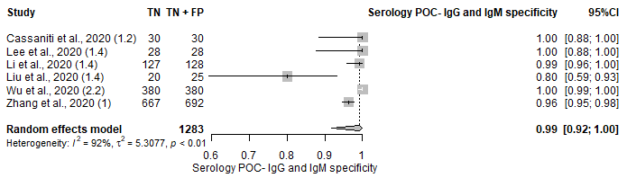

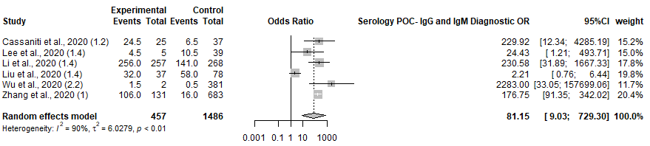

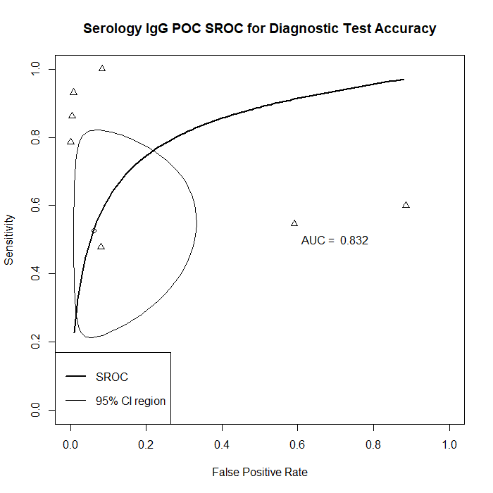
12. Serology-POC (IgG)
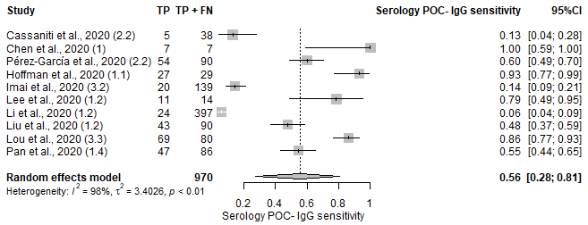
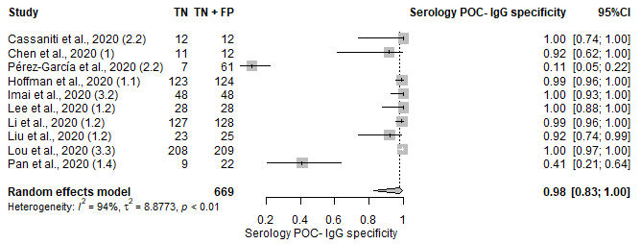
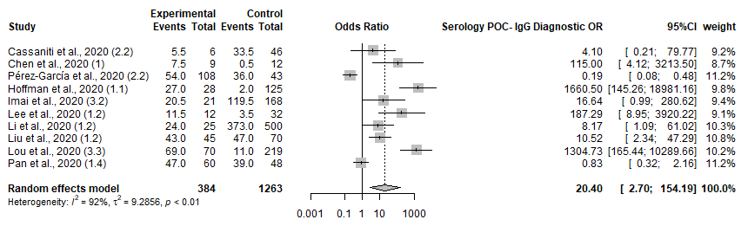

13. Serology-POC (IgM)
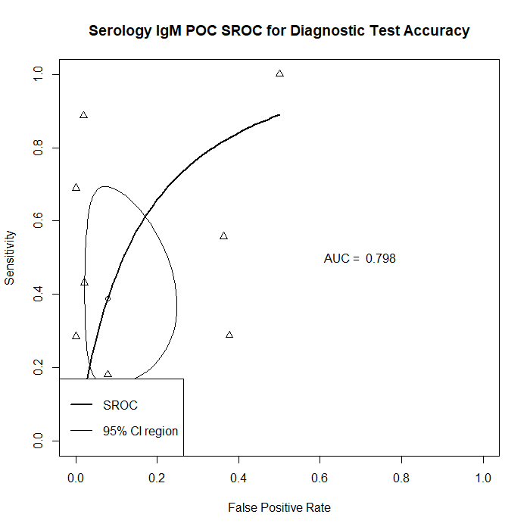
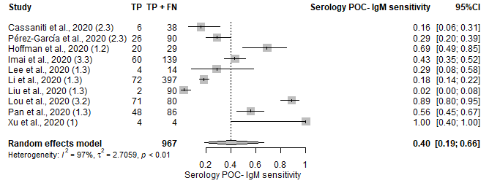
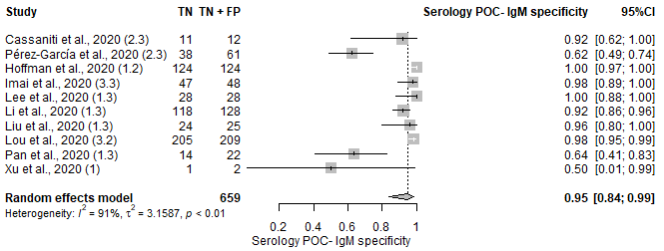
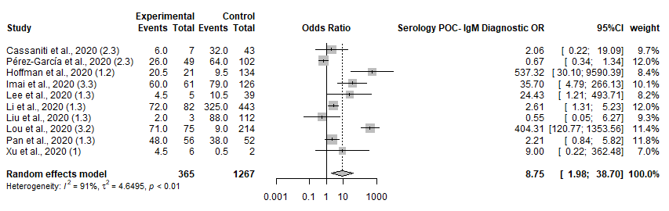

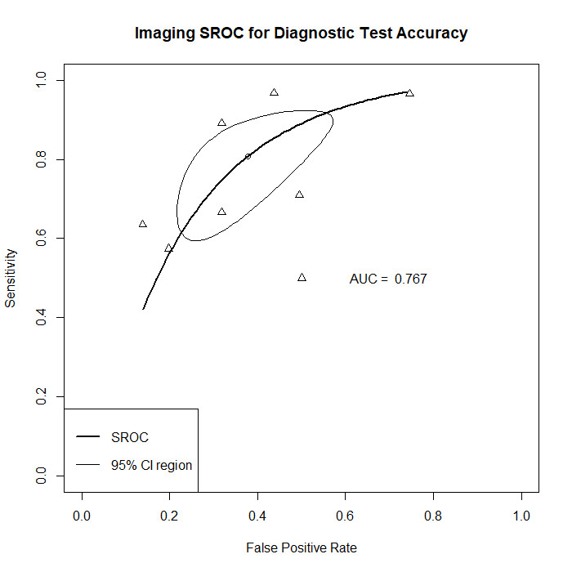
14. Imaging
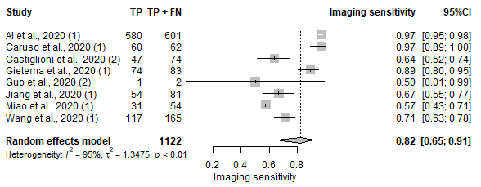
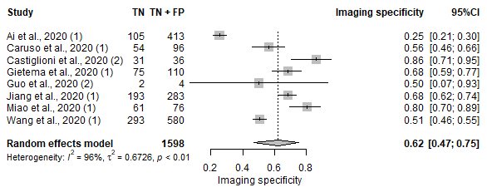
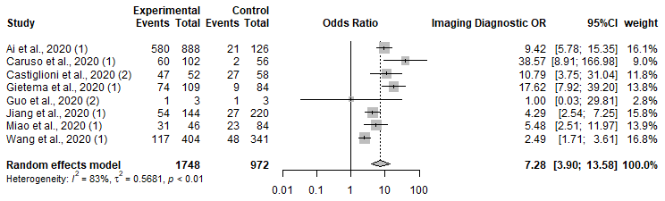

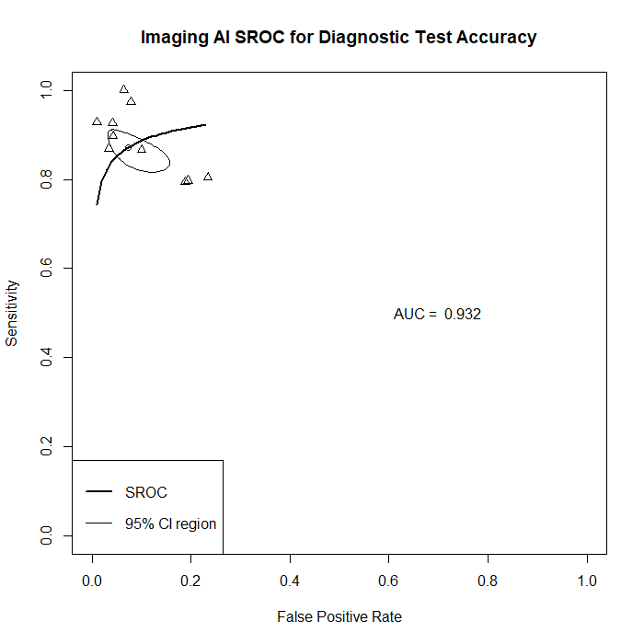
15. Imaging (AI)
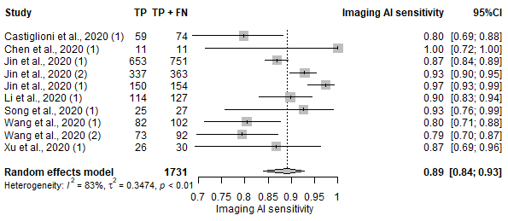
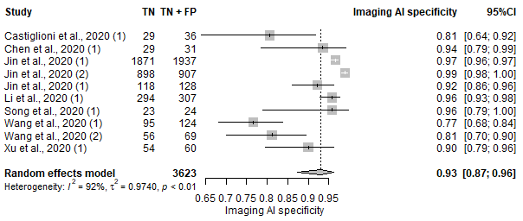
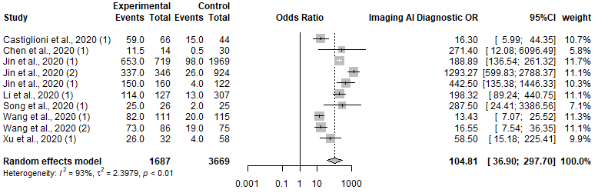

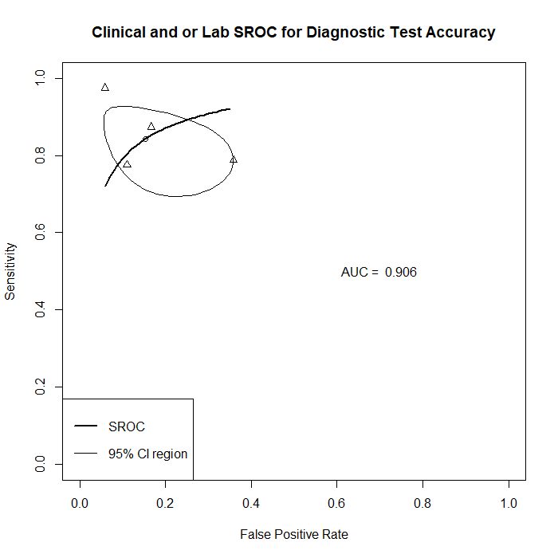
16. Clinical Features and Laboratory Parameters Model
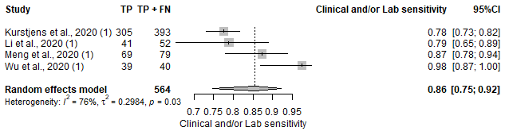
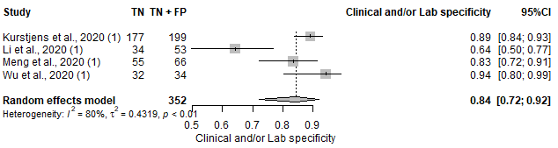
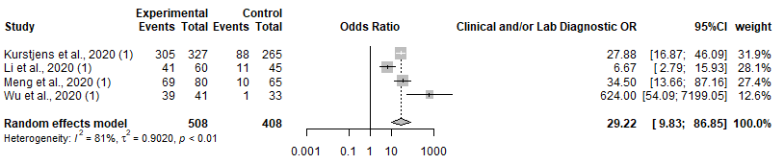

Figure S2: Serology Test Late Phase (≥7) Forest Plot on Sensitivity and Specificity, SROC and Diagnostic OR for 1. IgG and/or IgM, 2. IgG, 3. IgM, 4. Ab, 5. IgG and/or IgM (POC), 6. IgG (POC) and 7. IgM (POC)

IgG and/or IgM
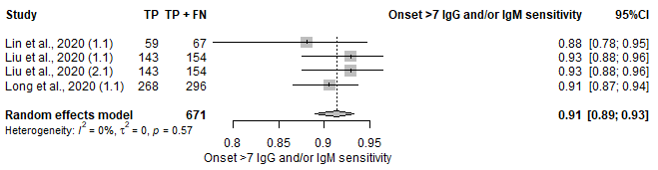

IgG
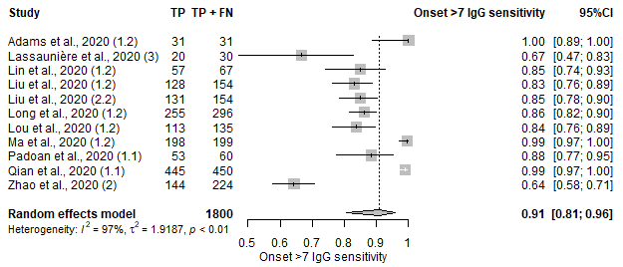

IgM
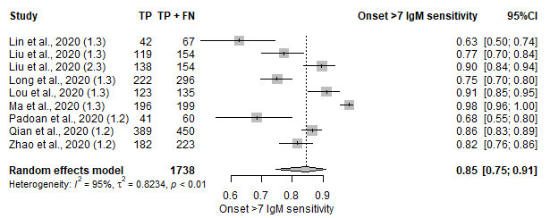

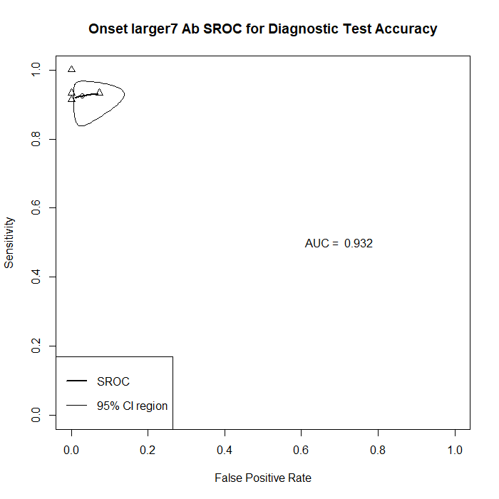
Ab
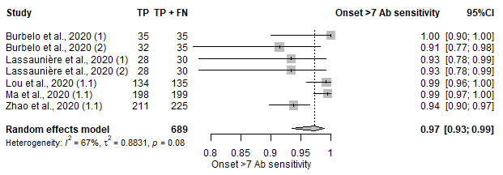
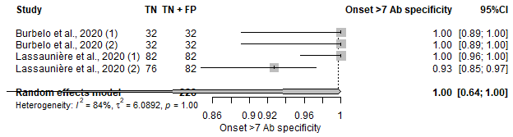
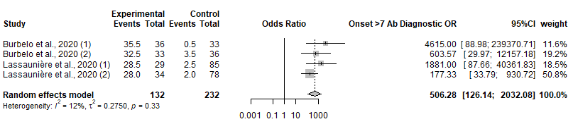

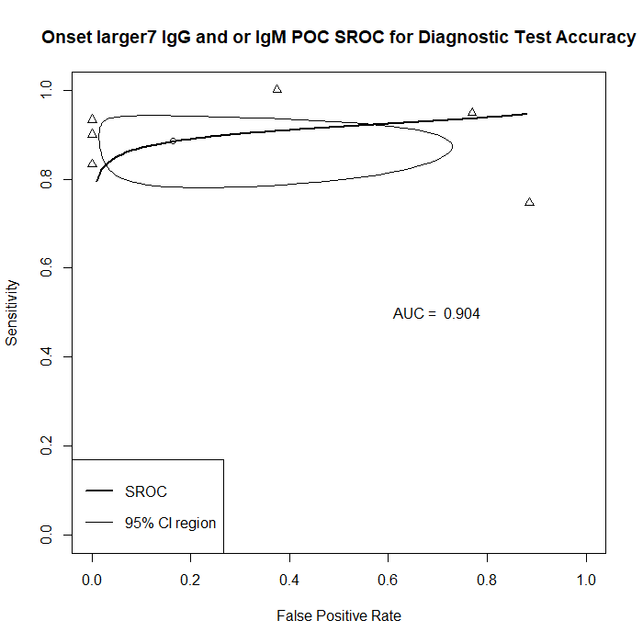
IgG and/or IgM (POC)
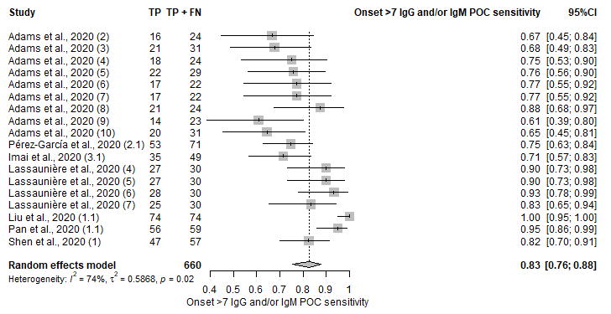
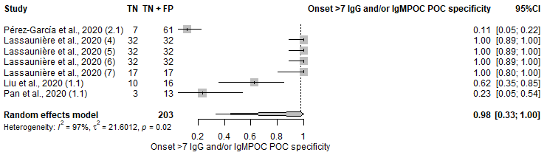
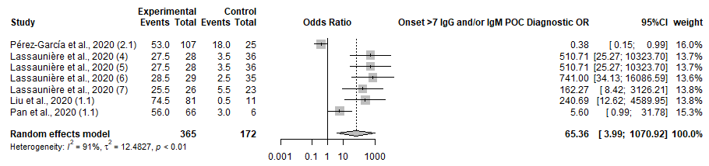

IgG (POC)
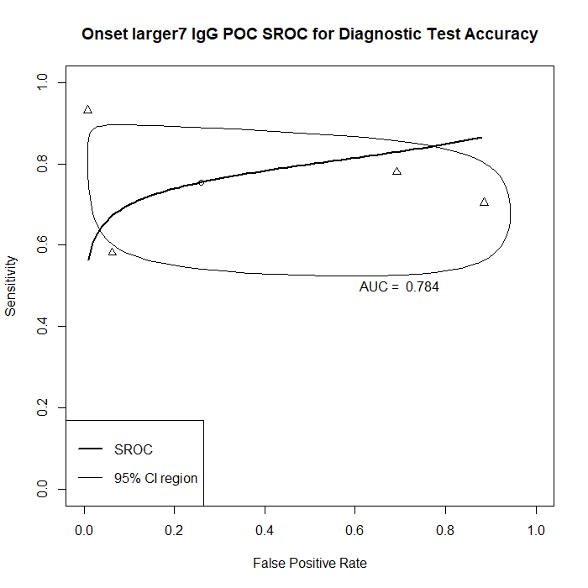
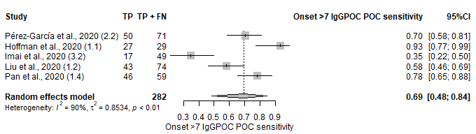
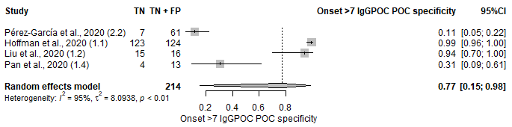
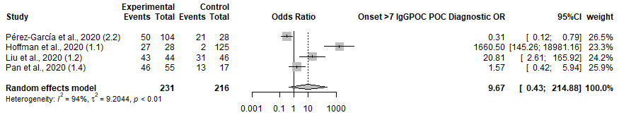

IgM (POC)
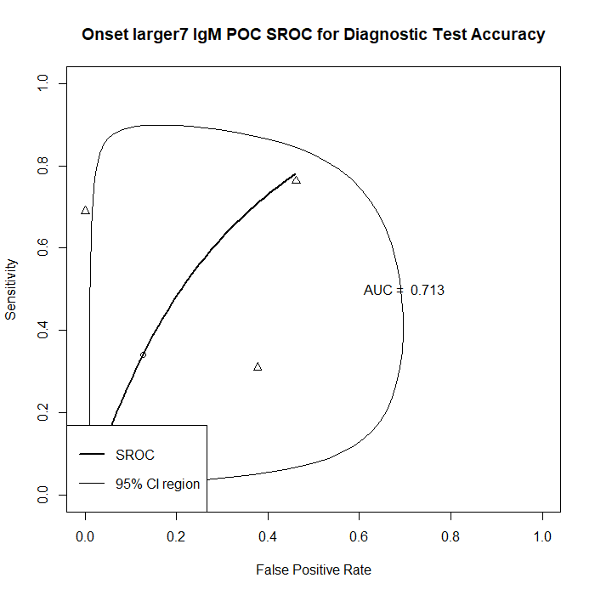
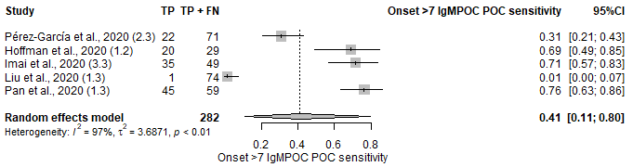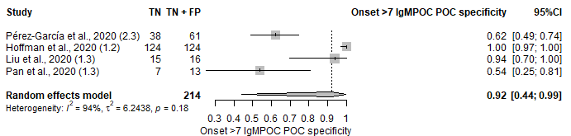
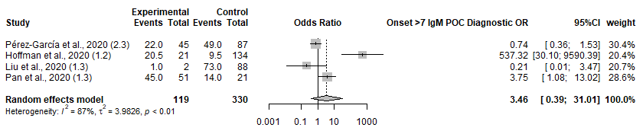

Figure S3: Serologic Test Early Phase (≤7) Forest Plot on Sensitivity and Specificity, SROC and Diagnostic OR for 1. IgG and/or IgM, 2. IgG, 3. IgM, 4. Ab, 5. IgG and/or IgM (POC), 6. IgG (POC) and 7. IgM (POC)

IgG and/or IgM
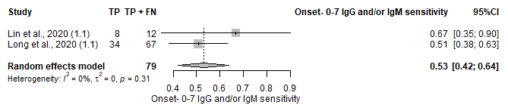

IgG
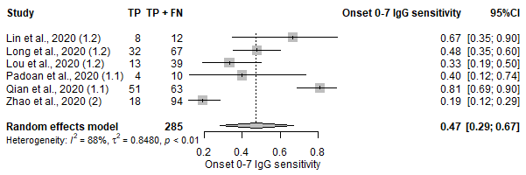

IgM
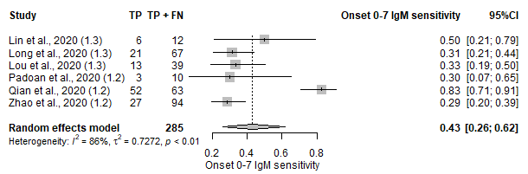

Ab
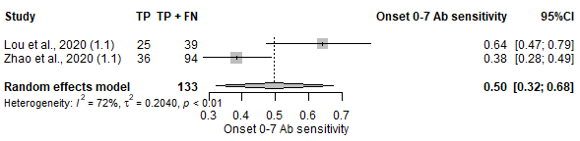

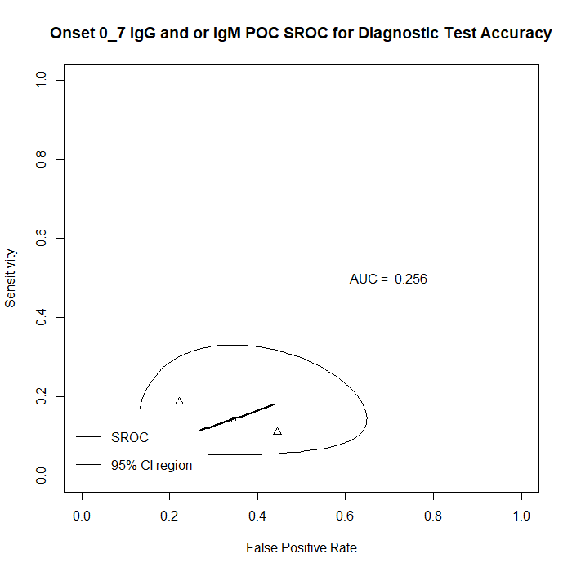
IgG and/or IgM (POC)
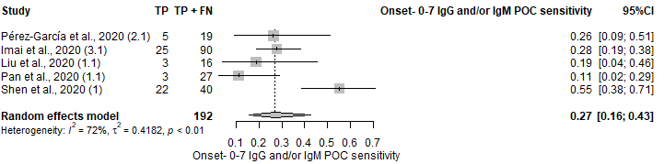

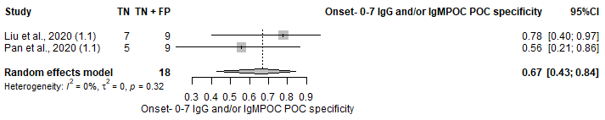

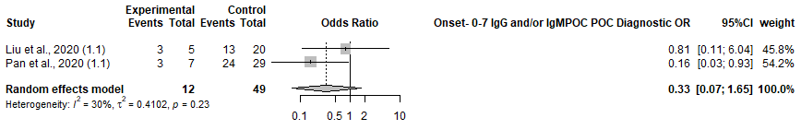

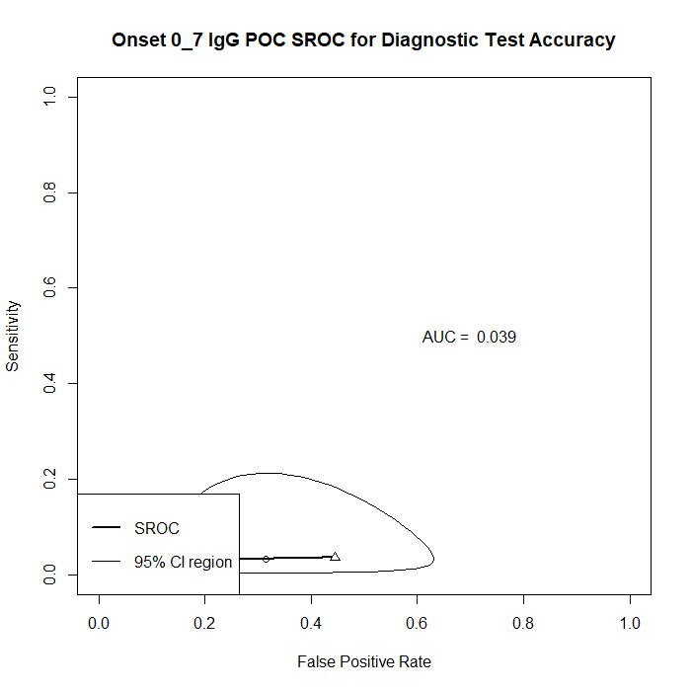
IgG (POC)
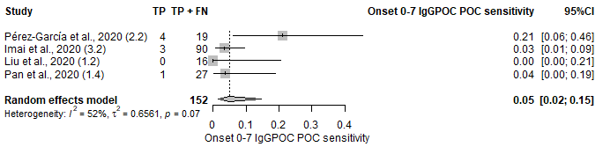
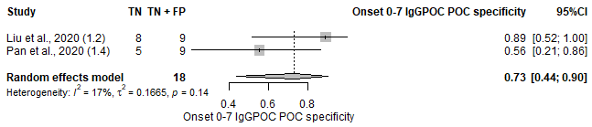
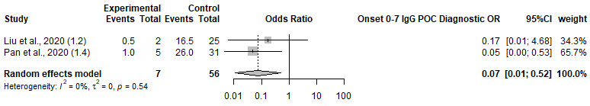

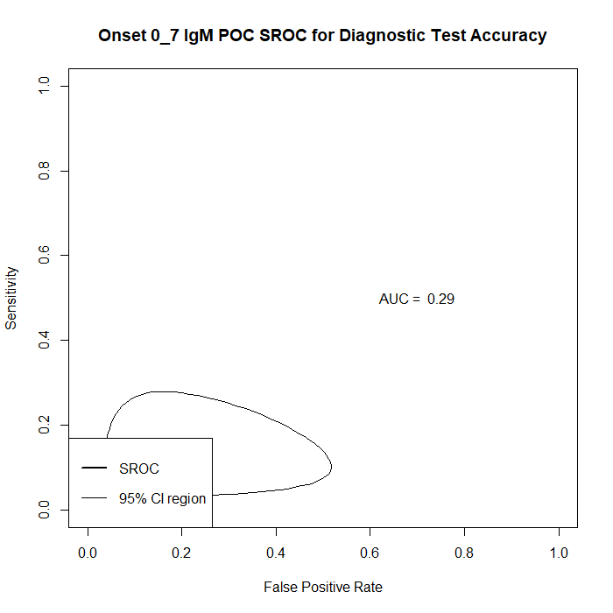
IgM (POC)
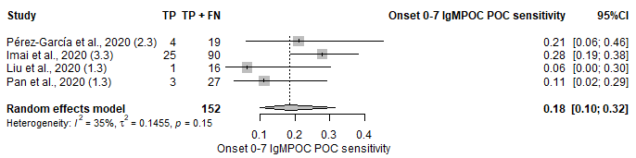
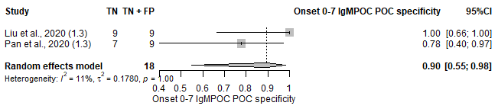
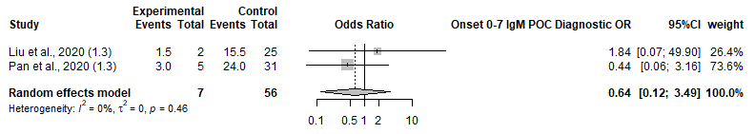

Figure S4: Diagnostic Test Accuracy between Symptomatic (Left) and Asymptomatic (Right) Patient Forest Plot on Sensitivity 1. NAAT, 2. Serology IgG and/or IgM, 3. Serology IgG and/or IgM 4. Serology IgG, 5. Serology IgM, 6. Serology IgG and/or IgM (POC), 7. Serology IgG (POC), 8. Serology IgM (POC) and 9. Imaging
- NAAT
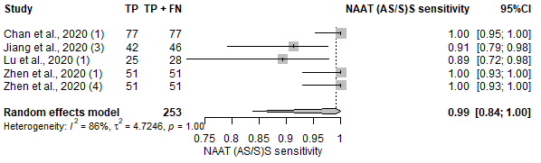 | 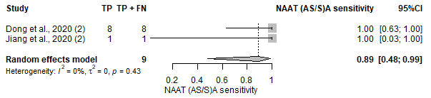
- Serology IgG and/or IgM
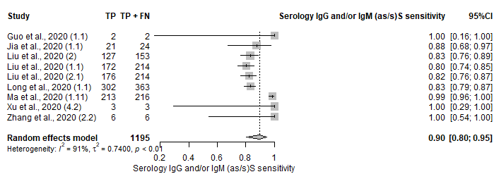 | 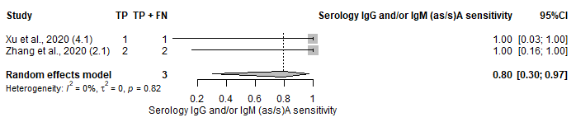
- Serology IgG and IgM
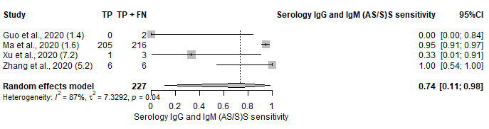 | 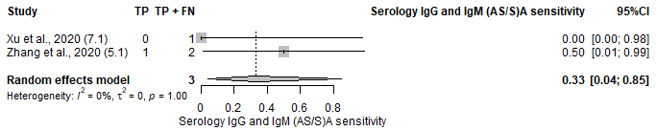
- Serology IgG
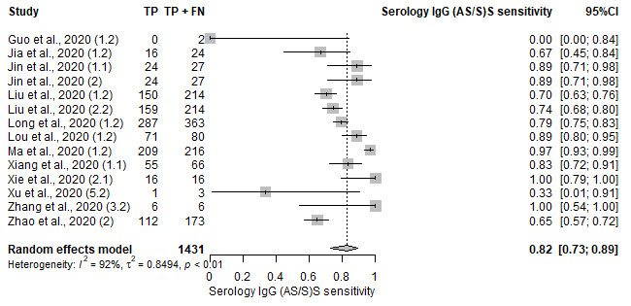 | 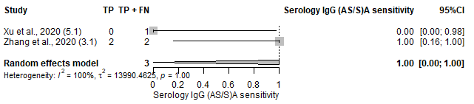
- Serology IgM
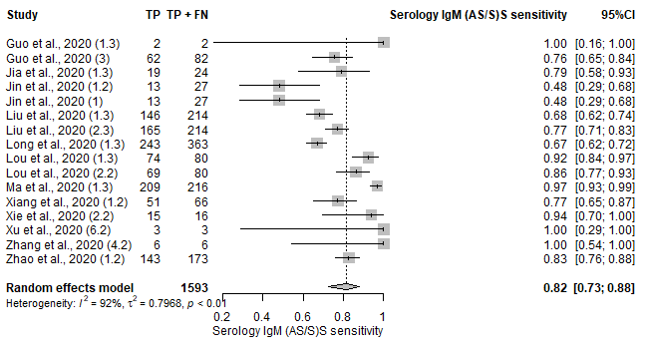 | 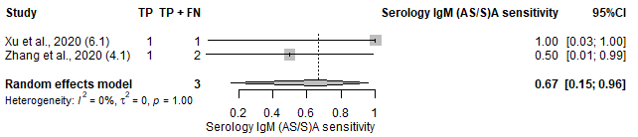
- Serology (POC) IgG and/or IgM
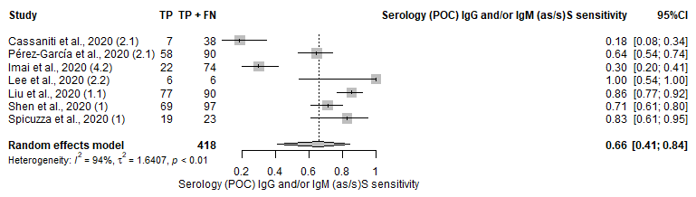
- Serology (POC) IgG
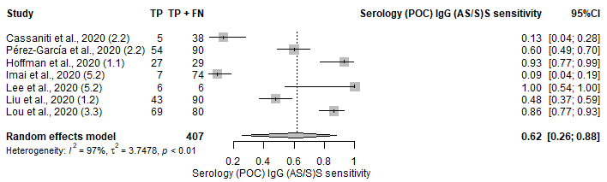
- Serology (POC) IgM
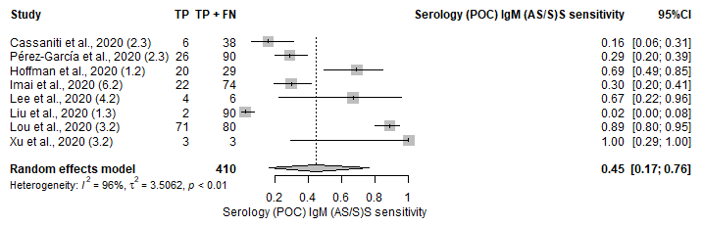 | 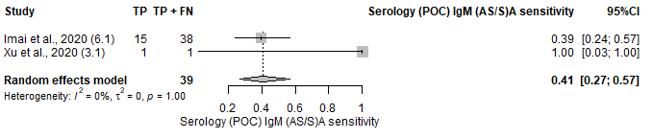
- Imaging
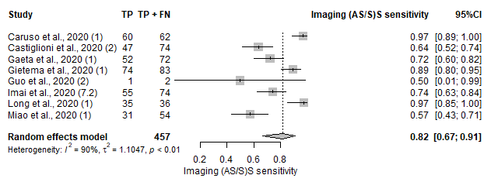

Figure S5: Geographical Forest Plot on Sensitivity and Specificity, SROC and Diagnostic OR for 1. NAAT, 2. NAAT (POC), 3. Serology (IgG and/or IgM), 4. Serology (IgG and IgM), 5. Serology (IgG), 6. Serology (IgM), 7. Serology (Ab), 8. Serology (IgA), 9. Serology (POC, IgG and/or IgM), 10. Serology (POC, IgG and IgM), 11. Serology (POC, IgG), 12. Serology (POC, IgM), 13. Imaging, 14. Imaging (AI), 15. Clinical Features and/or Laboratory Parameters and 16. Molecular + Imaging

NAAT
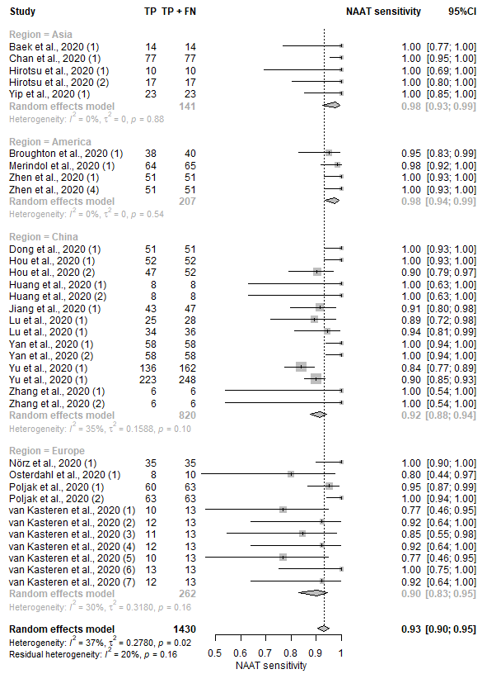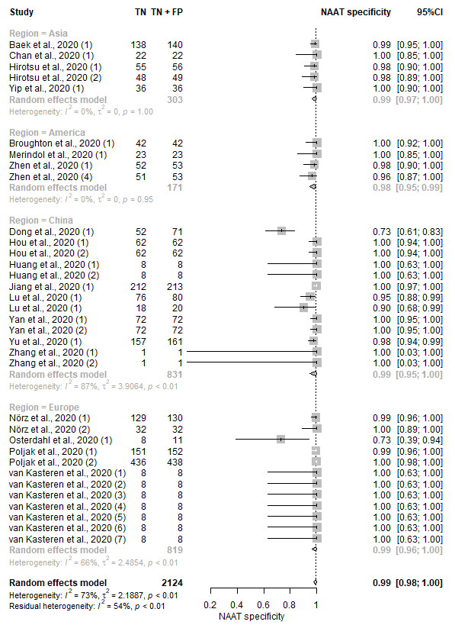
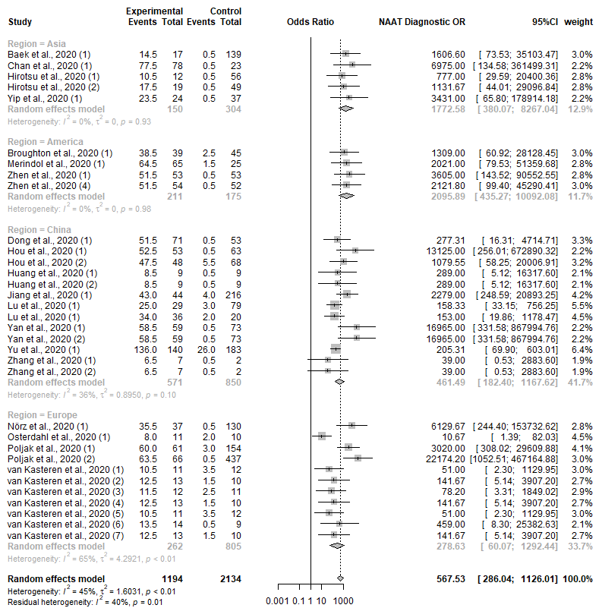

NAAT (POC)
`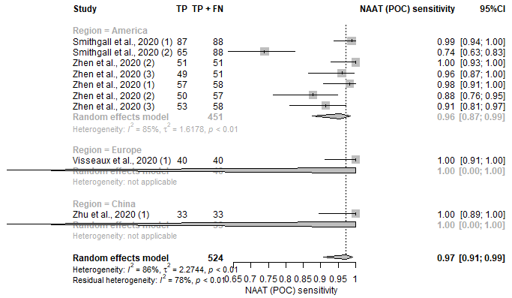 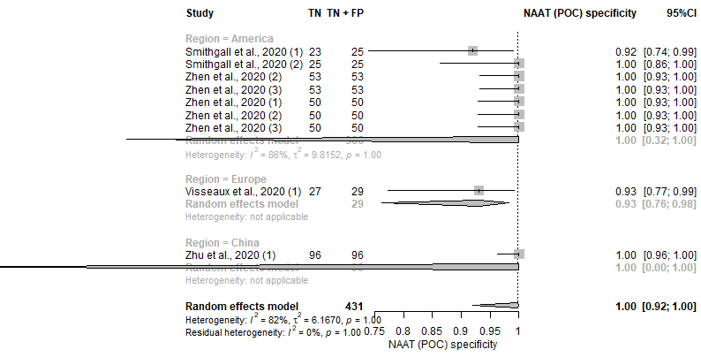
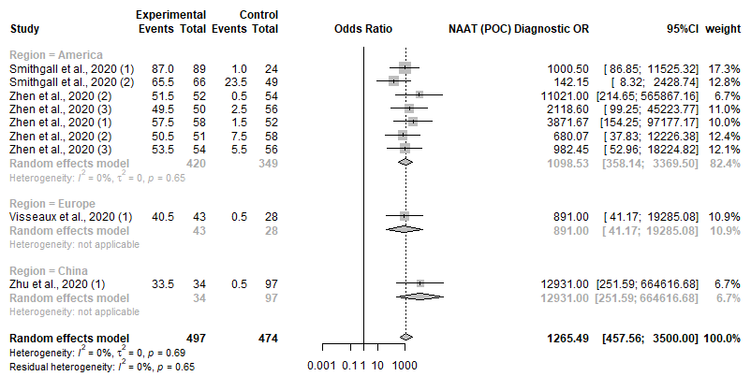

Serology IgG and/or IgM
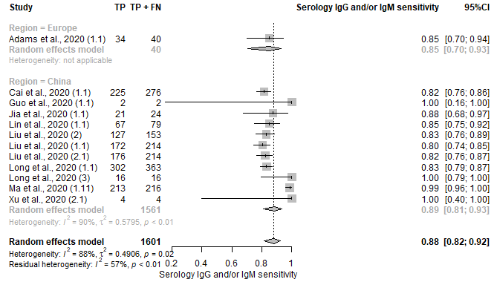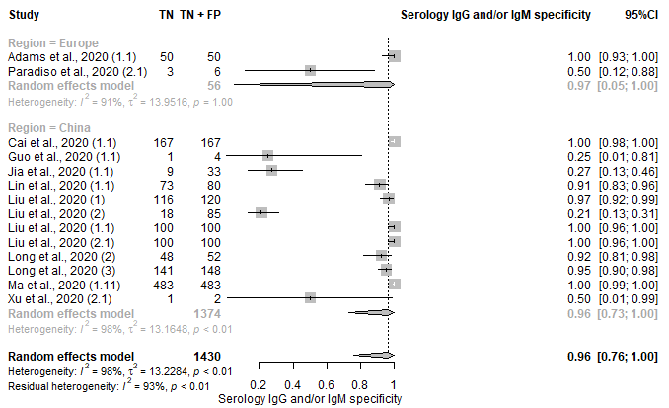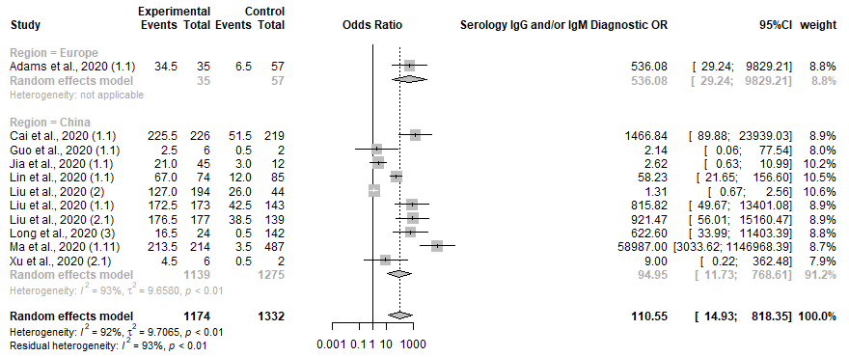

Serology (IgG and IgM)
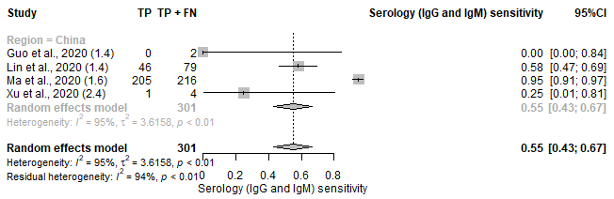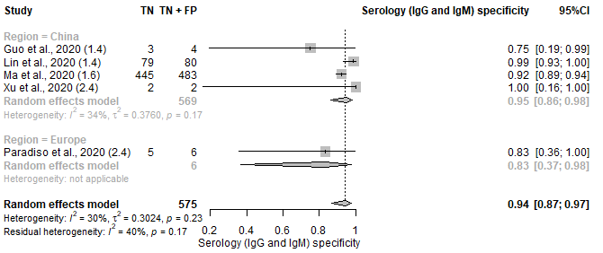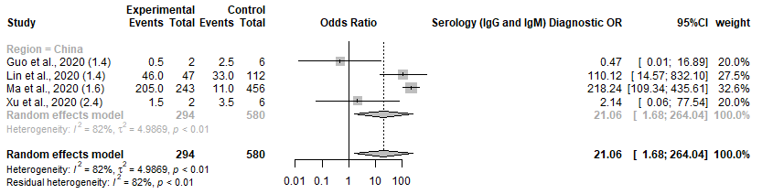

Serology (IgG)
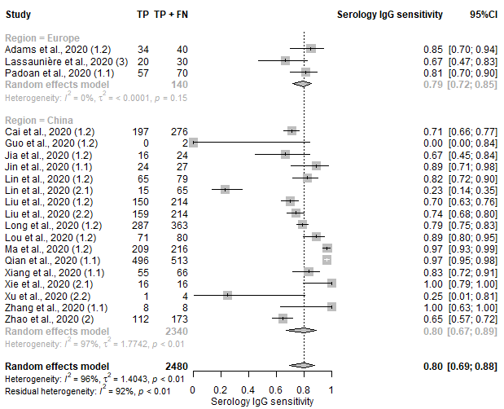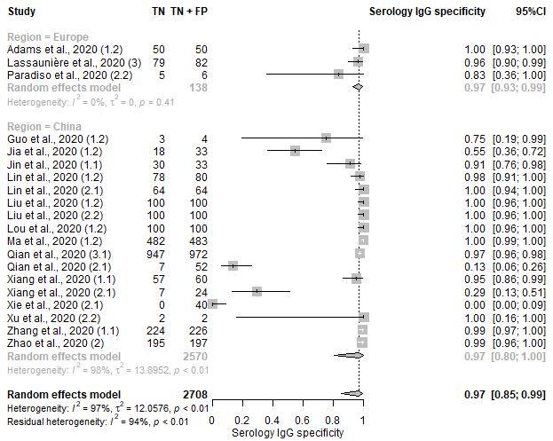
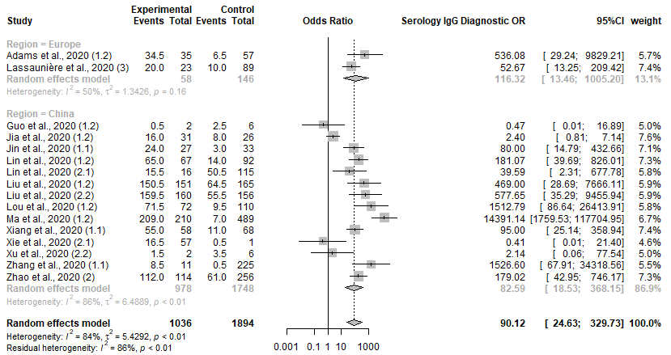

Serology (IgM)
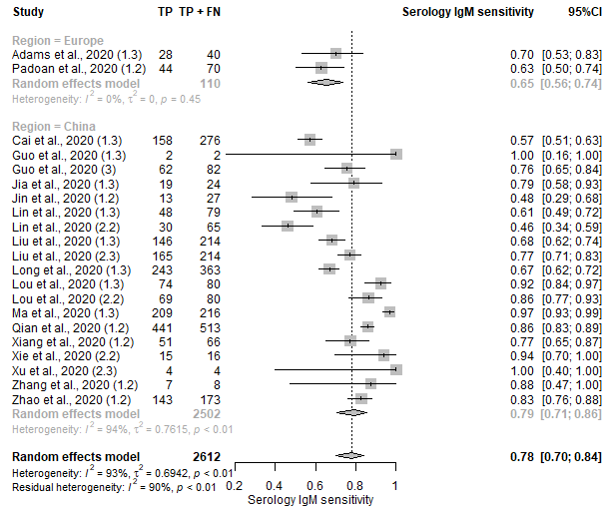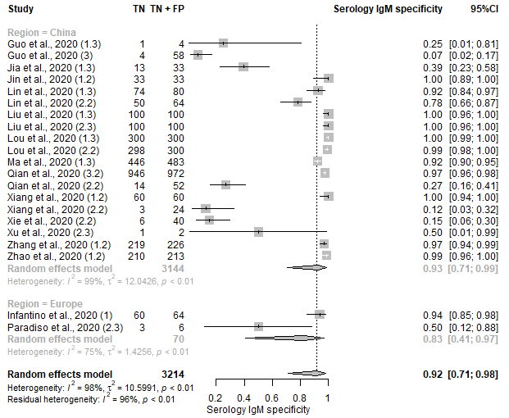
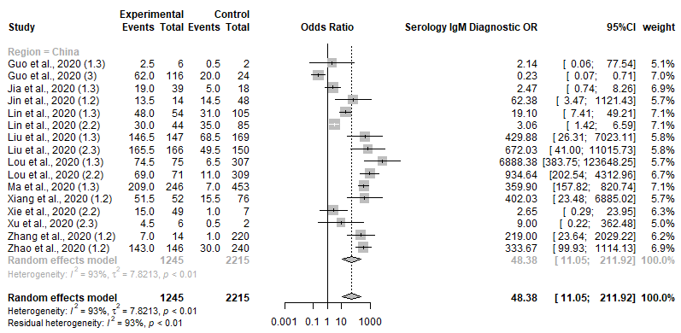

Serology (Ab)
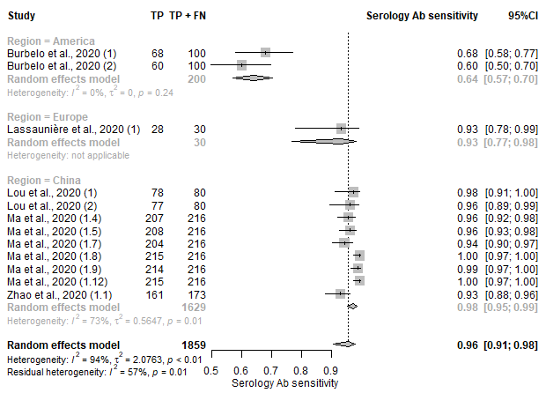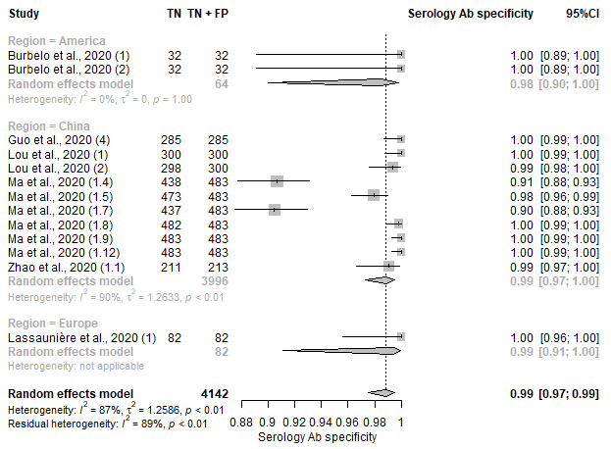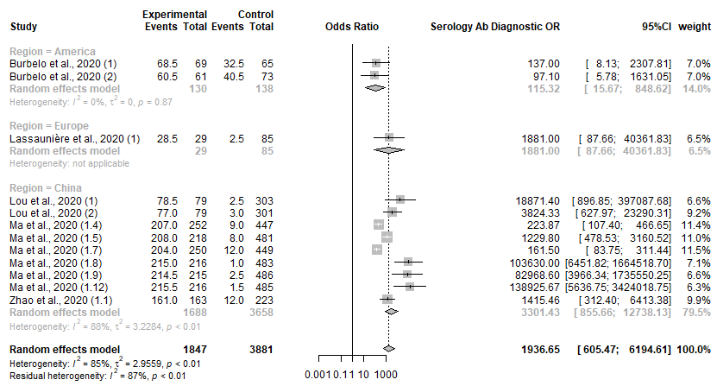

Serology (IgA)
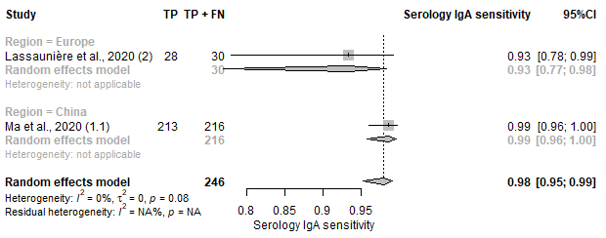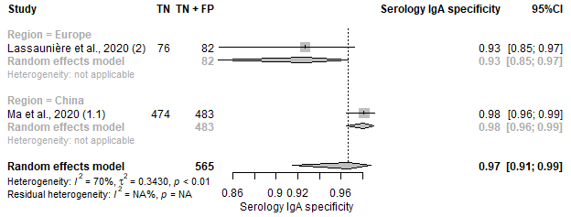
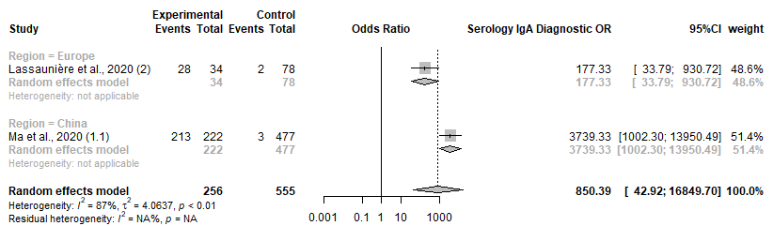

Serology-POC (IgG and/or IgM)
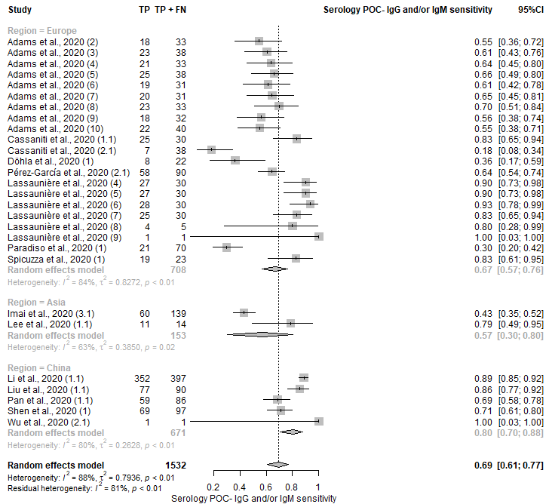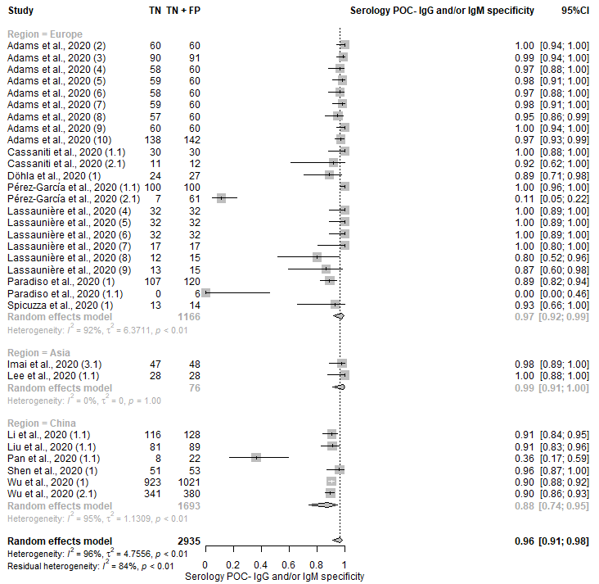
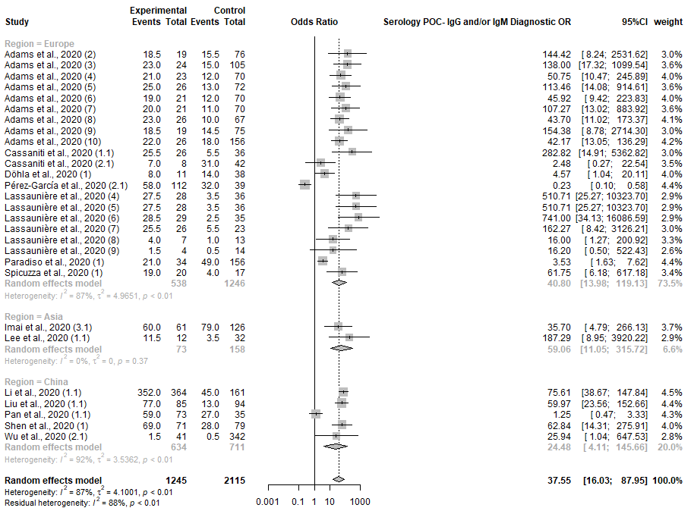

Serology – POC (IgG and IgM)

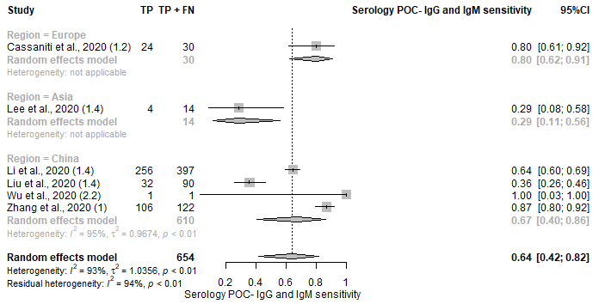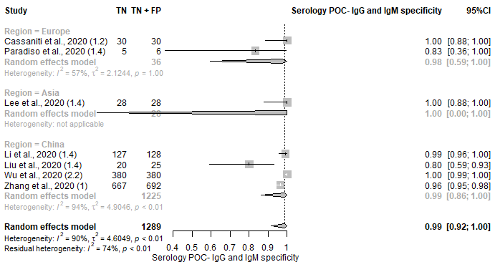
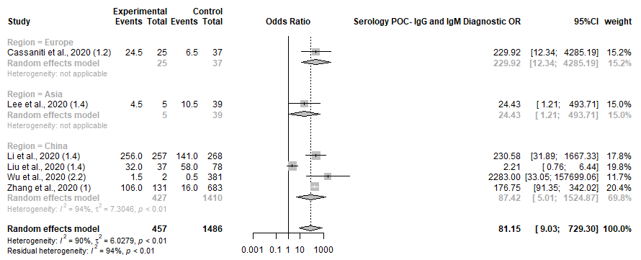

Serology – POC (IgG)
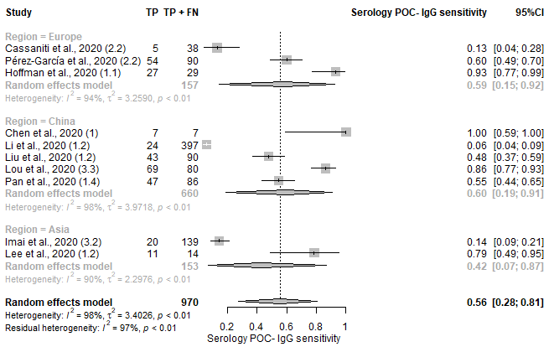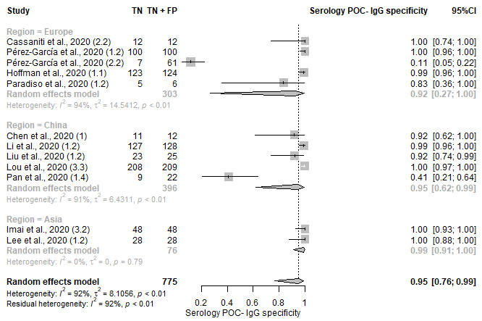
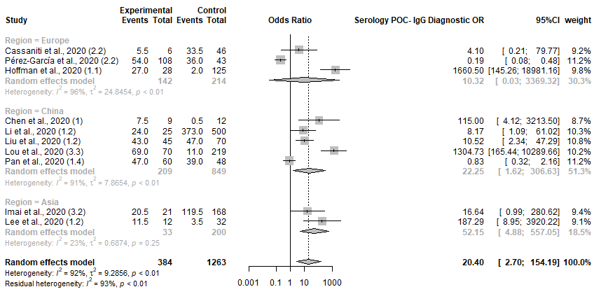

Serology – POC (IgM)
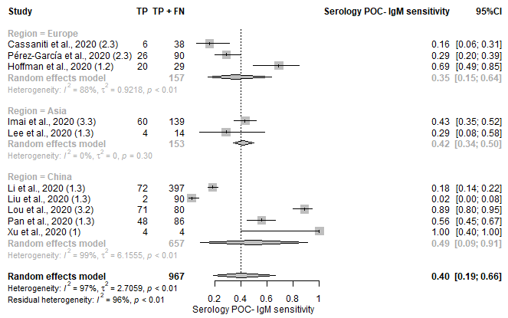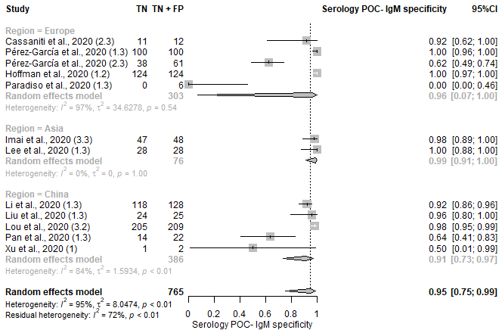
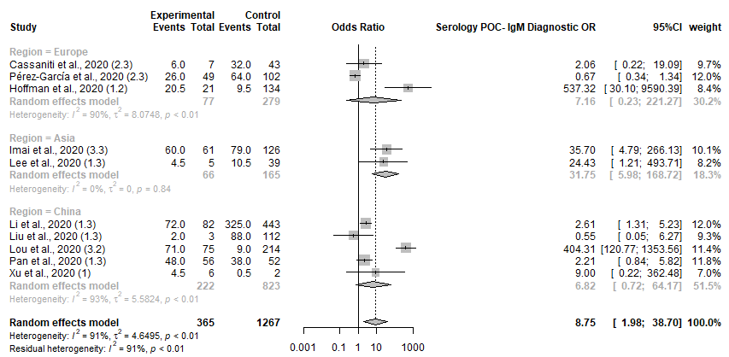

Imaging
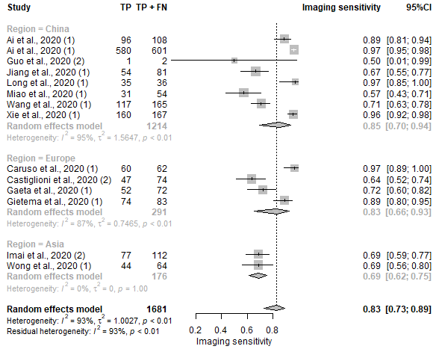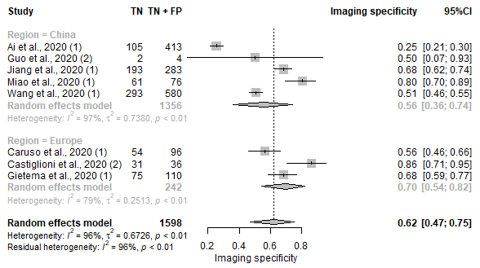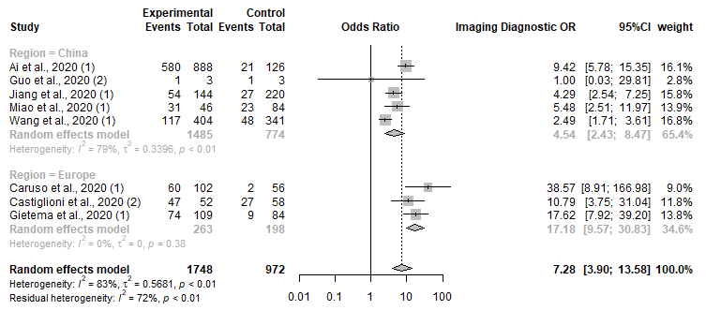

Imaging (AI)
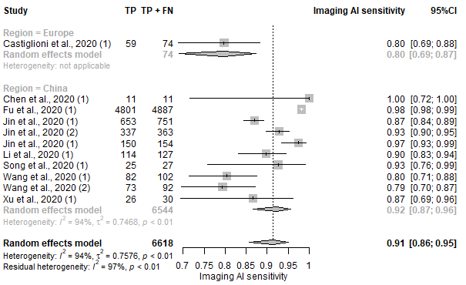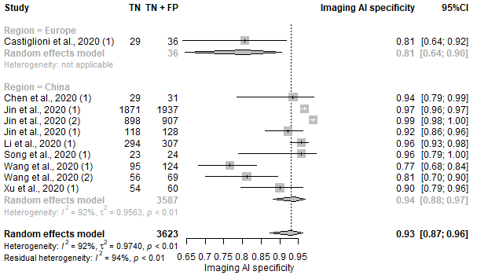
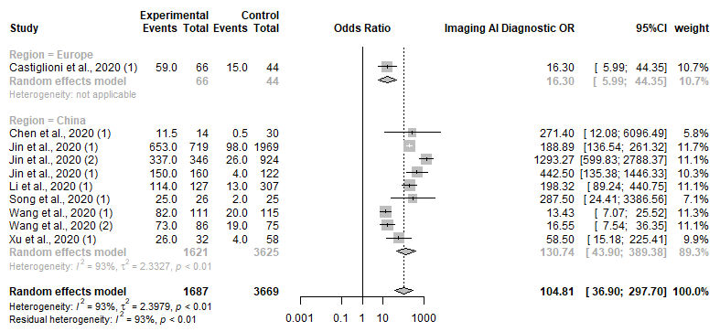

Clinical Features and/or Laboratory Parameters
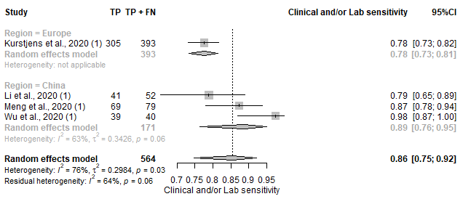
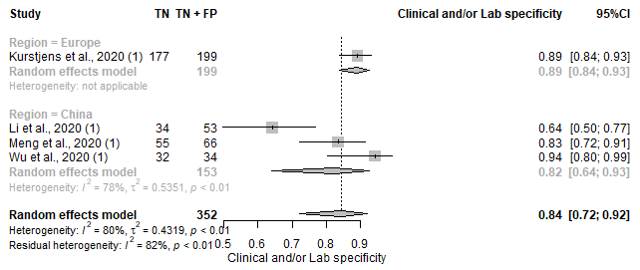
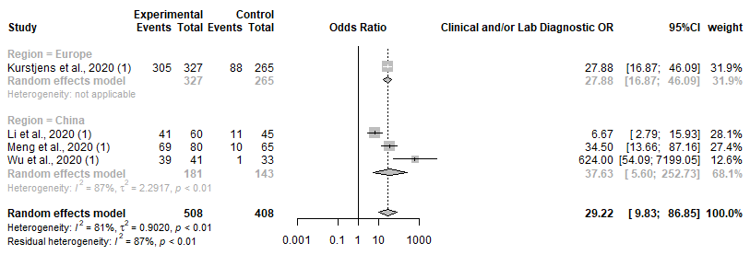

Molecular + Imaging
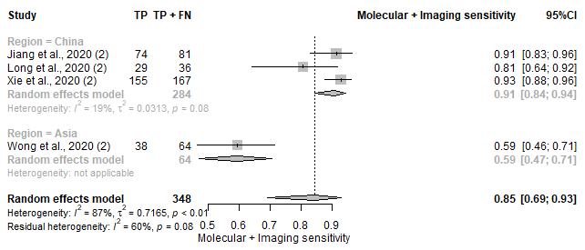
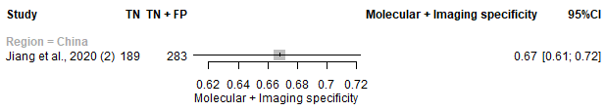
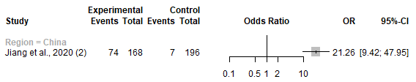

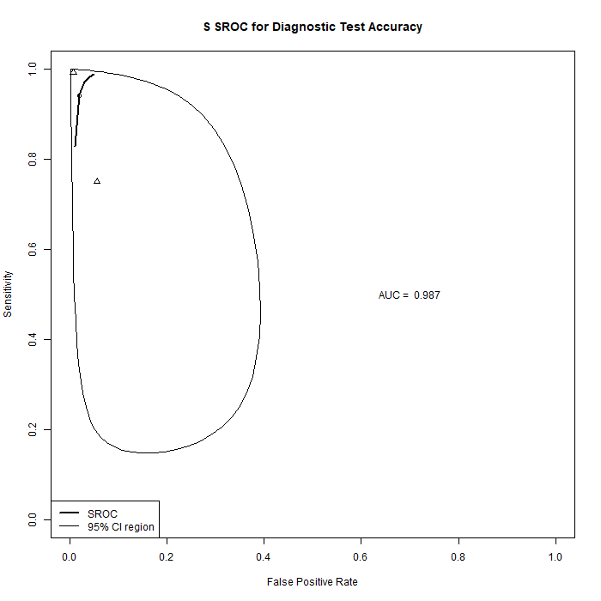
Figure S6: Gene Target Forest Plot on Sensitivity and Specificity, SROC and Diagnostic OR for 1. S gene, 2. RdRp gene, 3. ORG1 gene, 4. N gene and 5. E gene.

S gene
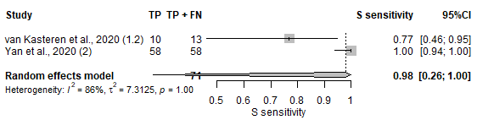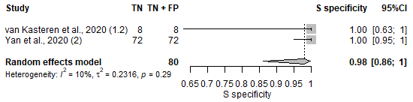
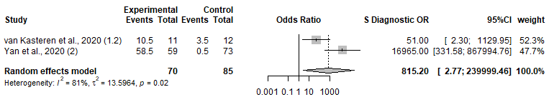

RdRp gene
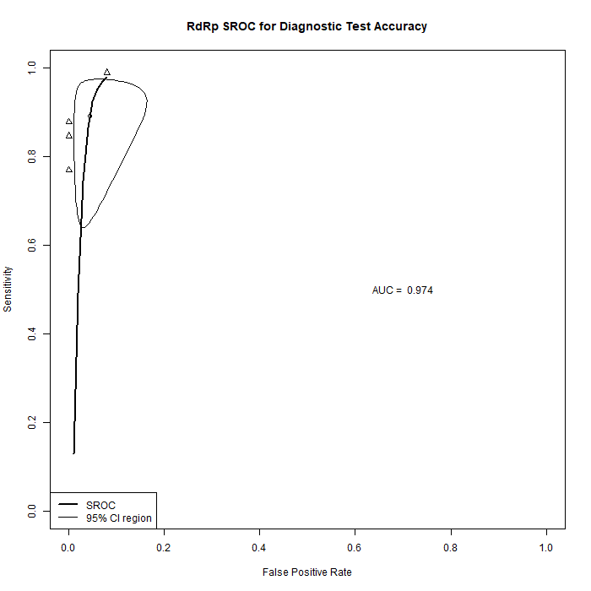
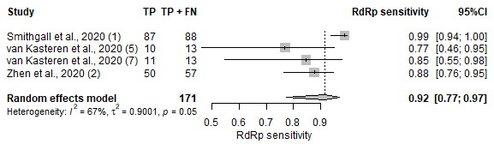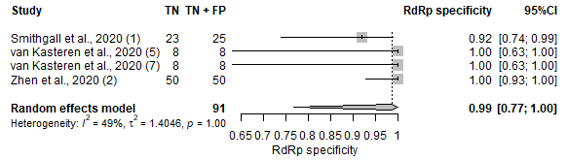
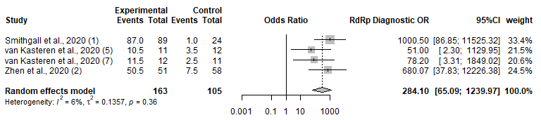

ORF1 gene
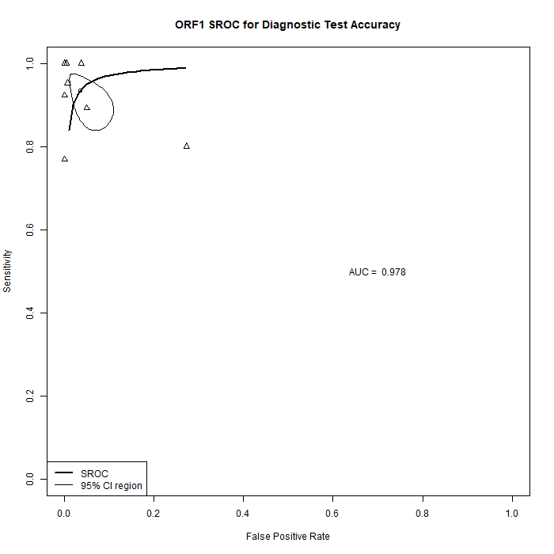
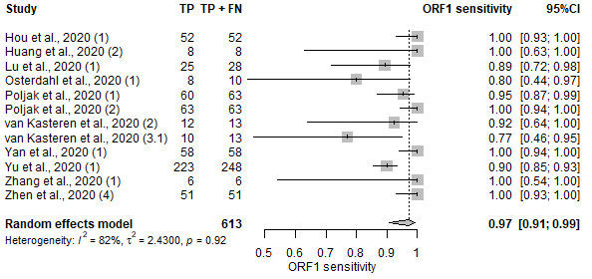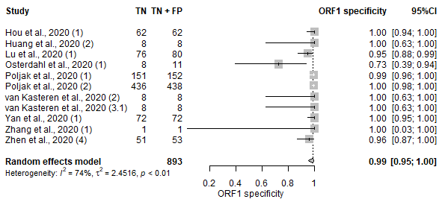
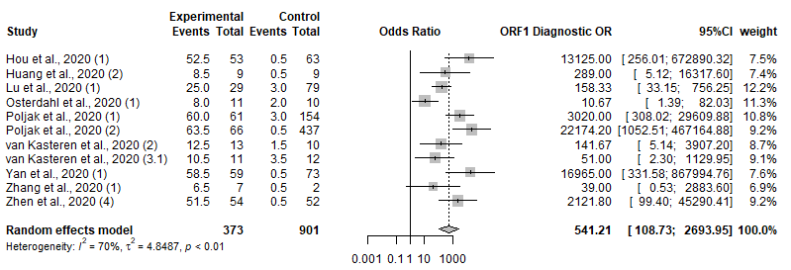

N gene
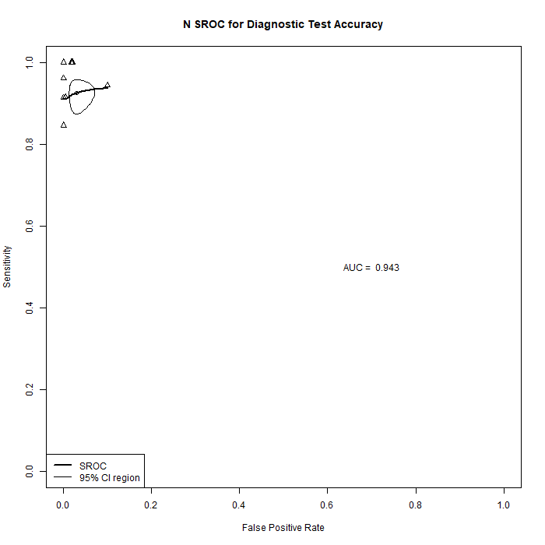
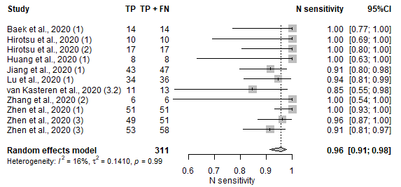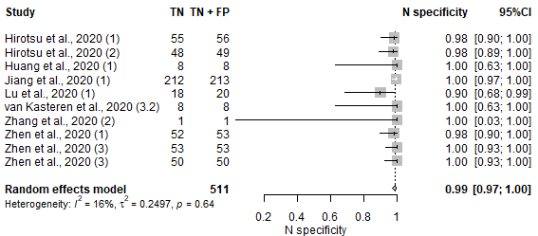
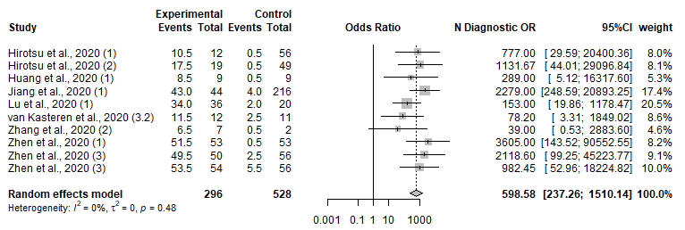

E gene
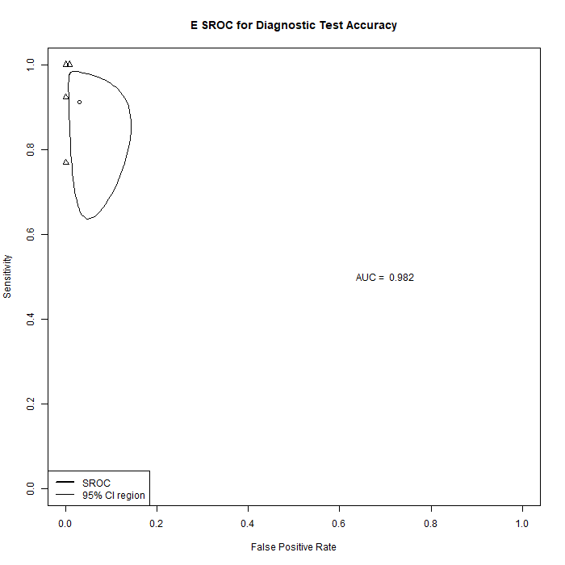
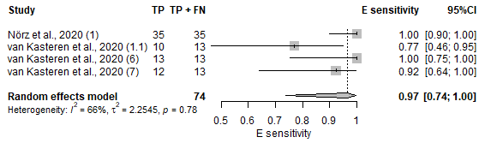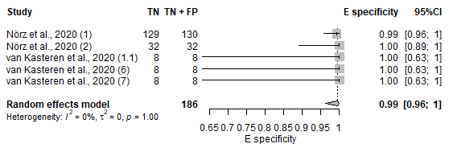
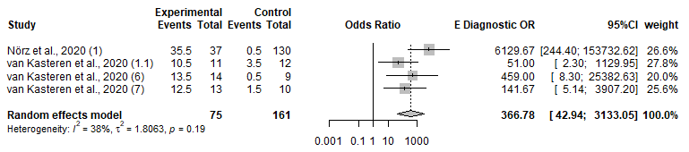

Figure S7: Specimen Site Forest Plot on Sensitivity and Specificity, SROC and Diagnostic OR for 1. Unspecified throat, 2. Nasopharyngeal, 3. Nasal and 4. Sputum

Unspecified Throat
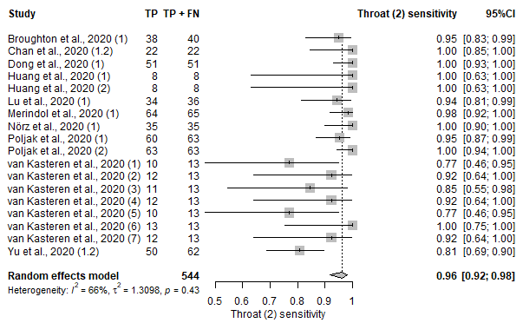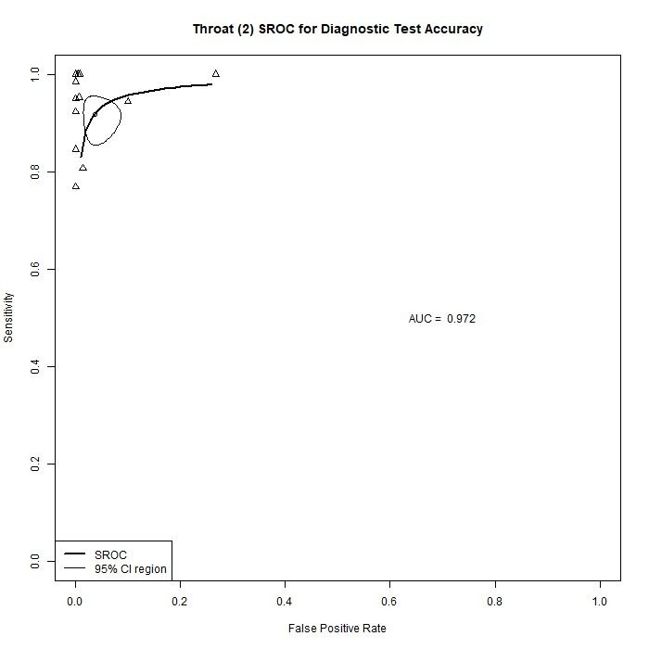
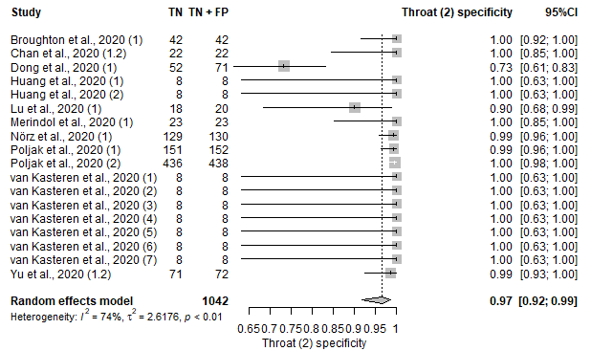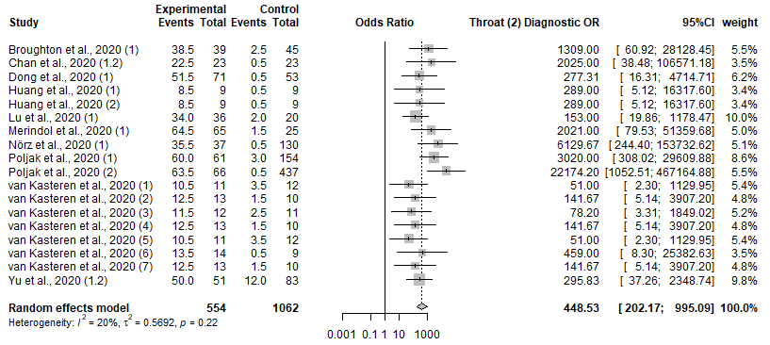

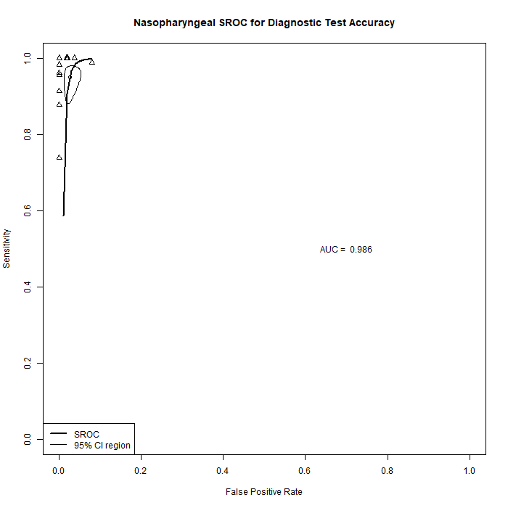
Nasopharyngeal
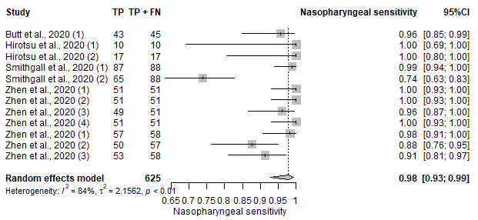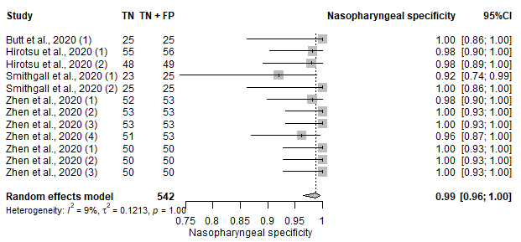
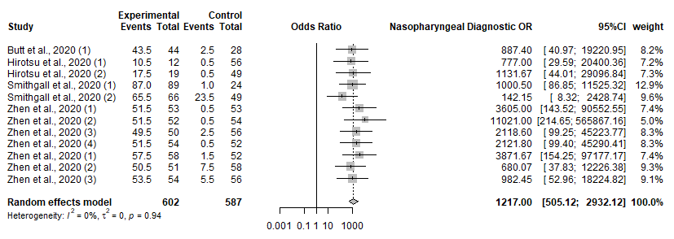

Nasal
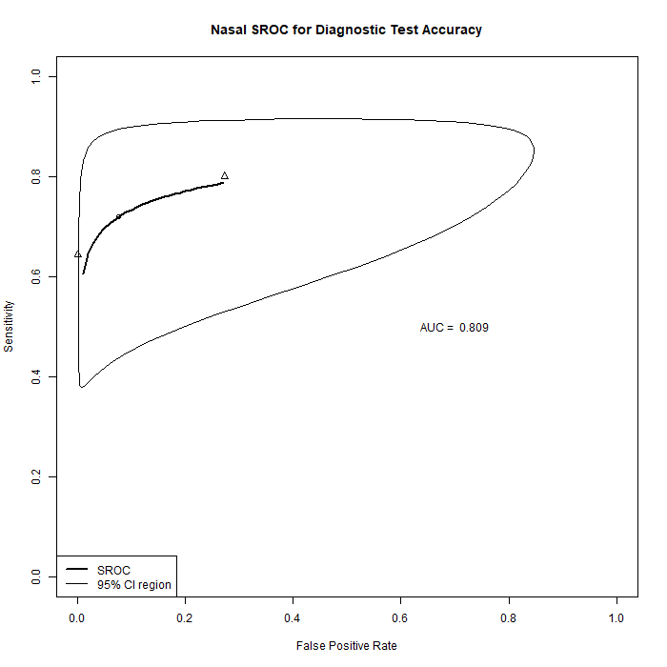
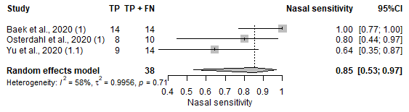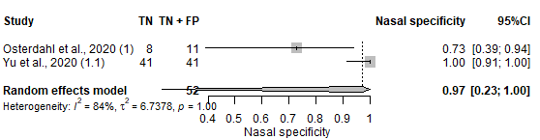
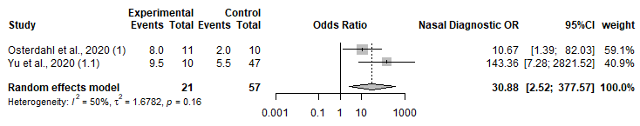

Sputum
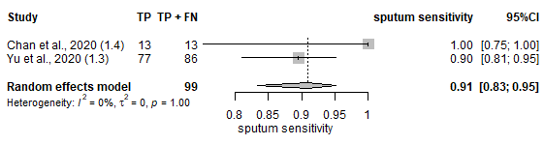

Figure S8: QUADAS Assessment

Figure S9: Publication Bias for a. Serology (POC) IgG and/or IgM b. Serology(POC) IgG and IgM, c. Serology (POC) IgG, d. Serology (POC) IgM, e. Imaging, f. Imaging (AI), g. Serology IgG and/or IgM, h. Serology IgG and IgM, i. Serology IgG, j. Serology IgM, k. Serology Ab, l. NAAT, m. NAAT (POC), n. Clinical Features and/or Laboratory Parameter Model
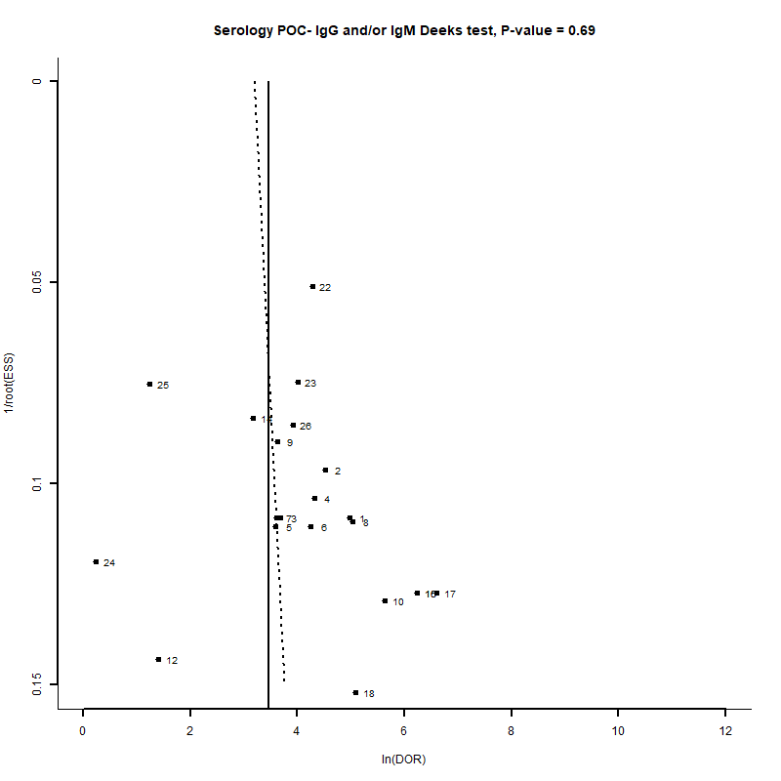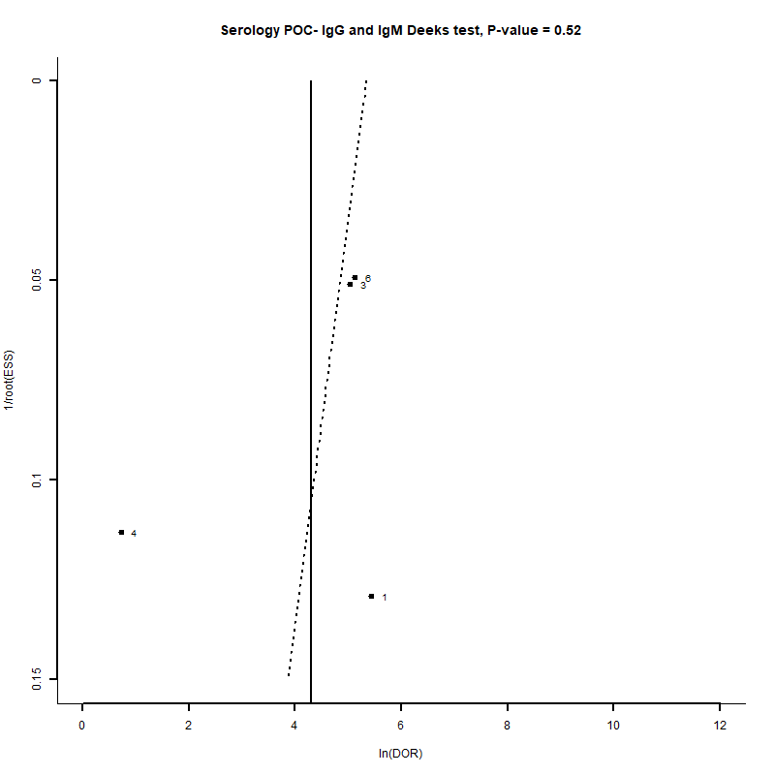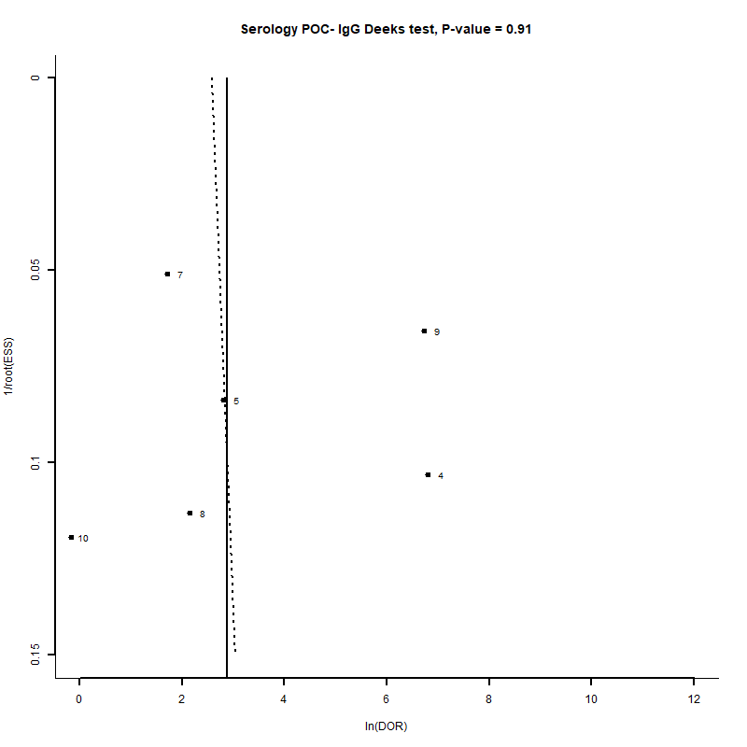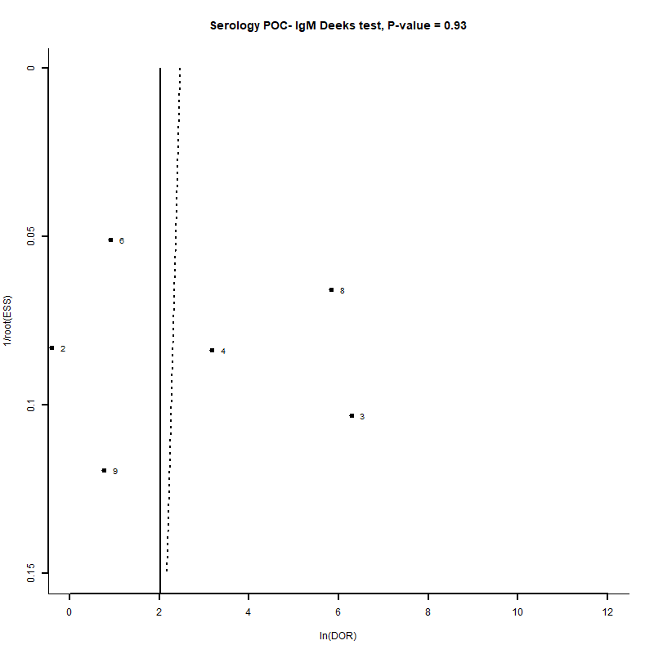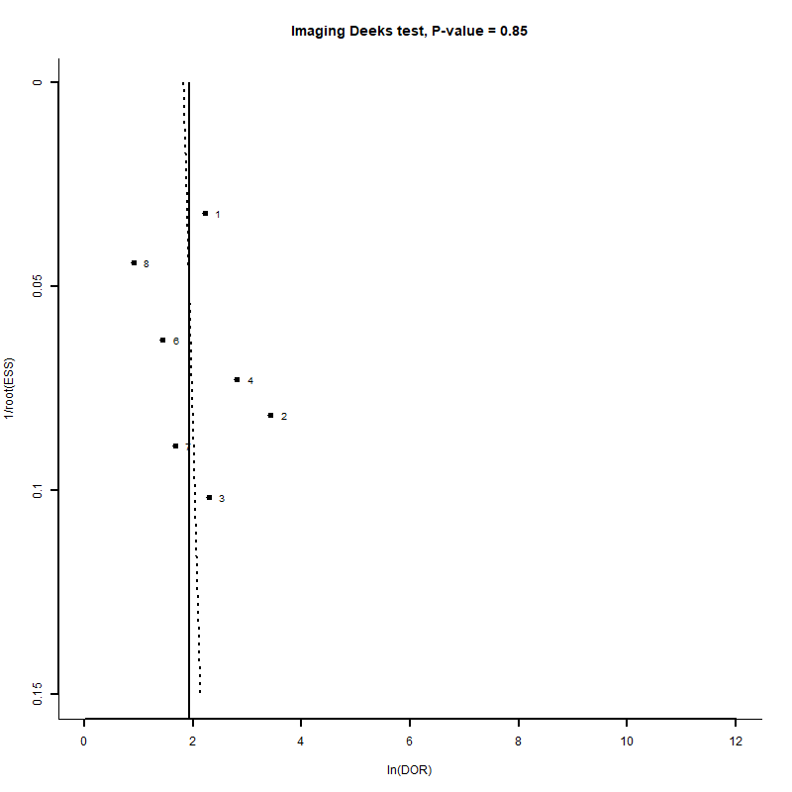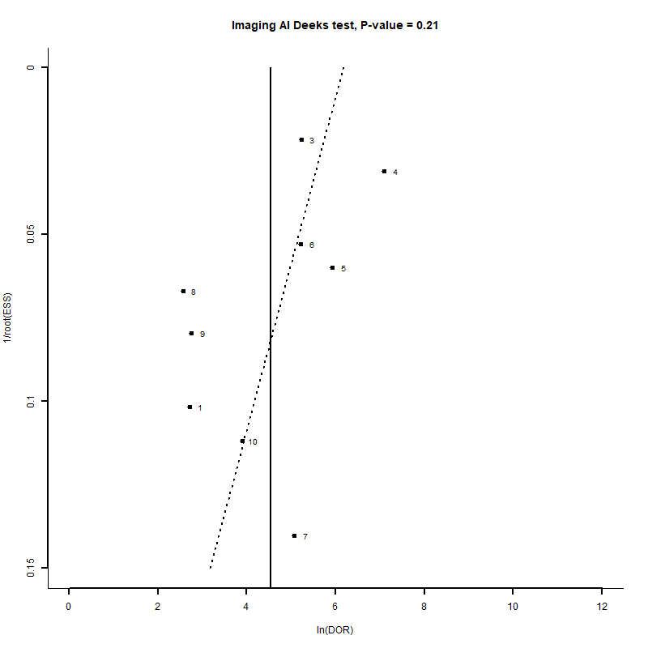
a
b
c
d
e
f

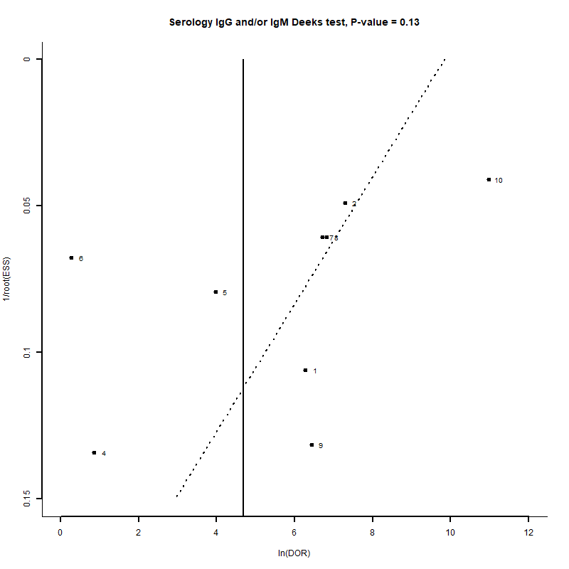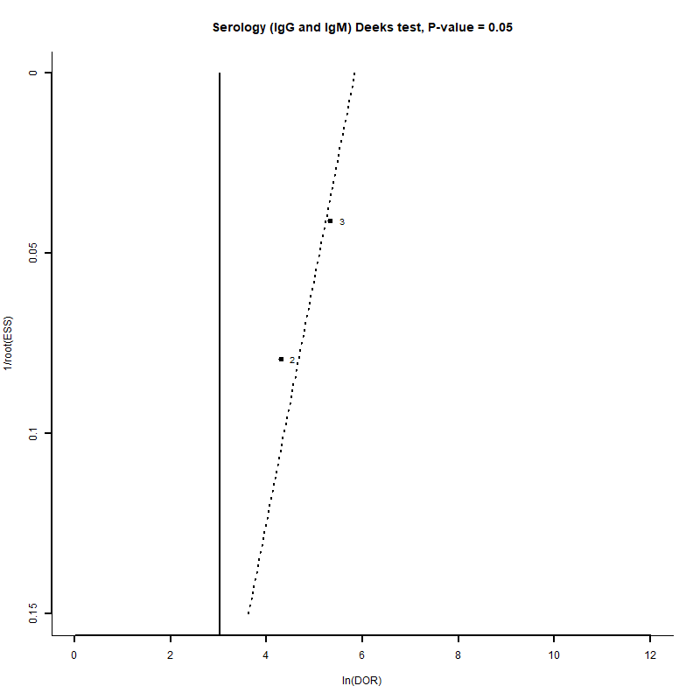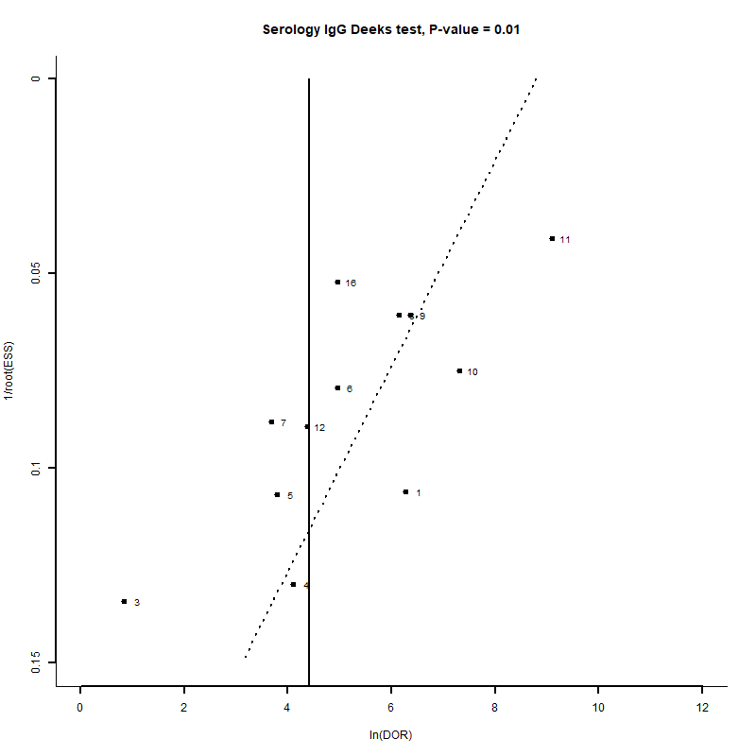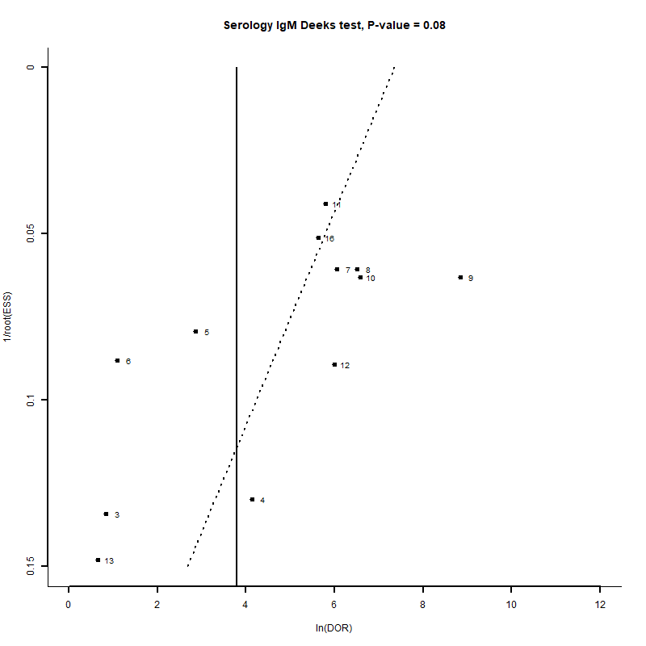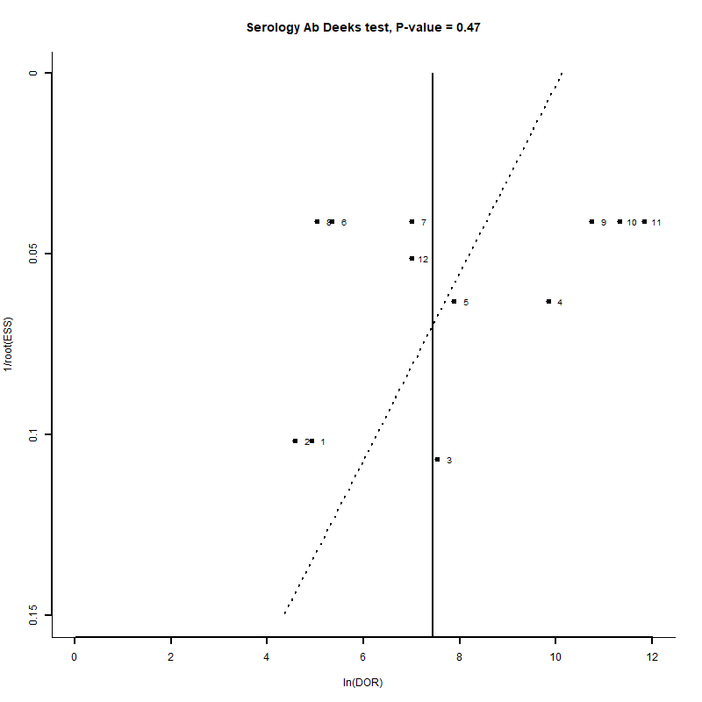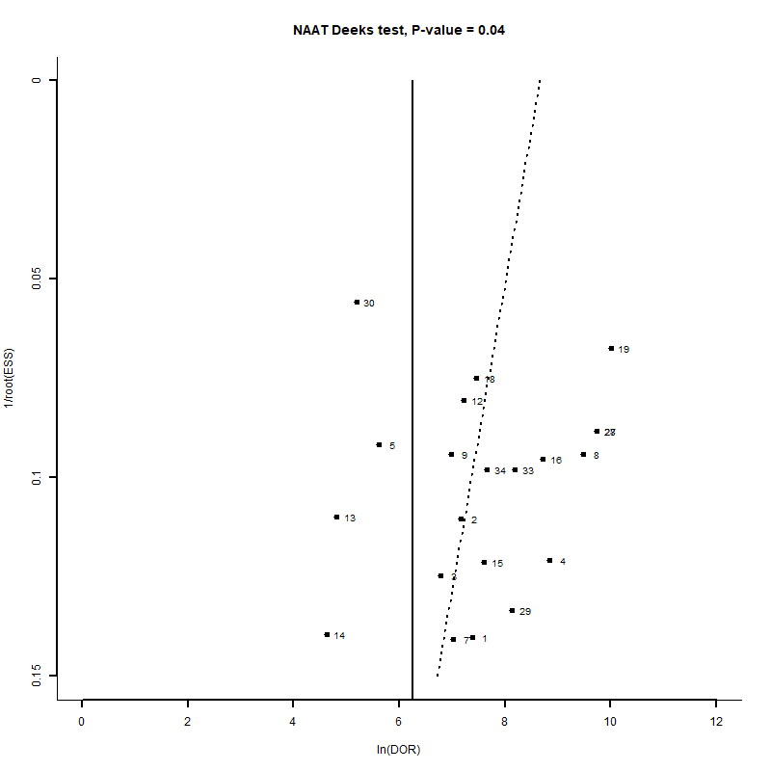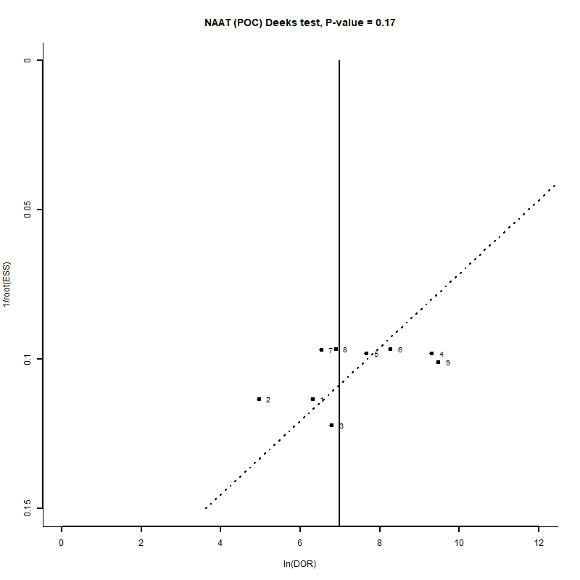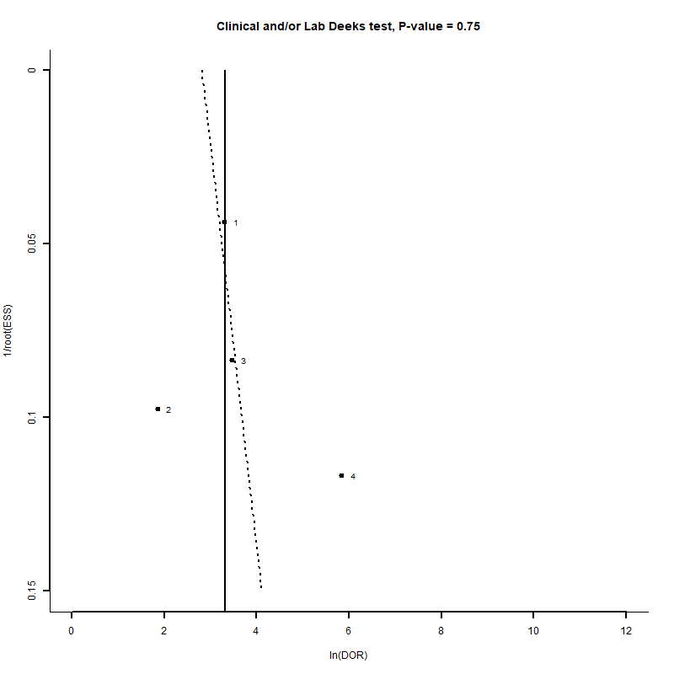
g
h
i
j
k
l
m
n

Tables

Table S1: Eligibility Criteria based on PICOS tool
Keywords | “covid-19”, “2019-ncov”, “novel coronavirus”, “wuhan virus”, “SAR-CoV-2”, “diagnos*”, “polymerase chain reaction”, “serology”, “point of care”, “PCR”, “molecular”, “Nucleic-acid amplification tests”, “CT” “valid”, “sensitivity”, “specificity”, “evaluate”
Eligibility Criteria
Participants | Cases are laboratory-confirmed COVID-19 patients. No restriction on control definitions, which may or may not be tested for COVID-19. Controls includes 1) laboratory-confirmed negative COVID-19 negative patients, 2) pre-pandemic controls without clinical suspicion of COVID-19, 3) controls with other confirmed infections or 4) healthy controls.  Includes:  i) Adults, Children, Elderly  ii) Any countries and races  iii) Asymptomatic, mild and severe (ICU, death, ECMO, HDU) cases.
Exposure/Intervention | Diagnostic Tests including Point-of-Care to identify SARS-CoV-2 infection at any point of the infection and any sites of sampling
Comparator | SARS-CoV-2 samples/patients confirmed by molecular test (e.g RT-PCR) or sequencing
Outcome | Clinical Sensitivity and Specificity  Other outcome if available: Negative Predictive Value, Positive Predictive Value, Agreement, Accuracy
Language | English
Time- frame | All publications from 1st January 2020 until 30th April, 2020

Table S2: Database Search Terms
Database | Search Terms
Pubmed | (((covid-19) OR (2019-ncov)) OR (novel coronavirus)) OR (wuhan virus) OR (SAR-CoV-2)) AND ((diagnos*) OR (polymerase chain reaction) OR (serology) OR (point of care) OR (polymerase chain reaction[MeSH Terms]) OR (serology [MeSH Terms]) OR (PCR) OR (molecular) OR (Nucleic-acid amplification tests) OR (Computed tomography[MeSH Terms]) OR (CT)) AND ((validation study[MeSH Terms]) OR (VALID) OR (SENSITIVITY) OR (SPECIFICITY) OR (evaluate))) Filters: from 2020 - 2020 Sort by: Most Recent
Embased | ('covid 19'/exp OR 'covid 19' OR '2019 ncov' OR (novel AND ('coronavirus'/exp OR coronavirus)) OR (wuhan AND ('virus'/exp OR virus)) OR 'sar cov 2') AND (diagnos* OR (('polymerase'/exp OR polymerase) AND chain AND ('reaction'/exp OR reaction)) OR 'serology'/exp OR serology OR (point AND of AND ('care'/exp OR care)) OR 'pcr'/exp OR pcr OR molecular OR (('nucleic acid'/exp OR 'nucleic acid') AND ('amplification'/exp OR amplification) AND tests) OR (computed AND tomography)) AND (valid OR 'sensitivity'/exp OR sensitivity OR 'specificity'/exp OR specificity OR evaluate) AND 2020:py
Scopus | ( ( covid-19 ) OR ( 2019-ncov ) OR ( novel AND coronavirus ) OR "wuhan virus" OR ( sar-cov-2 ) ) AND ( ( diagnos* ) OR ( polymerase AND chain AND reaction ) OR ( serology ) OR ( point AND of AND care ) OR ( pcr ) OR ( molecular ) OR ( nucleic-acid AND amplification AND tests ) OR ( computed AND tomography ) OR ct ) AND ( ( valid ) OR ( sensitivity ) OR ( specificity ) OR ( evaluate ) ) AND ( LIMIT-TO ( PUBYEAR , 2020 ) )
Cochrane | #1 | Covid-19
Cochrane | #2 | 2019 ncov
Cochrane | #3 | Novel coronavirus
Cochrane | #4 | Wuhan virus
Cochrane | #5 | SAR-CoV-2
Cochrane | #6 | #1 OR #2 OR #3 OR #4 OR #5
Cochrane | #7 | Diagnos*
Cochrane | #8 | MeSH descriptor:[Diagnosis] explode all trees
Cochrane | #9 | Point of care
Cochrane | #10 | MeSH descriptor:[Point-of-Care Testing] explode all trees
Cochrane | #11 | Polymerase chain reaction
Cochrane | #12 | MeSH descriptor:[Polymerase Chain Reaction] explode all trees
Cochrane | #13 | Serology
Cochrane | #14 | MeSH descriptor:[Serology] explode all trees
Cochrane | #15 | PCR
Cochrane | #16 | Molecular
Cochrane | #17 | Nucleic-acid amplification test
Cochrane | #18 | Computed tomography
Cochrane | #19 | MeSH descriptor:[Diagnostic Tests, Routine] explode all trees
Cochrane | #20 | #7 OR #8 OR #9 OR #10 OR #11 OR #12 OR #13 OR #14 OR #15 OR #16 OR #17 OR #18 #19
Cochrane | #21 | Valid
Cochrane | #22 | MeSH descriptor:[Validation Study] explode all trees
Cochrane | #23 | Sensitivity
Cochrane | #24 | Specificity
Cochrane | #25 | Evaluate
Cochrane | #26 | MeSH descriptor:[Sensitivity and Specificity] explode all trees
Cochrane | #27 | #21 OR #22 OR #23 OR #24 OR #25 OR #26
Cochrane | #28 | #6 AND #20 AND #27
Medrvix and Biorvix | "serology "polymerase chain reaction" "Computed tomography" sensitivity specificity PCR CT" (match any words) and full text or abstract or title "covid-19 2019-ncov SARS-CoV-2 diagnos*" (match whole any) and posted between "01 Jan, 2020 and 30 Apr, 2020"

Table S3a: Summary of Patients’ Characteristic

First Author [Reference] | Country of Study | Adult/Child; Age; | Male (%) | Severity | COVID-19  Reference Test
 |  |  |  | Cases | Cases | Controls
Adams et al. (89) | United Kingdom | Adult;  NR | NR | 9 critical, 4 severe, 26 mild cases  Asymptomatic: 1 (2.5) | RT-PCR | Pre-pandemic:  healthy blood donors (n=60)  organ donors (n=50)  healthy volunteer (n=32)
Ai et al. (90) | China | Cases:  Adult: 106, Children: 2  Mean (SD) 50.3(17.43)  Range: 1yr 6mth - 90yrs | Case: 53 (49.1) | NR | RT-PCR | NA (no control)
Ai et al. (91) | China | Total:  Adult, Children  Mean (SD): 51(15) Range: 2-95 | Total: 467 (46)  Case: 284 (47.3)  Non case: 183 (44.3) | NR | TaqMan One-Step RT-PCR (Shanghai Huirui Biotechnology Co., Ltd or Shanghai BioGerm Medical Biotechnology Co., Ltd,) | Negative PCR
Baek et al. (92) | Korea | NR | NR | NR | qRT-PCR (iTaq Universal Probes One-Step Kit (Bio-Rad, Hercules, CA, USA)) | 85 nasal swab specimens collected during the outbreak, and previously confirmed in the hospital for other respiratory disease-causing viruses.  55 samples confirmed for other respiratory disease-causing viruses and collected prior to the outbreak  Not all controls were tested
Bai et al. (93) # | China, United States | (In all test set)  Adult, <20 years old (unspecified);  Mean (SD)  Case: 46(16) Control: 62 (19) | 653 (In all sets) | Mild, Medium, Severe, Critical | Taqman One-Step RT-PCR (Shanghai BioGerm Medical Biotechnology Co., Ltd & Shanghai Huirui Biotechnology Co., Ltd); US Cases: COVID-19 RT-PCR test | Pneumonia patients reported from January 1, 2017 to December 30, 2019 from the radiology search engine, no mention of RT-PCR confirmation
Brinati et al. (94) # | Italy | Mean (SD) (of the 279 subjects)  61.3 (18.5) | NR | NR | RT-PCR | Negative RT-PCR
Broughton et al. (95) | United State | NR | NR | NR | CDC SARS-CoV-2 qRT-PCR assay | Influenza Patients (n=5), Common human seasonal coronavirus infections (n=7) Negative qRT-PCR for COVID-19 but positive for another viral respiratory virus panel multiplex PCR testing or negative by all testing (n=30)  (All qRT-PCR negative)
Burbelo et al. (96) | United State | NIH controls: ND | NIH controls: ND | Asymptomatic: 0 (0) | CDC SARS-CoV-2 RT-PCR assay | Blood donors from 2018 (n=32)
Burbelo et al. (96) | United State | UCSD cases:  Adult: 3, Child: 0;  Mean: 73  Range: 59-84 | UCSD: 2 (66) | Asymptomatic: 0 (0) | CDC SARS-CoV-2 RT-PCR assay | Blood donors from 2018 (n=32)
Burbelo et al. (96) | United State | UW cases:  Adult: 13, Child: 0;  Mean 66  Range: 43-95 | UW: 10 (77) | Asymptomatic: 0 (0) | CDC SARS-CoV-2 RT-PCR assay | Blood donors from 2018 (n=32)
Burbelo et al. (96) | United State | EH cases:  Adult: 13, Child: 0;  Mean: 59  Range: 19-88 | EH: 3 (30) | Asymptomatic: 0 (0) | CDC SARS-CoV-2 RT-PCR assay | Blood donors from 2018 (n=32)
Burbelo et al. (96) | United State | NIH cases:  Adult: 6, Child: 0  Mean: 45  Range: 22-67 | NIH: 5 (83) | Asymptomatic: 0 (0) | CDC SARS-CoV-2 RT-PCR assay | Blood donors from 2018 (n=32)
Butt et al. (97) |  | NR | NR | NR | rRT-PCR | Negative rRT-PCR
Cai et al. (98) | China | Adult, Child;  Cases  Median (IQR): 48 (37-56)  Range: 0.66-84 | Cases: 151 (54.71) | NR | real time RT-PCR (DAAN Gene Co., Ltd.) | 167 sera from patients with infection with other pathogens
Caruso et al. (99) | Italy | Total  Adult: 158, Child: 0;  Mean (SD): 57 (17)  Range: 18-89 | 83 (52.5) | Asymptomatic: 0 (0) | real time RT-PCR (Charitè, Berlin, Germany) | Negative RT-PCR
Cassaniti et al. (100) | Italy | Intensive Care Unit  Adult: 60, Child: 0;  Median (IQR)  Cases: 73.5 (38-86)  Range: 38-86  Controls: 38.5 (25-69)  Range: 25-69 | 36 (60) | NR | real time RT-PCR | Healthy Volunteer (n=30) including 10 subjects with past coronavirus infection.  Negative Covid-19 RT-PCR
Cassaniti et al. (100) | Italy | Emergency Room  Adult: 50, Child: 0; Median: 61.5 Range: 33-97 | 34 (68) | Asymptomatic: 0 (0) | real time RT-PCR | Negative Covid-19 real time RT-PCR
Castiglioni et al. (101) | Italy | NR | NR | Asymptomatic: 0 (0) | RT-PCR | Negative RT-PCR
Chan et al. (17) | Hong Kong | Total  Adult: 37, Child: 0;  Case  Median: 63  Range: 37-75 | Case: 8 (53.3) | Critical: 3  Asymptomatic: 0 (0) | RT-PCR | 22 archived nasopharyngeal aspirates/ swabs and throat swabs that were positive for other respiratory pathogens
Chen et al. (102) | China | Testing Set  Adult; Median (IQR)  Case: 42 (34.5-65.5)  Control:47 (34.5-54.5) | 26 (61.9)  Case: 7 (63.6)  Control: 19 (61.29) | NR | Fluorescent RT-PCR (Shanghai Geneodx Biotechnology Co., Ltd.) | 31 controls of other disease (unclear if tested)
Chen et al. (103) # | China | Validation cohort only (Total)  Mean (SD): 41.08 (21.07) | Validation cohort only  23 (60.5) | Asymptomatic: NA | RT-PCR and Next Generation Sequencing | Negative RT-PCR
Chen et al. (104) | China | NR | NR | NR | RT-PCR | Negative RT-PCR
Diao et al. (105) # | China | NR | NR | NR | RT-PCR; RT-PCR (CT ≤30); RT-PCR (CT ≤40) | Negative nucleic acid
Döhla et al. (106) | Germany | Median (IQR): 46 (28-72) | 25 (51) | NR | RT-qPCR (Altona Diagnostics) | RT-qPCR-negative
Dong et al. (107) | China | NR | NR | Asymptomatic: At least 9 of 126 patients | RT-qPCR (H&R Shanghai Huirui Biotechnology Co., Ltd, BioGerm from Shanghai BioGerm Medical Biotechnology, Daan from Daan Gene Co., Ltd) | Negative RT-qPCR
Freeman et al. (108) # | United State | NR | NR | Asymptomatic: 0/99 cases | RT-PCR | Healthy adults between 2016-2019 (n=377), suspected hantavirus patients between 2016-2019 (n=101), suspected HIV patients between 2011-2012 (n=21), suspected hepatitis B virus patients between 2011-2012 (n=10), HCV positive patients between 2011-2012 (n=10)
Fu et al. (109) | China | Adult | NR | NR | RT-PCR | 52 cases of non-COVID-19 viral pneumonia, 53 cases of bacterial 254 pneumonia, 54 cases of pulmonary tuberculosis, 100 cases of normal lung  (unclear if tested)
Gaeta et al. (110) | Italy | Adult: 72;  Mean: 68.8  Range: 43-100 | 47 (65.3) | Almost severe (34), severe (29) and critical (9)  Asymptomatic: 0 | RT-PCR | NA (no control)
Perez-Garcia et al. (111) | Spain | Group 1  Median (IQR): 50 (33-65) | 55 (55) | Asymptomatic: 0 | VIASURE SARS-CoV-2 Real Time PCR Detection Kit (Certest Biotech,  Zaragoza, Spain) and Allplex 2019-nCoV assay (Seegene, Seoul, South  Korea) | Patients whose serum sample taken for other serologic studies, from September 1 to November 30, 2019 (before the first cases of COVID-19 were reported) (n=100)
Perez-Garcia et al. (111) | Spain | Group 2  Median (IQR): 64 (55-79) | 52 (57.8) | Mild (17), Non-severe pneumonia (87), Severe pneumonia (40), Critical (7)  Asymptomatic: 0 |  | NA (no control)
Perez-Garcia et al. (111) | Spain | Group 3  Median (IQR): 67 (57-73) | 45 (73.8) |  |  | Negative Covid-19 Real Time PCR
Gietema et al. (112) | Netherland | Adult; Median (IQR): 66 (55-76) | 113 (58.5) | Asymptomatic: 0 | RT-PCR | Negative PCR
Guo et al. (113) | China | Family-clustered: Adult: 4, Children: 2  Mean: 35 | Family-clustered: 3 (50) | Asymptomatic: 0 | Deep sequencing or qPCR | Negative PCR
Guo et al. (113) | China | Confirm/Probable cases: NR | NR | Severe: 28, mild to moderate: 54 Asymptomatic: 0 | Deep sequencing or qPCR | qPCR negative with typical manifestation
Guo et al. (113) | China | Negative control: NR | NR |  | Deep sequencing or qPCR | Adults with acute lower respiratory tract infections in 2018 (n=135), Health individuals undergoing regular health checkup in 2018-2019 (n=150)
Hirotsu et al. (114) | Japan | NR | NR | NR | RT-PCR, NIID recommended single-quencher probes | Negative PCR
Hoffman et al. (115) | Sweden | Adult: at least 80; Children: at least 20 | NR | Asymptomatic: 0 | PCR | Healthy volunteers, without any known history of SARS-CoV-2 infection/COVID-19 (n=24)  Anonymous blood donor sera from healthy adults (n = 80) and serum samples from babies (6–12 months) collected before or during 2018 (n=20)
Hou et al. (116) | China | NR | NR | NR | mNGS | nCoV-/hCoV+ cases (n=17) and healthy subjects (n=36)  (Unclear if tested)  suspected case with negative mNGS (n=9)
Huang et al. (117) | China | NR | NR | NR | RT-qPCR (Shanghai ZJ Bio-Tech, China) | Negative RT-qPCR
Imai et al. (118) | Japan | Adult  Median (IQR)  Case: 67 (45-74)  Range: 20-93 | Cases: 64 (57.1) | Asymptomatic: 38 (33.9%) | RT-qPCR | Serum samples from patients from April to October 2019, before SARS-COV2 was first reported in China
Infantino et al. (119) # | Italy | Mean (SD)  Case:  59 (23)  Control:  Pre-Covid 19: 49 (17)  Blood donor: 44(11) | Cases: 26 (42.6)  Control: 21 (32.8) | mild to moderate: 30  Severe: 31  Asymptomatic: 0 | RT-PCR | Pre‐COVID‐19 (2018‐2019) disease control group of 44 patients who had rheumatic diseases (n = 31) and infectious diseases (n = 13). Twenty blood donors from the COVID 19 era (winter 2019)
Jia et al. (120) | China | NR | NR | Asymptomatic: 0 | NAT (DAAN, Sansure Biotech, BGI, ShangHai ZJ Biotech, Geneodx,Biogerm) | Negative nucleic acid
Jiang et al. (121) | China | Children and Adult | Of 568 subjects: 334 (58.8) | Of 568 subjects:  severe:14  mild: 73  Asymptomatic: NR | rRT-PCR | Negative RT-PCR
Jiang et al. (122) | China | NR | NR | Asymptomatic: 1 | qRT-PCR (Shanghai BioGerm Medical  Biotechnology Co. Ltd., DAAN Gene Co., Ltd) | Negative NMPA RT-PCR
Jin et al. (123) | China | NR | 854 (53.7) | NR | RT-PCR | Test Cohort:  1,229 non-pneumonia subjects (healthy volunteers from Wuhan; PCR negative), 668 CAP [from pre-COVID period], 42 influenza A/B cases [from pre-COVID period]  CC-CCII:  425 non-pneumonia subjects, 482 CAP.
Jin et al. (124) | China | NR | NR | NR | NAT | 21 healthy cases,107 cases with other known lung diseases with CT imaging features similar to COVID-19 to some extent (lobar pneumonia, lobster pneumonia, old lesions, tumor, pneumothorax, nodule, fungal pneumonia, other viral pneumonia)  (unclear if tested)
Jin et al. (125) | China | Adult, Children  Median (IQR):  Case (of 43 cases): 47 (34-59)  Control: 31 (25.5-37.5)  Range: Case: 7-74 | Cases: 39 (51.3%) | Asymptomatic: 0 | real time RT-PCR | Negative molecular test
Kurstjens et al. (48) | Netherlands | Validation Cohort  Mean (SD):  Case: 69 (12)  control: 63 (17)  Median (IQR):  Case: 71 (61-77)  control: 67 (51-76) | Case: (63.8)  Control: (53.3) | Asymptomatic: 0 | RT-PCR | Negative RT-PCR
Lassaunière et al. (126) | Denmark | NR | NR | NR | NAT | Archived anonymous serum samples obtained from healthy blood donors 18-64 years with no history of SARS-CoV-2 infection (n = 10) and no recent travel history, sera from patients with acute viral respiratory tract infections caused by other coronaviruses (n = 5) or non-coronaviruses (n = 45), and sera from patients positive for dengue virus (n = 9), cytomegalovirus (CMV; n = 2) and Epstein Barr virus (EBV; n = 10). One patient was positive for both CMV and EBV
Lee et al. (127) | Taiwan | Adult cases: 14;  Median:  Symptomatic: 52  Asymptomatic: 50  Range: case: 30-88 | Case: 7 (50) | Asymptomatic/mild: 8 | rRT-PCR | Negative rRT-PCR
Li et al. (128) | China | Independent Test  Mean (SD):  Covid: 52 (17)  CAP:51 (20)  Non-pneumonia: 41 (13) | 194 (55)  Case: 30 (52)  Control: 164 (84.5) | NR | RT-PCR | Randomly selected from hospital between Aug 16, 2016 and Feb 17, 2020  Community acquired pneumonia= 155 (exams: n=175)  Non-Pneumonia= 130 (exams: n= 132)
Li et al. (49) | China | Adults;  Mean (Range):  Case: 57 (49-69)  Control: 51 (41-61) | 56 (53.3)  Case: 26 (50)  Control: 30 (56.6) | Asymptomatic: 0 (0%) | rRT-PCR (BioGerm, Shanghai, China) | SARS-CoV-2- negative
Li et al. (129) | China | NR | NR | NR | PCR | Negative PCR
Lin et al. (130) | China | Cases:  Adult: 67, Child: 12  Mean: 42.25  Range: 2-78  Control  Adult: 78, Child: 2 | 66 ((41.5)  Case: 28 (35.4)  Control: 38 (47.5) | NR | GeneoDX kit (TaqMan RT-PCR method, targeting the ORF1ab and N genes) | Healthy Cohort: 29  Tuberculosis: 51  All Negative RT-PCR
Liu et al. (131) | China | Median (IQR)  confirm/control: 55 (38.3-65)  confirmed: 54 (39.0-64.0)  control: 55 (38.0-65.0) | confirm/control: 138 (58)  confirmed: 93 (60.8)  control: 45 (52.3) | Asymptomatic: 0 (0%) | rRT-PCR (Daan, Guangzhou, China) | Negative rRT-PCR
Liu et al. (131) | China | NR | NR | Asymptomatic: 0 (0%) | rRT-PCR (Daan, Guangzhou, China) | Healthy blood donor: 50  ordinary people: 70  Not all controls were tested
Liu et al. (132) | China | NR | NR | Asymptomatic: 0 (0%) | RT-PCR | Healthy Blood Donor  (n=100)
Liu et al. (133) | China | Mean (SD)  case: 76 (15)  control: 56 (21) | 98 (54.7) | Mild/common:46 (51.1%)  Severe/critical:44 (48.9%)  Asymptomatic: 0 (0%) | RT-PCR | Negative PCR
Long et al. (134) | China | Mean (SD)  case: 44.8 (18.2) | case: 20 (55.6) | Asymptomatic: 0 (0%) | rRT-PCR | NA (no control)
Long et al. (135) | China | Confirmed cases  CD | CD | Asymptomatic: 0 (0%) | RT-PCR | NA (no control)
Long et al. (135) | China | Suspected Cases  NR | NR | Asymptomatic: 0 (0) | RT-PCR | Negative viral RNA
Long et al. (135) | China | Close Contact  NR | NR | Asymptomatic: 3/16 (18.8) | RT-PCR | Negative RT-PCR
Lou et al. (136) | China | Median (IQR)  Total cases: 55 (45-64)  Non critical cases: 51 (38-39)  Critical cases: 65 (52-74) | Cases: 49 (61.3) | Asymptomatic: 0 (0) | qRT-PCR, commercial 1-step real-time reverse transcription polymerase chain reaction (RT-PCR) assay (Bio-Germ, Shanghai, China) | Healthy controls (n=300)
Lu et al. (137) | China | NR | NR | Asymptomatic: 0 (0) | RT-PCR (Liferiver Bio-Tech) | Negative RT-PCR
Lu et al. (138) | China | NR | NR | NR | SARS-CoV-2 RT-qPCR kit (Liferiver Bio, Shanghai, China) | Negative RT-qPCR
Ma et al. (139) | China | Cases: Adult  Mean: cases: 47.4  Median: cases: 48  Range: cases: 21-91 | NR | Critical (5), Severe (17)  Moderate (56) Mild (9)  Asymptomatic: 0 (0) | RT-qPCR | 330 archived sera from healthy donors (samples collected before October 2019), 138 interfering sera from no-COVID-19 patients with underlying diseases, and fifteen sera from once suspected cases (negative RT-qPCR but had typical manifestation of pneumonia)
Meng et al. (47) | China | Adult  Median (IQR)  Case: 48 (58-67)  control: 66 (76-84) | Case: (69.4)  Control: (68.79) | NR | RT-PCR, Viral Gene Sequencing | Negative nucleic acid detection
Merindol et al. (140) | Canada | NR | NR | NR | RT-PCR (Altona RealStar® SARS-CoV-2 RT-PCR Kit) | Negative PCR
Miao et al. (141) | China | Adult: 130;  Mean (SD)  Case: 45.1 (13.4)  Control: 41.8 (13.6)  Range:  case: 19-77  control: 19-81 | 77 (59.2) | Asymptomatic: 0 (0) | RT-PCR | Negative RT-PCR
Nörz et al. (142) | Germany | NR | NR | NR | cobas6800-based SARS-CoV-2 UCT assay | Negative cobas6800-based SARS-CoV-2 UCT assay
 |  |  |  |  |  | Clinical samples positive for other respiratory samples (n=32)
Osterdahl et al. (143) | United Kingdom | Adult: 21;  Median (IQR): 76 (61-81)  Range: 52-89 | 4 (30) | NR | Multiplex tandem RT-PCR | Negative PCR
Padoan et al. (144) | Italy | NR | NR | NR | rRT-PCR | NA (no control)
Pan et al. (145) | China | NR | NR | NR | qRT-PCR (BioGerm, Shanghai, China) | Negative rRT-PCR
Paradiso et al. (146) | Italy | Median (of 191): 58.5 | (60.62) | Asymptomatic: 14/160 (8.8) | RT-PCR (Allplex2019-nCoV Assay; Seegene, Seoul, Republic of Korea) | Negative RT-PCR
Paradiso et al. (147) | Italy | NR | NR | Asymptomatic: 0 (0) | RT-PCR (Allplex2019-nCoV Assay; Seegene, Seoul, Republic of Korea) | Negative RT-PCR
Poljak et al. (148) | Slovenia | In-house validation panel: NR | NR | NR | LightMix two-target RT-PCR (E gene and RdRp gene) | Negative RT-PCR
Poljak et al. (148) | Slovenia | Head-to-head prospective comparison: NR | NR | NR | LightMix two-target RT-PCR (E gene and RdRp gene) | Negative RT-PCR
Qian et al. (149) | China | Confirmed cases  Adult, Child  Mean: 53  Range: 1 month-92 years | NR | NR | RT-PCR | NA (no control)
Qian et al. (149) | China | Control  Adult, Child  Mean: 48  Range: 1-90 | NR | NR | RT-PCR | Negative RT-PCR
Qian et al. (149) | China | Suspected Cases (of 54 cases)  Adult  Mean: 49  Range: 26-70 | NR | NR | RT-PCR | Negative RT-PCR
Shen et al. (150) | China | Median (IQR)  Case: 38 (46-56)  Control: 32 (20-42.5) | 89 (59.3) | Ordinary: 76 (78.4)  Severe: 21 (21.6)  Asymptomatic: 0 (0) | real time RT-PCR | Negative RT-PCR
Smithgall et al. (151) | United State | Adult: 111, Child: 2  Mean: Case: 64.9  control: 42.6  Range:  Adult: 23-101  Child: 1-5 days old | 61 (54)  Case: 53 (60.2)  Control: 8 (32.0) | NR | Roche cobas SARS-CoV-2 assay | Negative RT-PCR
Song et al. (152) | China | NR | NR | NR | fluorescent RT-PCR | 86 healthy people included in testing and training set  (unclear if tested)
Spicuzza et al. (153) | Italy | Mean (SD)  case: 57 (17)  suspected: 67 (15)  Control: NR | NR | Asymptomatic: 0 (0) | real time RT-PCR | Suspected/Control: Negative molecular test
van Kasteren et al. (154) | Netherland | NR | NR | NR | in-house E-gene PCR | Confirmed non-coronavirus respiratory viral infections
Mertens et al. (155) # | Belgium and Brussels | NR | NR | Asymptomatic: 0 (0) | qRT-PCR/RT-PCR | Negative PCR
Visseaux et al. (156) | France | NR | NR | NR | WHO RT-PCR | Negative RT-PCR
Wang et al. (157) # | China | NR | NR | NR | RT-qPCR kit (kit 1, Huirui, China) | Negative RT-qPCR
 |  |  |  |  | RT-qPCR | Negative RT-qPCR
 |  |  |  |  | multiplex PCR | Five virus-positive throat samples (influenza A virus, influenza B virus, parainfluenza, respiratory syncytial virus, and rhinovirus) collected from November 2019 to January 2020. All were previously confirmed using a China Food and Drug Administration approved kit (Health Gene Technologies, China) based on multiplex PCR and capillary electrophoresis analysis.
Wang et al. (158) | China | NR | NR | NR | Nucleic acid testing | (Training and validation set)  180 cases of typical viral pneumonia diagnosed previously before the COVID-19 outbreak
Wang et al. (159) | China | Validation Set 1  Mean (SD): 49.15 (18.44) | 131 (58.0) | NR | RT-PCR | 124 Other pneumonia patients before Dec 2019
Wang et al. (159) | China | Validation Set 2  Mean (SD): 58.44 (16.19) | 108 (67.1) | NR | RT-PCR | 69 Other pneumonia patients before Dec 2019
Wong et al. (160) # | Hong Kong | Adult, Children;  Mean (SD): 56 (19)  Range: 16-96 | 26 (41) | Asymptomatic: 9/64 (14.1) | QuantiNova Probe RT-PCR Kit (QIAGEN, Hilden, Germany) | NA (no control)
Wu et al. (46) | China | External Validation  NR | NR | NR | RT-PCR | Diagnosed by at least two professional experts based on comprehensive examination results.
Wu et al. (161) | China | Resuming Group  NR | NR | NR | Nucleic acid test | Negative NAT
Wu et al. (161) | China | Hospitalized Group  NR | NR | NR | Nucleic acid test | Negative NAT
Xiang et al. (162) | China | Case/Control  Median (IQR)  Of all 85 confirmed cases: 51 (32.0-65)  control: 34 (29.0-51.0) | NR | Severe (18/85 cases)  Asymptomatic: 0 (0) | RT-PCR | Negative PCR
Xiang et al. (162) | China | Suspected  Median (IQR): 44 (35.5-60.5) | 12 (50) | Severe (2 cases)  Asymptomatic: 0 (0) | RT-PCR | Negative PCR
Xie et al. (163) | China | Median (IQR)  Of all 56 patients:  56.5 (49.25-64.75)  Of 34 severe patients:  60.0 (50.75-67.0) | 24 (42.9) | Asymptomatic: 0 (0) | RT-PCR | Negative nucleic acid test
Xie et al. (164) | China | NR | NR | mild, common, severe and fatal | rRT-PCR | NA (no control)
Xu et al. (165) | China | Test Set  NR | NR | NR | rRT-PCR | Healthy People & Influenza-A viral pneumonia (IAVP) (n=30 each in testing set)
Xu et al. (166) | China | NR | NR | Asymptomatic: 1/6 | RT-PCR | Negative RT-PCR
Yan et al. (167) | China | NR | NR | NR | rRT-PCR (BGI PathoGenesis Pharmaceutical Technology, Shenzhen, China) | Negative RT-PCR
Yip et al. (168) | Hong Kong | NR | NR | NR | COVID-19-RdRp/Hel assay rRT-PCR (QuantiNova SYBR Green RT-PCR Kit (QIAGEN, Hilden, Germany)) | Negative RT-PCR
Yu et al. (18) | China | Adult, Children;  Of 76 patients:  Median (IQR): 40 (32-63)  Range: 6months -92 yrs | case: 38 (50) | Mild: 59 (77.6%)  Severe: 17 (22.4%)  Asymptomatic: 2/76 (2.6) | RT-PCR kit (Shanghai BioGerm Medical Technology Co Ltd, China). | Negative RT-PCR
Yu et al. (169) | China | NR | NR | NR | RT-qPCR | NA (no control)
Zhang et al. (170) | China | Median  Case:46.5  Range:  Case: 19-57  negative PCR: 1-86 | Case: 4 (50)  Negative PCR: 124 (54.9) | Mild: 3  Severe: 4  Asymptomatic: 2/8 cases (25) | RT-PCR | Negative RT-PCR
Zhang et al. (171) | China | NR | NR | NR | RT-PCR | Negative RT-PCR
Zhang et al. (172) | China | NR | NR | NR | commercial COVID-19 RT-PCR kit (Jienuo Inc, Shanghai, China) | Negative RT-qPCR
Zhao et al. (53) | China | Median (IQR):  Case: 48 (35-61) | Case: 84 (49) | Case: critical (32), non-critical (141)  Asymptomatic: 0 (0) | rRT-PCR | Healthy individuals before the outbreak of SARS-CoV-2
Zhen et al. (173) | New York, United States | NR | NR | Asymptomatic: 0 (0) | Reference Standard not available  result obtained from at least 3 of the 4 molecular assays | Negative result from 3 molecular assays
Zhen et al. (174) | United State | NR | NR | Asymptomatic: 0 (0) | Hologic Panther Fusion® SARS-CoV-2 assay | Negative PCR
Zhong et al. (175) # | China | Adult: case: 47  Mean: Case: 48.2  Range: case: 18-82 | case: 16 (34) | Mild (22), Moderate (14), Severe (6), Critical (5) | nucleic acid test | Healthy Control (n=300)
Zhu et al. (176) | China | Case  Adult: 33, Child: 0  Mean: 52.5  Range: 25-76 | Case: 18 (54.5) | NR | rRT-PCR (Daangene Co. LtD. and BGI Co. LtD.) | Other pathogen patient (Negative rRT-PCR)
NR: Not reported. # Study is not included in analysis. *Patients characteristics mentioned may not include all recruited patients in the study

Table S3b: Summary of diagnostic tests
Author | No. of Cases/Controls  (Patients, P; Samples, S) | Novel Test |  |  |  |  |  | Outcome
Author | No. of Cases/Controls  (Patients, P; Samples, S) | Type of test (LFIA, CLIA etc) | Name of test; Manufacturer | Target Gene/ Protein ;  Antibody |  | Sample collection; Days from onset |  | Cut-off | Sensitivity (95% CI); [TP/TP+FP] | Specificity (95% CI); [TN/TN+FN] | PPV | NPV | Accuracy | Agreement
NAAT (Excluding Sequencing)
Baek et al. (92) | S: 14/140 | RT-LAMP | NR | N gene |  | Nasal |  | Successful RT-LAMP reaction  results in a colorimetric reaction – change in the colour of phenol red pH indicator from pink to yellow | 100  (77, 100) | 99  (95, 100) | - | - | - | -
Broughton et al. (95) | S: 40/42 | RT-LAMP + CRISPR (output measured by fluorescence or lateral flow) | DNA Endonuclease-Targeted CRISPR Trans Reporter (DETECTR) (Output uses fluorescence) | E and N gene |  | Naso/Oropharyngeal |  | NR | 95  (83, 99) | 100  (92, 100) | - | - | - | -
Butt et al. (97) | P: 45/25 | RT-LAMP | NR | ORF1A, N gene |  | Nasopharyngeal |  | Positive samples turned  yellow while negative samples remained pink. | 96  (85, 99) | 100  (86, 100) | 100 | 95 | - | -
Chan et al. (17) | S: 77/22 | RT-PCR | COVID-19-RdRp/Hel | RdRp/Hel gene |  | Respiratory (NPA/NPS/TS, Saliva, sputum) and non-respiratory (plasma, urine, faeces/rectal swabs) |  | NR | 100  (95, 100) | 100  (85, 100) | - | - | - | -
Dong et al. (107) | P: 51/71 | RT-dPCR |  | ORF1ab, N, E gene |  | Pharyngeal |  | quantification of any one of the three gene targets is ≥2 copies/ reaction | 100  (93, 100) | 73  (61, 83) | - | - | 93 | -
Hirotsu et al. (114) | S: 10/56 | RT-PCR, double-quencher probes | YCH-N1 assay | N gene (N1) |  | Nasopharyngeal |  | NR | 100  (69, 100) | 98  (90, 100) | - | - | - | -
Hirotsu et al. (114) | S: 17/49 | RT-PCR, double-quencher probes | YCH-N2 assay | N gene (N2) |  |  |  | NR | 100  (93, 100) | 98  (89, 100)
Hou et al. (116) | S: 52/62 | RT-LAMP (CRISPR) | CRISPR n-CoV | Orf1 a/b gene |  | Nasopharyngeal/ Bronchoalveolar |  | Median FC (fold-change) 22.8 Range 5-66.3 | 100  (93, 100) | 100  (94, 100) | - | - | - | -
Hou et al. (116) | S: 52/62 | PCR | NR | NR |  |  |  | Median Ct 35.8 Range 28.8-40.4 | 90  (71, 97) | 100  (94, 100)
Huang et al. (117) | S: 8/8 | RT-LAMP | NR | Orf1ab (O117 primers) |  | Throat |  | Positive samples turned  yellow while negative samples remained pink. | 100  (63, 100) | 100  (63, 100) | - | - | - | -
 |  |  |  | N gene (N15 primers) |  |  |  |  | 100  (63, 100) | 100  (63, 100)
Jiang et al. (122) | S: 47/213 | RT-LAMP | NR | N gene |  | sputum, nasopharyngeal swabs and tears |  | NR | 91  (80, 98) | 100  (97, 100) | 97.7 | 98.1 | 98.08 | -
Lu et al. (137) | S: 28/80 | dPCR | Digital PCR (dPCR) instrument, DropX-2000 RainSure Novel Coronavirus (SARS-CoV-2) Nucleic Acid Detection Kit. | ORF1ab gene |  | Pharyngeal, Stool, Serum, Sputum |  | NR | 89  (72, 98) | 95  (88, 99) | - | - | 96.3 | -
Lu et al. (138) | S: 36/20 | RT-LAMP | NR | N gene |  | Throat |  | NR | 94  (81, 99) | 90  (68, 99) | - | - | - | 92.9
Merindol et al. (140) | S: 65/23 | PCR | SeeGene AllplexTM 2019-nCoV RT-QPCR Assay | E/N/RdRP genes |  | nasopharyngeal and oropharyngeal |  | Positive: positive signal (gene E or S in Altona, genes E, N or RdRP in SeeGene) detected at any Cts. Negative: if the internal control was amplified but not the viral genes (N, E and RdRP) | 98  (92, 100) | 100  (85, 100) | - | - | - | -
Noerz et al. (142) | S:35/130 | Adaptation of E-gene-LDT assay for NeuModx 96 system (Fully automated system) | NR | E gene |  | Oropharyngeal/Nasopharyngeal |  | Median ct: 25.15 (IQR: 20.87-27.04) | 100  (90, 100) | 99  (96, 100) | - | - | - | 100
Noerz et al. (142) | S:0/32 |  |  |  |  |  |  |  | NA | 100  (89, 100) | - | - | - | 100
Osterdahl et al. (143) | P: 10/11 | RT-LAMP | MicrosensDx RapiPrep® SARS-CoV-2 research use test. | ORF1a gene |  | Pharyngeal/Deep Nasal |  | NR | 80  (44,97) | 73  (39, 94) | 73  (39-94) | 80  (44-98) | - | -
Poljak et al. (148) | S:63/152  ( In-house validation panel) | Fully automated high throughput PCR | cobas 6800 SARS-CoV-2 (Roche Molecular Systems, Branchburg, NJ, USA) | ORF1ab & E gene |  | Nasopharyngeal/Oropharyngeal |  | SARS-CoV-2 positive if cobas showed positive results either  for both ORF1 (target 1) and E (target 2) genes or for the ORF1 gene only. | 95  (87, 99) | 99  (96, 100) | - | - | - | 98.1 (95.0-99.4)
Poljak et al. (148) | S: 63/438  ( Head-to-head prospective comparison) |  |  |  |  |  |  |  | 100  (94, 100) | 100  (98, 100) | - | - | - | 99.6 (98.4-99.9)
van Kasteren et al. (154) | S: 13/8 | RT-PCR | Altona Diagnostics | E, S genes |  | naso- and/or oropharyngeal |  | Ct range: 18.2-33.85 | 77  (46, 95) | 100  (63, 100) | - | - | - | -
van Kasteren et al. (154) | S: 13/8 | RT-PCR | BGI | ORF1ab gene |  |  |  | Ct range: 18.56-35 | 92  (64, 100) | 100  (63, 100)
van Kasteren et al. (154) | S: 13/8 | RT-PCR | CerTest Biotec | ORF1ab,N genes |  |  |  | Ct range: 19.81-36.62 | 85  (55, 98) | 100  (63, 100)
van Kasteren et al. (154) | S: 13/8 | RT-PCR | KH Medical | S, RdRp genes |  |  |  | Ct range: 21.25-40 | 92  (64, 100) | 100  (63, 100)
van Kasteren et al. (154) | S: 13/8 | RT-PCR | PrimerDesign | RdRp gene |  |  |  | Ct range: 20.26-37.64 | 77  (46, 95) | 100  (63, 100)
van Kasteren et al. (154) | S: 13/8 | RT-PCR | R-BioPharm | E gene |  |  |  | Ct range: 19.91-40 | 100  (75, 100) | 100  (63, 100)
van Kasteren et al. (154) | S: 13/8 | RT-PCR | Seegene | RdRp,E genes |  |  |  | Ct range: 18.23-37.92 | 92  (64, 100) | 100  (63, 100)
Yan et al. (167) | S: 58/72 | RT-LAMP | Loopamp RNA amplification kit  (Eiken Chemical Co., Ltd., Tokyo, Japan) | orf1ab |  | swabs and bronchoalveolar lavage fluid |  | Colour change  from orange to green for positive  reaction. | 100  (94, 100) | 100  (95, 100) | - | - | - | -
 |  |  |  | S genes |  |  |  | Colour change  from orange to green for positive  reaction. | 100  (94, 100) | 100  (95, 100)
Yip et al. (168) | S: 23/36 | rRT-PCR nsp2 assay | COVID-19-nsp2 assay | nsp 2 protein (nonstructural protein) |  | (26 respiratory specimens including nasopharyngeal aspirate/swab, throat swab, endotracheal aspirate, sputum and saliva  33 non-respiratory specimens including plasma, urine, rectal swab/stool |  | Cp value (Crossing Point): 18.69 to 36.21 | 100  (85, 100) | 100  (90, 100) | - | - | - | -
Yu et al. (18) | S: 162/161 | Droplet digital PCR | COVID-19 digital PCR detection kit & TargetingOne Digital PCR System  (TargetingOne, Beijing, China) | ORF1AB gene, N gene |  | Nasal swabs, throat swabs, sputum, blood, and urine |  | NR | 84  (77, 89) | 98  (94, 99) | - | - | - | -
Yu et al. (169) | S: 248/0 | RT-LAMP | iLACO | ORF1ab gene |  | NR |  | By exposure to blue  light, green fluorescence for  positive reaction whereas it remained pink in negative control | 90  (85, 93) | NA | - | - | - | -
Zhang et al. (172) | S: 6/1 | RT-LAMP | NR | ORF1A, gene |  | respiratory specimens |  | Color change indicate positive sample while remain pink indicate negative sample | 100  (54, 100) | 100  (0, 100) | - | - | - | 100
 |  |  |  | N gene |  |  |  |  | 100  (54, 100) | 100  (0, 100) | - | - | - | -
Zhen et al. (173) | S: 51/53 | rRT-PCR | New York SARS-CoV-2 Real-time Reverse Transcriptase (RT)-PCR Diagnostic Panel (Modified CDC) | nucleocapsid (N) gene N1 and N2 targets |  | nasopharyngeal swab |  | Positive specimen when both N1 and N2 targets detected | 100  (93,100) | 98  (90, 100) | - | - | - | -
Zhen et al. (173) | S: 51/53 | rRT-PCR | Hologic Panther Fusion® SARS-CoV-2 assay (Hologic Inc., Marlborough, MA) | ORF1ab gene |  |  |  | Positive sample when either ORF1a or ORF1b detected | 100  (93,100) | 96  (87,100)
NAAT (Excluding Sequencing; POC)
Smithgall et al. (151) | S: 88/25 | RT-PCR (POC) | Cepheid Xpert Xpress SARS-CoV-2  (Cepheid, Sunnyvale, CA) | N2, E gene |  | nasopharyngeal |  | Ct range: 12.1-43.8  0-44.5 | 99  (94, 100) | 92  (74, 99) | - | - | - | -
Smithgall et al. (151) | S: 88/25 | RT-LAMP (POC) | Abbott ID Now SARS-CoV-2  (Abbott Chicago IL) | RdRp gene |  |  |  | NR | 74  (63, 83) | 100  (86,100)
Visseaux et al. (156) | S: 40/29 | multiplex PCR (POC) | QIAstat-Dx Respiratory SARS-CoV-2 Panel (QIAstat-SARS) | NR |  | Nasopharyngeal/lower respiratory tract (66 NPS, 1 BAL and 1 tracheal aspirate and 1 bronchial aspirate) |  | NR | 100  (91, 100) | 93  (77, 99) | - | - | - | 97
Zhen et al. (173) | S: 51/53 | rRT-PCR (POC) | Simplexa COVID-19 Direct  (Diasorin Molecular LLC, Cypress, CA) | S gene, ORF1ab gene |  | nasopharyngeal swab |  | Positive when either S or ORF1ab detected | 100  (93, 100) | 100  (93,100) | - | - | - | -
Zhen et al. (173) | S: 51/53 | rRT-PCR (POC) | GenMark ePlex SARS-CoV-2 assay  (GenMark Diagnostics, Carlsbad, CA) | N gene |  |  |  | NR | 96  (87, 100) | 100  (93, 100)
Zhen et al. (174) | S: 58/50 | rRT-PCR (POC) | Cepheid Xpert® Xpress SARS-CoV-2  (Cepheid) | N2, E gene |  | nasopharyngeal swabs |  | NR | 98  (91, 100) | 100  (93, 100) | - | - | - | -
Zhen et al. (174) | S: 58/50 | RT-PCR (POC) | GenMark ePlex® SARS-CoV-2 Test  (GenMark) | N gene |  |  |  | NR | 91  (81, 97) | 100  (93, 100)
Zhen et al. (174) | S: 57/50 | RT-LAMP (POC) | Abbott ID NOW™ COVID-19  (Abbott) | RdRp gene |  |  |  | NR | 88  (76, 95) | 100  (93, 100)
Zhu et al. (176) | S: 33/96 | mRT-LAMP-LFB (POC) | NR | ORF1ab, N gene |  | oropharynx |  | Color band | 100  (89, 100) | 100  (96, 100) | - | - | - | -
Sequencing
Wang et al. (157)# | P: 19/11  *4 results from novel test were inconclusive | Nanopore Target Sequencing | NR | S Protein, ORF3a, M protein, ORF6, ORF7a, ORF8, N Protein,, ORF10, ORF1a |  | Throat swab |  | NTS>2.4: positive  NTS 1.2-2.3: inconclusive  NTS<1.2: negative | 100  (82, 100) | 43  (10, 82) | - | - | - | -
Wang et al. (157)# | P: 9/4 |  |  |  |  |  |  |  | 100  (66, 100) | 0  (0, 60)
Wang et al. (157)# | P: 0/5 |  |  |  |  |  |  |  | NA | 100  (48, 100)
Imaging
Ai et al. (90) | P: 108/0 | CT | NR | NA |  | - |  | Obvious imaging features of COVID-19 | 89  (81, 94) | NA | - | - | - | -
Ai et al. (91) | P: 601/413 | CT | - | NA |  | - |  | - | 97  (95, 98) | 25  (21, 30) | 65 (62-68) | 83 (76-89) | 68 (65-70) | -
Bai et al. (93)# | P: 42/77 | CT (Radiologist only) | - | NA |  | - |  | - | 79  (64, 89) | 88  (78, 94) | - | - | 85 (77-90) | -
Caruso et al. (99) | P: 62/96 | CT | - | NA |  | - |  | Viral pneumonia | 97  (89,100) | 56  (46,66) | 59  (53-64) | 96  (87-99) | 72 (64-78) | -
Castiglioni et al. (101) | P: 74/36 | CXR (Radiologist 2) | - | NA |  | - |  | - | 64  (52,74) | 86  (71, 95) | 90(80-96) | 53 (61-79) | - | -
Gaeta et al. (110) | P: 72/0 | CXR Radiologist 2 | - | NA |  | - |  | None | 72  (60, 82) | NA | - | - | - | -
Gietema et al. (112) | P: 83/110  Overall | CT | Alliance Medical equipped with GE lightspeed 16 slice scanner | NA |  | - |  | - | 89  (80, 95) | 68  (59-77) | 67.9 (61.4-73.7) | 89.3 (81.6-94.0) | - | -
Guo et al. (113) | P: 2/4  (family cluster) | CT | - | NA |  | - |  | - | 50  (1, 99) | 50  (7, 93) | - | - | - | -
Imai et al. (118) | P: 112/0 | CT | - | NA |  | - |  | Specific features caused by COVID-19 (Based on Bai. H. X. et al. (2020)) | 69  (59, 77) | NA | - | - | - | -
Jiang et al. (121) | S (CT):81/283  *60 results from novel test were inconclusive | CT | - | NA |  | - |  | According to the Diagnosis and Treatment Program of 2019 New Coronavirus Pneumonia (trial sixth version) : bilateral multiple lobular and subsegmental areas of consolidation, bilateral ground glass opacity and subsegmental areas of consolidation | 67  (55, 77) | 68  (62, 74) | 56.8 | 92.3 | - | -
Long et al. (134) | P: 36/0 | CT | - | NA |  | - |  | lobar location and pattern of the lesion | 97  (85, 100) | NA | - | - | - | -
Miao et al. (141) | P: 54/76 | CT | - | NA |  | - |  | GGOs with bilateral pulmonary distribution | 57  (43, 71) | 80  (70, 89) | - | - | - | -
Wang et al. (158) | S: 165/580 | CT (Radiologist 1) | - | NA |  | - |  | - | 71  (63, 78) | 51  (46, 55) | 29 | 86 | 55.8 | -
Wong et al. (160)# | P: 64/0 | X-ray (using Radiographic Assessment of Lung Edema score) | - | NA |  | - |  | Extent of involvement by consolidation or GGO tabulated as CXR severity score. Baseline CXR severity score >0 considered positive | 69  (56, 80) | NA | - | - | - | -
Xie et al. (164) | P: 167/0 | CT | - | NA |  | - |  | - | 96  (92, 98) | NA | - | - | - | -
Imaging (AI)
Bai et al. (93)# | NA  (Internal test set) | CT (AI only) | - | NA |  | - |  | - | 95  (83, 100) | 96  (88, 99) | - | - | 96 (90-98) | -
Bai et al. (93)# | P: 42/77  (Test set) | CT (Radiologist + AI assistance) | - | NA |  | - |  | - | 88  (74, 95) | 91  (82, 96) | - | - | 90 (83-94) | -
Bai et al. (93)# | P: 107/168  (External test set) | CT (AI only) | - | NA |  | - |  | - | 89  (81, 94) | 86  (80, 90) | - | - | 87 (82-90) | -
Bai et al. (93)# | P: 180/215  (Equal split test set) | CT (AI only) | - | NA |  | - |  | - | 94  (90, 97) | 87  (82, 91) | - | - | 91 (87-93) | -
Castiglioni et al. (101) | P: 74/36 | CXR (AI) | - | NA |  | - |  | - | 80  (69, 88) | 81  (64, 92) | 89(82-94) | 66 (57-75) | - | -
Chen et al. (102) | P: 11/31 | CT(AI) | CTAngel |  |  |  |  | when three consecutive images were predicted to have lesions in the same quadrant | 100  (72, 100)  (Per person) | 94  (79, 99)  (Per person) | 84.62 | 100 | 95.24 | -
Chen et al. (103) # | P: 19/19 | R Model; Model using radiological features (total number of mixed GGO in peripheral area, total number of consolidation, total number of solid nodules with ground-glass opacities, interlobular septal thickening, crazy raving pattern, tree-in-bud, pleural thickening, offending vessel augmentation in lesions) | - | NA |  | - |  | - | 100 | 36.8 | - | - | 68.4 | -
Fu et al. (109) | S: 4887/CD | CT (AI) | - | NA |  | - |  | - | 98  (98, 99) | 98.9 | 94.5 | 99.7 | 98.8 | -
Jin et al. (123) | P: 751/1937  (Test Cohort) | CT (AI) | - | NA |  | - |  | (1) lung segmentation network, (2) slice diagnosis network, (3) COVID-infectious slice locating network, (4) visualization module for interpreting the attentional region of deep networks, and (5) image phenotype analysis  module for explaining the features of the attentional region | 87  (84, 89) | 97  (96, 97) | - | - | - | -
Jin et al. (123) | P: 363/907  (CC-CCII Test Cohort) |  |  |  |  |  |  |  | 93  (90, 95) | 99  (98, 100)
Jin et al. (124) | P: 154/128 | CT (AI) | - | NA |  | - |  | typical lesion characteristics of COVID-19 pneumonia, including ground-glass opacity, intralobular septal thickening, air bronchogram sign, vessel thickening, crazy-paving pattern, fibre stripes, and honeycomb lung syndrome. | 97  (93, 99) | 92  (86, 96) | - | - | - | -
Li et al. (128) | S: 127/307 | CT (AI) | COVID-19 detection neural network (COVNet) | NA |  | Median: 7  Range: 0-20 |  | - | 90  (83, 94) | 96  (93, 98) | - | - | - | -
Song et al. (152) | P: 27/24 | CT (AI) | DeepPneumonia | NA |  | - |  | - | 93  (76, 99) | 96  (79, 100) | 96 |  | 94 | -
Wang et al. (158) | S: 95/360  (Internal validation set) | CT (AI) | - | NA |  | - |  | - | 88 | 87 | 71 | 95 | 89.5 | -
Wang et al. (158) | S: 70/220  External validation set (based on region of interest) |  |  |  |  |  |  |  | 83 | 67 | 55 | 90 | 79.3 | -
Wang et al. (158) | S: 70/220  External validation set (based on patients) |  |  |  |  |  |  |  | 75 | 86 | 69 | 89 | 82.5 | -
Wang et al. (159) | P: 102/124  (Validation set 1) | CT (AI) | - | NA |  | - |  | - | 80  (71, 88) | 77  (68, 84) | - | - | 78.32 | -
Wang et al. (159) | P: 92/69  (Validation set 2) |  |  |  |  |  |  |  | 79  (70, 87) | 81  (70, 90) | - | - | 80.12 | -
Xu et al. (165) | S: 30/60  (Test Set) | CT (AI) | - | NA |  | - |  | Ground-glass appearance, peripheral distribution along with the pleura, and >1 independent focus of infection in a single case | 87  (69, 96) | 90  (79, 96) | 81.3 | - | - | -
Serology
Adams et al. (89) | S: 40/50 | ELISA | University of Oxford | S protein | IgG and/or IgM | Plasma  10 (4-27 (n=16))  13 (8-19 (n=6))  48 (31-62 (n=18)) | Total  4-62 | - | 85  (70, 94) | 100  (93, 100) | - | - | - | -
Adams et al. (89) | S: 40/50 | ELISA | University of Oxford | S protein | IgG | Plasma  10 (4-27 (n=16))  13 (8-19 (n=6))  48 (31-62 (n=18)) | Total  4-62 | 0.4 | 85  (70, 94) | 100  (93, 100)
Adams et al. (89) | S: 40/0 | ELISA | University of Oxford | S protein | IgM | Plasma  10 (4-27 (n=16))  13 (8-19 (n=6))  48 (31-62 (n=18)) | Total  4-62 | 0.07 | 70  (53, 83) | NA
Adams et al. (89) | S: 31/0 | ELISA | University of Oxford | S protein | IgG | Plasma  10 (4-27 (n=16))  13 (8-19 (n=6))  48 (31-62 (n=18)) | >=10 | 0.4 | 100  (89, 100) | NA
Burbelo et al. (96) | 100/32 | LIPS | - | - | Anti-N Ab | Plasma, Serum, Blood  UCSD: 7.8 (5-14)  UW: 13.2 (4-24)  EH: 18 (2-50)  NIH: 5.5 (0-11) | Total | 125 000 LU | 68  (58, 77) | 100  (89, 100) | - | - | - | -
Burbelo et al. (96) | 35/32 |  |  |  |  |  | >14 | 125 000 LU | 100  (90, 100) | 100  (89, 100)
Burbelo et al. (96) | 100/32 | LIPS | - | - | Anti-S Ab |  | Total | - | 60  (50, 70) | 100  (89, 100)
Burbelo et al. (96) | 35/32 |  |  |  |  |  | >14 | 45 000 LU | 91  (77, 98) | 100  (89, 100)
Cai et al. (98) | P: 276/167  S: 276/167 | MCLIA | - | S protein | IgG and/or IgM | Serum Range: 2-27 | Unspecified | - | 82  (76, 86) | 100  (98, 100) | - | - | - | -
Cai et al. (98) | P: 276/0  S: 276/0 | MCLIA | - | S protein | IgG | Serum Range: 2-27 | Unspecified | 0.7 | 71  (66, 77) | NA
Cai et al. (98) | P: 276/0  S: 276/0 | MCLIA | - | S protein | IgM | Serum Range: 2-27 | Unspecified | 0.7 | 57  (51, 63) | NA
Freeman et al. (108)# | P: 99/519 | ELISA | - | S protein | Pan IgG | Serum  >10 days | - | - | 96  (90, 99) | 99  (98, 100) | - | - | - | -
 |  |  |  |  | IgM | Serum  >10 days | - | - | 76  (64, 86) | NA
 |  |  |  |  | IgG | Serum  >10 days | - | - | 95  (85, 99) | NA
Guo et al. (113) | P: 2/4  (family cluster) | ELISA | - | N protein | IgM and/or IgG | Serum | Unspecified | 0.13 (IgM), 0.3 (IgG) | 100  (16, 100) | 25  (1, 81) | - | - | - | -
 |  |  |  |  | IgG and IgM | Serum | Unspecified | 0.13 (IgM), 0.3 (IgG) | 0  (0, 84) | 75  (19, 99)
 |  |  |  |  | IgG | Serum | Unspecified | 0.13 (IgM), 0.3 (IgG) | 0  (0, 84) | 75  (19, 99)
 |  |  |  |  | IgM | Serum | Unspecified | 0.13 (IgM), 0.3 (IgG) | 100  (16, 100) | 25  (1, 81)
Guo et al. (113) | P: 82/58  (confirm/ probable case) | ELISA | - | N protein | IgM | Serum | Unspecified | 0.13 | 76  (65, 84) | 7  (2, 17)
Guo et al. (113) | S: 0/285  (negative control) | ELISA | - | N protein | Ab | Serum | Unspecified | - | NA | 100  (99, 100)
Infantino et al. (119)# | P: 61/64 | CLIA | SARS‐CoV‐2 antibodies IgM and IgG CLIA kits, (Shenzhen YHLO Biotech Co. Ltd, China) | N protein, S protein | IgM | Mean: 12  Range: 8-17 | Unspecified  >7 | 10 AU/mL | 73  (56, 87) | 94  (85, 98) | 81.5 (64.3-92.9) | 88.1 (78.9-94.4) | - | -
 |  |  |  |  | IgG | Mean: 12  Range: 8-17 | Unspecified  >7 | 10 AU /mL | 77  (60, 89) | 100  (94, 100) | - | 90.1 (81.8-95.6) | - | -
Jia et al. (120) | P: 24/33 | Fluorescence immunochromatographic assay | COVID IgM/IgG antibodies kit  (Beijing Diagreat Biotechnologies Co., Ltd) | - | IgG and/ or IgM | Range 1-34 | Unspecified | - | 88  (68, 97) | 27  (13, 46) | - | - | - | -
 |  |  |  |  | IgM | Range 1-34 | Unspecified | 0.88 Flu | 79  (58, 93) | 39  (23, 58)
 |  |  |  |  | IgG | Range 1-34 | Unspecified | 1.02 Flu | 67  (45, 84) | 55  (36, 72)
Jin et al. (125) | P: 27/33 | CLIA | SARS-CoV-2 IgM and IgG chemiluminescence immunoassay (CLIA) kits (Shenzhen YHLO Biotech Co. Ltd , China) | N protein, S protein | IgG | Serum  Case: 16 (IQR: 9-20)  control: 3 (IQR:2-8) | Unspecified | 10 AU/ml | 89  (71, 98) | 91  (76, 98) | 88.9 | 90.9 | - | -
 |  |  |  |  | IgM | Serum  Case: 16 (IQR: 9-20)  control: 3 (IQR:2-8) | Unspecified | - | 48  (29, 68) | 100  (89, 100) | 100 | 70.2 | - | -
Lassaunière et al. (126) | P: 30/82 | ELISA | Wantai SARS-CoV2 Ab ELISA  (Beijing Wantai Biological Pharmacy Enterprise) | Spike protein | Total Ab | Serum | Total (≥7) | adding the calculated negative control value to 0.160 | 93  (78, 99) | 100  (96, 100) | 100 | 98 | - | -
Lassaunière et al. (126) | P: 30/82 | ELISA | Euroimmun IgA* (Euroimmun Medizinische Labordiagnostika, Lübeck, Germany) | Spike protein (S1) | Ig A | Serum | Total (≥7) | ratio >=1.1 | 93  (78, 99) | 93  (85, 97) | 82 | 97 | - | -
Lassaunière et al. (126) | P: 30/82 | ELISA | Euroimmun IgG* (Euroimmun Medizinische Labordiagnostika, Lübeck, Germany) | Spike protein (S1) | IgG | Serum | Total (≥7) | ratio >=1.1 | 67  (47, 83) | 96  (90, 99) | 87 | 89 | - | -
Lin et al. (130) | P: 65/64 | ELISA | Darui Biotech | Nucleocapsid Antigen | IgM | Blood | Unspecified | - | 46  (34, 59) | 78  (66, 87) | - | - | - | -
 |  |  |  |  | IgG | Blood | Unspecified | - | 23  (14, 35) | 100  (94, 100)
Lin et al. (130) | P: 79/80 | chemiluminescence immunoassay | - | Nucleocapsid Antigen | IgG and IgM | Blood | Total | - | 58  (47, 69) | 99  (93, 100) | - | - | - | -
Lin et al. (130) | P: 12/0 |  |  |  |  |  | ≤7 | - | 50  (21, 79) | NA
Lin et al. (130) | P: 67/0 |  |  |  |  |  | >7 | - | 60  (47, 72) | NA
Lin et al. (130) | P: 79/80 | chemiluminescence immunoassay | - | Nucleocapsid Antigen | IgG and/or IgM | Blood | Total | - | 85  (75, 92) | 91  (83, 96)
Lin et al. (130) | P: 12/0 |  |  |  |  |  | ≤7 | - | 67  (35, 90) | NA
Lin et al. (130) | P: 67/0 |  |  |  |  |  | >7 | - | 88  (78, 95) | NA
Lin et al. (130) | P: 79/80 | chemiluminescence immunoassay | - | Nucleocapsid Antigen | IgM | Blood | Total | - | 61  (49, 72) | 92  (84, 97)
Lin et al. (130) | P: 12/0 |  |  |  |  |  | ≤7 | - | 50  (21, 79) | NA
Lin et al. (130) | P: 67/0 |  |  |  |  |  | >7 | - | 63  (50, 74) | NA
Lin et al. (130) | P: 79/80 | chemiluminescence immunoassay | - | Nucleocapsid Antigen | IgG | Blood | Total | - | 82  (72, 90) | 98  (91, 100)
Lin et al. (130) | P: 12/0 |  |  |  |  |  | ≤7 | - | 67  (35, 90) | NA
Lin et al. (130) | P: 67/0 |  |  |  |  |  | >7 | - | 85  (74, 93) | NA
Liu et al. (131) | P: 153/85 | ELISA | Lizhu, Zhuhai, China | N protein | IgG and/or IgM | Serum | Total | - | 83  (76, 89) | 21  (13, 31) | - | - | - | -
Liu et al. (131) | P: 0/120 |  |  |  |  |  | Unspecified | - | NA | 97  (92, 99)
Liu et al. (132) | P: 214/100 | rN-based ELISA | Lizhu, Zhuhai, China | N Protein | IgG and/or IgM | Serum  Median: 15  Range: 0-55 | Total | - | 80  (74, 85) | 100  (96, 100) | - | - | - | -
Liu et al. (132) | P: 154/0 |  |  |  |  |  | >10 | - | 93  (88, 96) | NA
Liu et al. (132) | P: 214/100 | rN-based ELISA | Lizhu, Zhuhai, China | N Protein | IgG | Serum  Median: 15  Range: 0-55 | Total | - | 70  (63, 76) | 100  (96, 100)
Liu et al. (132) | P: 154/0 |  |  |  |  |  | >10 | - | 83  (76, 89) | NA
Liu et al. (132) | P: 214/100 | rN-based ELISA | Lizhu, Zhuhai, China | N Protein | IgM | Serum  Median: 15  Range: 0-55 | Total | - | 68  (62, 74) | 100  (96, 100)
Liu et al. (132) | P: 154/0 |  |  |  |  |  | >10 | - | 77  (70, 84) | NA
Liu et al. (132) | P: 214/100 | rS-based ELISA | Hotgen, Beijing, China | S Protein | IgG and/or IgM | Serum  Median: 15  Range: 0-55 | Total | - | 82  (76, 87) | 100  (96, 100)
Liu et al. (132) | P: 154/0 |  |  |  |  |  | >10 | - | 93  (88, 96) | NA
Liu et al. (132) | P: 214/100 | rS-based ELISA | Hotgen, Beijing, China | S Protein | IgG | Serum  Median: 15  Range: 0-55 | Total | - | 74  (68, 80) | 100  (96, 100)
Liu et al. (132) | P: 154/0 |  |  |  |  |  | >10 | - | 85  (78, 90) | NA
Liu et al. (132) | P: 214/100 | rS-based ELISA | Hotgen, Beijing, China | S Protein | IgM | Serum  Median: 15  Range: 0-55 | Total | - | 77  (71, 83) | 100  (96, 100)
Liu et al. (132) | P: 154/0 |  |  |  |  |  | >10 | - | 90  (84, 94) | NA
Long et al. (135) | S:363/0 | MCLIA | Bioscience Co. | Nucleoprotein, S protein | IgG and/ or IgM | Serum | Total | Antibody levels were presented as the measured chemiluminescence values divided by the cutoff (absorbance/cutoff, S/CO): S/CO > 1 was defined as positive and S/CO ≤ 1 as negative. | 83  (79, 87) | NA | - | - | - | -
Long et al. (135) | S: 67/0 |  |  |  |  |  | ≤7 |  | 51  (38, 63) | NA
Long et al. (135) | S: 296/0 |  |  |  |  |  | >7 |  | 91  (87, 94) | NA
Long et al. (135) | S:363/0 | MCLIA | Bioscience Co. | Nucleoprotein, S protein | IgG | Serum | Total |  | 79  (75, 83) | NA
Long et al. (135) | S: 67/0 |  |  |  |  |  | ≤7 |  | 48  (35, 60) | NA
Long et al. (135) | S: 296/0 |  |  |  |  |  | >7 |  | 86  (82, 90) | NA
Long et al. (135) | S:363/0 | MCLIA | Bioscience Co. | Nucleoprotein, S protein | IgM | Serum | Total |  | 67  (62, 72) | NA
Long et al. (135) | S: 67/0 |  |  |  |  |  | ≤7 |  | 31  (21, 44) | NA
Long et al. (135) | S: 296/0 |  |  |  |  |  | >7 |  | 75  (70, 80) | NA
Long et al. (135) | P: 0/52 | MCLIA | Bioscience Co. | Nucleoprotein, S protein | IgG and/ or IgM | Serum | Unspecified |  | NA | 92  (81, 98)
Long et al. (135) | P: 16/148 | MCLIA | Bioscience Co. | Nucleoprotein, S protein | IgG and/ or IgM | Serum | Unspecified |  | 100  (79, 100) | 95  (90, 98)
Lou et al. (136) | P: 80/300 | ELISA | - | S protein | Ab | Blood  Median: 8 (IQR: 6-10) | Total | - | 98  (91, 100) | 100  (99, 100) | - | - | - | -
Lou et al. (136) | P: 39/0 |  |  |  |  |  | ≤7 | - | 64  (47, 79) | NA
Lou et al. (136) | P: 135/0 |  |  |  |  |  | >7 | - | 99  (96, 100) | NA
Lou et al. (136) | P: 80/300 | ELISA | - | S protein | IgM | Blood  Median: 8 (IQR: 6-10) | Total | - | 92  (84, 97) | 100  (99, 100)
Lou et al. (136) | P: 39/0 |  |  |  |  |  | ≤7 | - | 33  (19, 50) | NA
Lou et al. (136) | P: 135/0 |  |  |  |  |  | >7 | - | 91  (85, 95) | NA
Lou et al. (136) | P: 80/100 | ELISA | - | N protein | IgG | Blood  Median: 8 (IQR: 6-10) | Total | - | 89  (80, 95) | 100  (96, 100)
Lou et al. (136) | P: 39/0 |  |  |  |  |  | ≤7 | - | 33  (19, 50) | NA
Lou et al. (136) | P: 135/0 |  |  |  |  |  | >7 | - | 84  (76, 89) | NA
Lou et al. (136) | P: 80/300 | CMIA | - | S protein | Ab | Blood  Median: 8 (IQR: 6-10) | Total | - | 96  (89, 99) | 99  (98, 100) | - | - | - | -
 |  |  |  |  | IgM | Blood  Median: 8 (IQR: 6-10) | Total | - | 86  (77, 93) | 99  (98, 100)
Ma et al. (139) | S:216/483 | CLIA | - | Receptor-binding domain (RBD) | IgA and IgM | Serum | Unspecified | - | 96  (92, 98) | 91  (88, 93) | - | - | - | 92.3
Ma et al. (139) | S:216/483 | CLIA | - | Receptor-binding domain (RBD) | IgA and IgG | Serum | Unspecified | - | 96  (93, 98) | 98  (96, 99) | - | - | - | 97.4
Ma et al. (139) | S:216/483 | CLIA | - | Receptor-binding domain (RBD) | IgM and IgG | Serum | Unspecified | - | 95  (91, 97) | 92  (89, 94) | - | - | - | 93
Ma et al. (139) | S:216/483 | CLIA | - | Receptor-binding domain (RBD) | IgA and IgM and IgG | Serum | Unspecified | - | 94  (90, 97) | 90  (88, 93) | - | - | - | 91.7
Ma et al. (139) | S:216/483 | CLIA | - | Receptor-binding domain (RBD) | IgA or IgM | Serum | Unspecified | - | 100  (97, 100) | 100  (99, 100) | - | - | - | 99.7
Ma et al. (139) | S:216/483 | CLIA | - | Receptor-binding domain (RBD) | IgA or IgG | Serum | Unspecified | - | 99  (97, 100) | 100  (99, 100) | - | - | - | 99.7
Ma et al. (139) | S:216/483 | CLIA | - | Receptor-binding domain (RBD) | IgM and/ or IgG | Serum | Unspecified | - | 99  (96, 100) | 100  (99, 100) | - | - | - | 99.6
Ma et al. (139) | S:216/483 | CLIA | - | Receptor-binding domain (RBD) | IgA or IgM or IgG | Serum | Unspecified | - | 100  (97, 100) | 100  (99, 100) | - | - | - | 99.9
Ma et al. (139) | S:216/483 | CLIA | - | Receptor-binding domain (RBD) | IgA | Serum | Unspecified | - | 99  (96, 100) | 98  (96, 99) | - | - | - | 98.3
Ma et al. (139) | S: 199/0 |  |  |  |  |  | >10 | - | 99  (97, 100) | NA | - | - | - | -
Ma et al. (139) | S:216/483 | CLIA | - | Receptor-binding domain (RBD) | IgM | Serum | Unspecified | - | 97  (93, 99) | 92  (90, 95) | - | - | - | 93.7
Ma et al. (139) | S: 199/0 |  |  |  |  |  | >10 | - | 98  (96, 100) | NA | - | - | - | -
Ma et al. (139) | S:216/483 | CLIA | - | Receptor-binding domain (RBD) | IgG | Serum | Unspecified | - | 97  (93, 99) | 100  (99, 100) | - | - | - | 98.9
Ma et al. (139) | S: 199/0 |  |  |  |  |  | >10 | - | 99  (97, 100) | NA | - | - | - | -
Padoan et al. (144) | S: 70/0 | CLIA | - | - | IgM | serum | Total | 1.0 AU/mL | 63  (50, 74) | NA | - | - | - | -
Padoan et al. (144) | S: 10/0 |  |  |  |  |  | ≤7 | 1.0 AU/mL | 30  (7, 65) | NA
Padoan et al. (144) | S: 60/0 |  |  |  |  |  | >7 | 1.0 AU/mL | 68  (55, 80) | NA
Padoan et al. (144) | S: 70/0 | CLIA | - | - | IgG | serum | Total | 1.1 AU/mL | 81  (70, 90) | NA
Padoan et al. (144) | S: 10/0 |  |  |  |  |  | ≤7 | 1.1 AU/mL | 40  (12, 74) | NA
Padoan et al. (144) | S: 60/0 |  |  |  |  |  | >7 | 1.1 AU/mL | 88  (77, 95) | NA
Paradiso et al. (147) | P: 0/6 | CLIA | MAGLUMI SARS-CoV-2 IgM/IgG Kit  (Shenzhen New Industries Biomedical Engineering Co) | - | IgG and/or IgM | Blood/ Serum  Range: 0-34 | Unspecified | CLIA >1 AU/mL | NA | 50  (12, 88) | - | - | - | -
 |  |  |  |  | IgG and IgM | Blood/ Serum  Range: 0-34 | Unspecified | CLIA >1 AU/mL | NA | 83  (36, 100)
 |  |  |  |  | IgM | Blood/ Serum  Range: 0-34 | Unspecified | CLIA >1 AU/mL | NA | 50  (12, 88)
 |  |  |  |  | IgG | Blood/ Serum  Range: 0-34 | Unspecified | CLIA >1 AU/mL | NA | 83  (36, 100)
Qian et al. (149) | P: 513/0 | CLIA | - | - | IgM | - | Total | 10 kAU/L | 86  (83, 89) | NA | - | - | - | -
Qian et al. (149) | P: 63/0 |  |  |  |  |  | <7 | 10 kAU/L | 83  (71, 91) | NA
Qian et al. (149) | P: 450/0 |  |  |  |  |  | ≥7 | 10 kAU/L | 86  (83, 89) | NA
Qian et al. (149) | P: 513/0 | CLIA | - | - | IgG | - | Total | 10 kAU/L | 97  (95, 98) | NA
Qian et al. (149) | P: 63/0 |  |  |  |  |  | <7 | 10 kAU/L | 81  (69, 90) | NA
Qian et al. (149) | P: 450/0 |  |  |  |  |  | ≥7 | 10 kAU/L | 99  (97, 100) | NA
Qian et al. (149) | P: 0/972  (Control) | CLIA | - | - | IgM | - | Unspecified | 10 kAU/L | NA | 97  (96, 98)
 |  |  |  |  | IgG | - | Unspecified | 10 kAU/L | NA | 97  (96, 98)
Qian et al. (149) | P: 0/52  (suspected) | CLIA | - | - | IgM | - | Unspecified | 10 kAU/L | NA | 27  (16, 41)
 |  |  |  |  | IgG | - | Unspecified | 10 kAU/L | NA | 13  (6, 26)
Xiang et al. (162) | P: 66/60  (case/control) | ELISA | Livzon Inc, Zhuhai, China, lot numbers 20200308 [IgM] and 20200308 [IgG] | N protein | IgM | Serum | Unspecified | - | 77  (65, 87) | 100  (94, 100) | 100 | 80 |  | 88.1
 |  |  |  |  | IgG | Serum | Unspecified | - | 83  (72, 91) | 95  (86, 99) | 94.8 | 83.8 |  | 88.9
Xiang et al. (162) | P: 0/24  (suspected) | ELISA |  | N protein | IgM | Serum | Unspecified | - | NA | 12  (3, 32)
 |  |  |  |  | IgG | Serum | Unspecified | - | NA | 29  (13, 51)
Xie et al. (163) | P: 16/40 | Chemiluminescence immunoassay | YHLO Biological Technology Co, Ltd, Shenzhen, China | E and N protein | IgM | Serum | Unspecified | 10 AU/mL | 94  (70, 100) | 15  (6, 30) | - | - | - | -
 |  |  |  |  | IgG | Serum | Unspecified | 10 AU/mL | 100  (79, 100) | 0  (0, 9)
Xu et al. (166) | P: 4/2 | ELISA | Institute of Pathogen Biology, Chinese Academy of Medical Sciences & Peking Union Medical College | - | IgG and/or IgM | - | Unspecified | - | 100  (40, 100) | 50  (1, 99) | - | - | - | -
 |  |  |  |  | IgG and IgM | - | Unspecified | - | 25  (1, 81) | 100  (16, 100)
 |  |  |  |  | IgM | - | Unspecified | - | 100  (40, 100) | 50  (1, 99)
 |  |  |  |  | IgG | - | Unspecified | - | 25 (1, 81) | 100 (16, 100)
Zhang et al. (170) | P: 8/226 | automated chemiluminescent immunoassay | Shenzhen Yahuilong Biotechnology Co. Ltd., Shenzhen, China | S protein (S1), Nucleocapsid protein (N) | IgM | Venous blood | Unspecified | 10 AU/mL | 88  (47, 100) | 97  (94, 99) | - | - | - | -
 |  |  |  |  | IgG | Venous blood | Unspecified | 10 AU/mL | 100  (63, 100) | 99  (97, 100)
Zhao et al. (53) | P: 173/213 | ELISA | Beijing Wantai Biological Pharmacy Enterprise Co.,Ltd | Spike Protein | Ab | Plasma  Median: 7 (IQR: 5-10) | Total | - | 93  (88, 96) | 99  (97, 100) | - | - | - | -
Zhao et al. (53) | P: 94/0 |  |  |  |  |  | ≤7 | - | 38 (28, 49) | NA
Zhao et al. (53) | P: 225/0 |  |  |  |  |  | >7 | - | 94  (90, 97) | NA
Zhao et al. (53) | P: 173/213 | ELISA | Beijing Wantai Biological Pharmacy Enterprise Co.,Ltd | Spike Protein | IgM | Plasma  Median: 7 (IQR: 5-10) | Total | - | 83  (76, 88) | 99  (96, 100)
Zhao et al. (53) | P: 94/0 |  |  |  |  |  | ≤7 | - | 29  (20, 39) | NA
Zhao et al. (53) | P: 223/0 |  |  |  |  |  | >7 | - | 82  (76, 86) | NA
Zhao et al. (53) | P: 173/197 | ELISA | Beijing Wantai Biological Pharmacy Enterprise Co.,Ltd | Nucleoprotein | IgG | Plasma  Median: 7 (IQR: 5-10) | Total | - | 65  (57, 72) | 99  (96, 100)
Zhao et al. (53) | P: 94/0 |  |  |  |  |  | ≤7 | - | 19  (12, 29) | NA
Zhao et al. (53) | P: 224/0 |  |  |  |  |  | >7 | - | 64  (58, 71) | NA
Zhong et al. (175)# | P: 47/300 | ELISA | - | N | IgG | Serum  Mean: 15.5  Range: 1-29 | Unspecified | 0.443 | 98 | 100 | - | - | - | -
 |  |  |  |  | IgM | Serum  Mean: 15.5  Range: 1-29 | Unspecified | - | 98 | 100
 |  |  |  | S | IgG | Serum  Mean: 15.5  Range: 1-29 | Unspecified | 0.176 | 96 | 86
 |  |  |  |  | IgM | Serum  Mean: 15.5  Range: 1-29 | Unspecified | 0.167 | 89 | 97
Zhong et al. (175)# | P: 47/300 | Chemiluminescence | - | S and N protein | IgG | Serum  Mean: 15.5  Range: 1-29 | Unspecified | 0.199 | 96 | 97
 |  |  |  |  | IgM | Serum  Mean: 15.5  Range: 1-29 | Unspecified | 0.23 | 98 | 95
Serology (POC)
Adams et al. (89) | S: 33/60 | LFIA | (commercial) | - | IgG and/or IgM | Plasma  10 (4-27 (n=16)) 13 (8-19 (n=6))  48 (31-62 (n=18)) | Unspecified | - | 55  (36, 72) | 100  (94, 100) | - | - | - | -
Adams et al. (89) | S: 24/0 |  |  |  |  |  | ≥ 10 | - | 67  (45, 84) | NA
Adams et al. (89) | S: 38/91 | LFIA | (commercial) | - | IgG and/or IgM | Plasma  10 (4-27 (n=16)) 13 (8-19 (n=6))  48 (31-62 (n=18)) | Unspecified | - | 61  (43, 76) | 99  (94, 100)
Adams et al. (89) | S: 31/0 |  |  |  |  |  | ≥ 10 | - | 68  (49, 83) | NA
Adams et al. (89) | S: 33/60 | LFIA | (commercial) | - | IgG and/or IgM | Plasma  10 (4-27 (n=16)) 13 (8-19 (n=6))  48 (31-62 (n=18)) | Unspecified | - | 64  (45, 80) | 97  (88-100)
Adams et al. (89) | S: 24/0 |  |  |  |  |  | ≥ 10 | - | 75  (53, 90) | NA
Adams et al. (89) | S: 38/60 | LFIA | (commercial) | - | IgG and/or IgM | Plasma  10 (4-27 (n=16)) 13 (8-19 (n=6))  48 (31-62 (n=18)) | Unspecified | - | 66  (49, 80) | 98  (91, 100)
Adams et al. (89) | S: 29/0 |  |  |  |  |  | ≥ 10 | - | 76  (56, 90) | NA
Adams et al. (89) | S: 31/60 | LFIA | (commercial) | - | IgG and/or IgM | Plasma  10 (4-27 (n=16)) 13 (8-19 (n=6))  48 (31-62 (n=18)) | Unspecified | - | 61  (42, 78) | 97  (88, 100)
Adams et al. (89) | S: 22/0 |  |  |  |  |  | ≥ 10 days | - | 77  (55, 92) | NA
Adams et al. (89) | S: 31/60 | LFIA | (commercial) | - | IgG and/or IgM | Plasma  10 (4-27 (n=16)) 13 (8-19 (n=6))  48 (31-62 (n=18)) | Unspecified | - | 65  (45, 81) | 98  (91, 100)
Adams et al. (89) | S: 22/0 |  |  |  |  |  | ≥ 10 | - | 77  (55, 92) | NA
Adams et al. (89) | S: 33/60 | LFIA | (commercial) | - | IgG and/or IgM | Plasma  10 (4-27 (n=16)) 13 (8-19 (n=6))  48 (31-62 (n=18)) | Unspecified | - | 70  (51, 84) | 95  (86, 99)
Adams et al. (89) | S: 24/0 |  |  |  |  |  | ≥ 10 | - | 88  (68, 97) | NA
Adams et al. (89) | S: 32/60 | LFIA | (commercial) | - | IgG and/or IgM | Plasma  10 (4-27 (n=16)) 13 (8-19 (n=6))  48 (31-62 (n=18)) | Unspecified | - | 56  (38, 74) | 100  (94, 100)
Adams et al. (89) | S: 23/0 |  |  |  |  |  | ≥ 10 | - | 61  (39, 80) | NA
Adams et al. (89) | S: 40/142 | LFIA | (commercial) | - | IgG and/or IgM | Plasma  10 (4-27 (n=16)) 13 (8-19 (n=6))  48 (31-62 (n=18)) | Unspecified | - | 55  (38, 71) | 97  (93, 99)
Adams et al. (89) | S: 31/0 |  |  |  |  |  | ≥ 10 | - | 65  (45, 81) | NA
Cassaniti et al. (100) | P: 30/30  (Intensive Care Unit) | LFIA | VivaDiag COVID‐19 IgM/IgG Rapid Test (VivaChek) | - | IgG and/or IgM | Serum, Blood | Unspecified | - | 83  (65, 94) | 100  (88, 100) | - | - | - | -
 |  |  |  |  | IgG and IgM | Serum, Blood | Unspecified | - | 80  (61, 92) | 100  (88, 100)
Cassaniti et al. (100) | P: 38/12  (Emergency Room) | LFIA | VivaDiag COVID‐19 IgM/IgG Rapid Test (VivaChek) | - | IgG and/ or IgM | Serum, Blood | Unspecified | - | 18  (8, 34) | 92  (62, 100) | 87.5 | 26.2 | - | -
 |  |  |  |  | IgM | Serum, Blood | Unspecified | - | 16  (6, 31) | 92  (62, 100) | - | - | - | -
 |  |  |  |  | IgG | Serum, Blood | Unspecified | - | 13  (4, 28) | 100  (74, 100)
Chen et al. (104) | S: 7/12 | LFIA | - | Nucleocapsid phosphoprotein | IgG | Serum | Unspecified | 0.66 | 100  (59, 100) | 92  (62, 100) | - | - | - | -
Döhla et al. (106) | P: 20/27 | SARS-CoV-2 rapid test, Qualitative IgG/IgM | - | - | IgG and/or IgM | Blood (Finger prick) | Unspecified | - | 36  (17, 59) | 89  (71,98) | 72.7 (39.0-94.0) | 63.2 (46.0-78.2) | - | -
Garcia et al. (111) | P: 0/100  (Group 1) | LFIA | AllTest COVID-19 IgG/IgM  (Hangzhou ALLTEST Biotech Co., Ltd., China) | - | IgG and/or IgM | Unspecified | NA | - | NA | 100  (96, 100) | - | - | - | -
 |  |  |  |  | IgG | Unspecified | NA | - | NA | 100  (96, 100)
 |  |  |  |  | IgM | Unspecified | NA | - | NA | 100  (96, 100)
Garcia et al. (111) | P:90/61  (Group 2 and 3) | LFIA |  | - | IgG and/or IgM | Group 2 (PCR positive)  Overall: 17 (IQR: 9-25)  Group 3 (patients with pneumonia of unknown etiology and negative PCR)  Overall: 17 (IQR: 15-20) | Overall | - | 64  (54, 74) | 11  (5, 22)
Garcia et al. (111) | P: 19/0  (Group 2) |  |  |  |  |  | ≤7 | - | 26  (9, 51) | NA
Garcia et al. (111) | P: 71/61  (Group 2 and 3) |  |  |  |  |  | >7 | - | 75  (63, 84) | 11  (5, 22)
Garcia et al. (111) | P:90/61  (Group 2 and 3) | LFIA |  | - | IgG |  | Overall | - | 60  (49, 70) | 11  (5, 22)
Garcia et al. (111) | P: 19/0  (Group 2) |  |  |  |  |  | ≤7 | - | 21  (6, 46) | NA
Garcia et al. (111) | P: 71/61  (Group 2 and 3) |  |  |  |  |  | >7 | - | 70  (58, 81) | 11  (5, 22)
Garcia et al. (111) | P:90/61  (Group 2 and 3) | LFIA |  | - | IgM |  | Overall | - | 29  (20, 39) | 62  (49, 74)
Garcia et al. (111) | P: 19/0  (Group 2) |  |  |  |  |  | ≤7 | - | 21  (6, 46) | NA
Garcia et al. (111) | P: 71/61  (Group 2 and 3) |  |  |  |  |  | >7 | - | 31  (21, 43) | 62  (49, 74)
Hoffman et al. (115) | P: 29/124  S: 29/124 | COVID-19 IgM and IgG rapid test | COVID-19 IgG/IgM Rapid Test Cassette  (Zhejiang Orient Gene Biotech Co Ltd) | - | IgM | blood samples, serum | 9-29 (Total/ >7) | - | 69  (49, 85) | 100  (97, 100) | 100 | 93.2 | - | 94.1
 |  |  |  |  | IgG | blood samples, serum | 9-29 (Total/ >7) | - | 93  (77, 99) | 99  (96, 100) | 96.4 | 98.4 | - | 98
Imai et al. (118) | S: 139/48 | IC | One Step Novel Coronavirus (COVID-19) IgM/IgG Antibody Test | - | IgG and/ or IgM | Serum  6 (IQR: 3-13) | Overall | - | 43  (35, 52) | 98  (89, 100) | - | - | - | -
 |  |  |  |  | IgM | Serum  6 (IQR: 3-13) | Overall | - | 43  (35, 52) | 98  (89, 100)
 |  |  |  |  | IgG | Serum  6 (IQR: 3-13) | Overall | - | 14  (9, 21) | 100  (93, 100)
Imai et al. (118) | S: 90/0 | IC | One Step Novel Coronavirus (COVID-19) IgM/IgG Antibody Test | - | IgG and/ or IgM | Serum  6 (IQR: 3-13) | <7 | - | 28  (19, 38) | NA
 |  |  |  |  | IgM | Serum  6 (IQR: 3-13) | <7 | - | 28  (19, 38) | NA
 |  |  |  |  | IgG | Serum  6 (IQR: 3-13) | <7 | - | 3  (1, 9) | NA
Imai et al. (118) | S: 49/0 | IC | One Step Novel Coronavirus (COVID-19) IgM/IgG Antibody Test | - | IgG and/ or IgM | Serum  6 (IQR: 3-13) | ≥7 | - | 71  (57, 83) | NA
 |  |  |  |  | IgM | Serum  6 (IQR: 3-13) | ≥7 | - | 71  (57, 83) | NA
 |  |  |  |  | IgG | Serum  6 (IQR: 3-13) | ≥7 | - | 35  (22, 50) | NA
Lassaunière et al. (126) | P: 30/32 | LFIA | 2019-nCOV IgG/IgM Rapid Test  (Dynamiker Biotechnology) | - | IgG and/or IgM | Serum | Total (≥7) | - | 90  (73, 98) | 100  (89, 100) | 100 | 89 | - | -
Lassaunière et al. (126) | P: 30/32 | LFIA | OnSiteTM COVID-19 IgG/IgM Rapid Test  (CTK biotech) | - | IgG and/or IgM | Serum | Total (≥7) | - | 90  (73, 98) | 100  (89, 100) | 100 | 89 | - | -
Lassaunière et al. (126) | P: 30/32 | LFIA | Anti-SARS-CoV-2 Rapid Test  (Autobio Diagnostics) | - | IgG and/or IgM | Serum | Total (≥7) | - | 93  (78, 99) | 100  (89, 100) | 100 | 91 | - | -
Lassaunière et al. (126) | P: 30/17 | LFIA | Coronavirus Diseases 2019 (COVID-19) IgM/IgG Antibody Test  (Artron Laboratories) | - | IgG and/or IgM | Serum | Total (≥7) | - | 83  (65, 94) | 100  (80, 100) | 100 | 74 | - | -
Lassaunière et al. (126) | P: 5/15 | LFIA | 2019-nCoV IgG/IgM Rapid Test Cassette  (Acro Biotech) | - | IgG and/or IgM | Serum | Total | - | 80  (28, 99) | 80  (52, 96) | 57 | 92 | - | -
Lassaunière et al. (126) | P: 1/15 | LFIA | 2019-nCoV IgG/IgM Rapid Test Cassette (Alltest Biotech) | - | IgG and/or IgM | Serum | Total | - | 100  (3, 100) | 87  (60, 98) | - | - | - | -
Lee et al. (127) | P: 14/28 | LFIA | ALLTEST 2019-nCoV IgG/IgM Rapid Test Cassette  (Hangzhou ALLTEST Biotech Co., Ltd. Hangzhou, China) | N Protein | IgG and/or IgM | Serum | Unspecified | - | 79  (49, 95) | 100  (88, 100) | - | - | - | -
 |  |  |  |  | IgG and IgM | Serum | Unspecified | - | 29  (8, 58) | 100  (88, 100)
 |  |  |  |  | IgM | Serum | Unspecified | - | 29  (8, 58) | 100  (88, 100)
 |  |  |  |  | IgG | Serum | Unspecified | - | 79  (49, 95) | 100  (88, 100)
Li et al. (129) | P: 397/128  S: 397/128 | LFIA | Jiangsu Medomics Medical Technologies | S protein | IgG and/or IgM | Blood (Serum and Plasma) | Unspecified | - | 89  (85, 92) | 91  (84, 95) | - | - | - | -
 |  |  |  |  | IgG and IgM | Blood (Serum and Plasma) | Unspecified | - | 60  (60, 69) | 99  (96, 100)
 |  |  |  |  | IgM | Blood (Serum and Plasma) | Unspecified | - | 18  (14, 22) | 92  (86, 96)
 |  |  |  |  | IgG | Blood (Serum and Plasma) | Unspecified | - | 6  (4, 9) | 99  (96, 100)
Liu et al. (133) | P: 90/89 | SARS-CoV-2 IgG/IgM test kit (POC) | SARS-CoV-2 IgG/IgM antibody test kit  (a Chinese biotechnology company) | - | IgG and/or IgM | Serum;  Mean:  case: 30 (17)  control: 18 (14) | Total | - | 86  (77, 92) | 91  (83, 96) | 95.1 | 82.7 | 88.3 | -
Liu et al. (133) | P: 16/9 |  |  |  |  |  | ≤7 | - | 19  (4, 46) | 78  (40, 97) | - | - | 40 | -
Liu et al. (133) | P: 74/ 16 |  |  |  |  |  | >7 | - | 100  (95, 100) | 62  (32, 85) | - | - | - | -
Liu et al. (133) | P: 90/25 | SARS-CoV-2 IgG/IgM test kit (POC) |  | - | IgG and IgM | Serum;  Mean:  case: 30 (17)  control: 18 (14) | Overall | - | 36  (26, 46) | 80  (59, 93) | - | - | - | -
Liu et al. (133) | P: 16/9 |  |  |  |  |  | ≤7 | - | 13  (2, 38) | 89  (52, 100)
Liu et al. (133) | P: 74/ 16 |  |  |  |  |  | >7 | - | 41  (29, 53) | 75  (48, 93)
Liu et al. (133) | P: 90/25 | SARS-CoV-2 IgG/IgM test kit (POC) |  | - | IgG | Serum;  Mean:  case: 30 (17)  control: 18 (14) | Overall | - | 48  (37, 59) | 92  (74, 99)
Liu et al. (133) | P: 16/9 |  |  |  |  |  | ≤7 | - | 0  (0, 21) | 89  (52, 100)
Liu et al. (133) | P: 74/ 16 |  |  |  |  |  | >7 | - | 58  (46, 69) | 94  (70, 100)
Liu et al. (133) | P: 90/25 | SARS-CoV-2 IgG/IgM test kit (POC) |  | - | IgM | Serum;  Mean:  case: 30 (17)  control: 18 (14) | Overall | - | 2  (0, 8) | 96  (80, 100)
Liu et al. (133) | P: 16/9 |  |  |  |  |  | ≤7 | - | 6  (0, 30) | 100  (66, 100)
Liu et al. (133) | P: 74/ 16 |  |  |  |  |  | >7 | - | 1  (0, 7) | 94  (70, 100)
Lou et al. (136) | P: 80/209 | LFIA (POC) | - | S Protein | Ab | Blood  Median: 8 (IQR: 6-10) | Total | - | 97  (91, 100) | 95  (91, 98) | - | - | - | -
 |  |  |  |  | IgM | Blood  Median: 8 (IQR: 6-10) | Total | - | 89  (80, 95) | 98  (95, 99)
 |  |  |  | N protein | IgG | Blood  Median: 8 (IQR: 6-10) | Total | - | 86  (77, 93) | 100  (97, 100)
Pan et al. (145) | S:86/22 | Colloidal gold-based immunochromatographic (ICG) strip assay | Zhuhai Livzon Diagnositic Inc. | - | IgM and/or IgG | Whole Blood/Serum/Plasma  Range: 0-34 | Total | - | 69  (58, 78) | 36  (17, 59) | - | - | - | -
Pan et al. (145) | S: 27/9 |  |  |  |  |  | ≤7 | - | 11  (2, 29) | 56  (21, 86)
Pan et al. (145) | S: 59/13 |  |  |  |  |  | >7 | - | 95  (86, 99) | 23  (5, 54)
Pan et al. (145) | S:86/22 | Colloidal gold-based immunochromatographic (ICG) strip assay | Zhuhai Livzon Diagnositic Inc. | - | IgM | Whole Blood/Serum/Plasma  Range: 0-34 | Total | - | 56  (45, 67) | 64  (41, 83)
Pan et al. (145) | S: 27/9 |  |  |  |  |  | ≤7 | - | 11  (2, 29) | 78  (40, 97)
Pan et al. (145) | S: 59/13 |  |  |  |  |  | >7 | - | 76  (63, 86) | 54  (25, 81)
Pan et al. (145) | S:86/22 | Colloidal gold-based immunochromatographic (ICG) strip assay | Zhuhai Livzon Diagnositic Inc. | - | IgG | Whole Blood/Serum/Plasma  Range: 0-34 | Total | - | 55  (44, 65) | 41  (21, 64)
Pan et al. (145) | S: 27/9 |  |  |  |  |  | ≤7 | - | 4  (0, 19) | 56  (21, 86)
Pan et al. (145) | S: 59/13 |  |  |  |  |  | >7 | - | 78  (65, 88) | 31  (9, 61)
Paradiso et al. (146) | P: 70/120 | LFIA | Viva-DiagTM kit  (Jiangsu Medomics Medical Technologies) | - | IgM and/or IgG | Serum | Unspecified | - | 30  (20, 42) | 89  (82, 94) | 67 (60.4-74.1) | - | - | -
Paradiso et al. (147) | P: 0/6 | LFIA | Viva-DiagTM kit  (Jiangsu Medomics Medical Technologies) | - | IgM and/or IgG | Serum | Unspecified | signal/cutoff (S/C) ratio ≥1 | NA | 0  (0, 46) | - | -- | - | -
 |  |  |  |  | IgG and IgM |  |  |  |  | 83  (36, 100)
 |  |  |  |  | IgG |  |  |  |  | 83  (36, 100)
 |  |  |  |  | IgM |  |  |  |  | 0  (0, 46)
Shen et al. (150) | P: 97/53 | colloidal gold immunochromatography assay (POC) | colloidal gold immunochromatography antibody detection kit (Shanghai Outdo Biotech Co. Ltd, China) | - | IgG and/or IgM | Blood | Total | - | 71  (61, 80) | 96  (87, 100) | 97.2 (89.3-99.5) | 64.6 (52.9-74.8) | - | -
Shen et al. (150) | P: 40/0 |  |  |  |  |  | ≤7 | - | 55  (38, 71) | NA | - | - | - | -
Shen et al. (150) | P: 57/0 |  |  |  |  |  | >7 | - | 82  (70, 91) | NA
Spicuzza et al. (153) | P: 23/14 | immunochromatographic assay (IC) (POC) | 2019-nCoV IgG/IgM Antibody Rapid Test Kit (Beijing Diagreat Biotechnologies Co., Ltd) | - | IgG and/or IgM | Blood  Median: Case: 18  suspected: 9 | Unspecified | - | 83  (61, 95) | 93  (66, 100) | - | - | - | -
Wu et al. (161) | P: 0/1021  (Resuming Group) | Solid-phase immunochromatography | 2019‐nCoV Ab Test (Colloidal Gold)  (Beijing Innovita Biological Technology Co, Ltd) | - | IgG and/or IgM (but patients appear IgG positive only) | - | Unspecified | - | - | 90  (88, 92) | - | - | - | -
Wu et al. (161) | P: 1/380  (Hospitalized Group) | Solid-phase immunochromatography |  | - | IgG and IgM | - | Unspecified | - | 100  (3, 100) | 100  (99, 100)
Wu et al. (161) | P: 1/380  (Hospitalized Group) | Solid-phase immunochromatography |  | - | IgG and/or IgM (but patients appear IgG positive only) | - | Unspecified | - | 100  (3, 100) | 90  (86, 93)
Xu et al. (166) | P: 4/2 | GICA (POC) | Hotgen Biotech Co Ltd, Beijing, China | - | IgM | - | Unspecified | - | 100  (40, 100) | 50  (1, 99) | - | - | - | -
Zhang et al. (171) | P: 122/692 | colloidal gold immunochromatography assay (POC) | - | rS-RBD and rS1 proteins | IgG and IgM | Serum | Unspecified | - | 87  (80, 92) | 96  (95, 98) | - | - | - | -
Antigen Tests (POC)
Diao et al. (105) # | P:56/31  (Ct≤30) | Fluorescence Immunochromatographic assay (POC) | - | N protein (N antigen) |  | Nasopharyngeal | Unspecified | - | 98  (90, 100) | 100  (89, 100) | 100 | 97 | 99
Mertens et al. (155) # | S: 328 (total) | immunochromatographic assay (POC) | Ag Respi-Strip | Nucleocapsid protein antigen |  | Nasopharyngeal | Unspecified | CT < 22 | 57.6 | 99.5 | 98.7 | 77.7 | 82.6 | -
Laboratory and Clinical Feature
Brinati et al. (94) # | NR | Laboratory parameters & Clinical features w/o gender (Leukocytes, platelets, C-reactive Protein, transaminases (AST), transaminases (ALT), Gamma Glutamil Transferasi (GGT), lactose dehydrogenase (LDH), neutrophils, lymphocytes, monocytes, eosinophils, basophils, age) | Random Forest Model | - |  | - |  | - | 92 | 65 | 83 | - | 82 | -
Brinati et al. (94) # | NR | Laboratory parameters & Clinical features, unsure if gender is included (Leukocytes, platelets, C-reactive Protein, transaminases (AST), transaminases (ALT), Gamma Glutamil Transferasi (GGT), lactose dehydrogenase (LDH), neutrophils, lymphocytes, monocytes, eosinophils, basophils, age) | Three-way Random Forest Model | - |  | - |  | - | 95 | 75 | 86 | - | 86 | -
Chen et al. (103) # | P: 19/19 | C Model; Model using clinical features (Respiration, heart rate, temperature, white blood cell count, cough, fatigue, lymphocyte count) | - | - |  | - |  | - | 84.2 | 85.9 | - | - | 86.8 | -
Kurstjens et al. (48) | P: 393/199 | Corona-score (clinical features) | - | Lab measurers (CRP, ALC, ANC, LDH, Ferritin), age, sex, CXR/CT |  | Nasopharyngeal, Pharyngeal, Venous blood |  | 9 | 78  (73, 82) | 89  (84, 93) | - | - | - | -
Li et al. (49) | P: 52/53 | Fever + respiratory symptoms + eosinopenia (<0.02) | - | Blood |  | - |  | - | 79  (65, 89) | 64  (50, 77) | 68.3 | 75.6 | - | -
Meng et al. (47) | S: 79/66 | Smartphone application based on clinical and demographic indicators | COVID-19 Diagnosis Aid APP | age, Activated Partial Thromboplastin Time, Red Blood Cell Distribution Width-SD, Uric Acid, Triglyceride, Serum Potassium, Albumin/globulin, 3-Hydroxybutyrate, Serum Calcium |  | - |  | - | 87  (78, 94) | 83  (72, 91) | 86.25 | 84.62 | - | -
Wu et al. (46) | P: 5/18  S:15/18  (Test Set) | Laboratory parameters (Total protein, glucose, calcium, creatine kinase isoenzyme, magnesium, basophil, bilirubin, creatinine, lactase dehydrogenase, kalium, platelet distribution width) | COVID-19 Assistant Discrimination 2.0 | Laboratory parameters |  | Blood |  | - | 100 | 94.4 |  |  | 97
Wu et al. (46) | S:40/34  (External Validation set) |  |  |  |  |  |  | 0.43 | 95.1 | 97 |  |  | 96
Imaging & Clinical Features
Chen et al. (103) # | P: 19/19 | CR Model; Model using clinical and radiological features (Total number of mixed GGO in peripheral area, tree-in-bud, offending vessel augmentation in lesions, repiration, heart ratio, temperature, WBC count, cough, fatigue, lymphocyte category) | - | - |  | - |  | - | 73.7 | 78.9 | - | - | 76.3 | -
Serology (POC) + Imaging
Imai et al. (118) | P: 112/0 | IC (POC) & CT | IC (POC): One Step Novel Coronavirus (COVID-19) IgM/IgG Antibody Test (Artron, Burnaby, Canada) | - | IgG and IgM | Serum | Overall | - | 78  (69, 85) | NA | - | - | - | -
NAAT + Imaging
Jiang et al. (121) | P: 87/481  S (CT):81/283  S(PCR): 623/792 | PCR + CT | - | - |  | - |  | - | 91  (83, 96) | 67  (61, 72) | 62.2 | 97.9 | - | -
Long et al. (134) | P: 36/0 | PCR + CT | - | - |  | - |  | - | 81  (64, 92) | NA | - | - | - | -
Wong et al. (160)# | P: 64/0 | X-ray (Radiographic Assessment of Lung Edema score) + PCR | - | NA |  | - |  | Extent of involvement by consolidation or GGO tabulated as CXR severity score. baseline CXR severity score >0 considered positive | 59  (46, 71) | NA | - | - | - | -
Xie et al. (164) | P: 167/0 | CT + PCR | - | NA |  | - |  | - | 93  (88, 96) | NA | - | - | - | -
Combination of Serology
Lin et al. (130) | P: 65/64 | Combined ELISA and Chemiluminescence | ELISA: Darui Biotech | Nucleocapsid Antigen | IgM | Blood | Unspecified | - | 38  (27, 51) | 98  (92, 100) | - | - | - | -
 |  |  |  |  | IgG | Blood | Unspecified | - | 23  (14, 35) | 100  (94, 100)
Serology + Serology (POC)
Lou et al. (136) | P: 80/209 | Combined ELISA + CMIA+ LFIA (POC) | - | S Protein | Ab | Blood | Total | - | 99  (93, 100) | 94  (90, 97) | - | - | - | -
Lou et al. (136) | P: 80/209 | Combined ELISA + CMIA+ LFIA (POC) | - | S Protein | IgM | Blood | Total | - | 94  (86, 98) | 97  (94, 99)
Lou et al. (136) | P: 80/100 | Combined ELISA + CMIA+ LFIA (POC) | - | N Protein | IgG | Blood | Total | - | 94  (86, 98) | 99  (95, 100)
NA: Not applicable
NR: Not Reported
# Study is not included in meta-analysis
*The table may not include all outcomes/ recruited subjects/ tests from the included studies.

Table S4: Quality Assessment of Diagnostic Accuracy Studies 2 (QUADAS-2) checklist
Domain 1: Patient Selection
Describe methods of patient selection
Was a consecutive or random sample of patients enrolled? | Yes/ No/ Unclear
Was a case-control design avoided? | Yes/ No
Did the study avoid inappropriate exclusions? | Yes/ No/ Unclear
Did the study avoid inappropriate inclusions? | Yes/ No/ Unclear
Risk of bias: Could the selection of patients have introduced bias? | High/ Low/ Unclear
Describe included patients (prior testing, presentation, intended use of index test and setting):
Applicability: Are there concerns that the included patients do not match the review question? | High/ Low/ Unclear
Domain 2: Index Test
Describe the index test and how it was conducted and interpreted:
Were the index test results interpreted without knowledge of the results of the reference standard? | Yes/ No/ Unclear
If a threshold was used, was it pre-specified? | Yes/ No/ Unclear
Risk of bias: Could the conduct or interpretation of the index test have introduced bias? | High/ Low/ Unclear
Applicability: Are there concerns that the index test, its conduct, or interpretation differ from the review question? | High/ Low/ Unclear
Domain 3: Reference Standard
Describe the reference standard and how it was conducted and interpreted:
Is the reference standard likely to correctly classify the target condition? | Yes/ No/ Unclear
Were the reference standard results interpreted without knowledge of the results of the index test? | Yes/ No/ Unclear
The definition of the reference standard did not incorporate results from the index test(s)? | Yes/ No/ Unclear/ Na (Imaging)
Risk of bias: Could the reference standard, its conduct, or its interpretation have introduced bias? | High/ Low/ Unclear
Applicability: Are there concerns that the target condition as defined by the reference standard does not match the review question? | High/ Low/ Unclear
Domain 4: Flow and Timing
Describe any patients who did not receive the index test(s) and/or reference standard or who were excluded from the 2x2 table (refer to flow diagram):
Describe the time interval and any interventions between index test(s) and reference standard:
Was there an appropriate interval between index test(s) and reference standard? | Yes/ No/ Unclear
Did all patients receive a reference standard? | Yes/ No/ Unclear
Were all patients included in the analysis? | Yes/ No/ Unclear
Risk of bias: Could the patient flow have introduced bias? | High/ Low/ Unclear

Table S5: Studies Excluded during Full-Text Screening
Population
1 | Ackerman, C. M., Myhrvold, C., Thakku, S. G., Freije, C. A., Metsky, H. C., Yang, D. K., . . . Sabeti, P. C. (2020). Massively multiplexed nucleic acid detection using Cas13. Nature. doi:10.1038/s41586-020-2279-8
2 | Al-karawi, D., Al-Zaidi, S., Polus, N., & Jassim, S. (2020). Machine Learning Analysis of Chest CT Scan Images as a Complementary Digital Test of Coronavirus (COVID-19) Patients. medRxiv, 2020.2004.2013.20063479. doi:10.1101/2020.04.13.20063479
3 | Annamalai, P., Kanta, M., Ramu, P., Ravi, B., Veerapandian, K., & Srinivasan, R. (2020). A SIMPLE COLORIMETRIC MOLECULAR DETECTION OF NOVEL CORONAVIRUS (COVID-19), AN ESSENTIAL DIAGNOSTIC TOOL FOR PANDEMIC SCREENING. medRxiv, 2020.2004.2010.20060293. doi:10.1101/2020.04.10.20060293
4 | Barra, G. B., Santa Rita, T. H., Mesquita, P. G., Jacomo, R. H., & Nery, L. F. A. (2020). Analytical sensibility and specificity of two RT-qPCR protocols for SARS-CoV-2 detection performed in an automated workflow. medRxiv, 2020.2003.2007.20032326. doi:10.1101/2020.03.07.20032326
5 | Corman, V. M., Landt, O., Kaiser, M., Molenkamp, R., Meijer, A., Chu, D. K. W., . . . Drosten, C. (2020). Detection of 2019 novel coronavirus (2019-nCoV) by real-time RT-PCR. Eurosurveillance, 25(3). doi:10.2807/1560-7917.ES.2020.25.3.2000045
6 | Ding, X., Yin, K., Li, Z., & Liu, C. (2020). All-in-One Dual CRISPR-Cas12a (AIOD-CRISPR) Assay: A Case for Rapid, Ultrasensitive and Visual Detection of Novel Coronavirus SARS-CoV-2 and HIV virus. bioRxiv, 2020.2003.2019.998724. doi:10.1101/2020.03.19.998724
7 | Eis-Hübinger, A. M., Hönemann, M., Wenzel, J. J., Berger, A., Widera, M., Schmidt, B., . . . Panning, M. (2020). Ad hoc laboratory-based surveillance of SARS-CoV-2 by real-time RT-PCR using minipools of RNA prepared from routine respiratory samples. Journal of Clinical Virology, 127. doi:10.1016/j.jcv.2020.104381
8 | Gonzalez-Gonzalez, E., Trujillo-de Santiago, G., Lara-Mayorga, I. M., Martinez-Chapa, S. O., & Alvarez, M. M. (2020). Portable and accurate diagnostics for COVID-19: Combined use of the miniPCR thermocycler and a well-plate reader for SARS-CoV-2 virus detection. medRxiv, 2020.2004.2003.20052860. doi:10.1101/2020.04.03.20052860
9 | Guo, L., Sun, X., Wang, X., Liang, C., Jiang, H., Gao, Q., . . . Li, W. (2020). SARS-CoV-2 detection with CRISPR diagnostics. bioRxiv, 2020.2004.2010.023358. doi:10.1101/2020.04.10.023358
10 | Hu, K., Patel, J., & Patel, B. C. (2020). Ophthalmic Manifestations Of Coronavirus (COVID-19). In StatPearls. Treasure Island (FL): StatPearls Publishing
11 | Jung, Y. J., Park, G.-S., Moon, J. H., Ku, K., Beak, S.-H., Kim, S., . . . Kim, H. G. (2020). Comparative analysis of primer-probe sets for the laboratory confirmation of SARS-CoV-2. bioRxiv, 2020.2002.2025.964775. doi:10.1101/2020.02.25.964775
12 | Nelson, A. C., Auch, B., Schomaker, M., Gohl, D. M., Grady, P., Johnson, D., . . . Yohe, S. (2020). Analytical Validation of a COVID-19 qRT-PCR Detection Assay Using a 384-well Format and Three Extraction Methods. bioRxiv, 2020.2004.2002.022186. doi:10.1101/2020.04.02.022186
13 | Park, G. S., Ku, K., Baek, S. H., Kim, S. J., Kim, S. I., Kim, B. T., & Maeng, J. S. (2020). Development of Reverse Transcription Loop-Mediated Isothermal Amplification Assays Targeting SARS-CoV-2. J Mol Diagn. doi:10.1016/j.jmoldx.2020.03.006
14 | Rabe, B. A., & Cepko, C. (2020). SARS-CoV-2 Detection Using an Isothermal Amplification Reaction and a Rapid, Inexpensive Protocol for Sample Inactivation and Purification. medRxiv, 2020.2004.2023.20076877. doi:10.1101/2020.04.23.20076877
15 | Tan, X., Lin, C., Zhang, J., Khaing Oo, M. K., & Fan, X. (2020). Rapid and quantitative detection of COVID-19 markers in micro-liter sized samples. bioRxiv, 2020.2004.2020.052233. doi:10.1101/2020.04.20.052233
16 | Wang, D. (2020). One-pot Detection of COVID-19 with Real-time Reverse-transcription Loop-mediated Isothermal Amplification (RT-LAMP) Assay and Visual RT-LAMP Assay. bioRxiv, 2020.2004.2021.052530. doi:10.1101/2020.04.21.052530
17 | Woo, C. H., Jang, S., Shin, G., Jung, G. Y., & Lee, J. W. (2020). Sensitive one-step isothermal detection of pathogen-derived RNAs. medRxiv, 2020.2003.2005.20031971. doi:10.1101/2020.03.05.20031971
18 | Xiang, J., Yan, M., Li, H., Liu, T., Lin, C., Huang, S., & Shen, C. (2020). Evaluation of Enzyme-Linked Immunoassay and Colloidal Gold- Immunochromatographic Assay Kit for Detection of Novel Coronavirus (SARS-Cov-2) Causing an Outbreak of Pneumonia (COVID-19). medRxiv, 2020.2002.2027.20028787. doi:10.1101/2020.02.27.20028787
19 | Yong, G., Yi, Y., Tuantuan, L., Xiaowu, W., Xiuyong, L., Ang, L., & Mingfeng, H. (2020). Evaluation of the auxiliary diagnostic value of antibody assays for the detection of novel coronavirus (SARS-CoV-2). J Med Virol. doi:10.1002/jmv.25919
20 | Beal, S. G., Posa, M., Gaffar, M., Reppucci, J., Mack, J. A., Gurka, M. J., . . . Kelly, M. N. (2020). Performance and Impact of a CLIA-waived, Point-of-care Respiratory PCR Panel in a Pediatric Clinic. Pediatr Infect Dis J, 39(3), 188-191. doi:10.1097/inf.0000000000002544
21 | Himoto Y, Sakata A, Kirita M, Hiroi T, Kobayashi KI, Kubo K, et al. Diagnostic performance of chest CT to differentiate COVID-19 pneumonia in non-high-epidemic area in Japan
Intervention
1 | Agostini, A., Floridi, C., Borgheresi, A., Badaloni, M., Esposto Pirani, P., Terilli, F., . . . Giovagnoni, A. (2020). Proposal of a low-dose, long-pitch, dual-source chest CT protocol on third-generation dual-source CT using a tin filter for spectral shaping at 100 kVp for CoronaVirus Disease 2019 (COVID-19) patients: a feasibility study. Radiol Med, 125(4), 365-373. doi:10.1007/s11547-020-01179-x
2 | Arumugam, A., Faron, M. L., Yu, P., Markham, C., & Wong, S. (2020). A Rapid COVID-19 RT-PCR Detection Assay for Low Resource Settings. bioRxiv, 2020.2004.2029.069591. doi:10.1101/2020.04.29.069591
3 | Chate, R. C., Fonseca, E., Passos, R. B. D., Teles, G., Shoji, H., & Szarf, G. (2020). Presentation of pulmonary infection on CT in COVID-19: initial experience in Brazil. J Bras Pneumol, 46(2), e20200121. doi:10.36416/1806-3756/e20200121
4 | Fang, Y., Zhang, H., Xie, J., Lin, M., Ying, L., Pang, P., & Ji, W. (2020). Sensitivity of Chest CT for COVID-19: Comparison to RT-PCR. Radiology, 200432. doi:10.1148/radiol.2020200432
5 | Kavsak, P. A., De Wit, K., & Worster, A. (2020). Clinical chemistry tests for patients with COVID-19-important caveats for interpretation. Clin Chem Lab Med. doi:10.1515/cclm-2020-0436
6 | Lim, Z. Y., Khoo, H. W., Hui, T. C. H., Kok, S. S. X., Kwan, K. E. L., Young, B. E., . . . Kaw, G. J. L. (2020). Variable computed tomography appearances of COVID-19. Singapore Med J. doi:10.11622/smedj.2020066
7 | Lu, W., Zhang, S., Chen, B., Chen, J., Xian, J., Lin, Y., . . . Su, Z. Z. (2020). A Clinical Study of Noninvasive Assessment of Lung Lesions in Patients with Coronavirus Disease-19 (COVID-19) by Bedside Ultrasound. Ultraschall Med. doi:10.1055/a-1154-8795
8 | Singh, D., Kumar, V., Vaishali, & Kaur, M. (2020). Classification of COVID-19 patients from chest CT images using multi-objective differential evolution-based convolutional neural networks. Eur J Clin Microbiol Infect Dis. doi:10.1007/s10096-020-03901-z
9 | Yasukawa, K., & Minami, T. (2020). Point-of-Care Lung Ultrasound Findings in Patients with Novel Coronavirus Disease (COVID-19) Pneumonia. Am J Trop Med Hyg. doi:10.4269/ajtmh.20-0280
10 | Huang, P., Liu, T., Huang, L., Liu, H., Lei, M., Xu, W., . . . Liu, B. (2020). Use of Chest CT in Combination with Negative RT-PCR Assay for the 2019 Novel Coronavirus but High Clinical Suspicion. Radiology, 295(1), 22-23. doi:10.1148/radiol.2020200330
11 | Lu, X., Zhang, L., Du, H., Zhang, J., Li, Y. Y., Qu, J., . . . Li, Y. (2020). SARS-CoV-2 infection in children. New England Journal of Medicine, 382(17), 1663-1665.
12 | Ng, M.-Y., Lee, E. Y. P., Yang, J., Yang, F., Li, X., Wang, H., . . . Kuo, M. D. (2020). Imaging Profile of the COVID-19 Infection: Radiologic Findings and Literature Review. Radiology: Cardiothoracic Imaging, 2(1), e200034. doi:10.1148/ryct.2020200034
13 | Poggiali, E., Dacrema, A., Bastoni, D., Tinelli, V., Demichele, E., Mateo Ramos, P., . . . Magnacavallo, A. (2020). Can Lung US Help Critical Care Clinicians in the Early Diagnosis of Novel Coronavirus (COVID-19) Pneumonia? Radiology, 295(3), E6. doi:10.1148/radiol.2020200847
14 | To, K. K.-W., Tsang, O. T.-Y., Leung, W.-S., Tam, A. R., Wu, T.-C., Lung, D. C., . . . Yuen, K.-Y. (2020). Temporal profiles of viral load in posterior oropharyngeal saliva samples and serum antibody responses during infection by SARS-CoV-2: an observational cohort study. The Lancet Infectious Diseases, 20(5), 565-574. doi:10.1016/S1473-3099(20)30196-1
15 | Wan, S., Xiang, Y., Fang, W., Zheng, Y., Li, B., Hu, Y., . . . Yang, R. (2020). Clinical features and treatment of COVID-19 patients in northeast Chongqing. J Med Virol, 92(7), 797-806. doi:10.1002/jmv.25783
16 | Wang, L., Gao, Y.-h., Lou, L.-L., & Zhang, G.-J. (2020). The clinical dynamics of 18 cases of COVID-19 outside of Wuhan, China. European Respiratory Journal, 55(4), 2000398. doi:10.1183/13993003.00398-2020
17 | Xia, W., Shao, J., Guo, Y., Peng, X., Li, Z., & Hu, D. (2020). Clinical and CT features in pediatric patients with COVID-19 infection: Different points from adults. Pediatric Pulmonology, 55(5), 1169-1174. doi:10.1002/ppul.24718
18 | Xiao, S.-Y., Wu, Y., & Liu, H. (2020). Evolving status of the 2019 novel coronavirus infection: Proposal of conventional serologic assays for disease diagnosis and infection monitoring. Journal of Medical Virology, 92(5), 464-467. doi:10.1002/jmv.25702
19 | Zhang, S., Li, H., Huang, S., You, W., & Sun, H. (2020). High-resolution computed tomography features of 17 cases of coronavirus disease 2019 in Sichuan province, China. European Respiratory Journal, 55(4).
20 | Zhu, W., Xie, K., Lu, H., Xu, L., Zhou, S., & Fang, S. Initial clinical features of suspected coronavirus disease 2019 in two emergency departments outside of Hubei, China. Journal of Medical Virology, n/a(n/a). doi:10.1002/jmv.25763
21 | Elghamrawy SM, Hassanien AE. Diagnosis and Prediction Model for COVID19 Patients Response to Treatment based on Convolutional Neural Networks and Whale Optimization Algorithm Using CT Images
22 | Xu X, Yu C, Qu J, Zhang L, Jiang S, Huang D, et al. Imaging and clinical features of patients with 2019 novel coronavirus SARS-CoV-2
23 | Yang W, Cao Q, Qin L, Wang X, Cheng Z, Pan A, et al. Clinical characteristics and imaging manifestations of the 2019 novel coronavirus disease (COVID-19):A multi-center study in Wenzhou city, Zhejiang, China
Outcome
1 | Amanat, F., Stadlbauer, D., Strohmeier, S., Nguyen, T., Chromikova, V., McMahon, M., . . . Moran, T. (2020). A serological assay to detect SARS-CoV-2 seroconversion in humans. medRxiv, 2020.2003.2017.20037713. doi:10.1101/2020.03.17.20037713
2 | Brown, J. R., O’Sullivan, D., Pereira, R. P. A., Whale, A. S., Busby, E., Huggett, J., & Harris, K. (2020). Comparison of SARS-CoV2 N gene real-time RT-PCR targets and commercially available mastermixes. bioRxiv, 2020.2004.2017.047118. doi:10.1101/2020.04.17.047118
3 | Bruce, E. A., Huang, M.-L., Perchetti, G. A., Tighe, S., Laaguiby, P., Hoffman, J. J., . . . Botten, J. W. (2020). DIRECT RT-qPCR DETECTION OF SARS-CoV-2 RNA FROM PATIENT NASOPHARYNGEAL SWABS WITHOUT AN RNA EXTRACTION STEP. bioRxiv, 2020.2003.2020.001008. doi:10.1101/2020.03.20.001008
4 | Buonsenso, D., Raffaelli, F., Tamburrini, E., Biasucci, D. G., Salvi, S., Smargiassi, A., . . . Moro, F. (2020). Clinical role of lung ultrasound for the diagnosis and monitoring of COVID-19 pneumonia in pregnant women. Ultrasound Obstet Gynecol. doi:10.1002/uog.22055
5 | He, X., Yang, X., Zhang, S., Zhao, J., Zhang, Y., Xing, E., & Xie, P. (2020). Sample-Efficient Deep Learning for COVID-19 Diagnosis Based on CT Scans. medRxiv, 2020.2004.2013.20063941. doi:10.1101/2020.04.13.20063941
6 | Ishige, T., Murata, S., Taniguchi, T., Miyabe, A., Kitamura, K., Kawasaki, K., . . . Matsushita, K. (2020). Highly sensitive detection of SARS-CoV-2 RNA by multiplex rRT-PCR for molecular diagnosis of COVID-19 by clinical laboratories. Clin Chim Acta, 507, 139-142. doi:10.1016/j.cca.2020.04.023
7 | Kelly, J. C., Dombrowksi, M., O'Neil-Callahan, M., Kernberg, A. S., Frolova, A. I., & Stout, M. J. (2020). False-Negative COVID-19 Testing: Considerations in Obstetrical Care. Am J Obstet Gynecol MFM, 100130. doi:10.1016/j.ajogmf.2020.100130
8 | Konrad, R., Eberle, U., Dangel, A., Treis, B., Berger, A., Bengs, K., . . . Sing, A. (2020). Rapid establishment of laboratory diagnostics for the novel coronavirus SARS-CoV-2 in Bavaria, Germany, February 2020. Eurosurveillance, 25(9). doi:10.2807/1560-7917.ES.2020.25.9.2000173
9 | Li, Y., & Xia, L. (2020). Coronavirus Disease 2019 (COVID-19): Role of Chest CT in Diagnosis and Management. AJR. American journal of roentgenology, 1-7. doi:10.2214/AJR.20.22954
10 | Lieberman, J., Pepper, G., Naccache, S. N., Huang, M., Jerome, K. R., & Greninger, A. L. (2020). Comparison of Commercially Available and Laboratory Developed Assays for in vitro Detection of SARS-CoV-2 in Clinical Laboratories. medRxiv, 2020.2004.2024.20074559. doi:10.1101/2020.04.24.20074559
11 | Liu, J., Yu, H., & Zhang, S. (2020). The indispensable role of chest CT in the detection of coronavirus disease 2019 (COVID-19). European Journal of Nuclear Medicine and Molecular Imaging. doi:10.1007/s00259-020-04795-x
12 | Liu, W. D., Chang, S. Y., Wang, J. T., Tsai, M. J., Hung, C. C., Hsu, C. L., & Chang, S. C. (2020). Prolonged virus shedding even after seroconversion in a patient with COVID-19. J Infect. doi:10.1016/j.jinf.2020.03.063
13 | Okba, N. M. A., Müller, M. A., Li, W., Wang, C., GeurtsvanKessel, C. H., Corman, V. M., . . . Haagmans, B. L. (2020). Severe Acute Respiratory Syndrome Coronavirus 2-Specific Antibody Responses in Coronavirus Disease 2019 Patients. Emerg Infect Dis, 26(7). doi:10.3201/eid2607.200841
14 | Perera, R. A., Mok, C. K., Tsang, O. T., Lv, H., Ko, R. L., Wu, N. C., . . . Peiris, M. (2020). Serological assays for severe acute respiratory syndrome coronavirus 2 (SARS-CoV-2), March 2020. Euro Surveill, 25(16). doi:10.2807/1560-7917.es.2020.25.16.2000421
15 | Pfefferle, S., Reucher, S., Nörz, D., & Lütgehetmann, M. (2020). Evaluation of a quantitative RT-PCR assay for the detection of the emerging coronavirus SARS-CoV-2 using a high throughput system. Eurosurveillance, 25(9). doi:10.2807/1560-7917.ES.2020.25.9.2000152
16 | Prokop, M., van Everdingen, W., van Rees Vellinga, T., Quarles van Ufford, J., Stöger, L., Beenen, L., . . . Brink, M. (2020). CO-RADS - A categorical CT assessment scheme for patients with suspected COVID-19: definition and evaluation. Radiology, 201473. doi:10.1148/radiol.2020201473
17 | Saito, M., Adachi, E., Yamayoshi, S., Koga, M., Iwatsuki-Horimoto, K., Kawaoka, Y., & Yotsuyanagi, H. (2020). Gargle lavage as a safe and sensitive alternative to swab samples to diagnose COVID-19: a case report in Japan. Clin Infect Dis. doi:10.1093/cid/ciaa377
18 | Seo, G., Lee, G., Kim, M. J., Baek, S. H., Choi, M., Ku, K. B., . . . Kim, S. I. (2020). Rapid Detection of COVID-19 Causative Virus (SARS-CoV-2) in Human Nasopharyngeal Swab Specimens Using Field-Effect Transistor-Based Biosensor. ACS Nano, 14(4), 5135-5142. doi:10.1021/acsnano.0c02823
19 | Sun, Y., Koh, V., Marimuthu, K., Ng, O. T., Young, B., Vasoo, S., . . . Leo, Y. S. (2020). Epidemiological and Clinical Predictors of COVID-19. Clin Infect Dis. doi:10.1093/cid/ciaa322
20 | Toptan, T., Hoehl, S., Westhaus, S., Bojkova, D., Berger, A., Rotter, B., . . . Widera, M. (2020). Optimized qRT-PCR approach for the detection of intra- and extra-cellular SARS-CoV-2 RNAs. bioRxiv, 2020.2004.2020.052258. doi:10.1101/2020.04.20.052258
21 | Vogels, C. B. F., Brito, A. F., Wyllie, A. L., Fauver, J. R., Ott, I. M., Kalinich, C. C., . . . Grubaugh, N. D. (2020). Analytical sensitivity and efficiency comparisons of SARS-COV-2 qRT-PCR primer-probe sets. medRxiv, 2020.2003.2030.20048108. doi:10.1101/2020.03.30.20048108
22 | Wan, W. Y., Lim, S. H., & Seng, E. H. (2020). Cross-reaction of sera from COVID-19 patients with SARS-CoV assays. medRxiv, 2020.2003.2017.20034454. doi:10.1101/2020.03.17.20034454
23 | Wang, K., Kang, S., Tian, R., Zhang, X., & Wang, Y. (2020). Imaging manifestations and diagnostic value of chest CT of coronavirus disease 2019 (COVID-19) in the Xiaogan area. Clinical Radiology, 75(5), 341-347. doi:10.1016/j.crad.2020.03.004
24 | Wang, M., Wu, Q., Xu, W., Qiao, B., Wang, J., Zheng, H., . . . Li, Y. (2020). Clinical diagnosis of 8274 samples with 2019-novel coronavirus in Wuhan. medRxiv, 2020.2002.2012.20022327. doi:10.1101/2020.02.12.20022327
25 | Woelfel, R., Corman, V. M., Guggemos, W., Seilmaier, M., Zange, S., Mueller, M. A., . . . Wendtner, C. (2020). Clinical presentation and virological assessment of hospitalized cases of coronavirus disease 2019 in a travel-associated transmission cluster. medRxiv, 2020.2003.2005.20030502. doi:10.1101/2020.03.05.20030502
26 | Zhang, Z., Shen, Y., Wang, H., Zhao, L., & Hu, D. (2020). High-resolution computed tomographic imaging disclosing COVID-19 pneumonia: A powerful tool in diagnosis. Journal of Infection. doi:10.1016/j.jinf.2020.03.047
27 | Zheng, C., Deng, X., Fu, Q., Zhou, Q., Feng, J., Ma, H., . . . Wang, X. (2020). Deep Learning-based Detection for COVID-19 from Chest CT using Weak Label. medRxiv, 2020.2003.2012.20027185. doi:10.1101/2020.03.12.20027185
28 | Zhou, F., Yu, X., Tong, X., & Zhang, R. (2020). Clinical features and outcomes of 197 adult discharged patients with COVID-19 in Yichang, Hubei. medRxiv, 2020.2003.2026.20041426. doi:10.1101/2020.03.26.20041426
29 | Bernheim, A., Mei, X., Huang, M., Yang, Y., Fayad, Z. A., Zhang, N., . . . Chung, M. (2020). Chest CT Findings in Coronavirus Disease-19 (COVID-19): Relationship to Duration of Infection. Radiology, 295(3), 200463. doi:10.1148/radiol.2020200463
30 | Chen, L., Liu, W., Zhang, Q., Xu, K., Ye, G., Wu, W., . . . Liu, Y. (2020). RNA based mNGS approach identifies a novel human coronavirus from two individual pneumonia cases in 2019 Wuhan outbreak. Emerg Microbes Infect, 9(1), 313-319. doi:10.1080/22221751.2020.1725399
31 | Cheng, Z., Lu, Y., Cao, Q., Qin, L., Pan, Z., Yan, F., & Yang, W. (2020). Clinical Features and Chest CT Manifestations of Coronavirus Disease 2019 (COVID-19) in a Single-Center Study in Shanghai, China. American Journal of Roentgenology, 215(1), 121-126. doi:10.2214/AJR.20.22959
32 | Guan, W.-j., Ni, Z.-y., Hu, Y., Liang, W.-h., Ou, C.-q., He, J.-x., . . . Zhong, N.-s. (2020). Clinical Characteristics of Coronavirus Disease 2019 in China. New England Journal of Medicine, 382(18), 1708-1720. doi:10.1056/NEJMoa2002032
33 | Pan, Y., Zhang, D., Yang, P., Poon, L. L. M., & Wang, Q. (2020). Viral load of SARS-CoV-2 in clinical samples. The Lancet. Infectious diseases, 20(4), 411-412. doi:10.1016/S1473-3099(20)30113-4
34 | Zhang, W., Du, R.-H., Li, B., Zheng, X.-S., Yang, X.-L., Hu, B., . . . Zhou, P. (2020). Molecular and serological investigation of 2019-nCoV infected patients: implication of multiple shedding routes. Emerg Microbes Infect, 9(1), 386-389. doi:10.1080/22221751.2020.1729071
35 | Yang W, Dang X, Wang Q, Xu M, Zhao Q, Zhou Y, et al. Rapid Detection of SARS-CoV-2 Using Reverse transcription RT-LAMP method
Comparator
1 | Alcoba-Florez, J., Gonzalez-Montelongo, R., Inigo-Campos, A., Garcia-Martinez de Artola, D., Gil-Campesino, H., Ciuffreda, L., . . . Flores, C. (2020). Fast SARS-CoV-2 detection by RT-qPCR in preheated nasopharyngeal swab samples. medRxiv, 2020.2004.2008.20058495. doi:10.1101/2020.04.08.20058495
2 | Bukhari, S. U. K., Bukhari, S. S. K., Syed, A., & Shah, S. S. H. (2020). The diagnostic evaluation of Convolutional Neural Network (CNN) for the assessment of chest X-ray of patients infected with COVID-19. medRxiv, 2020.2003.2026.20044610. doi:10.1101/2020.03.26.20044610
3 | Chu, D. K. W., Pan, Y., Cheng, S. M. S., Hui, K. P. Y., Krishnan, P., Liu, Y., . . . Poon, L. L. M. (2020). Molecular Diagnosis of a Novel Coronavirus (2019-nCoV) Causing an Outbreak of Pneumonia. Clin Chem, 66(4), 549-555. doi:10.1093/clinchem/hvaa029
4 | Fomsgaard, A. S., & Rosenstierne, M. W. (2020). An alternative workflow for molecular detection of SARS-CoV-2 - escape from the NA extraction kit-shortage, Copenhagen, Denmark, March 2020. Euro Surveill, 25(14). doi:10.2807/1560-7917.ES.2020.25.14.2000398
5 | Gueguim Kana, E. B., Zebaze Kana, M. G., Donfack Kana, A. F., & Azanfack Kenfack, R. H. (2020). A web-based Diagnostic Tool for COVID-19 Using Machine Learning on Chest Radiographs (CXR). medRxiv, 2020.2004.2021.20063263. doi:10.1101/2020.04.21.20063263
6 | Hassanien, A. E., Mahdy, L. N., Ezzat, K. A., Elmousalami, H. H., & Aboul Ella, H. (2020). Automatic X-ray COVID-19 Lung Image Classification System based on Multi-Level Thresholding and Support Vector Machine. medRxiv, 2020.2003.2030.20047787. doi:10.1101/2020.03.30.20047787
7 | Khobahi, S., Agarwal, C., & Soltanalian, M. (2020). CoroNet: A Deep Network Architecture for Semi-Supervised Task-Based Identification of COVID-19 from Chest X-ray Images. medRxiv, 2020.2004.2014.20065722. doi:10.1101/2020.04.14.20065722
8 | Lei, P., Fan, B., Mao, J., & Wang, P. (2020). Multiple parameters required for diagnosis of COVID-19 in clinical practice. Journal of Infection. doi:10.1016/j.jinf.2020.03.016
9 | Nalla, A. K., Casto, A. M., Huang, M. W., Perchetti, G. A., Sampoleo, R., Shrestha, L., . . . Greninger, A. L. (2020). Comparative Performance of SARS-CoV-2 Detection Assays using Seven Different Primer/Probe Sets and One Assay Kit. J Clin Microbiol. doi:10.1128/jcm.00557-20
10 | Xiong, Y., Li, Z.-Z., Zhuang, Q.-Z., Chao, Y., Li, F., Ge, Y.-Y., . . . Huang, X.-Z. (2020). Comparative performance of four nucleic acid amplification tests for SARS-CoV-2 virus. bioRxiv, 2020.2003.2026.010975. doi:10.1101/2020.03.26.010975
11 | Yang, Y., Yang, M., Shen, C., Wang, F., Yuan, J., Li, J., . . . Liu, Y. (2020). Evaluating the accuracy of different respiratory specimens in the laboratory diagnosis and monitoring the viral shedding of 2019-nCoV infections. medRxiv, 2020.2002.2011.20021493. doi:10.1101/2020.02.11.20021493
12 | Zhao, R., Li, M., Song, H., Chen, J., Ren, W., Feng, Y., . . . Sun, L. (2020). Serological diagnostic kit of SARS-CoV-2 antibodies using CHO-expressed full-length SARS-CoV-2 S1 proteins. medRxiv, 2020.2003.2026.20042184. doi:10.1101/2020.03.26.20042184
13 | Gozes, O., Frid-Adar, M., Greenspan, H., Browning, P. D., Zhang, H., Ji, W., . . . Siegel, E. (2020). Rapid ai development cycle for the coronavirus (covid-19) pandemic: Initial results for automated detection & patient monitoring using deep learning ct image analysis. arXiv preprint arXiv:2003.05037.
14 | Grzelak L, Temmam S, Planchais C, Demeret C, Huon C, Guivel F, et al. SARS-CoV-2 serological analysis of COVID-19 hospitalized patients, pauci-symptomatic individuals and blood donors
Study Design
1 | Adams, H. J. A., Kwee, T. C., & Kwee, R. M. (2020). COVID-19 and chest CT: do not put the sensitivity value in the isolation room and look beyond the numbers. Radiology, 201709. doi:10.1148/radiol.2020201709
2 | Zhifeng, J., Feng, A., & Li, T. (2020). Consistency analysis of COVID-19 nucleic acid tests and the changes of lung CT. Journal of Clinical Virology, 127. doi:10.1016/j.jcv.2020.104359
3 | Bai HX, Hsieh B, Xiong Z, Halsey K, Choi JW, Tran TML, et al. Performance of radiologists in differentiating COVID-19 from viral pneumonia on chest CT
4 | Beltrán-Pavez C, Márquez CL, Muñoz G, Valiente-Echeverría F, Gaggero A, Soto-Rifo R, et al. SARS-CoV-2 detection from nasopharyngeal swab samples without RNA extraction
Language
1 | Xiong, Z., Fu, L., Zhou, H., Liu, J. K., Wang, A. M., Huang, Y., . . . Liao, W. H. (2020). Construction and evaluation of a novel diagnosis process for 2019-Corona Virus Disease. Zhonghua yi xue za zhi, 100, E019. doi:10.3760/cma.j.cn112137-20200228-00499
2 | Li, X., Liu, J., Liu, Q., Yu, L., Wu, S., & Yin, X. (2020). [Optimization of a fluorescent qPCR detection for RNA of SARS-CoV-2]. Sheng Wu Gong Cheng Xue Bao, 36(4), 732-739. doi:10.13345/j.cjb.200088
3 | Nie, W., Feng, Z., Mao, X., Rong, P., Wang, W., & Liang, Q. (2020). First CT characteristic appearance of patients with coronavirus disease 2019. Zhong Nan Da Xue Xue Bao Yi Xue Ban, 45(3), 262-268. doi:10.11817/j.issn.1672-7347.2020.200136

Table S6: Comparison of sensitivity and specificity estimates for Serology and Serology (POC) in early and late phase of disease
Test | Early Phase ( ≤7 days) |  |  |  |  |  | Late Phase (≥7 days)
Test | No. of studies | Sensitivity | No. of studies | Specificity | DOR | SROC | No. of studies | Sensitivity | No. of studies | Specificity | DOR | SROC
Serology
IgG and/or IgM | 2 | 67*  (35, 90)  51*  (38, 63) | 0 | - | - | - | 4 | 91  (89, 93) | 0 | - | - | -
IgG and IgM | 1 | 50*  (21, 79) | 0 | - | - | - | 1 | 60*  (47, 72) | 0 | - | - | -
IgG | 6 | 47  (29, 67) | 0 | - | - | - | 11 | 91  (81, 96) | 1 | 96*  (90, 99) | - | -
IgM | 6 | 43  (26, 62) | 0 | - | - | - | 10 | 85  (75, 91) | 1 | 94*  (85, 98) | - | -
Ab | 2 | 64*  (47, 79)  38*  (28, 49) | 0 | - | - | - | 7 | 97  (93, 99) | 4 | 100  (64, 100) | 506.3  (126.1, 2032.1) | 0.932
Serology (POC)
IgG and/or IgM | 5 | 27  (16, 43) | 2 | 78*  (40, 97)  56*  (21, 86) |  |  | 18 | 83  (76, 88) | 7 | 98  (33, 100) | 65.4  (4.0, 1070.9) | 0.904
IgG and IgM | 1 | 13*  (2, 38) | 1 | 89*  (52, 100) | - | - | 1 | 41*  (29, 53) | 1 | 75*  (48, 93) | - | -
IgG | 4 | 5  (2, 15) | 2 | 89* (52, 100)  56* (21, 86) | - | - | 5 | 69  (48, 84) | 4 | 77  (15, 98) | 9.7  (0.4, 214.9) | 0.784
IgM | 4 | 18  (10, 32) | 2 | 100* (66, 100)  78* (40, 97) | - | - | 5 | 41  (11, 80) | 4 | 92  (44, 99) | 3.5  (0.4, 31.0) | 0.713
*results were not pooled due to insufficient studies

Table S7: Pooled sensitivity estimates for symptomatic and asymptomatic patients
Tests | Symptomatic |  | Asymptomatic
Tests | No. of Studies | Sensitivity | No. of Studies | Sensitivity
Serology IgG and/or IgM | 9 | 90 (80, 95) | 2 | 100* (3, 100)  100* (16, 100)
Serology IgG and IgM | 4 | 74 (11, 98) | 2 | 0* (0, 98)  50* (1, 99)
Serology IgG | 14 | 82 (73, 89) | 2 | 0* (0, 98)  100* (16, 100)
Serology IgM | 16 | 82 (73, 88) | 2 | 100* (3, 100)  50* (1, 99)
Serology IgG and/or IgM (POC) | 7 | 66 (41, 84) | 1 | 39* (24, 57)
Serology IgG (POC) | 7 | 62 (26, 88) | 1 | 0* (0, 9)
Serology IgM (POC) | 8 | 45 (17, 76) | 2 | 39* (24, 57)  100* (3, 100)
NAAT | 5 | 99 (84, 100) | 2 | 100* (63, 100)  100* (3 100)
Imaging | 8 | 82 (67, 91) | 1 | 100* (90, 100)
* results were not pooled due to insufficient studies

Table S8. Pooled sensitivity and specificity estimates for different diagnostic tests by geographical regions.
 | Asia (Exc. China) |  |  |  | America |  |  |  | China |  |  |  | Europe
 | Total no. of studies | Sensitivity | Total no. of studies | Specificity | Total no. of studies | Sensitivity | Total no. of studies | Specificity | Total no. of studies | Sensitivity | Total no. of studies | Specificity | Total no. of studies | Sensitivity | Total no. of studies | Specificity
NAAT | 5 | 98  (93, 100) | 5 | 99  (97, 100) | 4 | 98  (94, 99) | 4 | 98  (95, 99) | 14 | 92  (88, 94) | 13 | 99  (95, 100) | 11 | 90  (83, 95) | 12 | 99  (96, 100)
NAAT (POC) | 0 | - | 0 | - | 7 | 96  (87, 99) | 7 | 100  (32, 100) | 1 | 100*  (89, 100) | 1 | 100*  (96, 100) | 1 | 100*  (91, 100) | 1 | 93*  (77, 99)
Serology IgG and/or IgM | 0 | - | 0 | - | 0 | - | 0 | - | 11 | 89  (81, 93) | 12 | 96  (73, 100) | 1 | 85*  (70, 94) | 2 | 100*  (93, 100)  50*  (12, 88)
Serology IgG and IgM | 0 | - | 0 | - | 0 | - | 0 | - | 4 | 55  (43, 67) | 4 | 95  (86, 98) | 0 | - | 1 | 83*  (36, 100)
Serology IgG | 0 | - | 0 | - | 0 | - | 0 | - | 17 | 80  (67, 89) | 17 | 97  (80, 100) | 3 | 79  (72, 85) | 3 | 97  (93, 99)
Serology IgM | 0 | - | 0 | - | 0 | - | 0 | - | 19 | 79  (71, 86) | 19 | 93  (71, 99) | 2 | 70* (53, 83)  63* (50, 74) | 2 | 94*  (85, 98)  50*  (12, 88)
Serology Ab | 0 | - | 0 | - | 2 | 68* (58, 77)  60* (50, 70) | 2 | 100*  (89, 100)  100*  (89, 100) | 9 | 98  (95, 99) | 10 | 99  (97, 100) | 1 | 93*  (78, 99) | 1 | 100*  (96, 100)
Serology IgA | 0 | - | 0 | - | 0 | - | 0 | - | 1 | 99*  (96, 100) | 1 | 98*  (96, 99) | 1 | 93*  (78, 99) | 1 | 93*  (85, 97)
Serology POC- IgG and/or IgM | 2 | 43*  (35, 52)  79*  (49, 95) | 2 | 98*  (89, 100)  100*  (88, 100) | 0 | - | 0 | - | 5 | 80  (70, 88) | 6 | 88  (74, 95) | 21 | 67  (57, 76) | 23 | 97  (92, 99)
Serology POC- IgG and IgM | 1 | 29*  (8, 58) | 1 | 100*  (88, 100) | 0 | - | 0 | - | 4 | 67  (40, 86) | 4 | 99  (86, 100) | 1 | 80*  (61, 92) | 2 | 100*  (88, 100)  83*  (36, 100)
Serology POC- IgG | 2 | 14*  (9, 21)  79*  (49, 95) | 2 | 100*  (93, 100)  100*  (88, 100) | 0 | - | 0 | - | 5 | 60  (19, 91) | 5 | 95  (62, 99) | 3 | 59  (15, 92) | 5 | 92  (27, 100)
Serology POC- IgM | 2 | 43*  (35, 52)  59*  (8, 58) | 2 | 98*  (89, 100)  100*(88, 100) | 0 | - | 0 | - | 5 | 49  (9, 91) | 5 | 91  (73, 97) | 3 | 35  (15, 64) | 5 | 96  (7, 100)
Imaging | 2 | 69*  (59, 77)  69*  (56, 80) | 0 | - | 0 | - | 0 | - | 8 | 85  (70, 94) | 5 | 56  (36, 74) | 4 | 83  (66, 93) | 3 | 70  (54, 82)
Imaging AI | 0 | - | 0 | - | 0 | - | 0 | - | 10 | 92  (87, 96) | 9 | 94  (88, 97) | 1 | 80*  (69, 88) | 1 | 81*  (64, 92)
Clinical and/or Laboratory | 0 | - | 0 | - | 0 | - | 0 | - | 3 | 89  (76, 95) | 3 | 82  (64, 93) | 1 | 78*  (73, 82) | 1 | 89*  (84, 93)
NAAT + Imaging | 1 | 59*  (47, 71) | 0 | - | 0 | - | 0 | - | 3 | 91  (84, 94) | 1 | 67*  (61, 72) | 0 | - | 0 | -
* results were not pooled due to insufficient studies

Table S9: Pooled sensitivity and specificity estimates for different genes
Gene | No. of Studies | Sensitivity | No. of Studies | Specificity
N | 11 | 96 (91, 98) | 10 | 99 (97, 100)
ORF1 | 12 | 97 (91, 99) | 11 | 99 (95, 100)
S | 2 | 77* (46, 95)  100* (94, 100) | 2 | 100* (63, 100)  100* (95, 100)
RdRp | 4 | 92 (77, 97) | 4 | 99 (77, 100)
E | 4 | 97 (74, 100) | 5 | 99 (96, 100)
Nsp2 | 1 | 100* (85, 100) | 1 | 100* (90, 100)
* results were not pooled due to insufficient studies

Table S10: Pooled sensitivity and specificity estimates for different specimen sites
Sites | No. of Studies | Sensitivity | No. of Studies | Specificity
Nasopharyngeal | 12 | 98 (93, 99) | 12 | 99 (96, 100)
Unspecified Throat | 18 | 96 (92, 98) | 18 | 97 (92, 99)
Nasal | 3 | 85 (53, 97) | 2 | 73* (39, 94)  100* (91, 100)
Sputum | 2 | 100* (75, 100)  90* (81, 95) | 1 | 90* (73, 98)
Saliva | 1 | 100* (91, 100) | 0 | -
Stool | 1 | 100* (40, 100) | 0 | -
* results were not pooled due to insufficient studies

Table S11: QUADAS-2
 | Risk of Bias |  |  |  | Applicability Concerns
 | PATIENT SELECTION | INDEX TEST | REFERENCE STANDARD | FLOW AND TIMING | PATIENT SELECTION | INDEX TEST | REFERENCE STANDARD
Adams et al., ELISA | High | Unclear | Unclear | High | High | High | Low
Adams et al., LFIA (POC) | High | Unclear | Unclear | High | High | Low | Low
Ai et al., CT | High | High | Unclear | High | Low | Low | Low
Ai et al., CT | High | Unclear | Unclear | Low | Low | Low | Low
Baek et al., RT-LAMP | High | Unclear | Unclear | High | High | High | Low
Bai et al., CT(AI) | High | High | Unclear | High | High | High | Low
Brinati et al., Laboratory Parameters | Unclear | High | Unclear | Unclear | Unclear | Low | Low
Broughton et al., Molecular | High | High | Unclear | Unclear | High | High | Low
Burbelo et al., LIPS | High | Unclear | Unclear | High | High | High | Low
Butt et al., RT-LAMP | High | Unclear | Unclear | Low | High | High | Low
Cai et al., MCLIA | High | Unclear | Unclear | High | High | High | Low
Caruso et al., CT | Low | Unclear | Unclear | High | Low | Low | Low
Cassaniti et al., LFIA (POC) | High | Unclear | Unclear | High | High | Low | Low
Castiglioni et al., X-Ray (POC, AI) | High | High | Unclear | Unclear | High | High | Low
Chan et al., rRT-PCR | High | Unclear | Unclear | High | High | High | Low
Chen et al., CT (AI) | High | High | Unclear | Unclear | High | High | Low
Chen et al., CT (AI) | High | High | Unclear | Unclear | High | High | Low
Chen et al., LFIA (POC) | High | High | Unclear | Unclear | High | High | Low
Diao et al., Fluorescence Immunochromatographic assay | High | Unclear | Unclear | Low | Low | High | Low
Döhla et al., SARS-CoV-2 rapid test, Qualitative IgG/IgM (POC) | High | Low | Unclear | Unclear | Low | Low | Low
Dong et al., RT-Dpcr | High | Unclear | Unclear | Unclear | High | High | Low
Freeman et al., ELISA | High | High | Unclear | High | High | High | Low
Fu et al., CT(AI) | High | High | Unclear | Unclear | High | High | Low
Gaeta et al., X-ray | High | Unclear | Unclear | Unclear | High | Low | Low
Garcia et al., LFIA (POC) | High | Unclear | Unclear | High | High | Low | Low
Gietema et al., CT | High | Unclear | Unclear | Low | Low | Low | Low
Guo et al., ELISA | High | Unclear | Unclear | High | High | High | Low
Hirotsu et al., RT-PCR, double-quencher probes | Unclear | Unclear | Unclear | Low | Low | Unclear | Low
Hoffman et al., IgM and IgG rapid test (POC) | High | Unclear | Unclear | High | High | Low | Low
Hou et al., CRIPSR | High | High | High | Unclear | High | High | Low
Hou et al., PCR | High | Unclear | High | Unclear | High | Unclear | Low
Huang et al., RT-LAMP | Unclear | Unclear | Low | Low | Low | High | Low
Imai et al., IC(POC) + CT | High | Unclear | Unclear | High | High | Low | Low
Imai et al., IC (POC) only | High | Unclear | Unclear | High | High | Low | Low
Imai et al., CT only | High | Unclear | Unclear | High | High | Low | Low
Infantino et al., CLIA | High | Low | Unclear | High | High | Low | Low
Jia et al., IC | Unclear | High | Unclear | Unclear | Low | Low | Low
Jiang et al., CT | Low | High | Unclear | High | Low | Low | Low
Jiang et al., RT-LAMP | Unclear | Unclear | Unclear | Low | Low | High | Low
Jin et al., CT(AI) | High | High | Unclear | High | High | High | Low
Jin et al., CT (AI) | High | High | Unclear | Unclear | High | High | Low
Jin et al., CLIA | High | Low | Unclear | Unclear | Low | Low | Low
Kurstjens et al., Clinical features | Unclear | High | Unclear | Unclear | Low | Low | Low
Lassaunière et al., LFIA (POC) | High | Unclear | Unclear | High | High | Low | Low
Lassaunière et al., ELISA | High | Unclear | Unclear | High | High | Low | Low
Lee et al., LFIA (POC) | High | Unclear | Low | High | High | Low | Low
Li et al., CT (AI) | High | High | Unclear | High | High | High | Low
Li et al., Clinical + Lab | High | Unclear | Unclear | Unclear | High | High | Low
Li et al., LFIA (POC) | Unclear | Unclear | Unclear | Unclear | Low | Low | Low
Lin et al., CLIA | High | High | Low | Unclear | High | High | Low
Lin et al., ELISA | High | Unclear | Low | High | High | Low | Low
Lin et al., CLIA+ ELISA | High | High | Low | High | High | High | Low
Liu et al., ELISA | High | Unclear | Unclear | High | High | Low | Low
Liu et al., ELISA | High | Unclear | Unclear | High | High | Low | Low
Liu et al., Serology (POC) | Unclear | Unclear | Unclear | Unclear | Low | Low | Low
Long et al., CT | High | Unclear | Unclear | High | Low | Low | Low
Long et al., PCR+CT | High | High | Unclear | High | Low | Low | Low
Long et al., MCLIA | High | High | Unclear | High | High | Low | Low
Lou et al., ELISA | High | Unclear | Unclear | High | High | Low | Low
Lou et al., CMIA | High | Unclear | Unclear | High | High | Low | Low
Lou et al., LFIA (POC) | High | Unclear | Unclear | High | High | Low | Low
Lou et al., ELISA+CMIA+LFIA(POC) | High | Unclear | Unclear | High | High | Low | Low
Lu et al., Dpcr | Unclear | Unclear | Unclear | Unclear | Low | Low | Low
Lu et al., RT-LAMP | High | Unclear | Unclear | Low | High | High | Low
Ma et al., Chemical luminescence | High | Unclear | Unclear | High | High | High | Low
Meng et al., Lab Features (AI) | High | High | Unclear | Unclear | High | High | Low
Merindol et al., RT-QPCR | High | Unclear | Unclear | Low | High | Low | Low
Miao et al., CT | Low | High | Unclear | Unclear | Low | Low | Low
Noerz et al., Molecular | Unclear | Unclear | Unclear | High | Unclear | High | Low
Osterdahl et al., RT-LAMP | High | Unclear | Unclear | Low | Low | Low | Low
Padoan et al., CLIA | High | Unclear | Unclear | Unclear | High | Low | Low
Pan et al., ICG strip assay | Unclear | Unclear | Unclear | High | High | Low | Low
Paradiso et al., Serology (POC) | Low | Low | Unclear | High | Low | Low | Low
Paradiso et al., CLIA (POC) | Low | Low | High | High | Low | Low | Low
Poljak et al., Fully automated high throughput PCR | Unclear | Low | Unclear | High | Low | Low | Low
Qian et al., CLIA | High | Unclear | Unclear | High | High | High | Low
Shen et al., IC (POC) | High | Unclear | Unclear | Unclear | High | Low | Low
Smithgall et al., Molecular (Xpert Xpress) | Unclear | Unclear | Unclear | Low | Low | Low | Low
Smithgall et al., Molecular (ID Now) | Unclear | Unclear | Unclear | Low | Low | Low | Low
Song et al., CT (AI) | High | High | Unclear | Unclear | High | High | Low
Spicuzza et al., IC (POC) | High | High | Unclear | Unclear | High | Low | Low
van Kasteren et al., RT-PCR | High | Unclear | High | High | High | Low | Low
Mertens et al., IC (POC) | Unclear | Unclear | Unclear | Low | Low | High | Low
Visseaux et al., Multiplex PCR (POC) | Unclear | Unclear | Unclear | Low | Low | Low | Low
Wang et al., Nanopore Target Sequencing | High | Unclear | Unclear | High | High | High | Low
Wang et al., CT (AI) | High | High | Unclear | High | High | High | Low
Wang et al., CT (AI) | High | High | Unclear | High | High | High | Low
Wong et al., X-Ray | High | Unclear | Unclear | Low | High | Low | Low
Wong et al., X-ray+PCR | High | High | Unclear | Low | High | Low | Low
Wu et al., Laboratory Parameters (AI) | High | High | Unclear | Unclear | High | High | Low
Wu et al., Solid-phase immunochromatography | Unclear | Unclear | Unclear | Unclear | Low | Low | Low
Xiang et al., ELISA | High | Unclear | Unclear | High | High | Low | Low
Xie et al., Chemiluminescence immunoassay | Unclear | Unclear | Unclear | Unclear | Low | Low | Low
Xie et al.,CT | High | Unclear | Unclear | Low | Unclear | Low | Low
Xie et al., PCR+CT | High | High | Unclear | Low | Unclear | Low | Low
Xu et al., CT (AI) | High | Low | Unclear | High | High | High | Low
Xu et al., GICA | High | Unclear | Unclear | High | High | Low | Low
Xu et al., ELISA | High | Unclear | Unclear | High | High | Low | Low
Yan et al., RT-LAMP | Unclear | Unclear | Unclear | Low | Unclear | High | Low
Yip et al., rRT-PCR | High | Unclear | Unclear | Unclear | Unclear | High | Low
Yu et al., dd PCR | Unclear | Unclear | Unclear | High | Low | Low | Low
Yu et al., RT-LAMP | High | Unclear | Unclear | Unclear | Unclear | High | Low
Zhang et al., CLIA (POC) | High | Unclear | Low | High | High | Low | Low
Zhang et al., GICA (POC) | Unclear | Unclear | Unclear | Unclear | Low | High | Low
Zhang et al., RT-LAMP | Unclear | Unclear | Unclear | Low | Unclear | High | Low
Zhao et al., ELISA | High | Unclear | Unclear | High | High | Low | Low
Zhen et al., RT-PCR | Unclear | Unclear | High | Low | Low | Low | Low
Zhen et al., RT-PCR (POC) | Unclear | Unclear | High | Low | Low | Low | Low
Zhen et al., RT-LAMP (POC) | Unclear | Unclear | Unclear | High | Unclear | Low | Low
Zhen et al., RT-PCR (POC) | Unclear | Unclear | Unclear | Low | Unclear | Low | Low
Zhong et al., ELISA | High | High | Unclear | High | High | High | Low
Zhong et al., chemiluminescence | High | High | Unclear | High | High | High | Low
Zhu et al., mRT-LAMP-LFB | Unclear | Unclear | Unclear | Low | High | High | Low

References
- Adams ER, Ainsworth M, Anand R, Andersson MI, Auckland K, Baillie JK, et al. Antibody testing for COVID-19: A report from the National COVID Scientific Advisory Panel. medRxiv (2020):2020.04.15.20066407. doi: 10.1101/2020.04.15.20066407.
- Ai J, Gong J, Xing L, He R, Tian F, Wang J, et al. Analysis of factors associated early diagnosis in coronavirus disease 2019 (COVID-19). medRxiv (2020):2020.04.09.20059352. doi: 10.1101/2020.04.09.20059352.
- Ai T, Yang Z, Hou H, Zhan C, Chen C, Lv W, et al. Correlation of Chest CT and RT-PCR Testing for Coronavirus Disease 2019 (COVID-19) in China: A Report of 1014 Cases. Radiology (2020) 296(2):E32-e40. Epub 2020/02/27. doi: 10.1148/radiol.2020200642. PubMed PMID: 32101510; PubMed Central PMCID: PMCPMC7233399.
- Baek YH, Um J, Antigua KJC, Park JH, Kim Y, Oh S, et al. Development of a reverse transcription-loop-mediated isothermal amplification as a rapid early-detection method for novel SARS-CoV-2. Emerging microbes & infections (2020):1-31. Epub 2020/04/21. doi: 10.1080/22221751.2020.1756698. PubMed PMID: 32306853.
- Bai HX, Wang R, Xiong Z, Hsieh B, Chang K, Halsey K, et al. AI Augmentation of Radiologist Performance in Distinguishing COVID-19 from Pneumonia of Other Etiology on Chest CT. Radiology (2020):201491. Epub 2020/04/28. doi: 10.1148/radiol.2020201491. PubMed PMID: 32339081; PubMed Central PMCID: PMCselected.
- Brinati D, Campagner A, Ferrari D, Locatelli M, Banfi G, Cabitza F. Detection of COVID-19 Infection from Routine Blood Exams with Machine Learning: A Feasibility Study. Journal of Medical Systems (2020) 44(8):135. doi: 10.1007/s10916-020-01597-4.
- Broughton JP, Deng X, Yu G, Fasching CL, Servellita V, Singh J, et al. CRISPR-Cas12-based detection of SARS-CoV-2. Nature biotechnology (2020). Epub 2020/04/18. doi: 10.1038/s41587-020-0513-4. PubMed PMID: 32300245.
- Burbelo PD, Riedo FX, Morishima C, Rawlings S, Smith D, Das S, et al. Sensitivity in Detection of Antibodies to Nucleocapsid and Spike Proteins of Severe Acute Respiratory Syndrome Coronavirus 2 in Patients With Coronavirus Disease 2019. J Infect Dis (2020) 222(2):206-13. Epub 2020/05/20. doi: 10.1093/infdis/jiaa273. PubMed PMID: 32427334; PubMed Central PMCID: PMCPMC7313936.
- Butt AM, Siddique S, An X, Tong Y. Development of a dual-gene loop-mediated isothermal amplification (LAMP) detection assay for SARS-CoV-2: A preliminary study. medRxiv (2020):2020.04.08.20056986. doi: 10.1101/2020.04.08.20056986.
- Cai X-f, Chen J, li Hu J-, Long Q-x, Deng H-j, Liu P, et al. A Peptide-Based Magnetic Chemiluminescence Enzyme Immunoassay for Serological Diagnosis of Coronavirus Disease 2019. The Journal of Infectious Diseases (2020) 222(2):189-93. doi: 10.1093/infdis/jiaa243.
- Caruso D, Zerunian M, Polici M, Pucciarelli F, Polidori T, Rucci C, et al. Chest CT Features of COVID-19 in Rome, Italy. Radiology (2020):201237. Epub 2020/04/04. doi: 10.1148/radiol.2020201237. PubMed PMID: 32243238.
- Cassaniti I, Novazzi F, Giardina F, Salinaro F, Sachs M, Perlini S, et al. Performance of VivaDiag COVID-19 IgM/IgG Rapid Test is inadequate for diagnosis of COVID-19 in acute patients referring to emergency room department. Journal of medical virology (2020):10.1002/jmv.25800. doi: 10.1002/jmv.25800. PubMed PMID: 32227490.
- Castiglioni I, Ippolito D, Interlenghi M, Monti CB, Salvatore C, Schiaffino S, et al. Artificial intelligence applied on chest X-ray can aid in the diagnosis of COVID-19 infection: a first experience from Lombardy, Italy. medRxiv (2020):2020.04.08.20040907. doi: 10.1101/2020.04.08.20040907.
- Chen J, Wu L, Zhang J, Zhang L, Gong D, Zhao Y, et al. Deep learning-based model for detecting 2019 novel coronavirus pneumonia on high-resolution computed tomography: a prospective study. medRxiv (2020):2020.02.25.20021568. doi: 10.1101/2020.02.25.20021568.
- Chen X, Tang Y, Mo Y, Li S, Lin D, Yang Z, et al. A diagnostic model for coronavirus disease 2019 (COVID-19) based on radiological semantic and clinical features: a multi-center study. European Radiology (2020). doi: 10.1007/s00330-020-06829-2.
- Chen Z, Zhang Z, Zhai X, Li Y, Lin L, Zhao H, et al. Rapid and sensitive detection of anti-SARS-CoV-2 IgG using lanthanide-doped nanoparticles-based lateral flow immunoassay. Anal Chem (2020). Epub 2020/04/24. doi: 10.1021/acs.analchem.0c00784. PubMed PMID: 32323974.
- Diao B, Wen K, Chen J, Liu Y, Yuan Z, Han C, et al. Diagnosis of Acute Respiratory Syndrome Coronavirus 2 Infection by Detection of Nucleocapsid Protein. medRxiv (2020):2020.03.07.20032524. doi: 10.1101/2020.03.07.20032524.
- Döhla M, Boesecke C, Schulte B, Diegmann C, Sib E, Richter E, et al. Rapid point-of-care testing for SARS-CoV-2 in a community screening setting shows low sensitivity. Public Health (2020) 182:170-2. Epub 2020/04/26. doi: 10.1016/j.puhe.2020.04.009. PubMed PMID: 32334183; PubMed Central PMCID: PMCPMC7165286.
- Dong L, Zhou J, Niu C, Wang Q, Pan Y, Sheng S, et al. Highly accurate and sensitive diagnostic detection of SARS-CoV-2 by digital PCR. medRxiv (2020):2020.03.14.20036129. doi: 10.1101/2020.03.14.20036129.
- Freeman B, Lester S, Mills L, Rasheed MAU, Moye S, Abiona O, et al. Validation of a SARS-CoV-2 spike protein ELISA for use in contact investigations and sero-surveillance. bioRxiv (2020):2020.04.24.057323. doi: 10.1101/2020.04.24.057323.
- Fu M, Yi S-L, Zeng Y, Ye F, Li Y, Dong X, et al. Deep Learning-Based Recognizing COVID-19 and other Common Infectious Diseases of the Lung by Chest CT Scan Images. medRxiv (2020):2020.03.28.20046045. doi: 10.1101/2020.03.28.20046045.
- Gaeta M, Cicero G, Marino MA, Angelo T, Mormina EM, Mazziotti S, et al. EFFECTIVENESS OF BASELINE AND POST-PROCESSED CHEST X-RAY IN NONEARLY COVID-19 PATIENTS. medRxiv (2020):2020.04.16.20061044. doi: 10.1101/2020.04.16.20061044.
- Pérez-García F, Pérez-Tanoira R, Romanyk J, Arroyo T, Gómez-Herruz P, Cuadros-González J. Alltest rapid lateral flow immunoassays is reliable in diagnosing SARS-CoV-2 infection from 14 days after symptom onset: A prospective single-center study. J Clin Virol (2020) 129:104473. Epub 2020/06/07. doi: 10.1016/j.jcv.2020.104473. PubMed PMID: 32504945; PubMed Central PMCID: PMCPMC7255149.
- Gietema HA, Zelis N, Nobel JM, Lambriks LJG, van Alphen LB, Oude Lashof AML, et al. CT in relation to RT-PCR in diagnosing COVID-19 in The Netherlands: A prospective study. PLoS One (2020) 15(7):e0235844. Epub 2020/07/10. doi: 10.1371/journal.pone.0235844. PubMed PMID: 32645053; PubMed Central PMCID: PMCPMC7347219.
- Guo L, Ren L, Yang S, Xiao M, Chang, Yang F, et al. Profiling Early Humoral Response to Diagnose Novel Coronavirus Disease (COVID-19). Clinical infectious diseases : an official publication of the Infectious Diseases Society of America (2020). doi: 10.1093/cid/ciaa310.
- Hirotsu Y, Mochizuki H, Omata M. Double-quencher probes improve detection sensitivity toward Severe Acute Respiratory Syndrome Coronavirus 2 (SARS-CoV-2) in a reverse-transcription polymerase chain reaction (RT-PCR) assay. Journal of Virological Methods (2020) 284:113926. doi: https://doi.org/10.1016/j.jviromet.2020.113926.
- Hoffman T, Nissen K, Krambrich J, Rönnberg B, Akaberi D, Esmaeilzadeh M, et al. Evaluation of a COVID-19 IgM and IgG rapid test; an efficient tool for assessment of past exposure to SARS-CoV-2. Infection Ecology and Epidemiology (2020) 10(1). doi: 10.1080/20008686.2020.1754538.
- Hou T, Zeng W, Yang M, Chen W, Ren L, Ai J, et al. Development and Evaluation of A CRISPR-based Diagnostic For 2019-novel Coronavirus. medRxiv (2020):2020.02.22.20025460. doi: 10.1101/2020.02.22.20025460.
- Huang WE, Lim B, Hsu CC, Xiong D, Wu W, Yu Y, et al. RT-LAMP for rapid diagnosis of coronavirus SARS-CoV-2. Microbial biotechnology (2020). Epub 2020/04/26. doi: 10.1111/1751-7915.13586. PubMed PMID: 32333644.
- Imai K, Tabata S, Ikeda M, Noguchi S, Kitagawa Y, Matuoka M, et al. Clinical evaluation of an immunochromatographic IgM/IgG antibody assay and chest computed tomography for the diagnosis of COVID-19. Journal of Clinical Virology (2020) 128:104393. doi: https://doi.org/10.1016/j.jcv.2020.104393.
- Infantino M, Grossi V, Lari B, Bambi R, Perri A, Manneschi M, et al. Diagnostic accuracy of an automated chemiluminescent immunoassay for anti-SARS-CoV-2 IgM and IgG antibodies: an Italian experience. Journal of medical virology (2020). Epub 2020/04/25. doi: 10.1002/jmv.25932. PubMed PMID: 32330291.
- Jia X, Zhang P, Tian Y, Wang J, Zeng H, Wang J, et al. Clinical significance of IgM and IgG test for diagnosis of highly suspected COVID-19 infection. medRxiv (2020):2020.02.28.20029025. doi: 10.1101/2020.02.28.20029025.
- Jiang G, Ren X, Liu Y, Chen H, Liu W, Guo Z, et al. Application and optimization of RT-PCR in diagnosis of SARS-CoV-2 infection. medRxiv (2020):2020.02.25.20027755. doi: 10.1101/2020.02.25.20027755.
- Jiang M, Pan W, Arasthfer A, Fang W, Ling L, Fang H, et al. Development and Validation of a Rapid, Single-Step Reverse Transcriptase Loop-Mediated Isothermal Amplification (RT-LAMP) System Potentially to Be Used for Reliable and High-Throughput Screening of COVID-19. Frontiers in Cellular and Infection Microbiology (2020) 10(331). doi: 10.3389/fcimb.2020.00331.
- Jin C, Chen W, Cao Y, Xu Z, Zhang X, Deng L, et al. Development and Evaluation of an AI System for COVID-19 Diagnosis. medRxiv (2020):2020.03.20.20039834. doi: 10.1101/2020.03.20.20039834.
- Jin S, Wang B, Xu H, Luo C, Wei L, Zhao W, et al. AI-assisted CT imaging analysis for COVID-19 screening: Building and deploying a medical AI system in four weeks. medRxiv (2020):2020.03.19.20039354. doi: 10.1101/2020.03.19.20039354.
- Jin Y, Wang M, Zuo Z, Fan C, Ye F, Cai Z, et al. Diagnostic value and dynamic variance of serum antibody in coronavirus disease 2019. International Journal of Infectious Diseases (2020) 94:49-52. doi: 10.1016/j.ijid.2020.03.065.
- Lassaunière R, Frische A, Harboe ZB, Nielsen ACY, Fomsgaard A, Krogfelt KA, et al. Evaluation of nine commercial SARS-CoV-2 immunoassays. medRxiv (2020):2020.04.09.20056325. doi: 10.1101/2020.04.09.20056325.
- Lee Y-L, Liao C-H, Liu P-Y, Cheng C-Y, Chung M-Y, Liu C-E, et al. Dynamics of anti-SARS-Cov-2 IgM and IgG antibodies among COVID-19 patients. The Journal of infection (2020):S0163-4453(20)30230-9. doi: 10.1016/j.jinf.2020.04.019. PubMed PMID: 32335168.
- Li L, Qin L, Xu Z, Yin Y, Wang X, Kong B, et al. Artificial Intelligence Distinguishes COVID-19 from Community Acquired Pneumonia on Chest CT. Radiology (2020):200905. Epub 2020/03/20. doi: 10.1148/radiol.2020200905. PubMed PMID: 32191588; PubMed Central PMCID: PMCselected.
- Li Z, Yi Y, Luo X, Xiong N, Liu Y, Li S, et al. Development and clinical application of a rapid IgM-IgG combined antibody test for SARS-CoV-2 infection diagnosis. Journal of Medical Virology (2020). doi: 10.1002/jmv.25727.
- Lin D, Liu L, Zhang M, Hu Y, Yang Q, Guo J, et al. Evaluations of the serological test in the diagnosis of 2019 novel coronavirus (SARS-CoV-2) infections during the COVID-19 outbreak. European Journal of Clinical Microbiology & Infectious Diseases (2020) 39(12):2271-7. doi: 10.1007/s10096-020-03978-6.
- Liu L, Liu W, Zheng Y, Jiang X, Kou G, Ding J, et al. A preliminary study on serological assay for severe acute respiratory syndrome coronavirus 2 (SARS-CoV-2) in 238 admitted hospital patients. Microbes and Infection (2020) 22(4):206-11. doi: https://doi.org/10.1016/j.micinf.2020.05.008.
- Liu W, Liu L, Kou G, Zheng Y, Ding Y, Ni W, et al. Evaluation of Nucleocapsid and Spike Protein-based ELISAs for detecting antibodies against SARS-CoV-2. Journal of clinical microbiology (2020). doi: 10.1128/JCM.00461-20.
- Liu Y, Liu Y, Diao B, Ren F, Wang Y, Ding J, et al. Diagnostic Indexes of a Rapid IgG/IgM Combined Antibody Test for SARS-CoV-2. medRxiv (2020):2020.03.26.20044883. doi: 10.1101/2020.03.26.20044883.
- Long C, Xu H, Shen Q, Zhang X, Fan B, Wang C, et al. Diagnosis of the Coronavirus disease (COVID-19): rRT-PCR or CT? European journal of radiology (2020):108961.
- Long Q-X, Liu B-Z, Deng H-J, Wu G-C, Deng K, Chen Y-K, et al. Antibody responses to SARS-CoV-2 in patients with COVID-19. Nature Medicine (2020) 26(6):845-8. doi: 10.1038/s41591-020-0897-1.
- Lou B, Li T-D, Zheng S-F, Su Y-Y, Li Z-Y, Liu W, et al. Serology characteristics of SARS-CoV-2 infection after exposure and post-symptom onset. European Respiratory Journal (2020) 56(2):2000763. doi: 10.1183/13993003.00763-2020.
- Lu R, Wang J, Li M, Wang Y, Dong J, Cai W. SARS-CoV-2 detection using digital PCR for COVID-19 diagnosis, treatment monitoring and criteria for discharge. medRxiv (2020):2020.03.24.20042689. doi: 10.1101/2020.03.24.20042689.
- Lu R, Wu X, Wan Z, Li Y, Jin X, Zhang C. A Novel Reverse Transcription Loop-Mediated Isothermal Amplification Method for Rapid Detection of SARS-CoV-2. Int J Mol Sci (2020) 21(8). Epub 2020/04/25. doi: 10.3390/ijms21082826. PubMed PMID: 32325642; PubMed Central PMCID: PMCPMC7216271.
- Ma H, Zeng W, He H, Zhao D, Jiang D, Zhou P, et al. Serum IgA, IgM, and IgG responses in COVID-19. Cellular & Molecular Immunology (2020) 17(7):773-5. doi: 10.1038/s41423-020-0474-z.
- Merindol N, Pépin G, Marchand C, Rheault M, Peterson C, Poirier A, et al. Optimization of SARS-CoV-2 detection by RT-QPCR without RNA extraction. bioRxiv (2020):2020.04.06.028902. doi: 10.1101/2020.04.06.028902.
- Miao C, Jin M, Miao L, Yang X, Huang P, Xiong H, et al. Early chest computed tomography to diagnose COVID-19 from suspected patients: A multicenter retrospective study. American Journal of Emergency Medicine (2020). doi: 10.1016/j.ajem.2020.04.051.
- Nörz D, Fischer N, Schultze A, Kluge S, Mayer-Runge U, Aepfelbacher M, et al. Clinical evaluation of a SARS-CoV-2 RT-PCR assay on a fully automated system for rapid on-demand testing in the hospital setting. Journal of Clinical Virology (2020) 128:104390. doi: https://doi.org/10.1016/j.jcv.2020.104390.
- Osterdahl MF, Lee KA, Ni Lochlainn M, Wilson S, Douthwaite S, Horsfall R, et al. Detecting SARS-CoV-2 at point of care: Preliminary data comparing Loop-mediated isothermal amplification (LAMP) to PCR. medRxiv (2020):2020.04.01.20047357. doi: 10.1101/2020.04.01.20047357.
- Padoan A, Cosma C, Sciacovelli L, Faggian D, Plebani M. Analytical performances of a chemiluminescence immunoassay for SARS-CoV-2 IgM/IgG and antibody kinetics. Clinical chemistry and laboratory medicine (2020). doi: 10.1515/cclm-2020-0443.
- Pan Y, Li X, Yang G, Fan J, Tang Y, Zhao J, et al. Serological immunochromatographic approach in diagnosis with SARS-CoV-2 infected COVID-19 patients. Journal of Infection (2020). doi: 10.1016/j.jinf.2020.03.051.
- Paradiso AV, De Summa S, Loconsole D, Procacci V, Sallustio A, Centrone F, et al. Clinical meanings of rapid serological assay in patients tested for SARS-Co2 RT-PCR. medRxiv (2020):2020.04.03.20052183. doi: 10.1101/2020.04.03.20052183.
- Paradiso AV, De Summa s, Silvestris N, Tommasi S, Tufaro A, De Palma G, et al. RAPID SEROLOGICAL TESTS HAVE A ROLE IN ASYMPTOMATIC HEALTH WORKERS COVID-19 SCREENING. medRxiv (2020):2020.04.15.20057786. doi: 10.1101/2020.04.15.20057786.
- Poljak M, Korva M, Knap Gašper N, Fujs Komloš K, Sagadin M, Uršič T, et al. Clinical evaluation of the cobas SARS-CoV-2 test and a diagnostic platform switch during 48 hours in the midst of the COVID-19 pandemic. J Clin Microbiol (2020). Epub 2020/04/12. doi: 10.1128/jcm.00599-20. PubMed PMID: 32277022.
- Qian C, Zhou M, Cheng F, Lin X, Gong Y, Xie X, et al. Development and multicenter performance evaluation of fully automated SARS-CoV-2 IgM and IgG immunoassays. Clinical Chemistry and Laboratory Medicine (CCLM) (2020) 58(9):1601. doi: https://doi.org/10.1515/cclm-2020-0548.
- Shen B, Zheng Y, Zhang X, Zhang W, Wang D, Jin J, et al. Clinical evaluation of a rapid colloidal gold immunochromatography assay for SARS-Cov-2 IgM/IgG. Am J Transl Res (2020) 12(4):1348-54. PubMed PMID: 32355546.
- Smithgall MC, Scherberkova I, Whittier S, Green DA. Comparison of Cepheid Xpert Xpress and Abbott ID Now to Roche cobas for the Rapid Detection of SARS-CoV-2. Journal of Clinical Virology (2020) 128:104428. doi: https://doi.org/10.1016/j.jcv.2020.104428.
- Song Y, Zheng S, Li L, Zhang X, Zhang X, Huang Z, et al. Deep learning Enables Accurate Diagnosis of Novel Coronavirus (COVID-19) with CT images. medRxiv (2020):2020.02.23.20026930. doi: 10.1101/2020.02.23.20026930.
- Spicuzza L, Montineri A, Manuele R, Crimi C, Pistorio MP, Campisi R, et al. Reliability and usefulness of a rapid IgM-IgG antibody test for the diagnosis of SARS-CoV-2 infection: A preliminary report. The Journal of infection (2020):S0163-4453(20)30231-0. doi: 10.1016/j.jinf.2020.04.022. PubMed PMID: 32335175.
- van Kasteren PB, van der Veer B, van den Brink S, Wijsman L, de Jonge J, van den Brandt A, et al. Comparison of seven commercial RT-PCR diagnostic kits for COVID-19. Journal of Clinical Virology (2020) 128:104412. doi: https://doi.org/10.1016/j.jcv.2020.104412.
- Mertens P, De Vos N, Martiny D, Jassoy C, Mirazimi A, Cuypers L, et al. Development and Potential Usefulness of the COVID-19 Ag Respi-Strip Diagnostic Assay in a Pandemic Context. Frontiers in Medicine (2020) 7(225). doi: 10.3389/fmed.2020.00225.
- Visseaux B, Le Hingrat Q, Collin G, Bouzid D, Lebourgeois S, Le Pluart D, et al. Evaluation of the QIAstat-Dx Respiratory SARS-CoV-2 Panel, the first rapid multiplex PCR commercial assay for SARS-CoV-2 detection. J Clin Microbiol (2020). Epub 2020/04/29. doi: 10.1128/jcm.00630-20. PubMed PMID: 32341142.
- Wang M, Fu A, Hu B, Tong Y, Liu R, Liu Z, et al. Nanopore Targeted Sequencing for the Accurate and Comprehensive Detection of SARS-CoV-2 and Other Respiratory Viruses. Small (2020) 16(32):2002169. doi: https://doi.org/10.1002/smll.202002169.
- Wang S, Kang B, Ma J, Zeng X, Xiao M, Guo J, et al. A deep learning algorithm using CT images to screen for Corona Virus Disease (COVID-19). medRxiv (2020):2020.02.14.20023028. doi: 10.1101/2020.02.14.20023028.
- Wang S, Zha Y, Li W, Wu Q, Li X, Niu M, et al. A fully automatic deep learning system for COVID-19 diagnostic and prognostic analysis. European Respiratory Journal (2020) 56(2):2000775. doi: 10.1183/13993003.00775-2020.
- Wong HYF, Lam HYS, Fong AH-T, Leung ST, Chin TW-Y, Lo CSY, et al. Frequency and Distribution of Chest Radiographic Findings in COVID-19 Positive Patients. Radiology 0(0):201160. doi: 10.1148/radiol.2020201160. PubMed PMID: 32216717.
- Wu X, Fu B, Chen L, Feng Y. Serological tests facilitate identification of asymptomatic SARS-CoV-2 infection in Wuhan, China. Journal of medical virology (2020). Epub 2020/04/21. doi: 10.1002/jmv.25904. PubMed PMID: 32311142.
- Xiang F, Wang X, He X, Peng Z, Yang B, Zhang J, et al. Antibody Detection and Dynamic Characteristics in Patients with COVID-19. Clinical infectious diseases : an official publication of the Infectious Diseases Society of America (2020). Epub 2020/04/20. doi: 10.1093/cid/ciaa461. PubMed PMID: 32306047.
- Xie J, Ding C, Li J, Wang Y, Guo H, Lu Z, et al. Characteristics of Patients with Coronavirus Disease (COVID-19) Confirmed using an IgM-IgG Antibody Test. Journal of medical virology (2020). Epub 2020/04/25. doi: 10.1002/jmv.25930. PubMed PMID: 32330303.
- Xie X, Zhong Z, Zhao W, Zheng C, Wang F, Liu J. Chest CT for Typical 2019-nCoV Pneumonia: Relationship to Negative RT-PCR Testing. Radiology (2020):200343. doi: 10.1148/radiol.2020200343.
- Xu X, Jiang X, Ma C, Du P, Li X, Lv S, et al. A Deep Learning System to Screen Novel Coronavirus Disease 2019 Pneumonia. Engineering (2020) 6(10):1122-9. doi: https://doi.org/10.1016/j.eng.2020.04.010.
- Xu Y, Xiao M, Liu X, Xu S, Du T, Xu J, et al. Significance of Serology Testing to Assist Timely Diagnosis of SARS-CoV-2 infections: Implication from a Family Cluster. Emerging microbes & infections (2020):1-12. Epub 2020/04/15. doi: 10.1080/22221751.2020.1752610. PubMed PMID: 32286155.
- Yan C, Cui J, Huang L, Du B, Chen L, Xue G, et al. Rapid and visual detection of 2019 novel coronavirus (SARS-CoV-2) by a reverse transcription loop-mediated isothermal amplification assay. Clinical Microbiology and Infection (2020). doi: 10.1016/j.cmi.2020.04.001.
- Yip CC, Ho CC, Chan JF, To KK, Chan HS, Wong SC, et al. Development of a Novel, Genome Subtraction-Derived, SARS-CoV-2-Specific COVID-19-nsp2 Real-Time RT-PCR Assay and Its Evaluation Using Clinical Specimens. Int J Mol Sci (2020) 21(7). Epub 2020/04/12. doi: 10.3390/ijms21072574. PubMed PMID: 32276333; PubMed Central PMCID: PMCPMC7177594.
- Yu L, Wu S, Hao X, Dong X, Mao L, Pelechano V, et al. Rapid Detection of COVID-19 Coronavirus Using a Reverse Transcriptional Loop-Mediated Isothermal Amplification (RT-LAMP) Diagnostic Platform. Clinical Chemistry (2020) 66(7):975-7. doi: 10.1093/clinchem/hvaa102.
- Zhang J, Zhang X, Liu J, Ban Y, Li N, Wu Y, et al. Serological detection of 2019-nCoV respond to the epidemic: A useful complement to nucleic acid testing. International Immunopharmacology (2020) 88:106861. doi: https://doi.org/10.1016/j.intimp.2020.106861.
- Zhang P, Gao Q, Wang T, Ke Y, Mo F, Jia R, et al. Evaluation of recombinant nucleocapsid and spike proteins for serological diagnosis of novel coronavirus disease 2019 (COVID-19). medRxiv (2020):2020.03.17.20036954. doi: 10.1101/2020.03.17.20036954.
- Zhang Y, Odiwuor N, Xiong J, Sun L, Nyaruaba RO, Wei H, et al. Rapid Molecular Detection of SARS-CoV-2 (COVID-19) Virus RNA Using Colorimetric LAMP. medRxiv (2020):2020.02.26.20028373. doi: 10.1101/2020.02.26.20028373.
- Zhen W, Manji R, Smith E, Berry GJ. Comparison of Four Molecular In Vitro Diagnostic Assays for the Detection of SARS-CoV-2 in Nasopharyngeal Specimens. J Clin Microbiol (2020). Epub 2020/04/29. doi: 10.1128/jcm.00743-20. PubMed PMID: 32341143.
- Zhen W, Smith E, Manji R, Schron D, Berry GJ. Clinical Evaluation of Three Sample-To-Answer Platforms for the Detection of SARS-CoV-2. J Clin Microbiol (2020). Epub 2020/04/26. doi: 10.1128/jcm.00783-20. PubMed PMID: 32332061.
- Zhong L, Chuan J, Gong B, Shuai P, Zhou Y, Zhang Y, et al. Detection of serum IgM and IgG for COVID-19 diagnosis. Science China Life Sciences (2020) 63(5):777-80. doi: 10.1007/s11427-020-1688-9.
- Zhu X, Wang X, Han L, Chen T, Wang L, Li H, et al. Multiplex reverse transcription loop-mediated isothermal amplification combined with nanoparticle-based lateral flow biosensor for the diagnosis of COVID-19. Biosensors and Bioelectronics (2020) 166:112437. doi: https://doi.org/10.1016/j.bios.2020.112437.

