Supplementary Materials
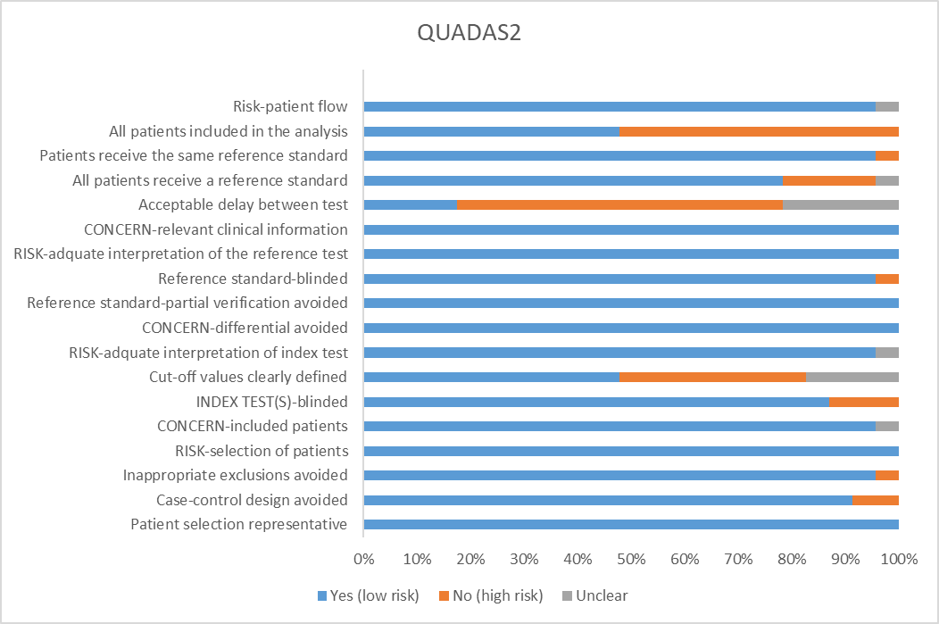
Figure S 1: Methodology quality assessment graph
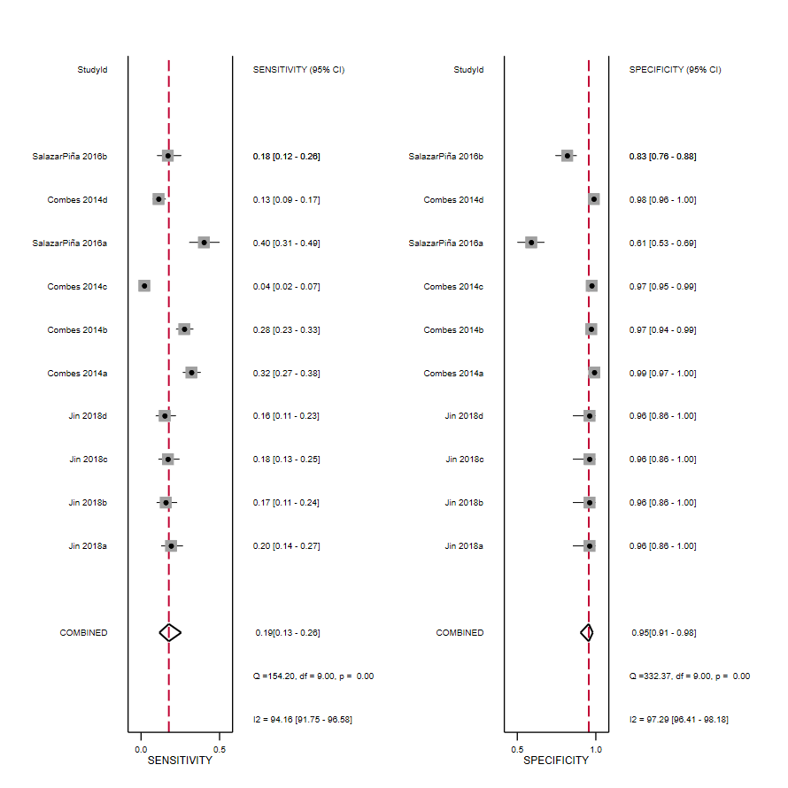
Figure S 2: Pooled Sensitivity and Specificity for HPV antibodies

Figure S 3: SROC curve in HPV-antibody tests

Figure S 4: HSROC curve showing heterogeneity in HPV-antibody study (Salazar-Piña study not included (Metandi was failing to run due to variations in the studies)

