ABD-D-21-00377_ Supplementary material

Supplementary Figure 1 Forest plot of comorbidity risk in mild and moderate/severe psoriatic patients.
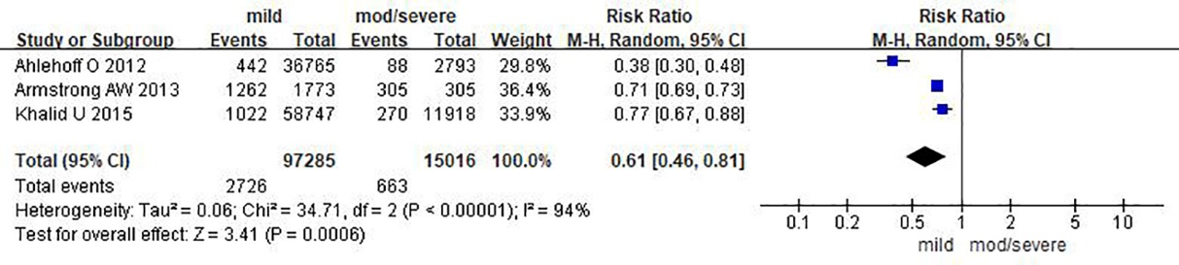

Supplementary Figure 2 Galbraith diagram was plotted by using the GALbr command.
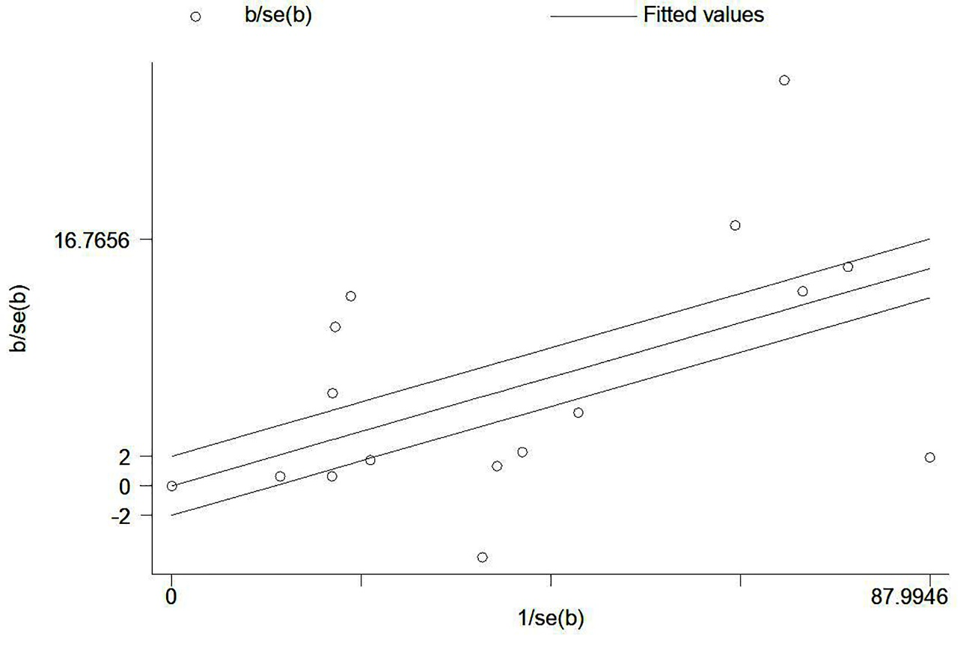
Supplementary Figure 3 Stata's Metaninf command was utilized to investigate the effect of a single study on the pooled effect size.
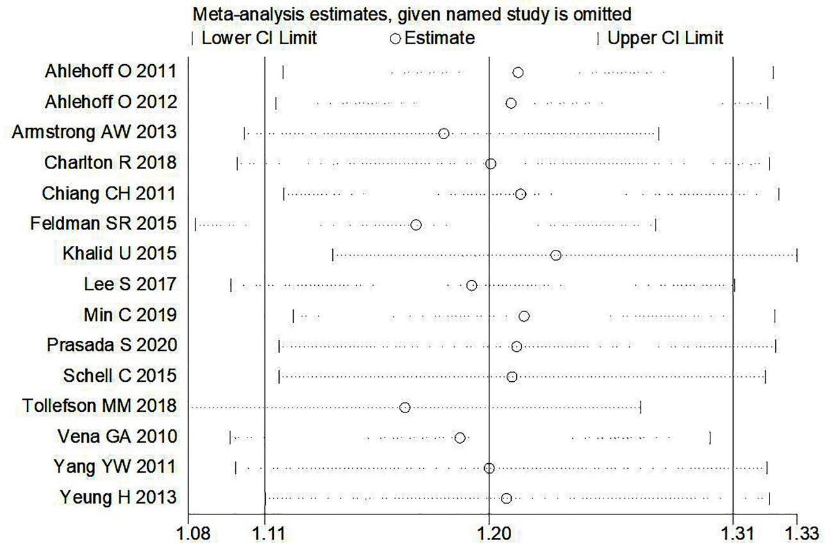

Supplementary Figure 4 Utilizing the Metabias command and the Egger method to show abias test.
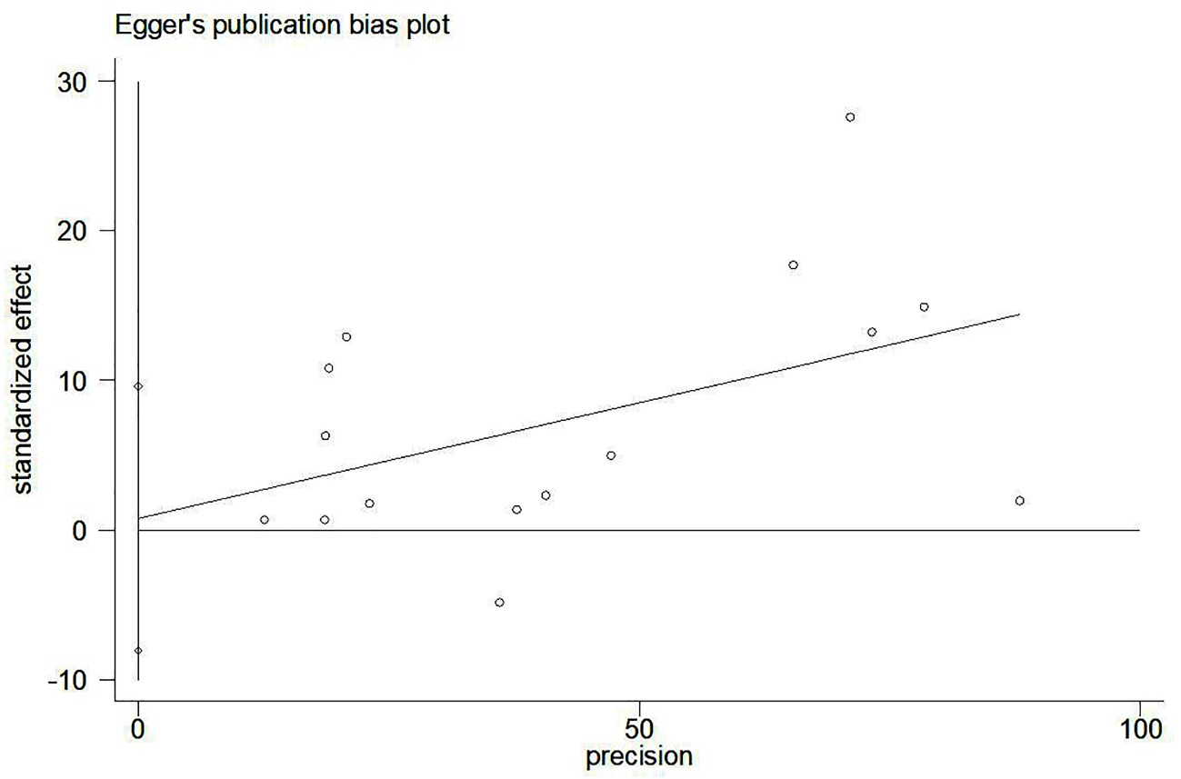

Supplementary Figure 5 Subgroup analyses in Western countries vs. Asian countries.
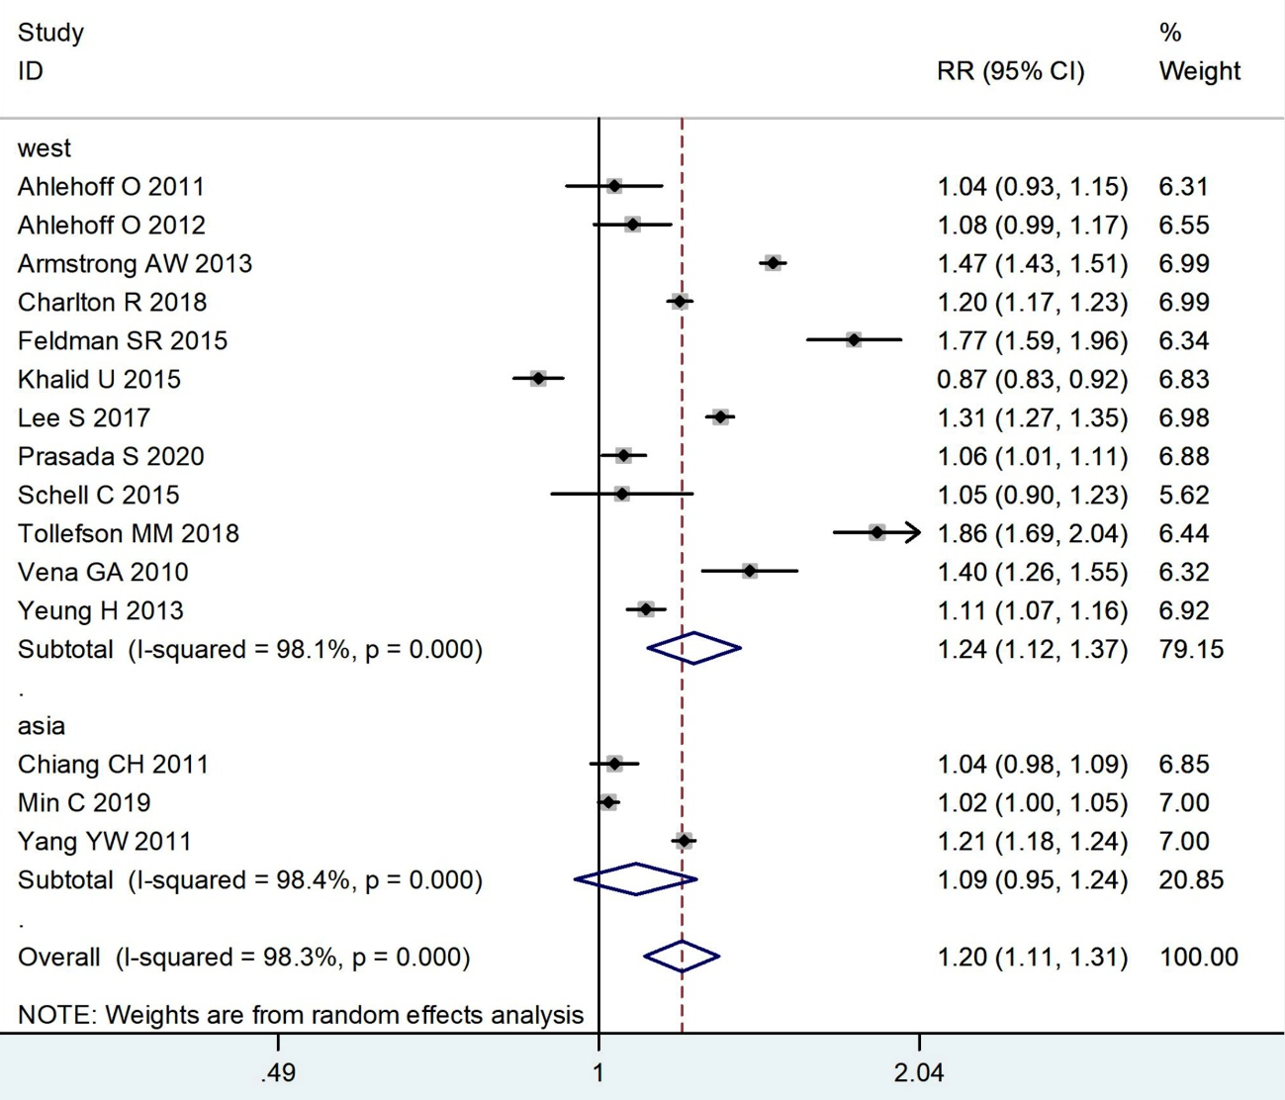

Supplementary Figure 6 Subgroup analyses in data of comorbidities covering and after the year of 2000.
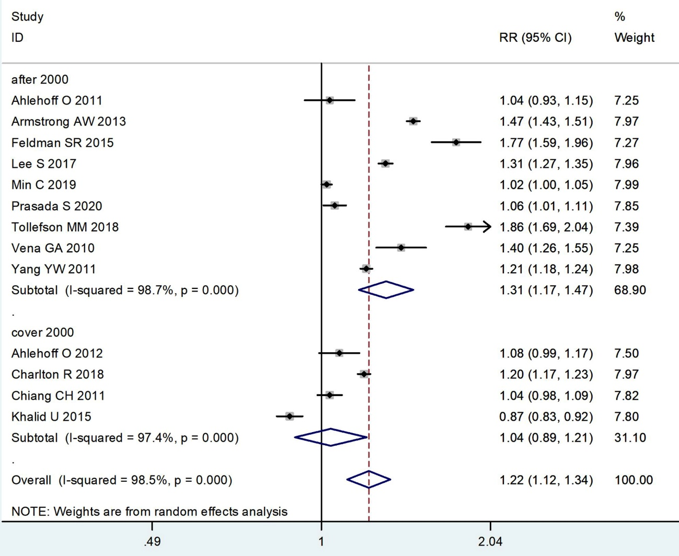
Supplementary Figure 7 Subgroup analyses in studies with or without funding.
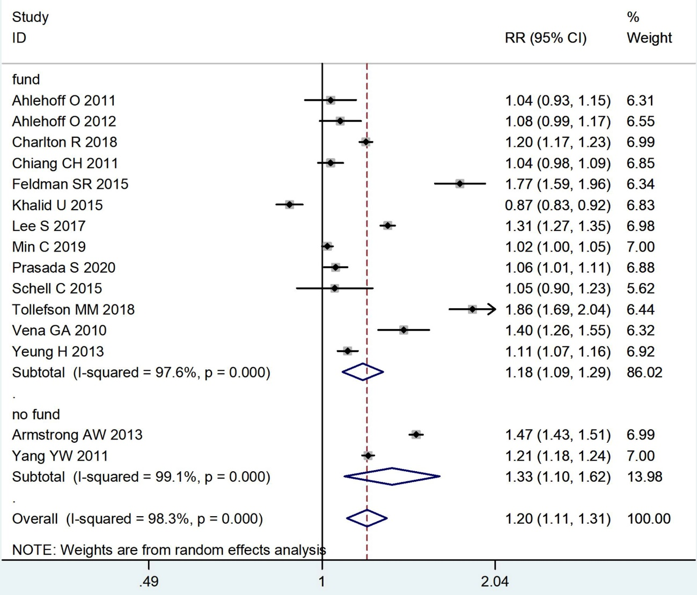
Supplementary Figure 8 Forest plot of comorbidity risks in psoriatic patients before and after 2006.
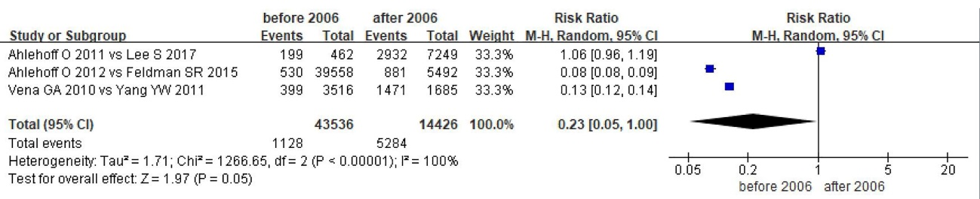
Supplementary Figure 9 Forest plot of comorbidity risks in psoriatic patients in Asia and West.



