Supplementary Figure 2. Risk of bias in included studies (ROB-2)
- Risk of bias graph: review authors' judgements about each risk of bias item presented as percentages across all included studies.
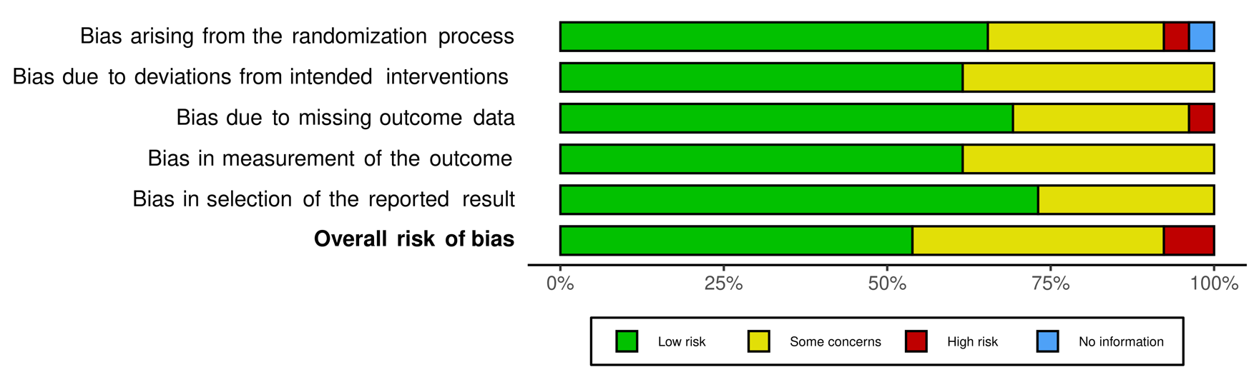

- Risk of bias summary: review authors' judgements about each risk of bias item for each included study.


