Funnel plots for all parameters

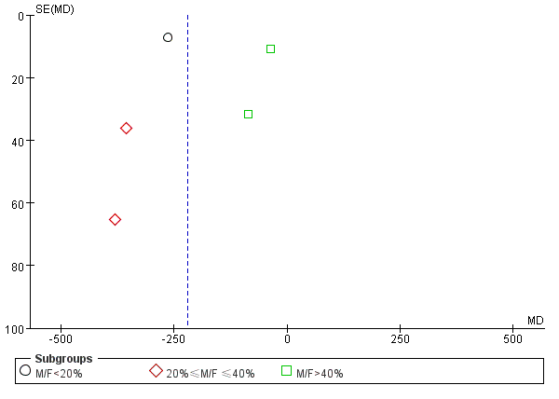
Figure S1. Funnel plot for total blood loss

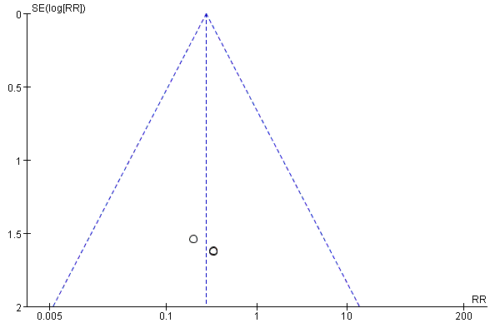
Figure S2. Funnel plot for transfusion

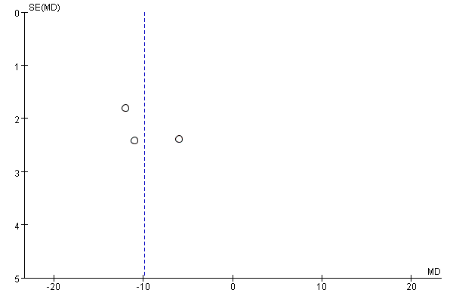
Figure S3. Funnel plot of hemoglobin decrease on POD1

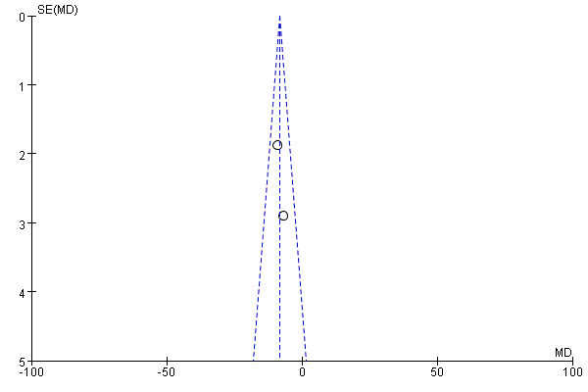
Figure S4. Funnel plot of hemoglobin decrease on POD2

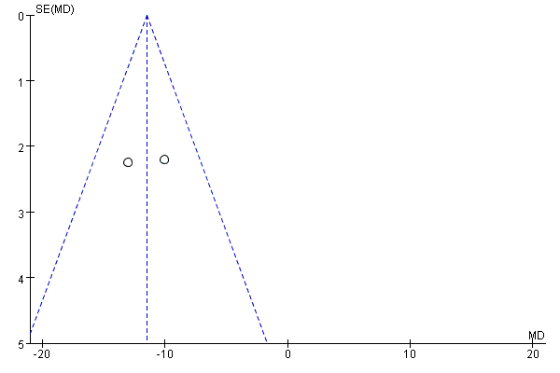
Figure S5. Funnel plot of hemoglobin decrease on POD5

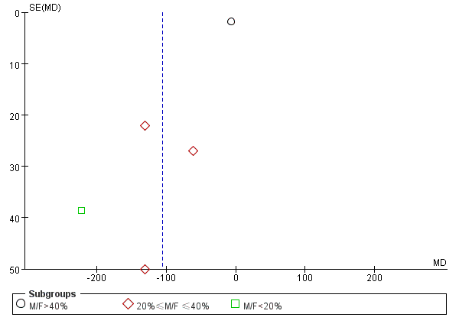
Figure S6. Funnel plot of total drainage amount

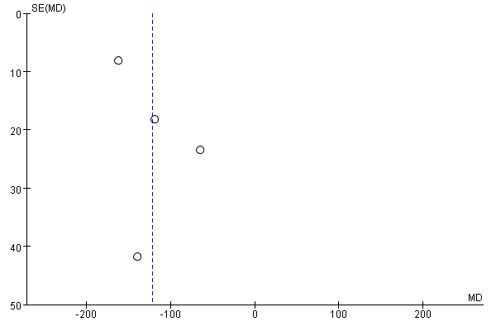
Figure S7. Funnel plot of drainage amount on POD1

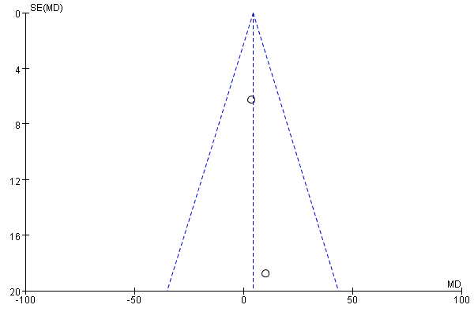
Figure S8. Funnel plot of drainage amount on POD2

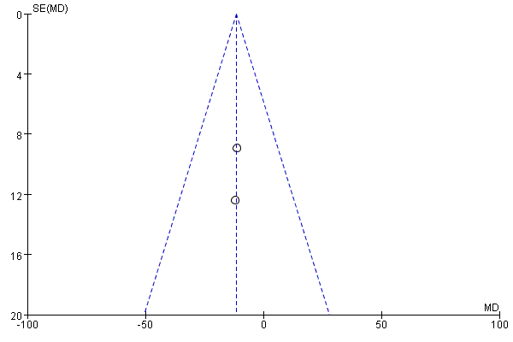
Figure S9. Funnel plot of drainage amount on POD3

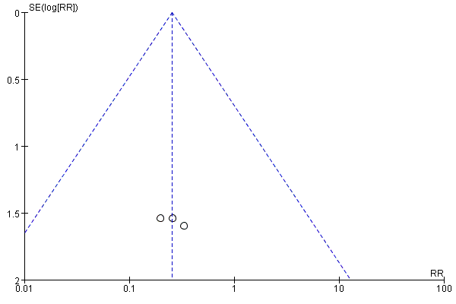
Figure S10. Funnel plot of wound complications

