Supplementary material

Supplemental Figure 1: Pooled estimate of ticagrelor effect on flow-mediated dilation by subgroup according to controlled administration

Supplemental Figure 2: Pooled estimate of ticagrelor effect on flow-mediated dilation by subgroup according to study population

Supplemental Figure 3: Pooled estimate of ticagrelor effect on flow-mediated dilation by subgroup according to study design

Supplemental Figure 4: Pooled estimate of ticagrelor effect on flow-mediated dilation by subgroup according to study sample size

Supplemental Figure 5: Pooled estimate of ticagrelor effect on flow-mediated dilation by subgroup according to participants’ age

Supplemental Figure 6: Pooled estimate of ticagrelor effect on reactive hyperemia index by subgroup according to controlled administration

Supplemental Figure 7: Pooled estimate of ticagrelor effect on reactive hyperemia index by subgroup according to study design

Supplemental Figure 8: Pooled estimate of ticagrelor effect on reactive hyperemia index by subgroup according to study duration

Supplemental Figure 9: Publication bias assessment by used Egger's test for flow-mediated dilation
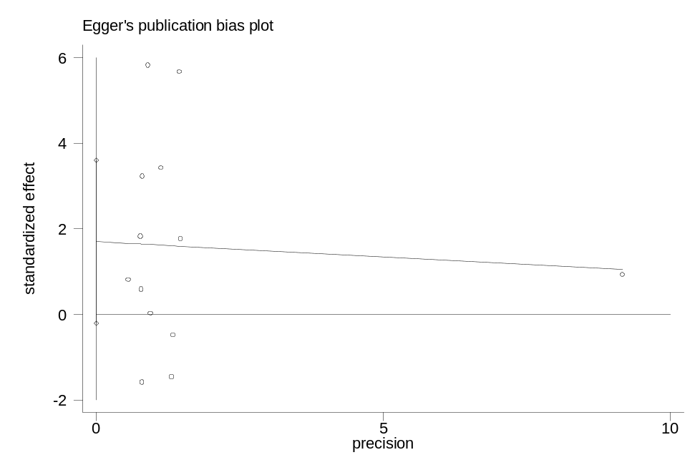

Supplemental Figure 10: Publication bias assessment by used Egger's test for reactive hyperemia index
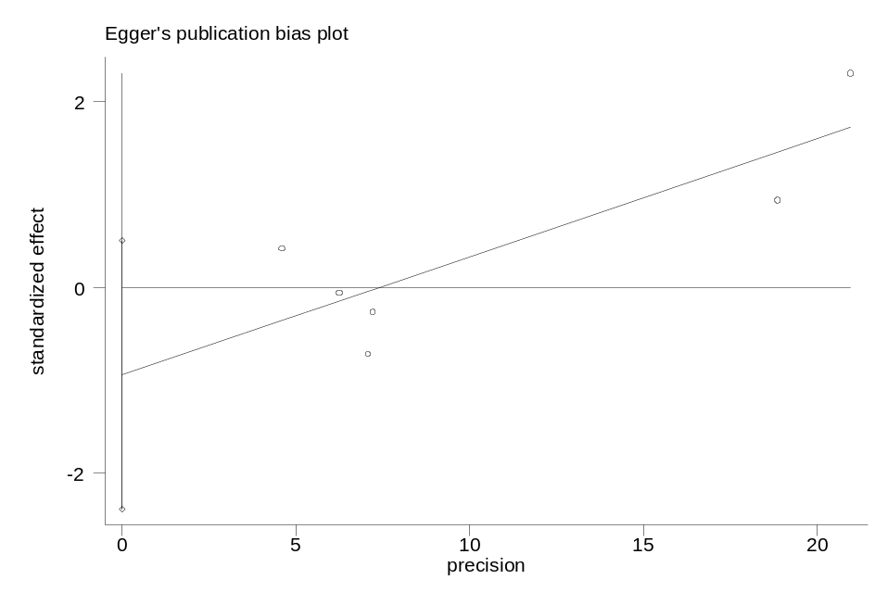

Supplemental Figure 11: Publication bias assessment by used Egger's test for index of microvascular resistance


