Appendix 1. Search Terms
PubMed
(("Hydrocephalus"[Mesh] OR Hydrocephalus [tw] OR noncommunicating hydrocephalus [tw] or non-communicating hydrocephalus[tw] OR obstructive hydrocephalus [tw] OR Hydrocephaly[tw] OR Cerebral Ventriculomegal*[tw] or Aqueductal Stenos*[tw]) AND (flexible neuroendoscop* [tw] OR flexible endoscop* [tw]) AND ("Ventriculostomy"[Mesh] or Ventriculostomy [tw] or Endoscopic Third Ventriculostomy [tw] or ETV* [tw] or Ventriculocisternostom*[tw] ))
OR
(("Hydrocephalus"[Mesh] OR Hydrocephalus [tw] OR noncommunicating hydrocephalus[tw] or non-communicating hydrocephalus [tw] OR obstructive hydrocephalus [tw] OR Hydrocephaly[tw] OR Cerebral Ventriculomegal*[tw] or Aqueductal Stenos*[tw]) AND (rigid neuroendoscop* [tw] OR rigid endoscop* [tw] or neuroendoscop* [tw] OR cerebral endoscop* [tw] or "Neuroendoscopy"[Mesh] or ventriculoscop*[tw] OR neurologic endoscop*[tw]) AND ("Ventriculostomy"[Mesh] or Endoscopic Third Ventriculostomy [tw] or ETV* [tw] OR Ventriculocisternostom*[tw] or ventriculostomy [tw]))
# of Articles: 743 on 11/10/2019

Embase
((exp hydrocephalus/ OR (Hydrocephalus OR noncommunicating hydrocephalus or non-communicating hydrocephalus OR obstructive hydrocephalus OR Hydrocephaly OR Cerebral Ventriculomegal* or Aqueductal Stenos*).tw. ) AND (third ventriculostomy/ OR (Endoscopic Third Ventriculostom* or ETV* OR Ventriculocisternostom* or third ventriculostom*).tw.) AND ( (flexible neuroendoscop* OR flexible endoscop*).tw))
OR
((exp hydrocephalus/ OR (Hydrocephalus OR noncommunicating hydrocephalus or non-communicating hydrocephalus OR obstructive hydrocephalus OR Hydrocephaly OR Cerebral Ventriculomegal* or Aqueductal Stenos*).tw. ) AND (third ventriculostomy/ OR (Endoscopic Third Ventriculostom* or ETV* OR Ventriculocisternostom or third ventriculostom*).tw.) AND ( (rigid neuroendoscop* OR rigid endoscop* or neuroendoscop* OR cerebral endoscop* or ventriculoscop* OR neurologic endoscop*).tw. or neurological endoscope/ OR neuroendoscopy/))
# of Articles: 602 on 11/10/2019

Cochrane
(Hydrocephalus[Mesh] OR (Hydrocephalus OR noncommunicating hydrocephalus or non-communicating hydrocephalus OR obstructive hydrocephalus OR Hydrocephaly OR Cerebral Ventriculomegal* or Aqueductal Stenos*):ti,ab,kw) AND (Ventriculostomy[Mesh] or (Endoscopic Third Ventriculostomy or ETV* or Ventriculocisternostom* or Ventriculostomy):ti,ab,kw) AND ((flexible neuroendoscop* OR flexible endoscop*):ti,ab,kw)
OR
(Hydrocephalus[Mesh] OR (Hydrocephalus OR noncommunicating hydrocephalus or non-communicating hydrocephalus OR obstructive hydrocephalus OR Hydrocephaly OR Cerebral Ventriculomegal* or Aqueductal Stenos*):ti,ab,kw) AND (Ventriculostomy[Mesh] or (Endoscopic Third Ventriculostomy or ETV* or Ventriculocisternostom* or Ventriculostomy):ti,ab,kw) AND (Neuroendoscopy [mesh](rigid neuroendoscop* OR rigid endoscop* or neuroendoscop*):ti,ab,kw)
# of Articles: 20 on 11/10/2019

Total: 1365 on 11/10/2019
Appendix 2. Forest plot for incidence of complications
Adult population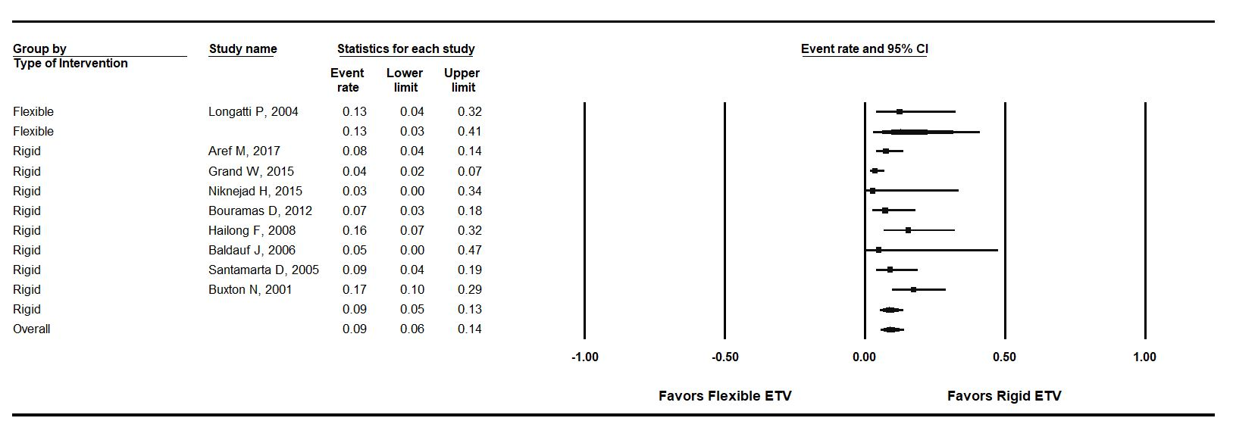Forest plot for incidence of complication in adults stratified by endoscopy type. For flexible ETV: incidence of failure = 13%; number of studies = 1; P-heterogeneity = 1.00; I² = N.A.; for rigid ETV: incidence of failure: 9% number of studies = 8; P-heterogeneity = 0.026; I² = 55.90%. P-value comparing flexible to rigid = 0.62. Error bars represent the 95% CI. ETV: endoscopic third-ventriculostomy

Pediatric population
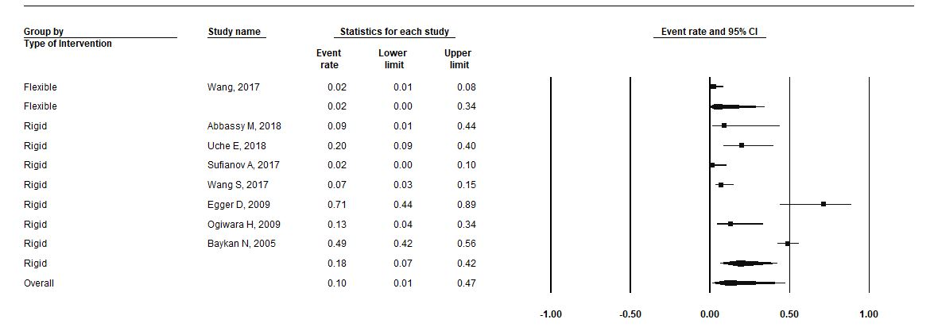
Forest plot for incidence of complication in pediatric population stratified by endoscopy type. For flexible ETV: incidence of failure = 2%; number of studies = 1; P-heterogeneity = 1.00; I² = N.A.; for rigid ETV: incidence of failure: 18% number of studies = 7; P-heterogeneity = 0.0; I² = 90.80%. P-value comparing flexible to rigid = 0.18. Error bars represent the 95% CI. ETV: endoscopic third-ventriculostomy

Mixed population
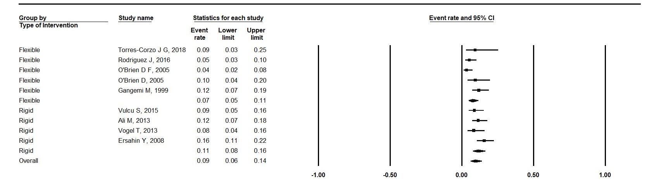
Forest plot for incidence of complication in mixed population stratified by endoscopy type. For flexible ETV: incidence of failure = 8%; number of studies = 5; P-heterogeneity = 0.07; I² = 54%.; for rigid ETV: incidence of failure: 11% number of studies = 4; P-heterogeneity = 0.24.; I² = 27.90%. P-value comparing flexible to rigid = 0.13. Error bars represent the 95% CI. ETV: endoscopic third-ventriculostomy

Appendix 3. Forest plots for incidence of bleeding
Adult population
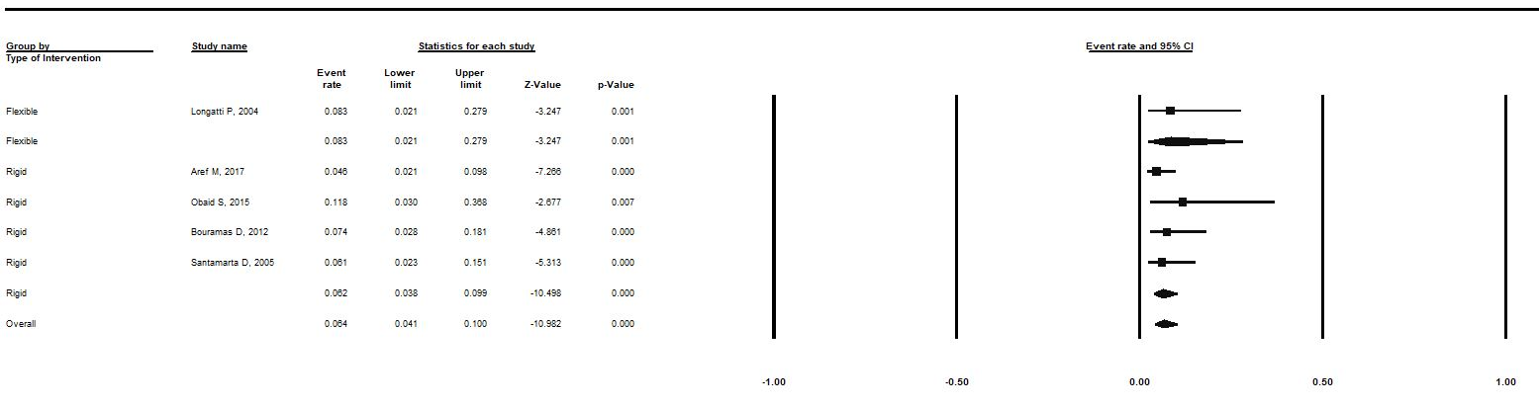
Forest plot for incidence of bleeding in adults stratified by endoscopy type. For flexible ETV: incidence of failure = 8%; number of studies = 1; P-heterogeneity = 1.00; I² = N.A.; for rigid ETV: incidence of failure: 6% number of studies = 4; P-heterogeneity = 0.661.; I² = 0.00%. P-value comparing flexible to rigid = 0.69. Error bars represent the 95% CI. ETV: endoscopic third-ventriculostomy

Mixed population
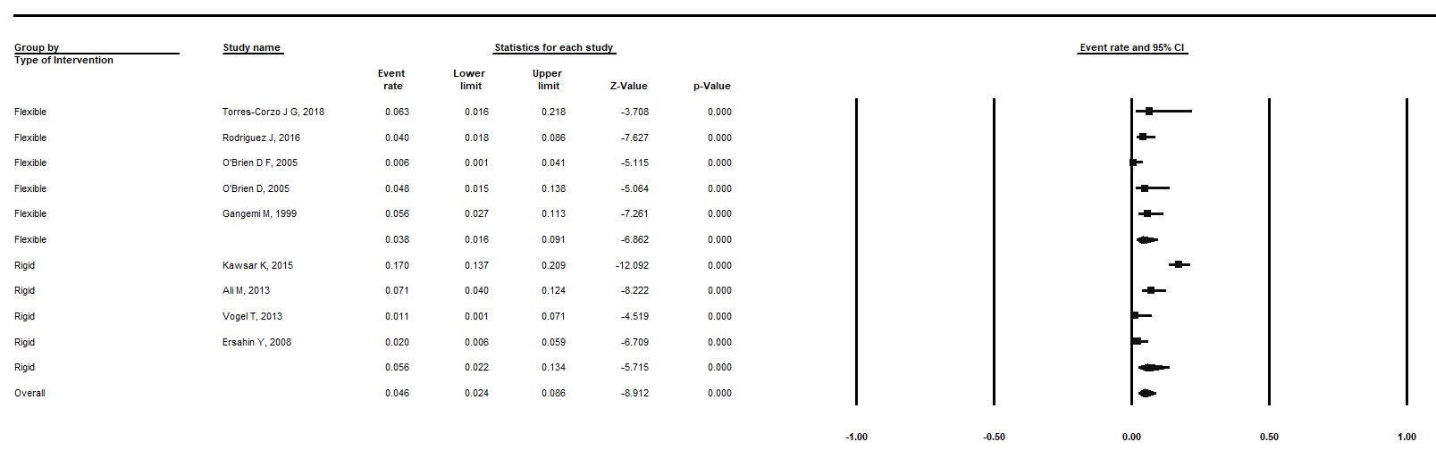
Forest plot for incidence of bleeding in mixed population stratified by endoscopy type. For flexible ETV: incidence of failure = 4%; number of studies = 5; P-heterogeneity = 0.29; I² = 19.1%; for rigid ETV: incidence of failure: 6% number of studies = 4; P-heterogeneity = 0.00.; I² = 89.7%. P-value comparing flexible to rigid = 0.57. Error bars represent the 95% CI. ETV: endoscopic third-ventriculostomy

Appendix 4. Forest plots for incidence of death
Adult population
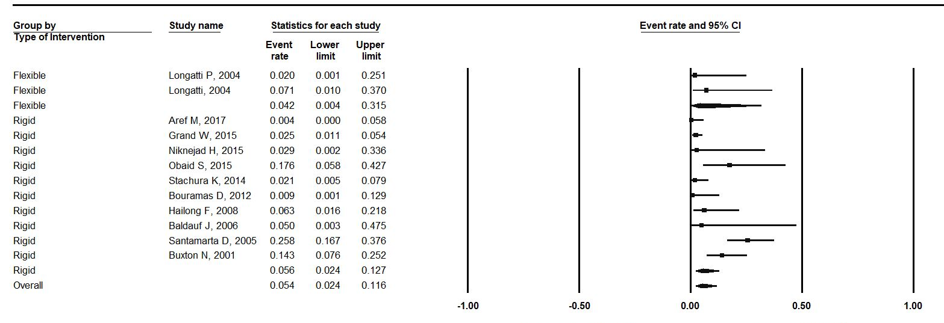
Forest plot for incidence of death in adults stratified by endoscopy type. For flexible ETV: incidence of failure = 4%; number of studies = 2; P-heterogeneity = 0.45; I² = 0.00%.; for rigid ETV: incidence of failure: 6% number of studies = 10; P-heterogeneity = 0.00; I² = 80.90%. P-value comparing flexible to rigid = 0.82. Error bars represent the 95% CI. ETV: endoscopic third-ventriculostomy

Pediatric population
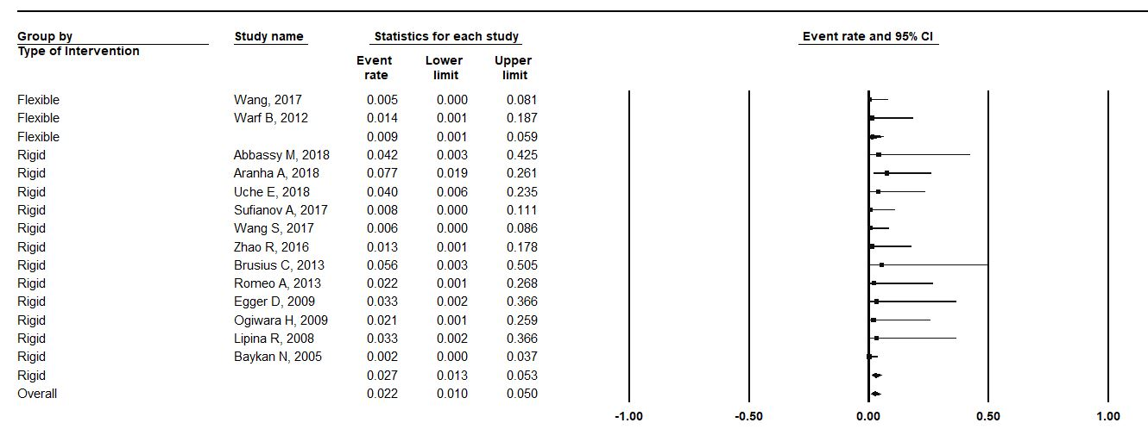
Forest plot for incidence of death in pediatric population stratified by endoscopy type. For flexible ETV: incidence of failure = 1%; number of studies = 2; P-heterogeneity = 0.64; I² = 0.00%.; for rigid ETV: incidence of failure: 3% number of studies = 12; P-heterogeneity = 0.70; I² = 0.00%. P-value comparing flexible to rigid = 0.28. Error bars represent the 95% CI. ETV: endoscopic third-ventriculostomy
Mixed population
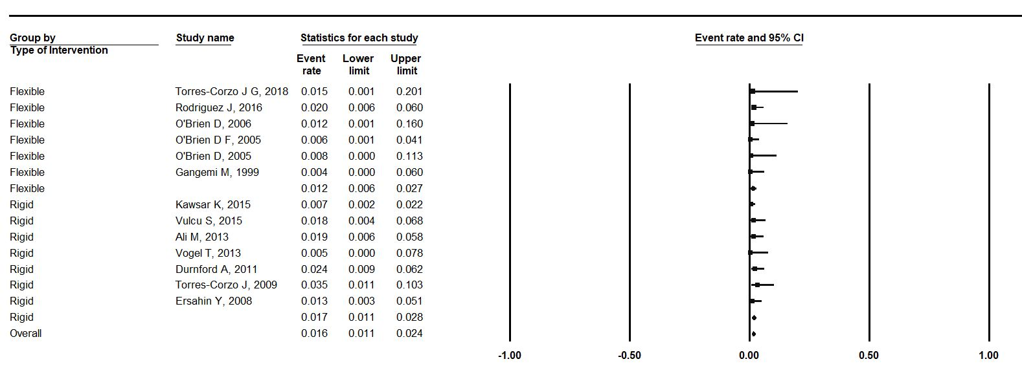
Forest plot for incidence of death in mixed population stratified by endoscopy type. For flexible ETV: incidence of failure = 1.2%; number of studies = 6; P-heterogeneity = 0.84; I² = 0.00%.; for rigid ETV: incidence of failure: 1.7% number of studies = 7; P-heterogeneity = 0.52; I² = 0.00%. P-value comparing flexible to rigid = 0.46. Error bars represent the 95% CI. ETV: endoscopic third-ventriculostomy

Appendix 5. Quality score assessment
Author, Year | Clear Study Objectives/Question | Well Defiend Study Protocol | Explicit Inclusion/Exclusion Criteria for Participants | Specified Time Interval for Patient Recruiotment | Consecutive Patient Enrollement | Clinically Relevant Outcomes | Prospective Outcome Data Collection | High Follow-Up Rate | Total
Abbassy M, 2018 | 1 | 0 | 1 | 0 | 0 | 1 | 0 | 0 | 3
Aranha A, 2018 | 1 | 1 | 1 | 0 | 0 | 1 | 0 | 0 | 4
Chiba K, 2018 | 1 | 0 | 1 | 1 | 1 | 1 | 0 | 0 | 5
Torres-Corzo J, 2018 | 1 | 1 | 1 | 0 | 0 | 1 | 0 | 0 | 4
Uche E, 2018 | 1 | 1 | 1 | 0 | 0 | 1 | 0 | 1 | 5
Wu Y, 2018 | 1 | 1 | 0 | 0 | 1 | 1 | 0 | 1 | 5
Aref M, 2017 | 1 | 1 | 0 | 0 | 1 | 1 | 0 | 0 | 4
Oertel J, 2017 | 1 | 0 | 1 | 0 | 0 | 1 | 0 | 0 | 3
Sufianov A, 2017 | 1 | 0 | 0 | 0 | 0 | 1 | 1 | 1 | 4
Wang, 2017 | 1 | 1 | 1 | 0 | 0 | 1 | 0 | 1 | 5
Rodriguez J, 2016 | 1 | 1 | 1 | 0 | 0 | 1 | 0 | 1 | 5
Zhao R, 2016 | 1 | 0 | 0 | 1 | 1 | 1 | 0 | 0 | 4
Grand W, 2015 | 1 | 0 | 0 | 1 | 0 | 1 | 0 | 1 | 4
Kawsar K, 2015 | 1 | 1 | 0 | 1 | 0 | 1 | 0 | 0 | 4
Niknejad H, 2015 | 0 | 1 | 0 | 1 | 1 | 1 | 0 | 1 | 5
Obaid S, 2015 | 1 | 1 | 0 | 1 | 0 | 1 | 0 | 1 | 5
Vulcu S, 2015 | 1 | 0 | 0 | 1 | 1 | 1 | 0 | 0 | 4
Bisht A, 2014 | 1 | 0 | 1 | 1 | 1 | 1 | 0 | 1 | 6
Salvador S, 2014 | 1 | 1 | 0 | 1 | 1 | 1 | 0 | 1 | 6
Stachura K, 2014 | 1 | 0 | 0 | 0 | 0 | 1 | 0 | 0 | 2
Ali M, 2013 | 1 | 0 | 1 | 1 | 1 | 1 | 0 | 0 | 5
Brusius C, 2013 | 1 | 0 | 1 | 1 | 1 | 1 | 1 | 1 | 7
Melot A, 2013 | 1 | 1 | 1 | 0 | 0 | 1 | 0 | 0 | 4
Romeo A, 2013 | 1 | 0 | 0 | 0 | 0 | 1 | 0 | 1 | 3
Vogel T, 2013 | 1 | 0 | 0 | 1 | 0 | 1 | 0 | 1 | 4
Bouramas D, 2012 | 1 | 1 | 0 | 0 | 1 | 1 | 0 | 1 | 5
Warf B, 2012 | 1 | 1 | 0 | 0 | 1 | 1 | 0 | 0 | 4
Durnford A, 2011 | 1 | 1 | 0 | 0 | 0 | 1 | 0 | 1 | 4
Egger D, 2009 | 1 | 0 | 0 | 1 | 1 | 1 | 0 | 1 | 5
Oertel J, 2009 | 1 | 1 | 1 | 0 | 1 | 1 | 1 | 0 | 6
Ogiwara H, 2009 | 1 | 0 | 0 | 0 | 1 | 1 | 0 | 1 | 4
Torres-Corzo J, 2009 | 1 | 0 | 1 | 0 | 0 | 1 | 0 | 1 | 4
Ersahin Y, 2008 | 1 | 1 | 1 | 0 | 0 | 1 | 0 | 1 | 5
Hailong F, 2008 | 1 | 0 | 0 | 0 | 0 | 1 | 0 | 1 | 3
Lipina R, 2008 | 1 | 1 | 0 | 1 | 0 | 1 | 0 | 1 | 5
Baldauf J, 2007 | 1 | 0 | 0 | 0 | 0 | 1 | 0 | 1 | 3
Idowu O, 2007 | 1 | 1 | 0 | 0 | 0 | 1 | 1 | 0 | 4
Baldauf J, 2006 | 1 | 0 | 0 | 1 | 0 | 1 | 0 | 1 | 4
O'Brien D, 2006 | 1 | 0 | 0 | 0 | 0 | 1 | 0 | 1 | 3
Baykan N, 2005 | 1 | 0 | 1 | 1 | 1 | 1 | 0 | 0 | 5
O'Brien D F, 2005 | 1 | 0 | 0 | 0 | 1 | 1 | 0 | 1 | 4
Santamarta D, 2005 | 1 | 1 | 0 | 0 | 1 | 1 | 0 | 1 | 5
Longatti P, 2004 | 1 | 1 | 0 | 1 | 1 | 1 | 0 | 0 | 5
Longatti P, 2004 | 1 | 1 | 0 | 1 | 1 | 1 | 0 | 0 | 5
Buxton N, 2001 | 1 | 1 | 0 | 1 | 1 | 1 | 1 | 1 | 7
Gangemi M,1999 | 1 | 1 | 0 | 1 | 1 | 1 | 0 | 1 | 6

Appendix 6 Sensitivity analysis for efficacy/failure
Sensitivity analysis for efficacy/failure outcomes (only includes studies with quality >= 4)
 |  | Flexible ETV |  | Rigid ETV
Outcome | Population  type; | Effect size  (95% C.I.) | # of  studies | Pooled incidence (95% C.I.) | # of  studies
Failure | Pediatric | 35%  (11%, 70%) | 2 | 29%  (18%, 42%) | 15
Failure | Adult | 50%  (18%, 82%) | 2 | 18%  (13%, 25%) | 13
Failure | Mixed | 21%  (14%, 30%) | 6 | 21%  (15%, 28%) | 8
C.I.: Confidence interval

Appendix 7 Sensitivity analysis for complications and death
Sensitivity analysis for safety outcomes of complications and death (only includes studies with quality >= 4)
 |  | Flexible ETV |  | Rigid ETV
Outcome | Population; | Pooled incidence (95% C.I.) | # of  studies | Pooled incidence (95% C.I.) | # of  studies
Complications | Pediatric | 2 %  (0.1%-34%) | 1 | 19 %  (7%-46%) | 6
Complications | Adult | 12 %  (3%-40%) | 1 | 8%  (5%-13%) | 7
Death | Pediatric | 1 %  (0.1%- 3%) | 2 | 3 %  (1%-5%) | 10
Death | Adult | 4 %  (0.4%- 32%) | 2 | 6 %  (2%-16%) | 8
Death | Mixed | 1.2 %  (0.6%-2.7%) | 5 | 1.7 %  (1.1%- 2.8%) | 7
C.I.: Confidence interval

