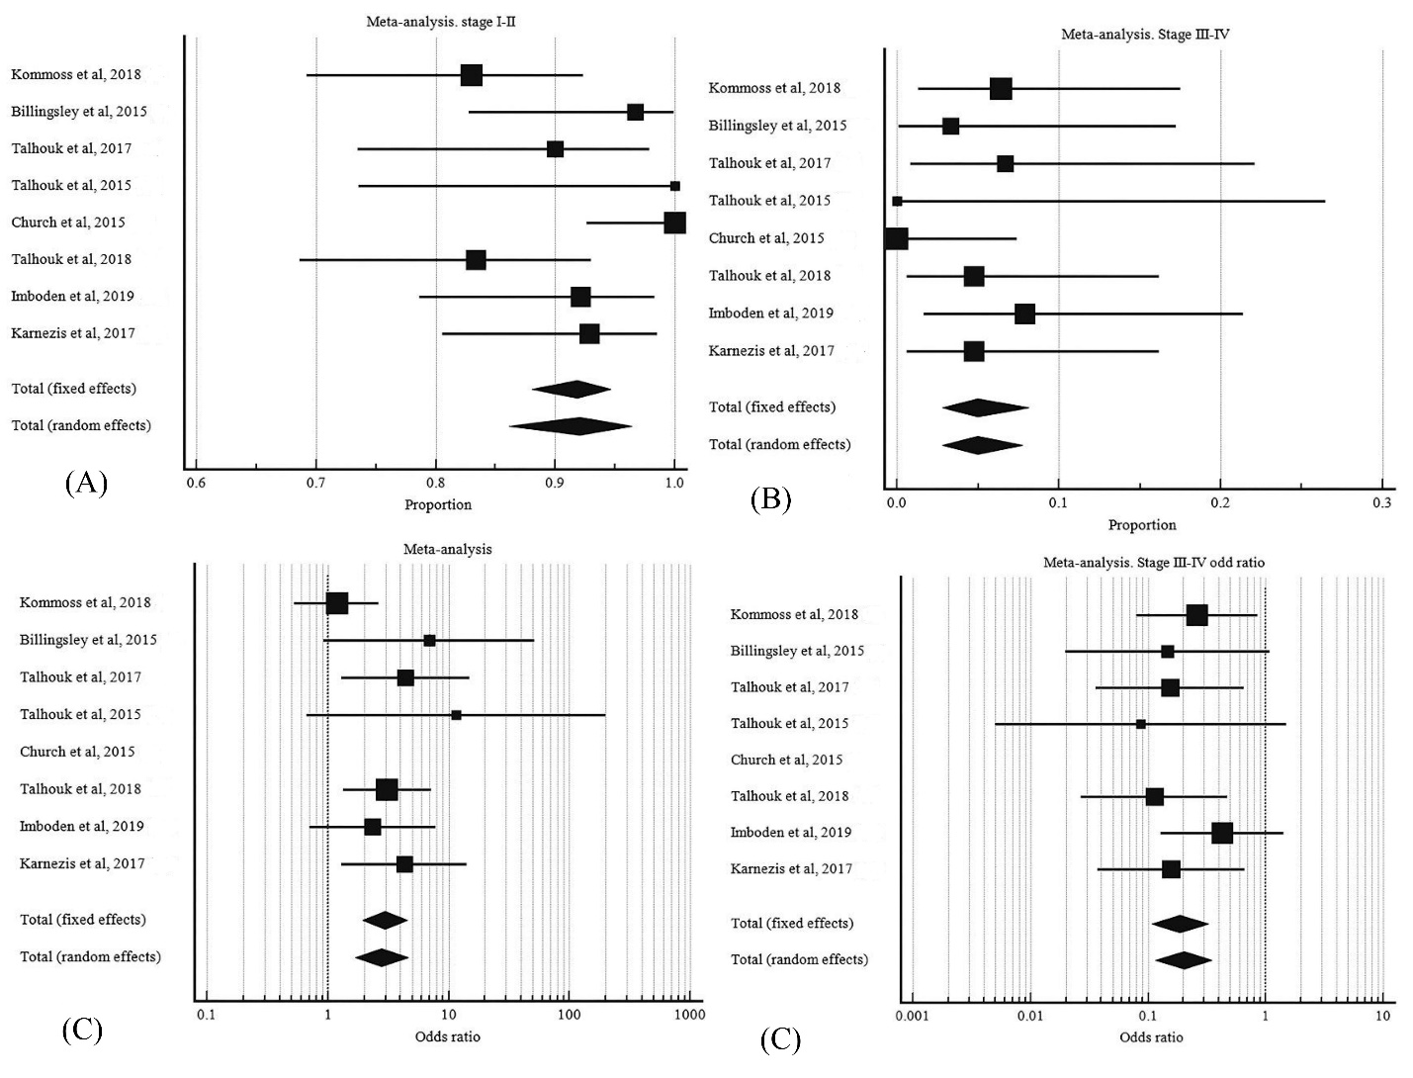
(D)

S3 Fig. FIGO stage in POLE mutant EC. A, pooled proportion of stage I-II. B, pooled proportion of stage III-IV. C, odd ratio of stage I-II POLE mutant EC to stage I-II wild type POLE EC. D, odd ratio of stage III-IV POLE mutant EC to stage III-IV wild type POLE EC.

