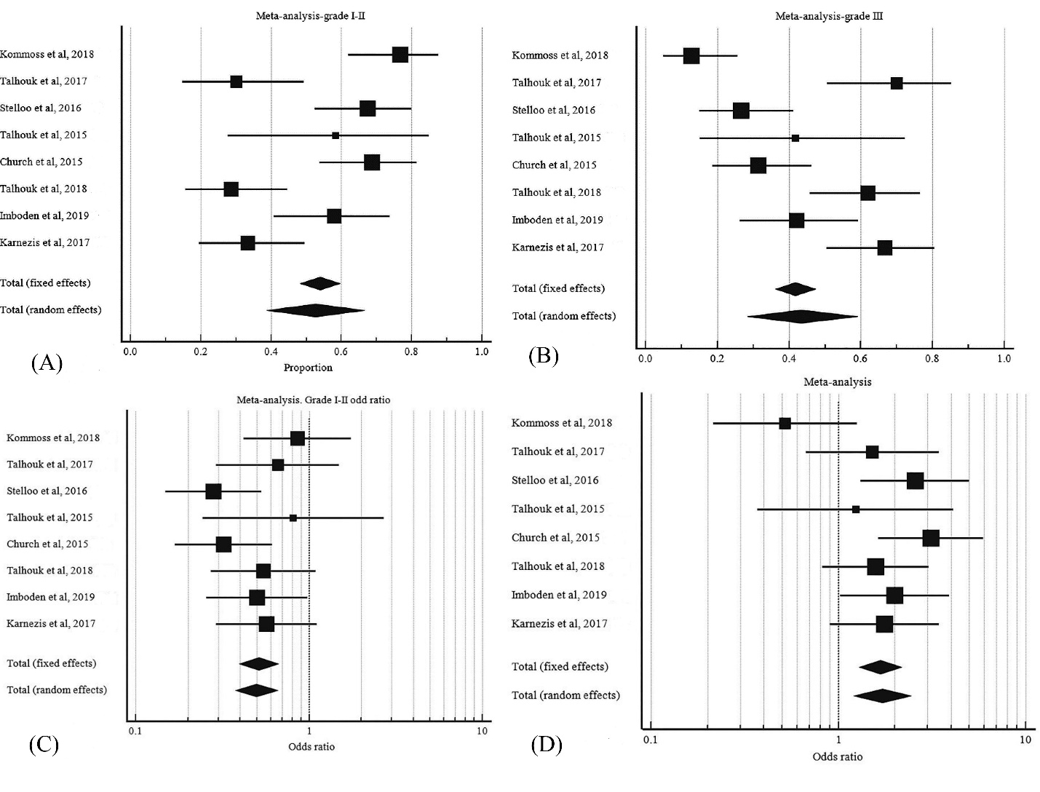
S4 Fig. FIGO grade in POLE mutant EC. A, pooled proportion of grade I-II. B, pooled proportion of grade III. C, odd ratio of grade I-II POLE mutant EC to grade I-II wild type POLE EC. D, odd ratio of grade III POLE mutant EC to grade III wild type POLE EC.

