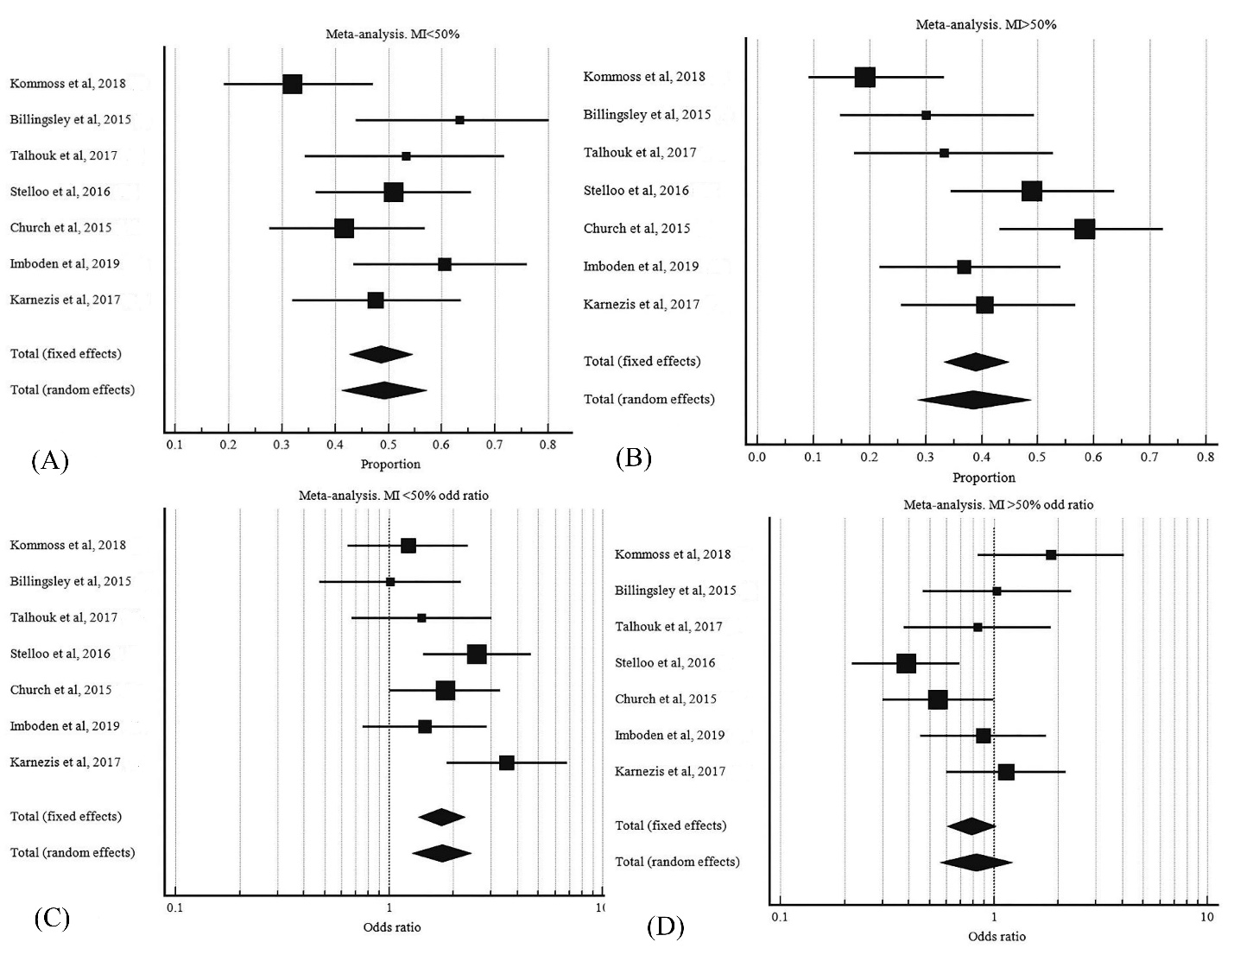

S5 Fig. Myometrial invasion extent in POLE mutant EC. A, pooled proportion MI<50%. B, pooled proportion of MI>50%. C, odd ratio of MI<50%. POLE mutant EC to MI<50% wild type POLE EC. D, odd ratio of MI>50% POLE mutant EC to MI>50% wild type POLE EC.

