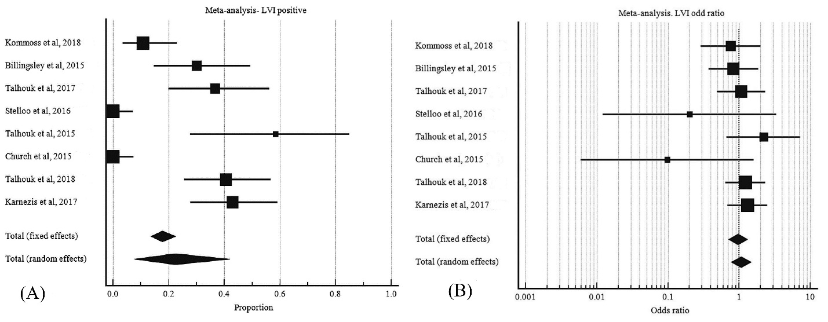

S6 Fig. LVI in POLE mutant EC. A, pooled proportion LVI. B, odd ratio of LVI POLE mutant EC to LVI wild type POLE EC.

