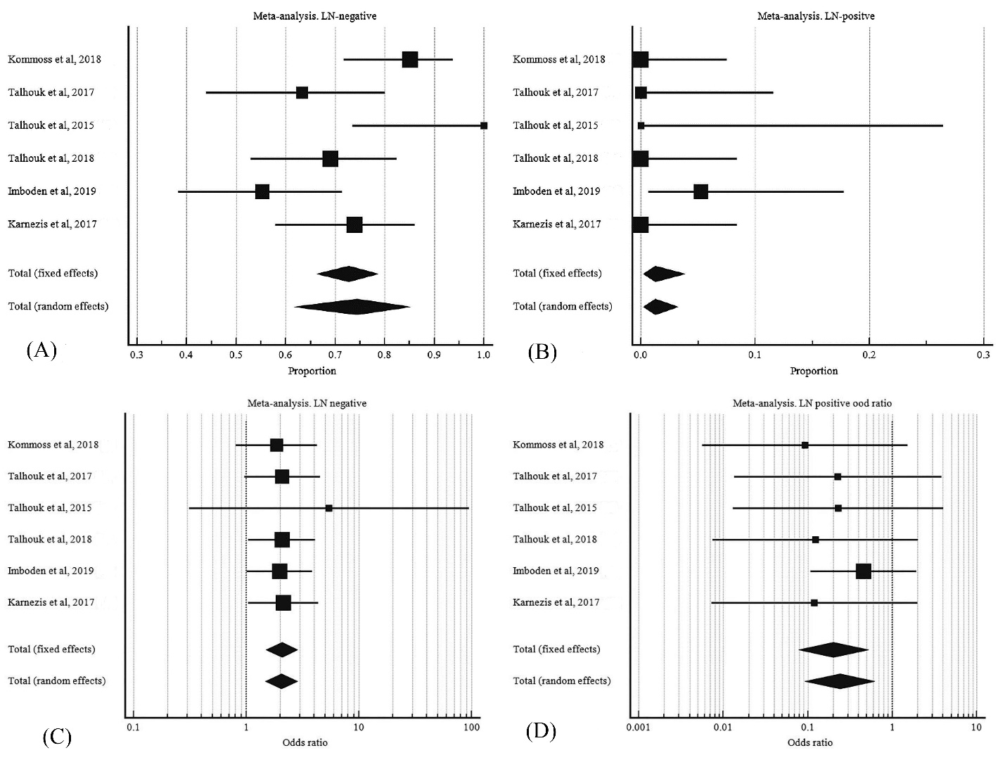

S7 Fig. LN involvements in POLE mutant EC. A, pooled proportion LN negative B, pooled proportion of LN positive. C, odd ratio of LN negative POLE mutant EC to LN negative wild type POLE EC. D, odd ratio of LN positive POLE mutant EC to LN positive wild type POLE EC.

