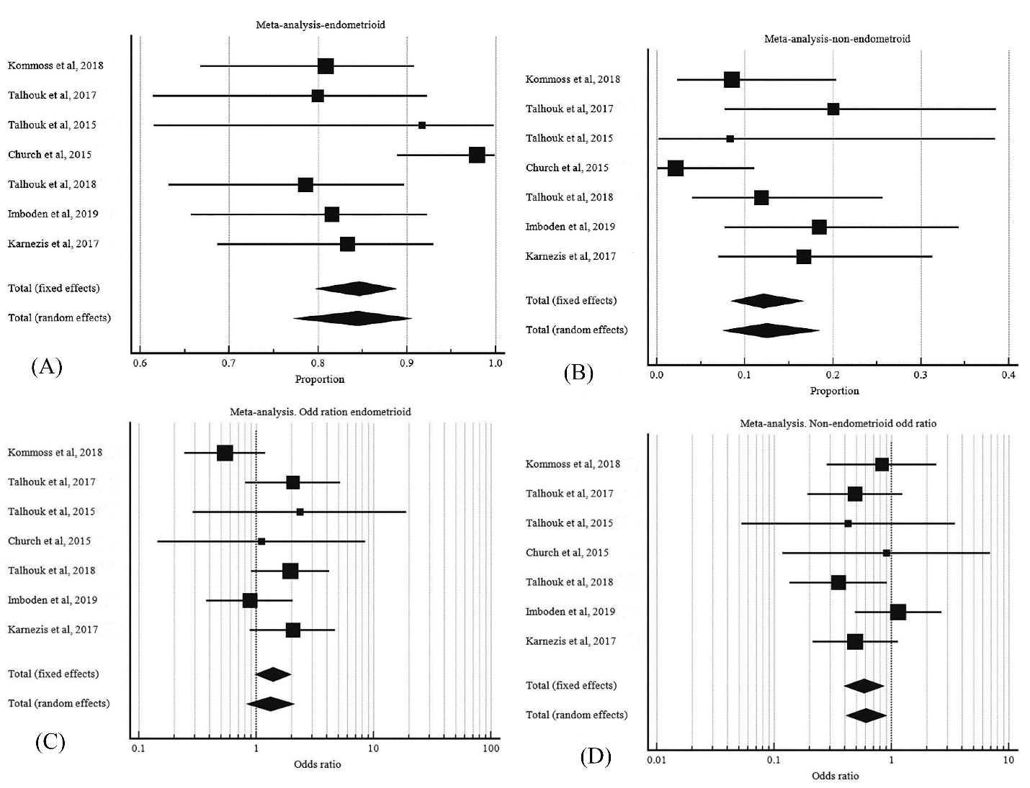

S8 Fig. Histology of POLE mutant EC. A, pooled proportion of endometroid type POLE mutant EC B, pooled proportion of non-endometroid type POLE mutant EC. C, odd ratio of endometrioid POLE mutant EC to endometrioid wild type POLE EC. D, odd ratio of non-endometrioid POLE mutant EC to non-endometrioid wild type POLE EC.

