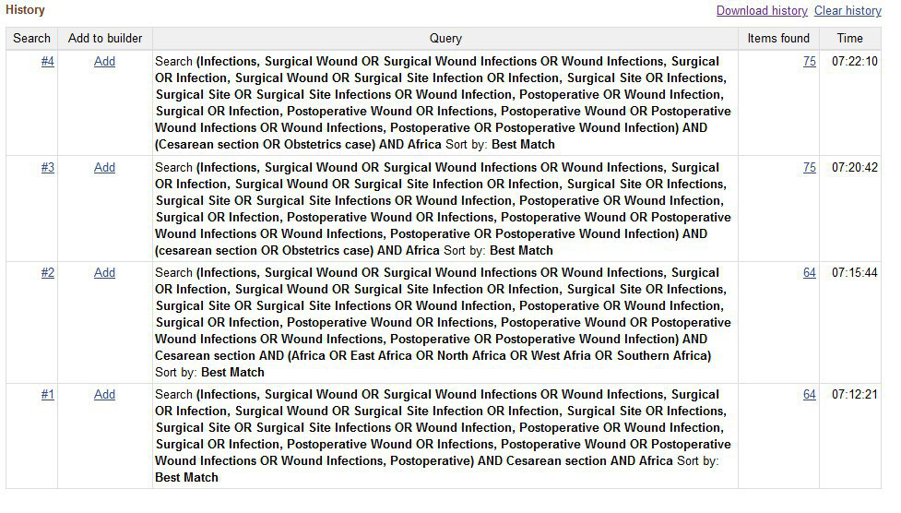
Scopus review
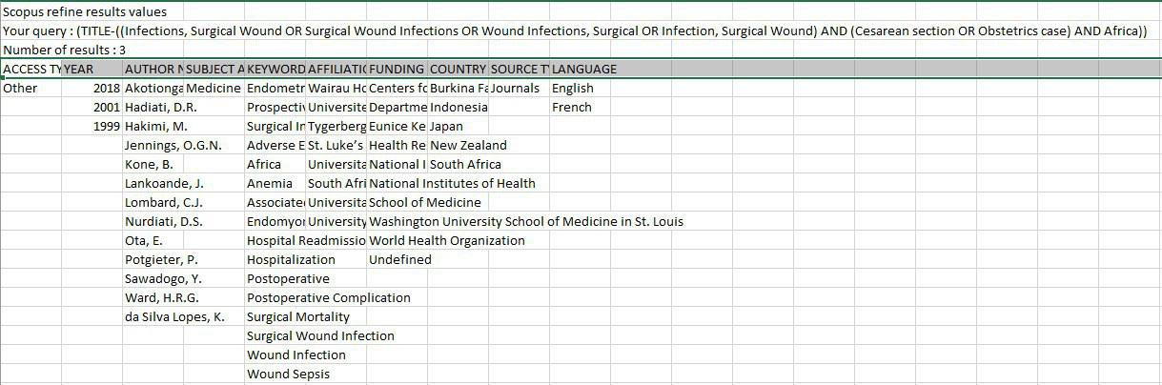
Additional file 1. MEDLINE via PubMed, Scopus database search for surgical site infection following cesarean section, March 2020.

