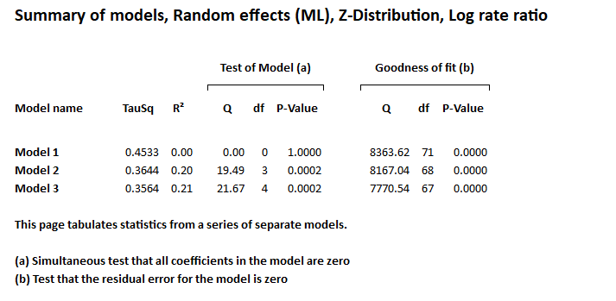

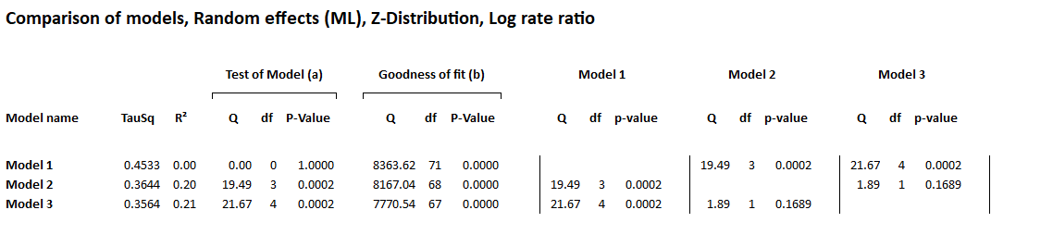

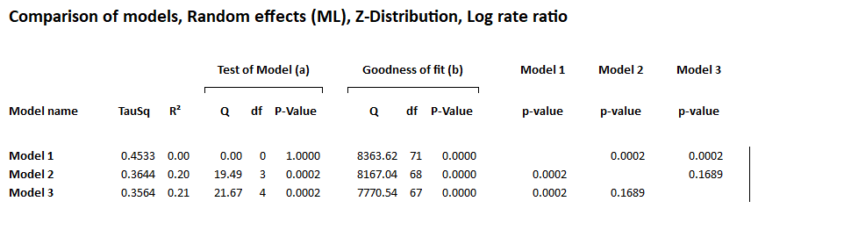
Model 1: Contains participants only
Model 2: Contains participants + Risk
Model 3 contains participants + Risk +time point

