Supplementary figures

Figure 1

Meta-analysis of 16 studies reporting LAD changes before and after PMBV in 991 MS patients
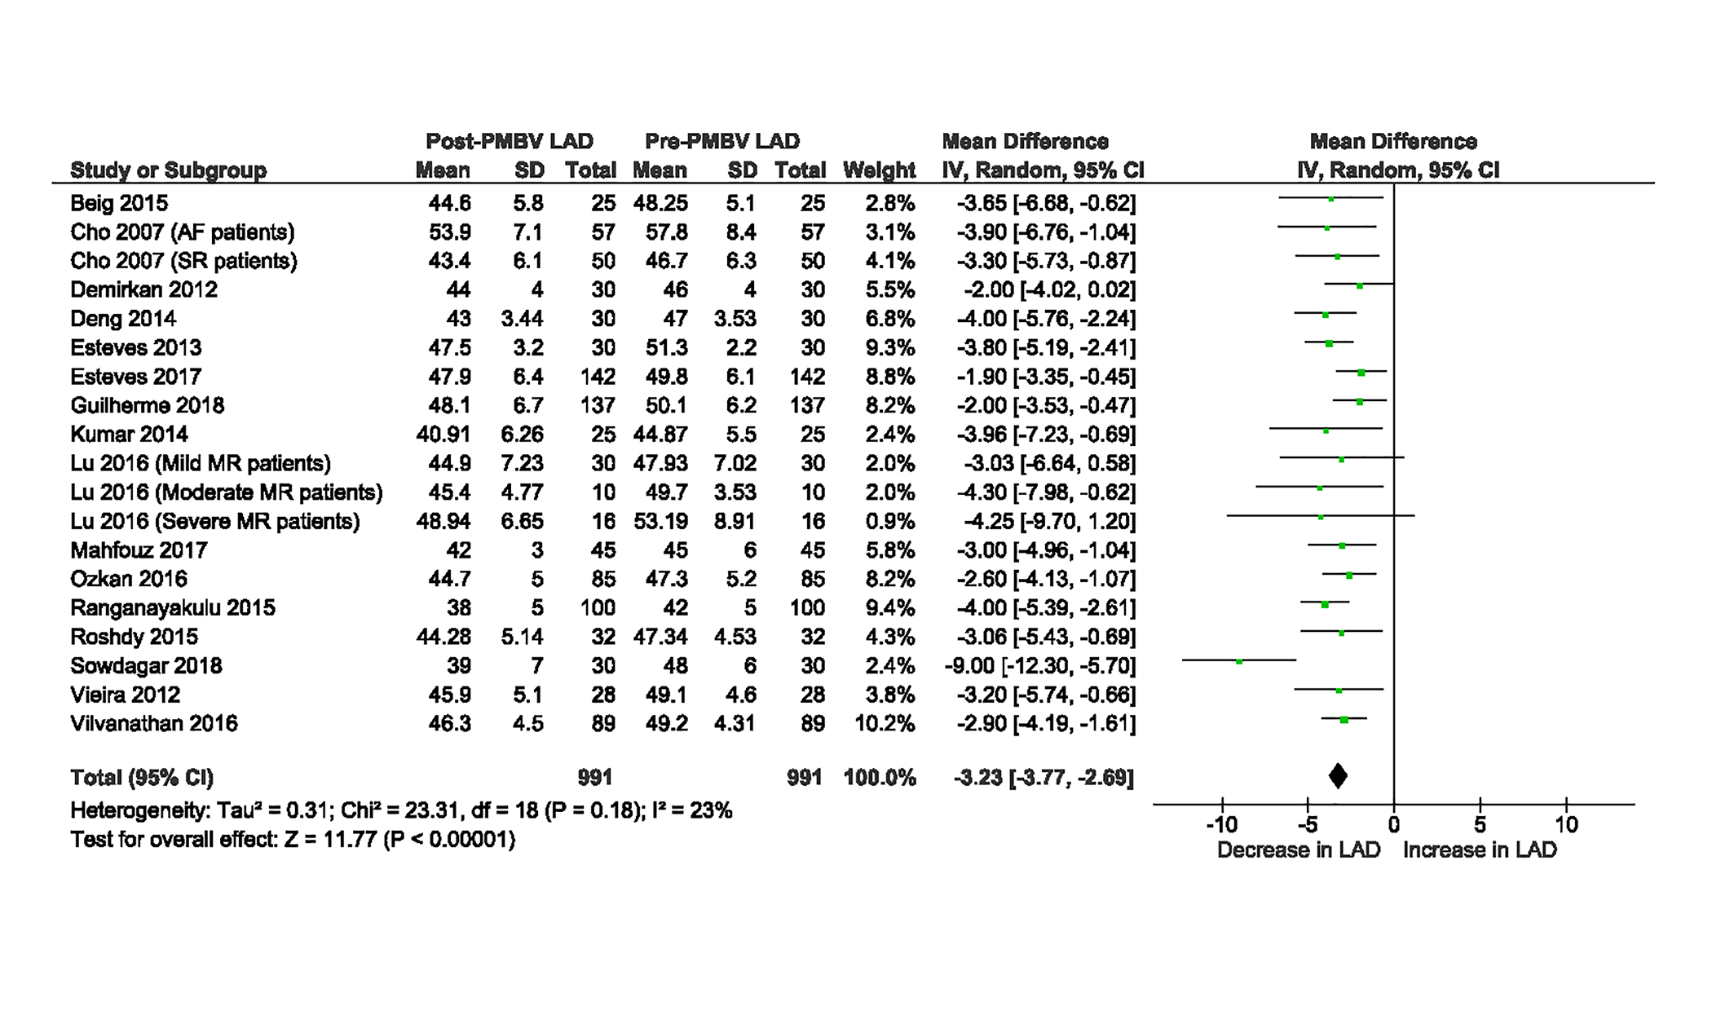

Figure 2
Meta-analysis of 14 studies reporting LAP changes before and after PMBV in 2056 MS patients
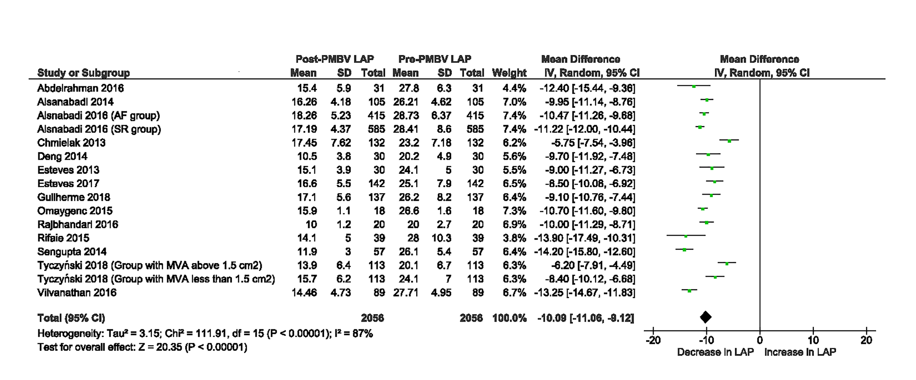

Figure 3
Meta-analysis of four studies reporting LV EDV changes before and after PMBV in 142 MS patients

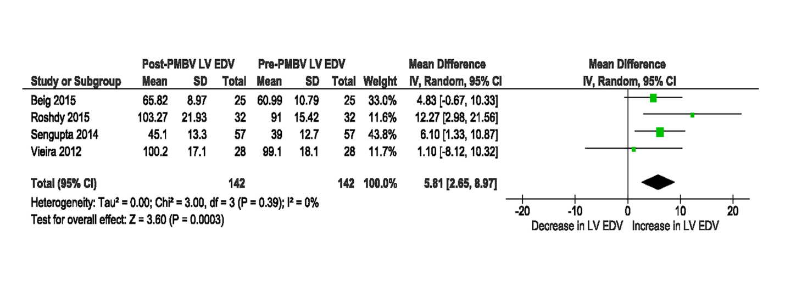

Figure 4
Meta-analysis of five studies reporting LV EDP changes before and after PMBV in 475 MS patients

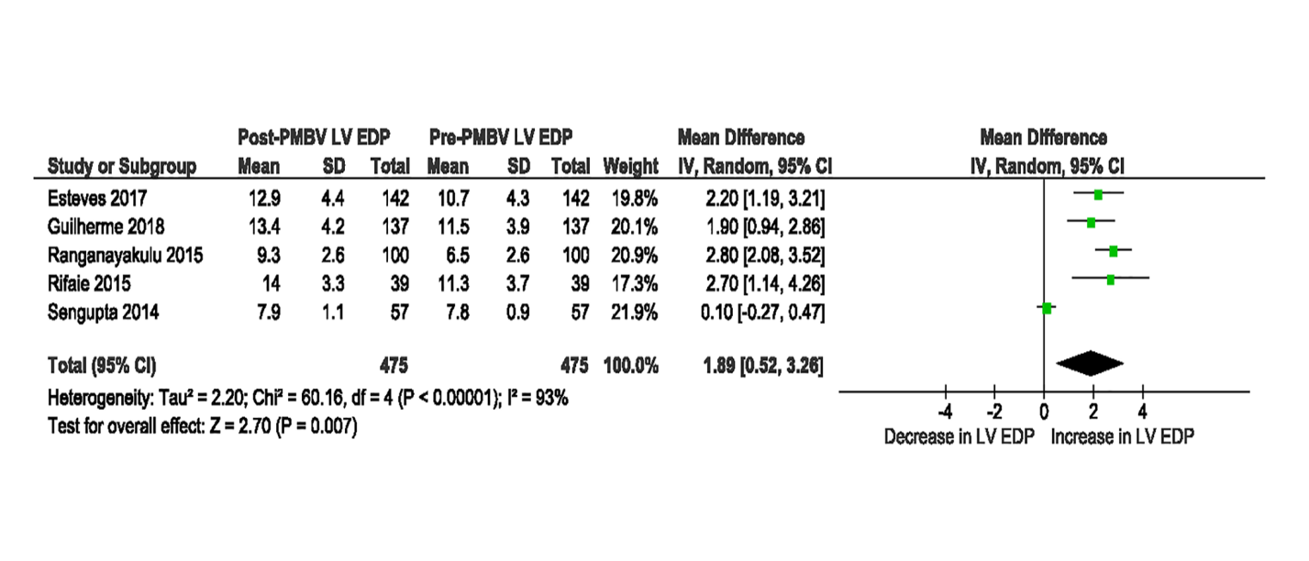

Figure 5

Meta-analysis of studies reporting the incidence of severe MR following PMBV on short term duration (A) and long term duration (B)

A
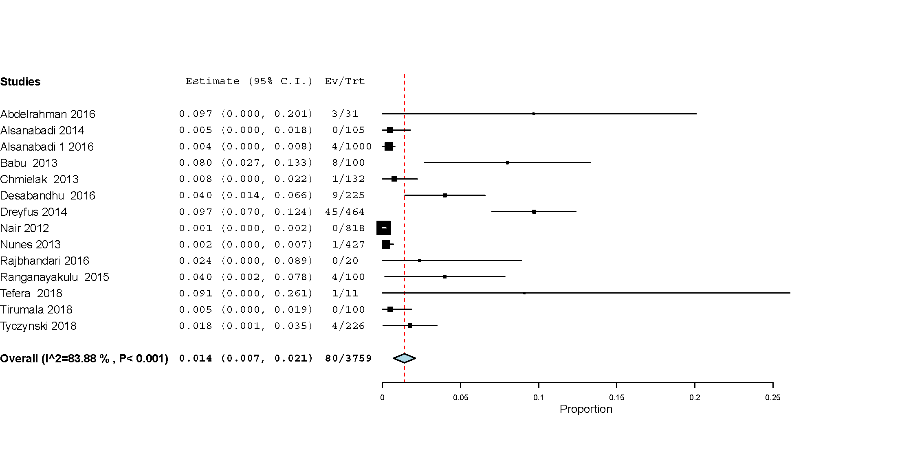
B
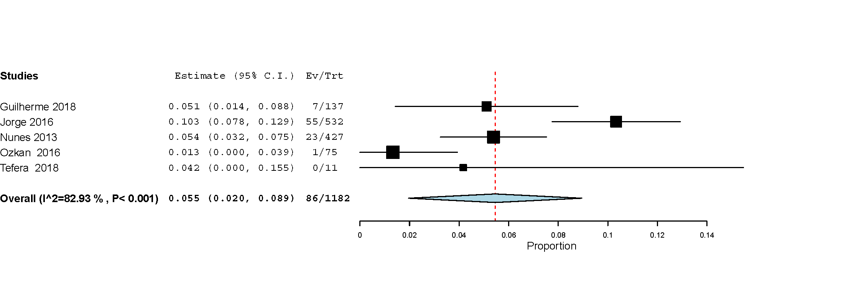

Figure 6
Meta-analysis of studies reporting the incidence of repeat PMBV following PMBV on short term duration (A) and long term duration (B)

A
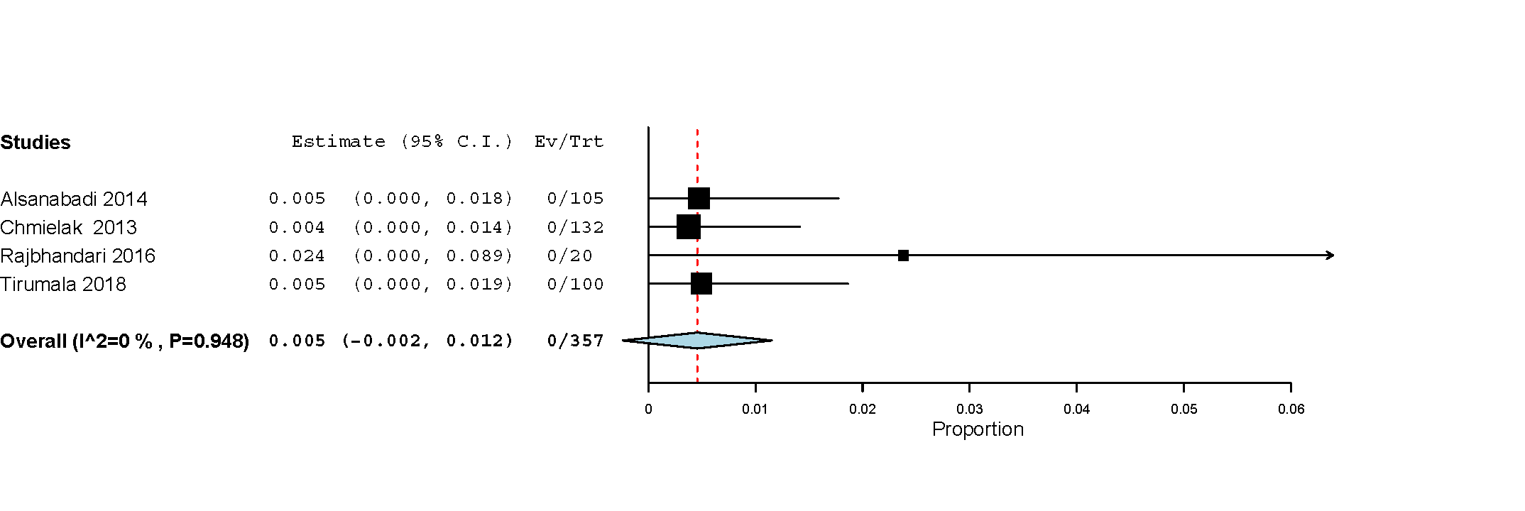
B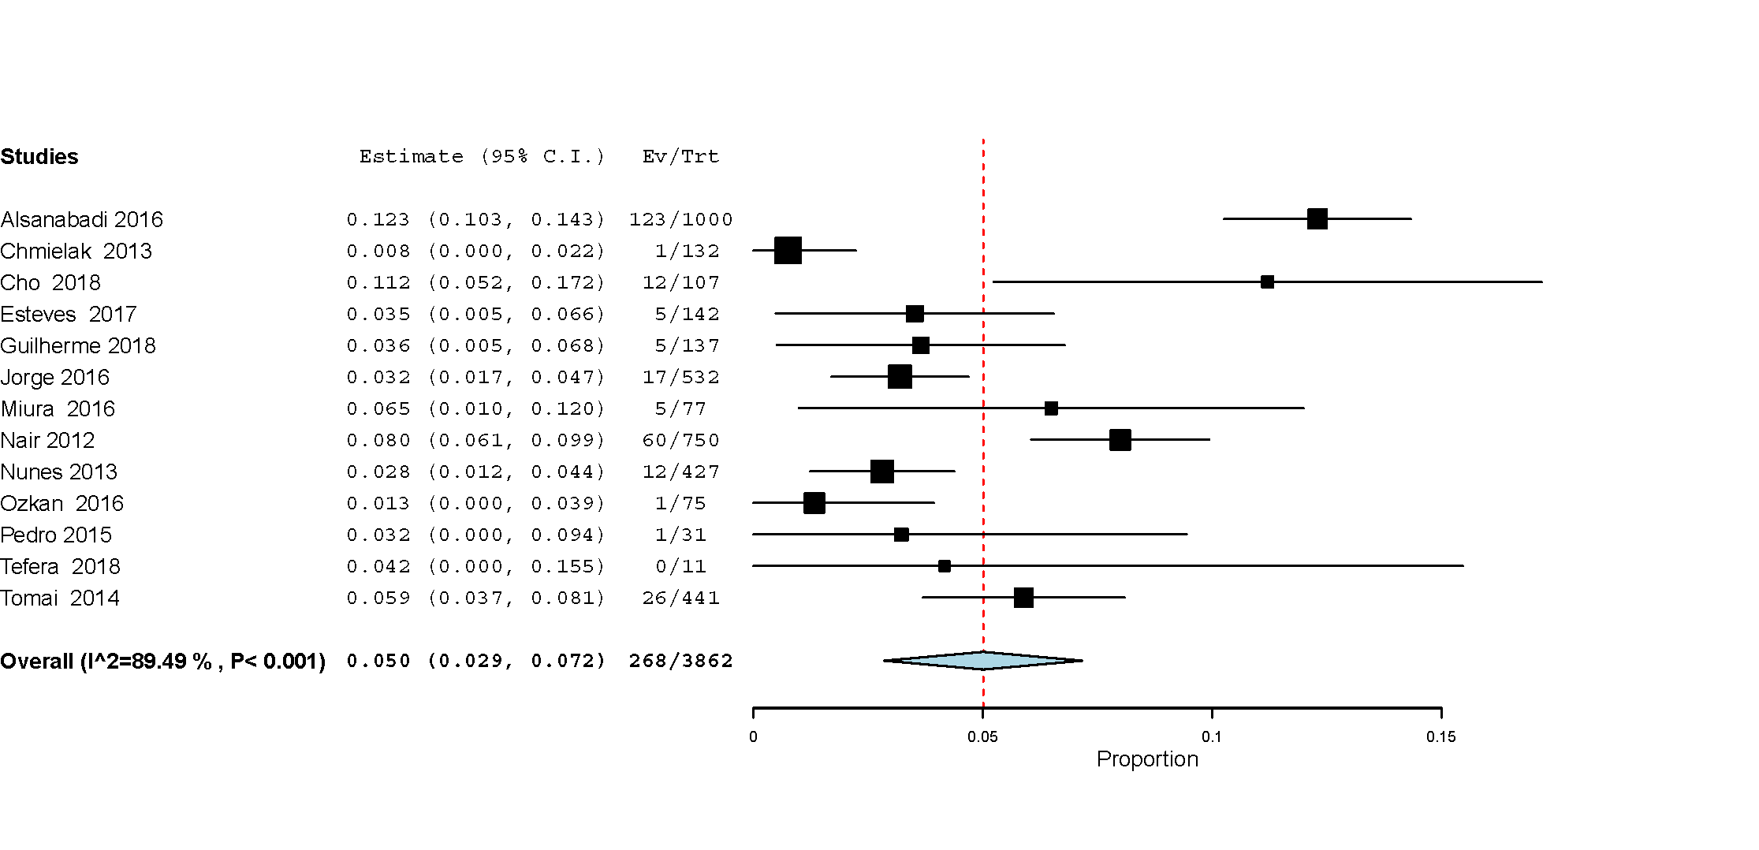
Figure 7
Meta-analysis of studies reporting the incidence of mitral valve surgery following PMBV on short term duration (A) and long term duration (B)

A
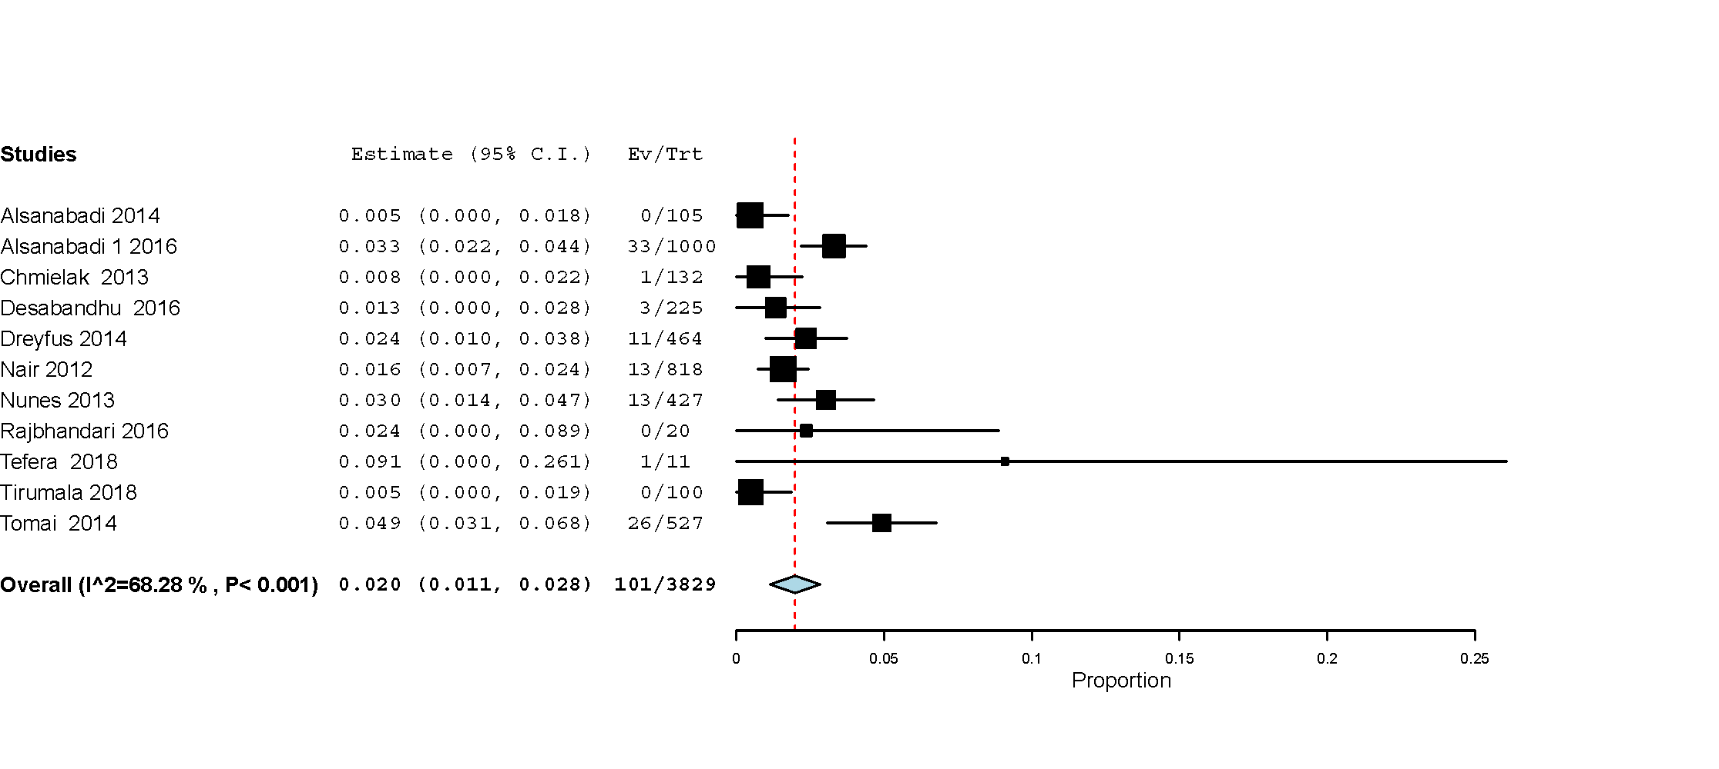
B
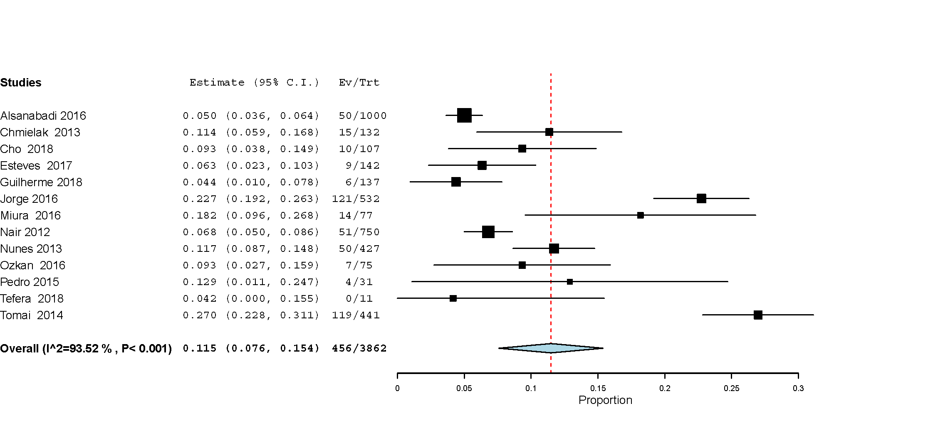

Figure 8
Meta-analysis of studies reporting the incidence of stroke following PMBV on short term duration (A) and long term duration (B)

A
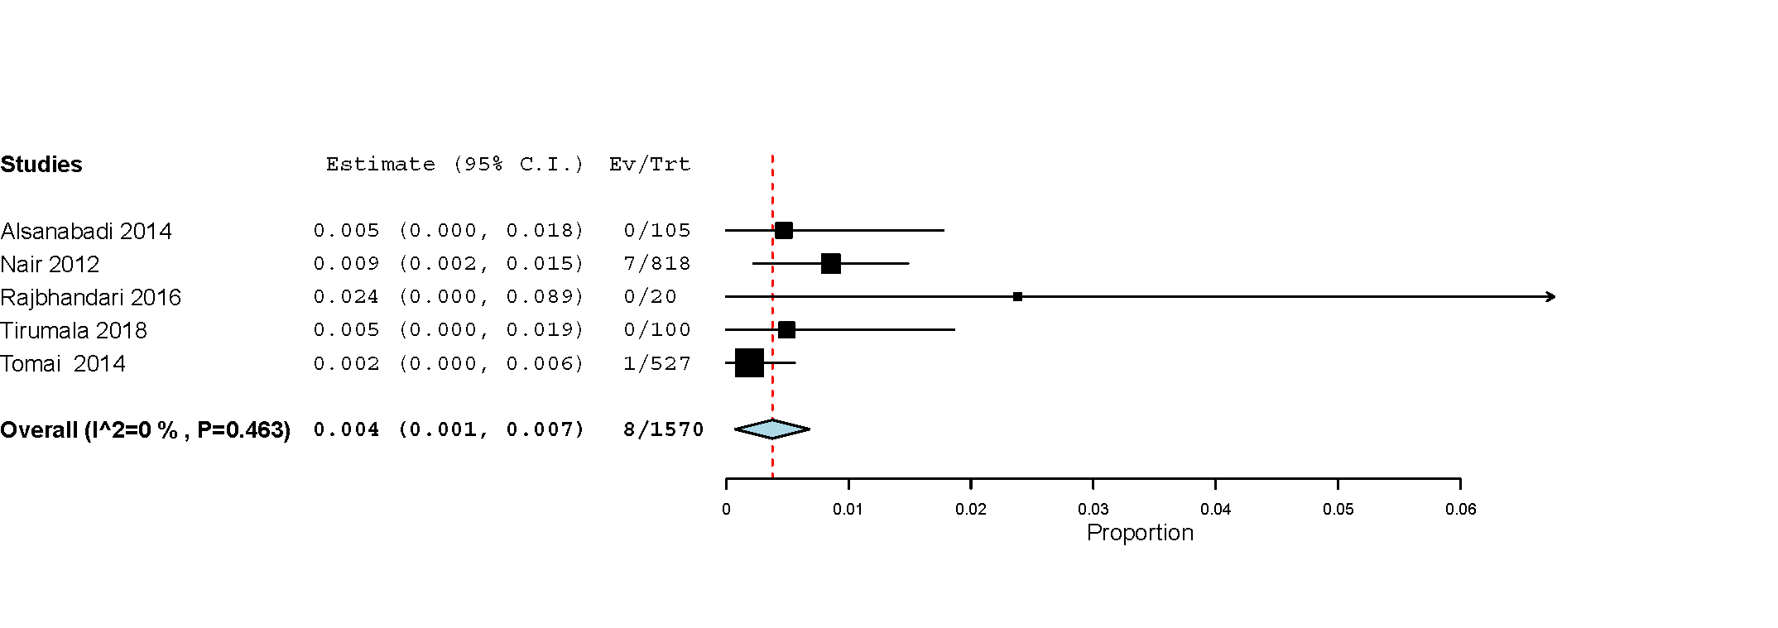
B
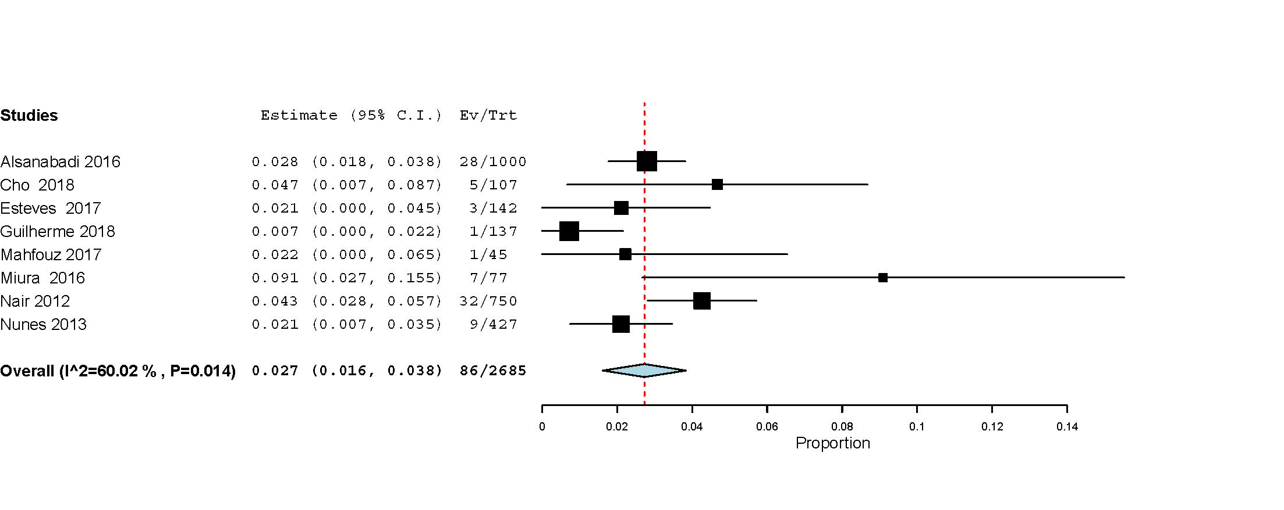

Figure 9
Meta-analysis of studies reporting the incidence of systemic thromboembolism following PMBV on short term duration (A) and long term duration (B)

A
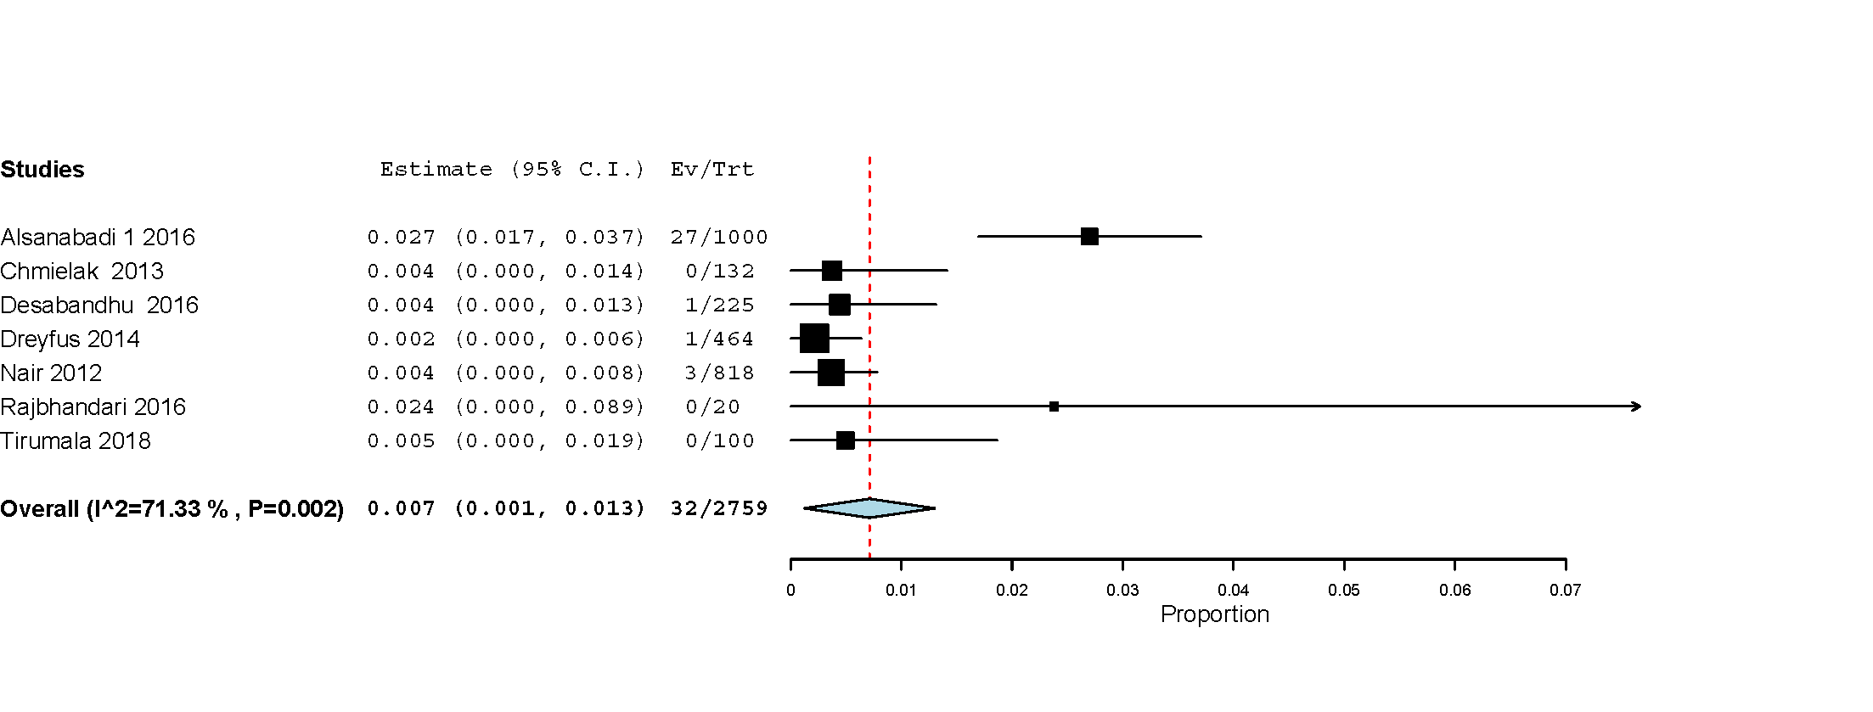
B
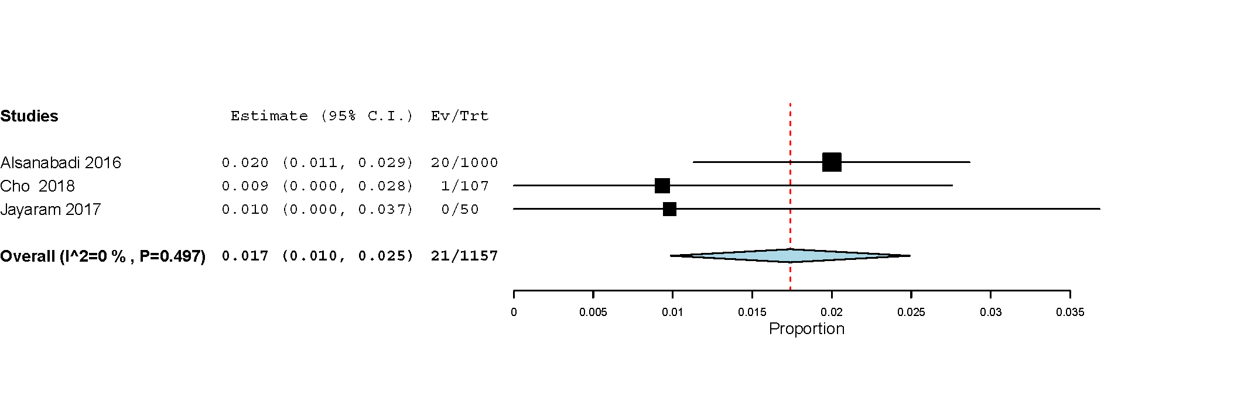

Figure 10
Meta-analysis of studies reporting the incidence of atrial fibrillation following PMBV on short term duration (A) and long term duration (B)

A
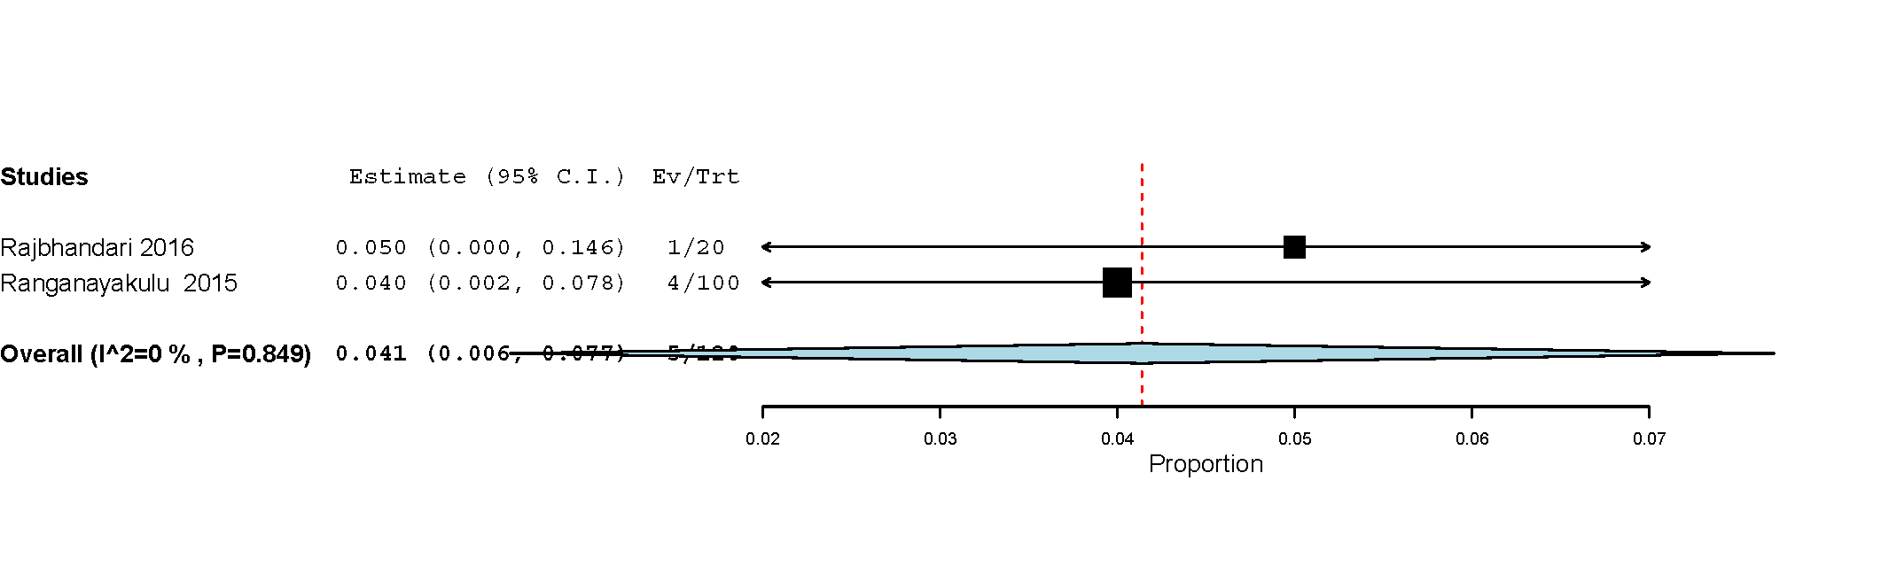
B
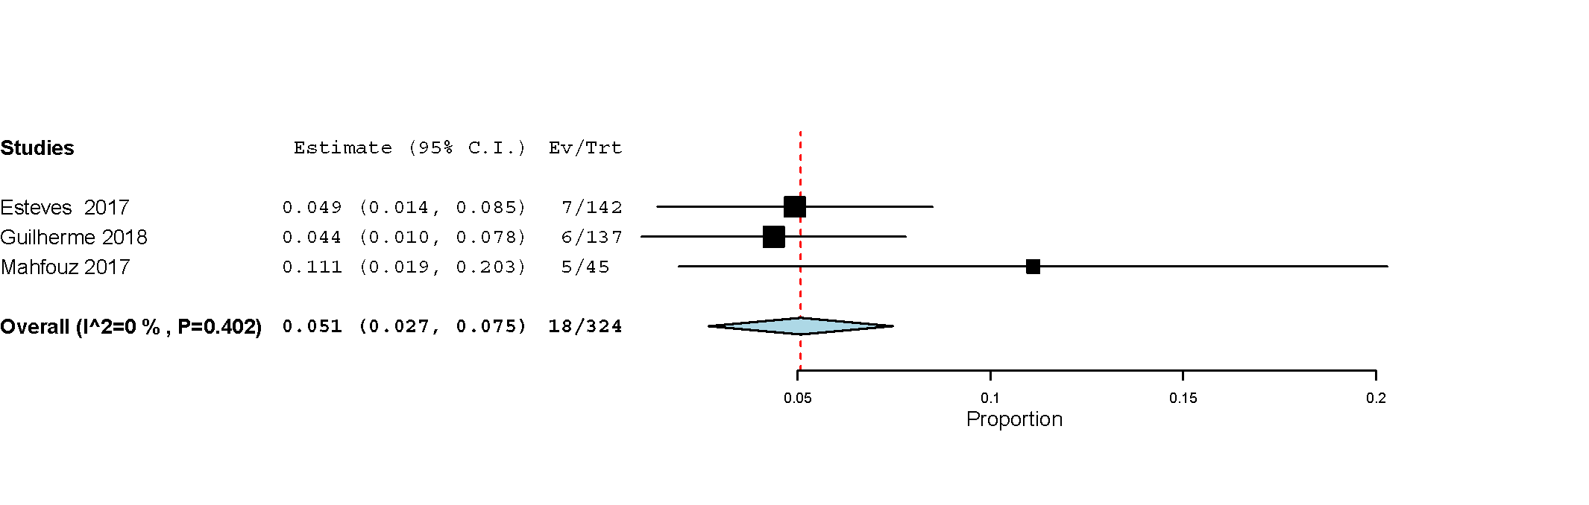

Figure 11
Meta-analysis of studies reporting the incidence of short term cardiac tamponade following PMBV

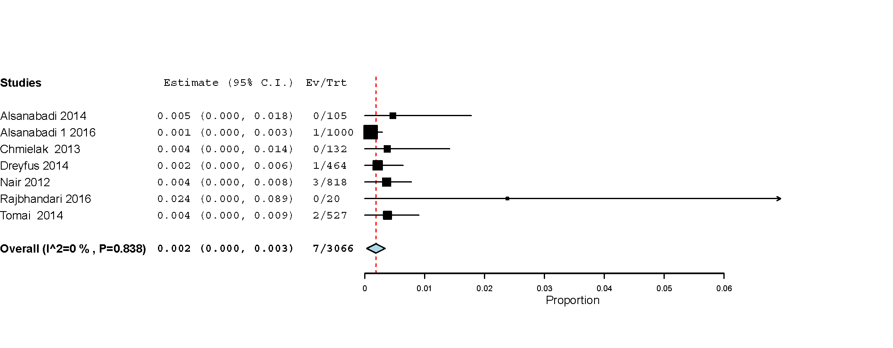

Figure 12
Meta-analysis of studies reporting the incidence of mortality following PMBV on short term duration (A) and long term duration (B)

A

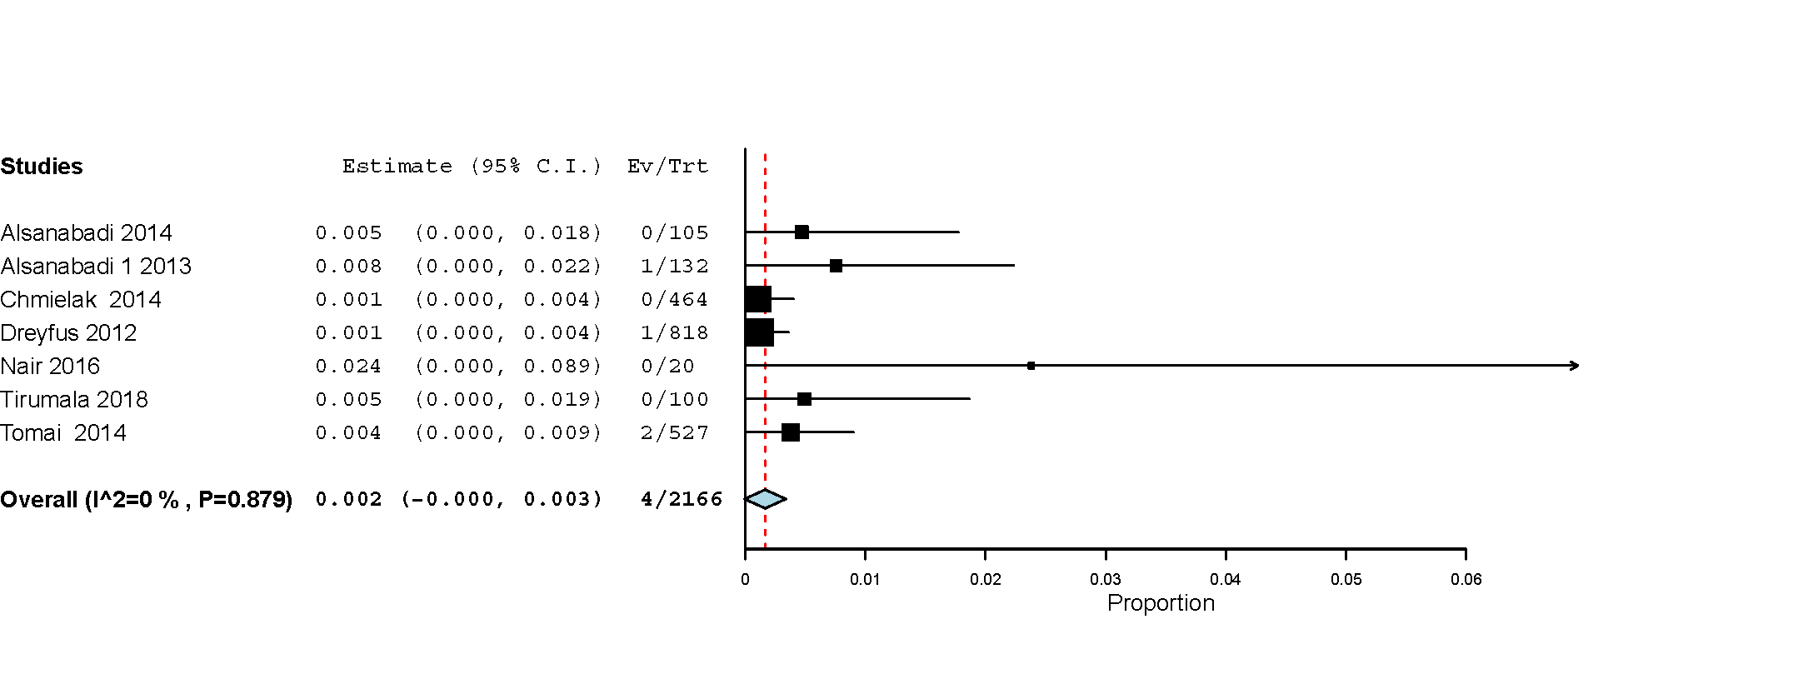
B
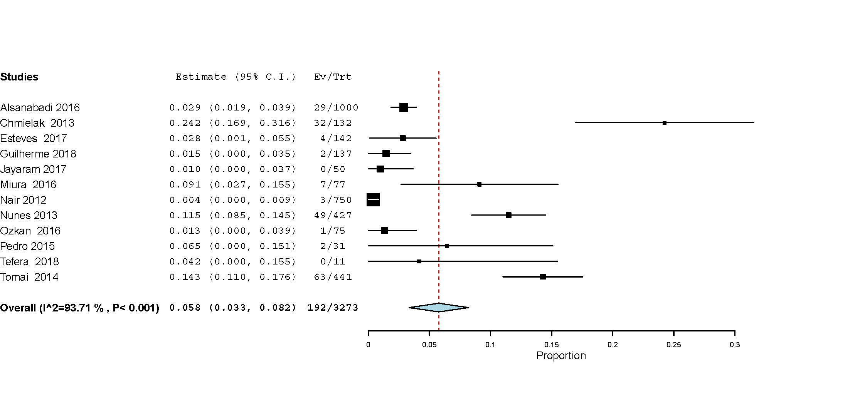

Figure 13

Funnel plot for meta-analysis of 37 studies reporting MVA changes before and after PMBV in 5572 MS patients

Figure 14
Funnel plot for meta-analysis of 31 studies reporting MPG changes before and after PMBV in 5223 MS patients

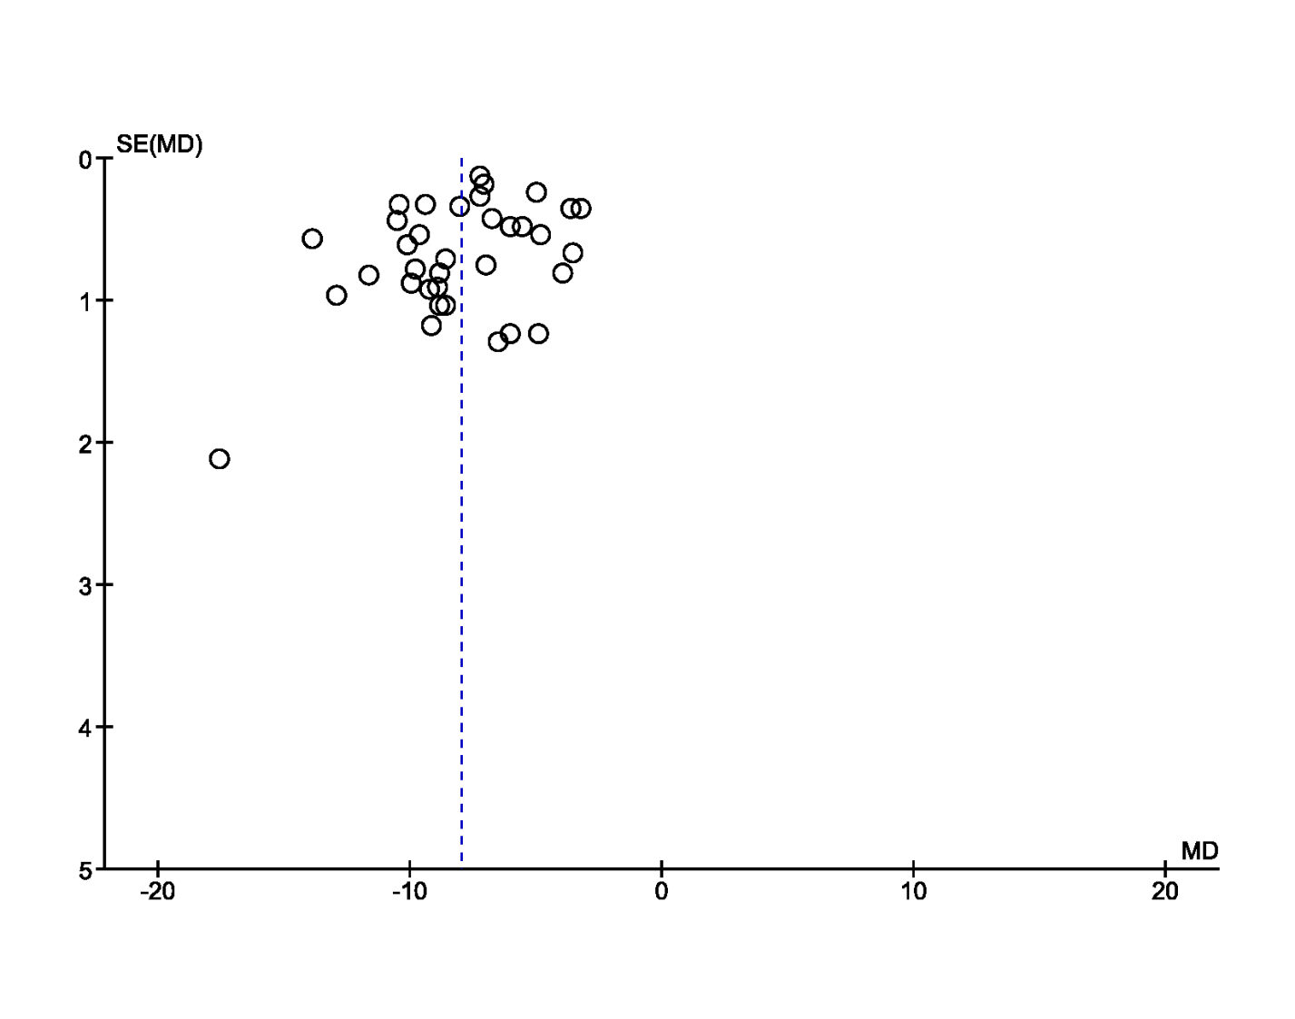

Figure 15
Funnel plot for meta-analysis of 24 studies reporting SPAP changes before and after PMBV in 4146 MS patients

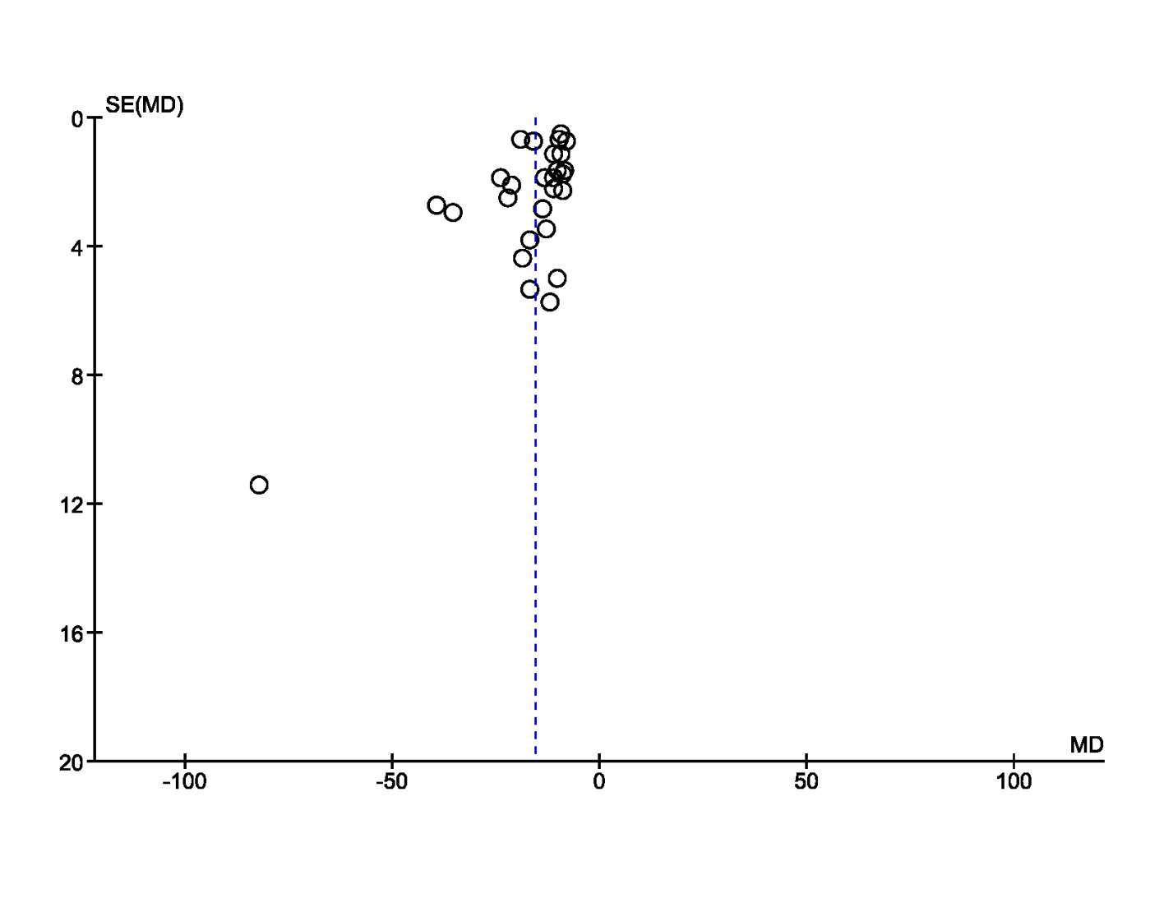

Figure 16

Funnel plot for meta-analysis of 16 studies reporting LAD changes before and after PMBV in 991 MS patients

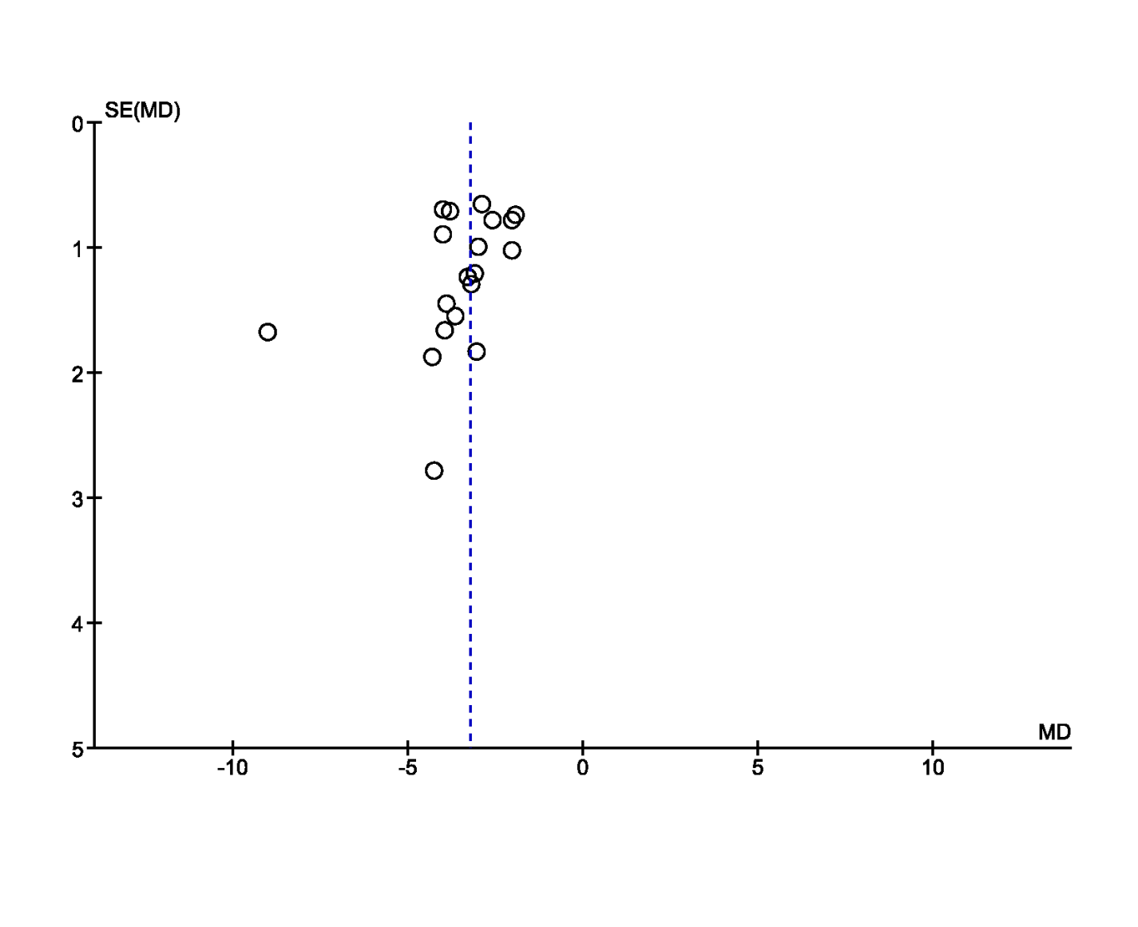

Figure 17
Funnel plot for meta-analysis of 14 studies reporting LAP changes before and after PMBV in 2056 MS patients
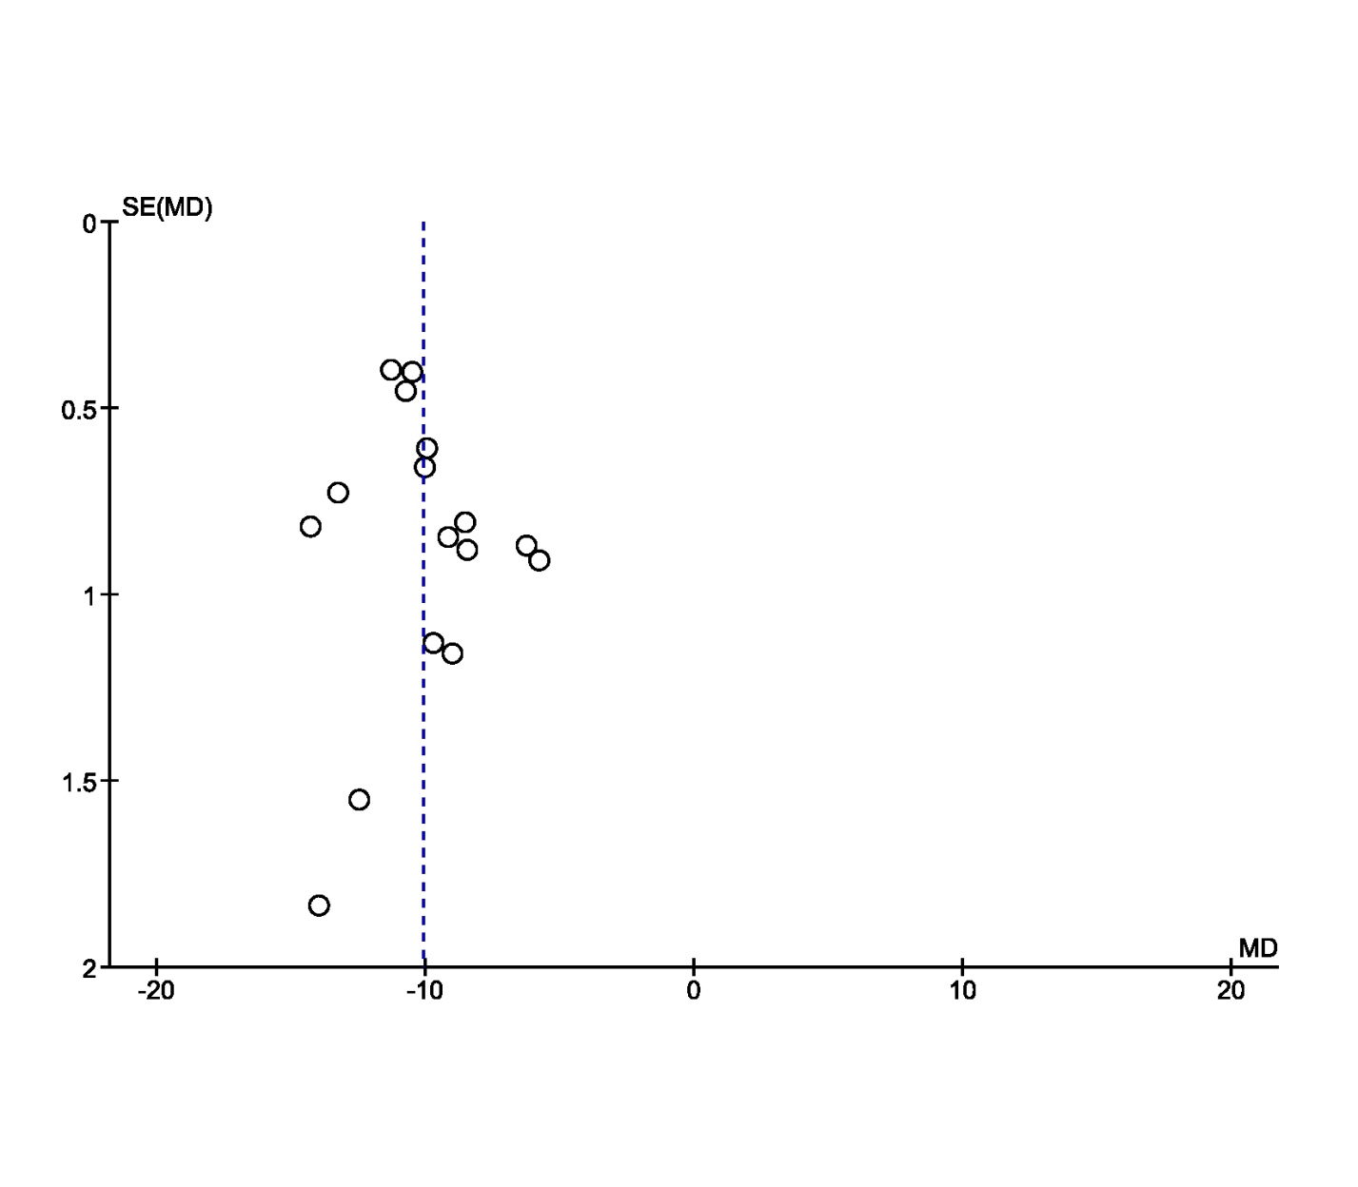

Supplementary Table
Quality appraisal using New Castle Ottawa scale NOS of all included studies
Study | Newcastle-Ottawa Quality Assessment items
Study | Selection |  |  |  | comparability | Outcome |  |  |  |  | Total score | Quality
Study | Representativeness of exposed cohort | Selection of nonexposed cohort | Ascertainment of exposure | Outcome not present at the start | comparability | Assessment of outcome | Sufficient follow-up duration |  |  | Adequate follow-up
Abdelrahman 2016 | * |  | * | * |  | * |  |  |  |  | 4 stars | Fair
Aslanabadi 2014 | * |  | * | * |  | * |  |  |  |  | 4 stars | Fair
Aslanabadi 2016 | * | * | * | * | * | * |  | * |  | * | 8 stars | Good
Babu 2013 | * |  | * | * |  | * |  |  |  |  | 4 stars | Fair
Beig 2015 | * |  | * | * |  | * |  |  |  |  | 4 stars | Fair
Celik 2012 | * | * | * | * | * | * |  |  |  |  | 6 stars | Fair
Chmielak 2013 | * |  | * | * |  | * |  | * |  | * | 6 stars | Fair
Cho 2018 | * | * | * | * | * | * |  | * |  | * | 8 stars | Good
Demirkan 2012 | * | * | * | * | * | * |  |  |  |  | 6 stars | Fair
Deng 2014 | * |  | * | * |  | * |  |  |  |  | 4 stars | Fair
Dreyfus 2014 | * | * | * | * | * | * |  |  |  |  | 6 stars | Fair
Esteves 2013 | * |  | * | * |  | * |  |  |  |  | 4 stars | Fair
Esteves 2017 | * |  | * | * |  | * |  | * |  | * | 6 stars | Fair
Guilherme 2018 | * |  | * | * |  | * |  | * |  | * | 6 stars | Fair
Hasan 2014 | * | * | * | * | * | * |  |  |  |  | 6 stars | Fair
İnci 2014 | * |  | * | * |  | * |  | * |  | * | 6 stars | Fair
Jayaram 2017 | * |  | * | * |  | * |  | * |  | * | 6 stars | Fair
Jorge 2016 | * |  | * | * |  | * |  | * |  | * | 6 stars | Fair
Kumar 2014 | * | * | * | * | * | * |  |  |  |  | 6 stars | Fair
Lee 2017 | * |  | * | * | * | * |  | * |  | * | 7 stars | Good
Lu 2016 | * | * | * | * | * | * |  |  |  |  | 6 stars | Fair
Mahfouz 2017 | * | * | * | * | * | * |  |  |  |  | 6 stars | Fair
Morttada 2014 | * |  | * | * |  | * |  |  |  |  | 4 stars | Fair
Miura 2016 | * | * | * | * | * | * |  | * |  | * | 8 stars | Good
Nair 2012 | * | * | * | * | * | * |  |  | * | * | 8 stars | Good
Nunes 2017 | * |  | * | * |  | * |  |  |  |  | 4 stars | Fair
Omaygenḉ 2015 | * |  | * | * |  | * |  |  |  |  | 4 stars | Fair
Ozkan 2016 | * |  | * | * |  | * |  |  | * | * | 6 stars | Fair
Pedro 2015 | * |  | * | * |  | * |  |  | * | * | 6 stars | Fair
Rajbhandari 2016 | * |  | * | * |  | * |  |  |  |  | 4 stars | Fair
Ranganayakulu 2015 | * |  | * | * |  | * |  |  |  |  | 4 stars | Fair
Rifaie 2015 | * |  | * | * |  | * |  |  |  |  | 4 stars | Fair
Roushdy 2015 | * | * | * | * | * | * |  |  |  |  | 6 stars | Fair
Saad 2015 | * |  | * | * |  | * |  |  |  |  | 4 stars | Fair
Safi 2017 | * | * | * | * | * | * |  |  |  |  | 6 stars | Fair
Sengupta 2014 | * | * | * | * | * | * |  |  |  |  | 6 stars | Fair
Sowdagar 2017 | * | * | * | * | * | * |  |  |  |  | 6 stars | Fair
Tefera 2018 | * |  | * | * |  | * |  |  |  |  | 4 stars | Fair
Tirumala 2018 | * |  | * | * |  | * |  |  |  |  | 4 stars | Fair
Tomai 2014 | * |  | * | * |  | * |  |  | * | * | 6 stars | Fair
Tyczyński 2018 | * | * | * | * | * | * |  |  |  |  | 5 stars | Fair
Vieira 2012 | * |  | * | * |  |  |  |  |  |  | 3 stars | Fair
Vilvanathan 2016 | * | * | * | * | * |  |  |  |  |  | 5 stars | Fair
Vinayakumar Desabandhu 2016 | * | * | * | * | * | * |  |  |  |  | 6 stars | Fair

