Supplementary files
Search Strategy
- Pelvis OR Pelvic
- Packing OR tamponade OR preperitoneal packing OR retroperitoneal packing
- Angio OR angioembolisation OR angioembolization OR embolization OR angiography
- 1 AND 2 AND 3

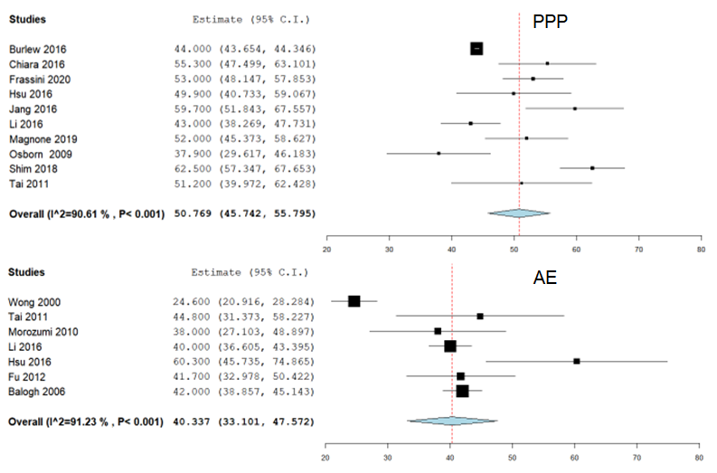
Supp Fig 1- Age PPP and AE

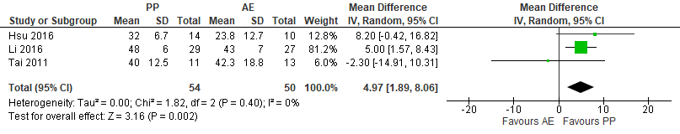
Supp Fig 2- Age Dual arm studies

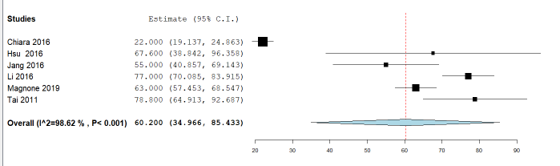
Supp Fig 3 – Injury Severity Score Dual arm studies

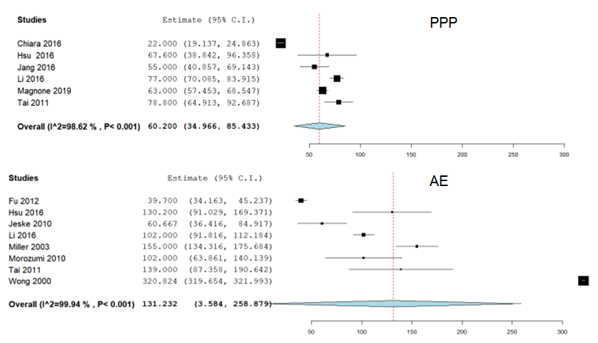
Supp Fig 4 – Time to intervention Pre-peritoneal Packing and Angioembolization

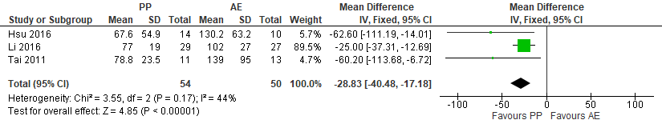
Supp Fig 5- Time to intervention – Dual Arm studies

