Additional file: S1 Table Quality assessment of included cohort studies by the Newcastle-Ottawa Scale (NOS).
Study ID | Selection |  |  |  | Comparability | Outcome |  |  | Overall scores
Study ID | Representativeness of the exposed cohort | Selection of the non-exposed cohort | Ascertainment of exposure | Demonstration that outcome of interest was not present at start of study | Comparability of cohorts on the basis of the design or analysis | Assessment of outcome | Was follow-up long enough for outcomes to occur | Adequacy of follow up of cohorts | Overall scores
Sun 2021^{[32]} | 1 | 1 | 1 | 0 | 1 | 1 | 1 | 1 | 7
Zhao 2020^{[49]} | 1 | 1 | 1 | 0 | 1 | 1 | 1 | 1 | 7
Tan 2016^{[33]} | 1 | 1 | 1 | 0 | 1 | 1 | 1 | 1 | 7
Zhuang 2017^{[52]} | 1 | 1 | 1 | 1 | 1 | 1 | 1 | 1 | 8
Cai 2019^{[13]} | 1 | 1 | 1 | 1 | 1 | 1 | 1 | 1 | 8
Zhang 2020^{[46]} | 1 | 1 | 1 | 0 | 1 | 1 | 1 | 1 | 7
Cui 2016^{[16]} | 1 | 1 | 1 | 1 | 1 | 1 | 1 | 0 | 7

Additional file: S2 Table Quality assessment of included cross-sectional studies by the Agency for Healthcare Research and Quality (AHRQ) Methodology Checklist.
Study ID | Define the source of information (survey, record review) | List inclusion and exclusion criteria for exposed and unexposed subjects (cases and controls) or refer to previous publications | Indicate time period used for identifying patients | Indicate whether or not subjects were consecutive if not population-based | Indicate if evaluators of subjective components of study were masked to other aspects of the status of the participants | Describe any assessments undertaken for quality assurance purposes (e.g., test/retest of primary outcome measurements) | Explain any patient exclusions from analysis | Describe how confounding was assessed and/or controlled | If applicable, explain how missing data were handled in the analysis | Summarize patient response rates and completeness of data collection | Clarify what follow-up, if any, was expected and the percentage of patients for which incomplete data or follow-up was obtained
Bao 2017^{[12]} | Yes | Yes | Yes | Yes | No | Yes | No | Yes | No | No | Yes
Chen 2018^{[15]} | Yes | Yes | Yes | Yes | No | Yes | No | Yes | No | No | No
Gong 2017^{[18]} | Yes | Yes | Yes | Yes | No | Yes | No | No | No | No | No
Guo 2019^{[19]} | Yes | No | Yes | Yes | No | Yes | No | No | No | No | No
He 2019^{[20]} | Yes | Yes | Yes | Yes | No | Yes | No | No | No | No | No
Kang 2019^{[24]} | Yes | No | Yes | Yes | No | Yes | No | No | No | No | No
Liu 2020^{[28]} | Yes | Yes | Yes | Yes | No | Yes | Yes | Yes | Yes | Yes | No
Sheng 2018^{[30]} | Yes | Yes | Yes | Yes | No | Yes | No | No | No | Yes | Yes
Tang 2019^{[35]} | Yes | Yes | Yes | Yes | No | Yes | No | No | No | Yes | Yes
Wang 2020^{[39]} | Yes | No | Yes | Yes | No | Yes | No | No | No | No | No
Wang F 2019^{[39]} | Yes | No | Yes | Yes | No | No | No | No | No | No | No
Wen 2021^{[41]} | Yes | No | Yes | Yes | No | No | No | No | No | No | No
Wu 2016^{[42]} | Yes | No | Yes | Yes | No | Yes | No | No | No | Yes | No
Ying 2019^{[43]} | Yes | No | Yes | Yes | Yes | Yes | No | No | No | No | No
Zhang Y 2020^{[48]} | Yes | Yes | Yes | Yes | Yes | Yes | No | No | No | Yes | Yes
Zhong 2018^{[50]} | No | Yes | Yes | Yes | No | Yes | No | No | No | No | No
Zhou 2019^{[51]} | Yes | Yes | Yes | Yes | No | Yes | No | Yes | Yes | Yes | No
Zou 2020^{[53]} | Yes | No | Yes | Yes | No | Yes | No | No | No | No | No
Liu 2019^{[27]} | Yes | No | Yes | Yes | Unclear | No | No | No | No | Yes | No
Liang 2017^{[26]} | Yes | Yes | Yes | Yes | No | Yes | No | No | No | Yes | No
Wang A 2019^{[37]} | Yes | No | Yes | Yes | No | Yes | No | No | No | No | No
Li 2016^{[25]} | Yes | Yes | Yes | Yes | No | Yes | No | No | No | Yes | Yes
Sun 2017^{[31]} | Yes | No | Yes | Yes | No | Yes | No | No | No | No | No
Wei 2019^{[40]} | Yes | No | Yes | Yes | No | Yes | No | No | No | Yes | No
Wang 2018^{[36]} | Yes | No | Yes | Yes | No | Yes | No | No | No | No | No
Zhang 2016^{[45]} | Yes | Yes | Yes | Yes | No | Yes | Yes | No | No | Yes | No
Zeng 2019^{[44]} | Yes | No | Yes | Yes | No | Yes | No | No | No | Yes | No
Huang 2017^{[22]} | Yes | Yes | Yes | Yes | No | Yes | Yes | Unclear | No | Yes | No
Ma 2019^{[29]} | Yes | No | Yes | Yes | No | Yes | No | No | No | No | No
Huang 2020^{[23]} | Yes | No | Yes | Yes | No | Yes | No | No | No | Yes | No
Du 2021^{[17]} | Yes | No | Yes | Yes | No | Yes | No | No | No | No | No
Zhang Q 2020^{[47]} | Yes | No | Yes | Yes | No | Yes | No | No | No | No | No
Chen 2016^{[14]} | Yes | No | Yes | Yes | No | Yes | No | No | No | No | No
Hu 2018^{[21]} | Yes | No | No | Yes | No | No | No | No | No | No | No
Tang 2017^{[34]} | Yes | No | Yes | Yes | No | No | No | No | No | No | No

Additional file: S figure1. Forest of subgroup by regional disparities
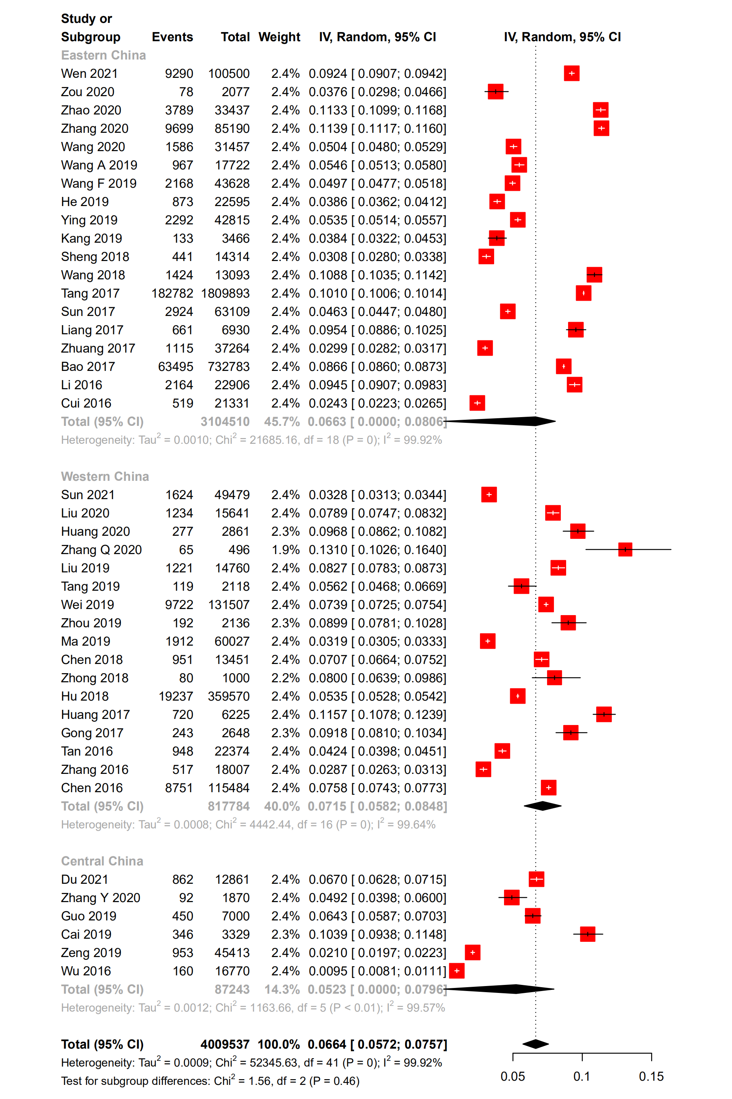
Additional file: S figure2. Forest of subgroup by economic level
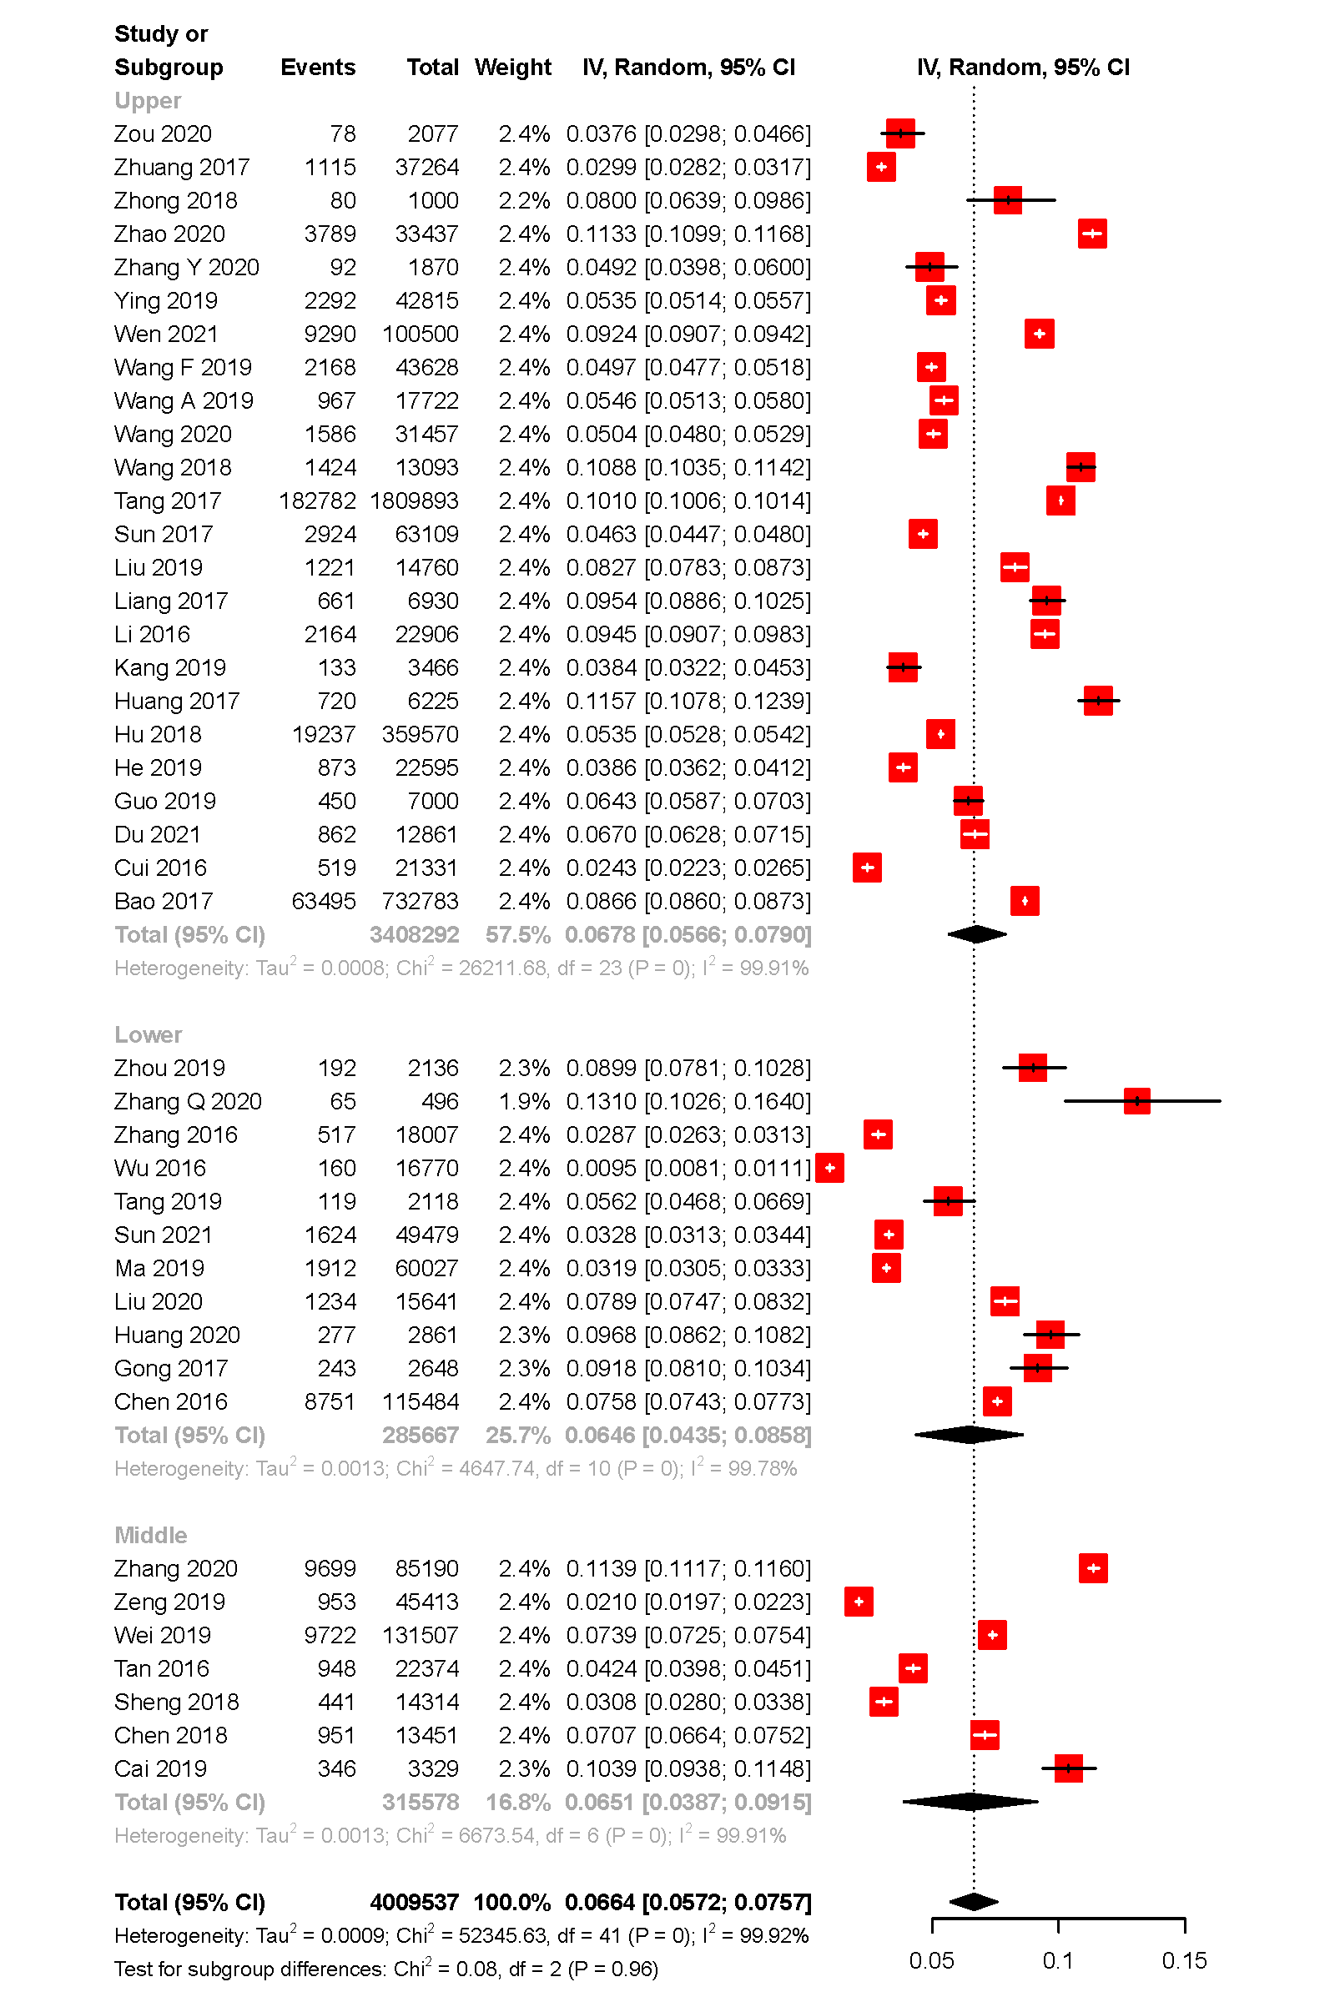
Additional file: S figure3. Forest of subgroup by source of data
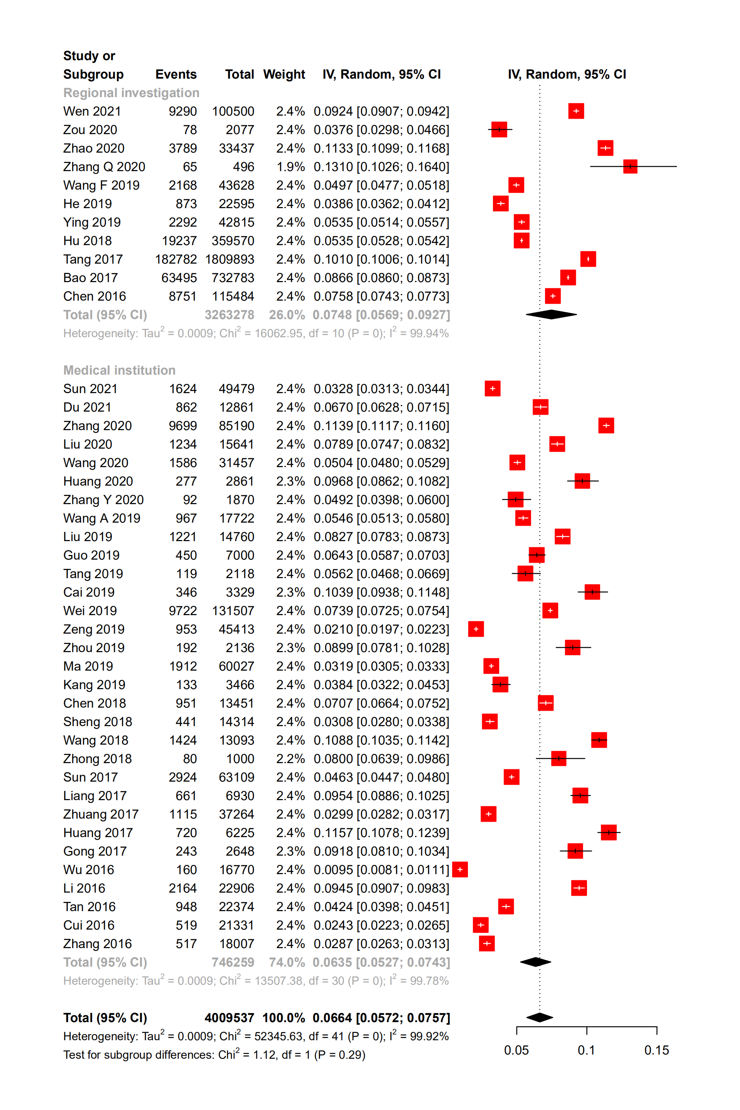
Additional file: S figure4. Forest of subgroup by study design


