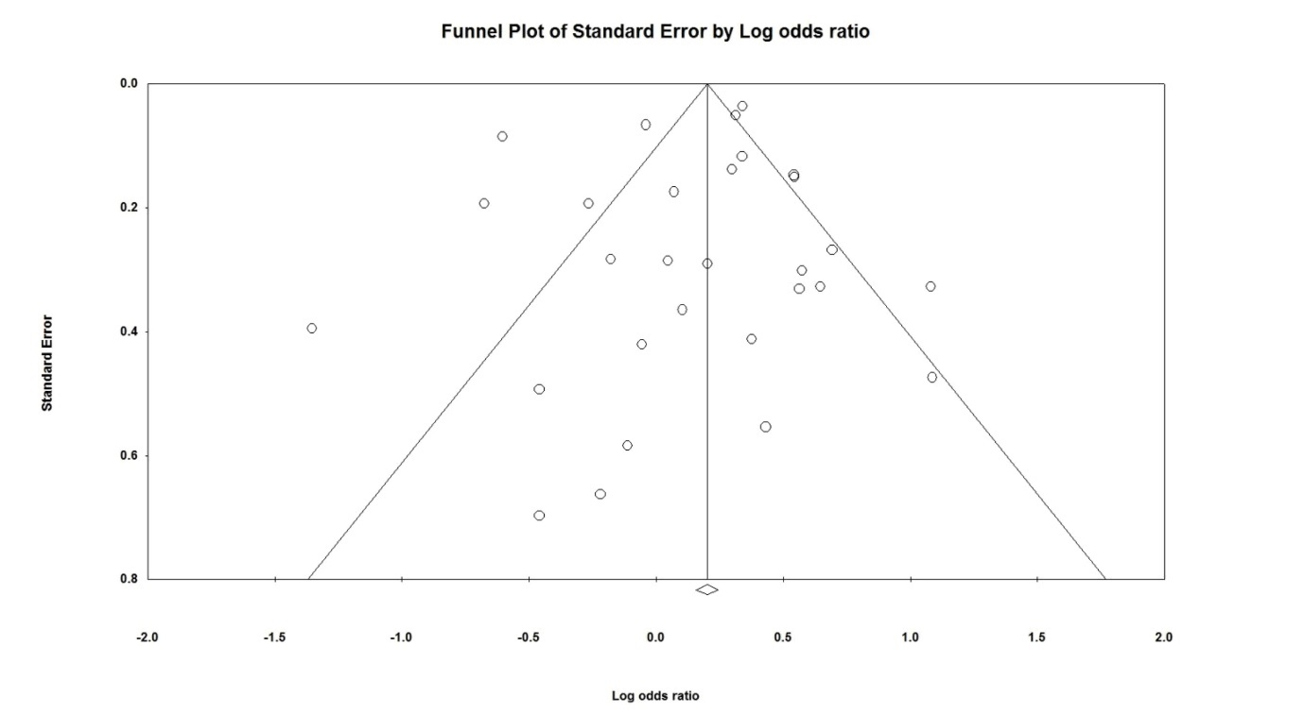
Supplementary Fig. 1. Funnel plot for the relationship between maternal pre-eclampsia and neonatal bronchopulmonary dysplasia defined as an oxygen requirement at 36 weeks of gestation.

