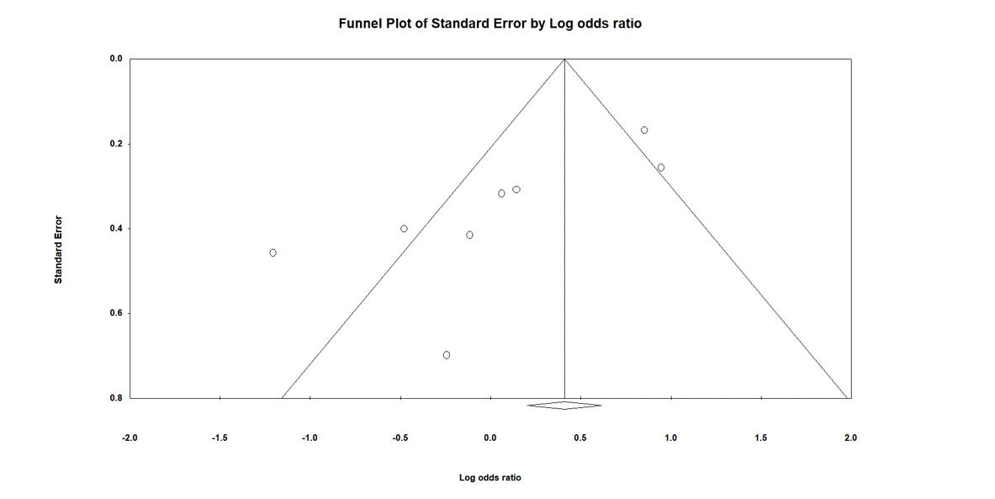
Supplementary Fig. 3. Funnel plot the relationship between maternal pre-eclampsia and neonatal bronchopulmonary dysplasia defined as an oxygen requirement at 28 days of age. An asymmetrical funnel plot indicated possible publication bias, thus, we performed a trim and fill adjustment.

