(A)
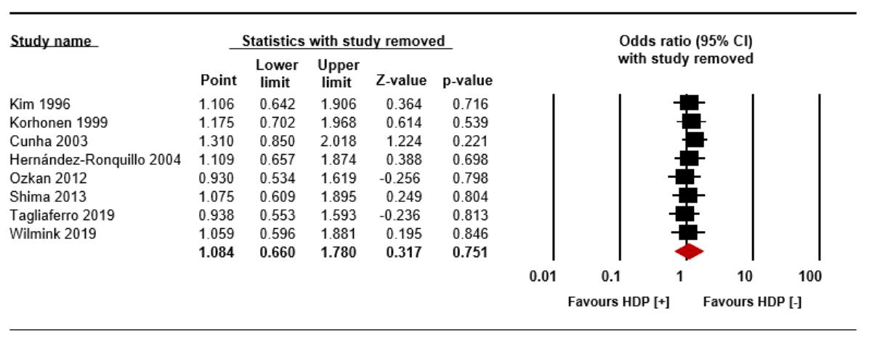
(B)
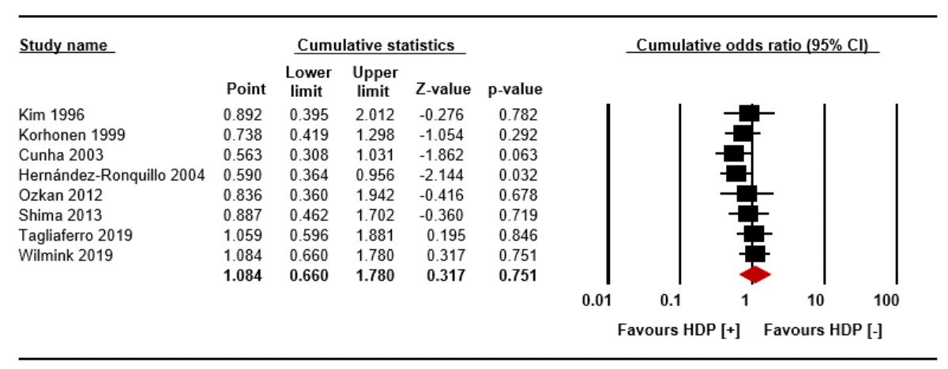
Supplementary Fig. 4. Sensitivity analysis (A) and cumulative analysis (B) for the relationship between maternal pre-eclampsia and neonatal bronchopulmonary dysplasia defined as an oxygen requirement at 28 days of age.
HDP = hypertension during pregnancy, CI = confidence interval.

