Supplementary material 2. Meta-analyses of primary outcomes grouped by intervention drug and follow-up period, and meta-analyses of secondary outcomes.
- All-cause mortality by intervention drug and follow-up

- Cardiovascular mortality by intervention drug and follow-up
- HF hospitalization by intervention drug and follow-up
- HF urgent visit by intervention drug and follow-up
- HF hospitalization or HF urgent visit by intervention drug and follow-up
- Cardiovascular mortality or HF hospitalization by intervention drug and follow-up

- Cardiovascular mortality, HF hospitalization or HF urgent visit by intervention drug and follow-up

- NT-proBNP by follow-up by intervention drug and follow-up

- KCCQ by follow-up by intervention drug and follow-up

- Any renal adverse event

- Any serious adverse events

- Amputation

- Atrial fibrillation

- Beta hydroxybutyrate

- Creatinine (umol/L)

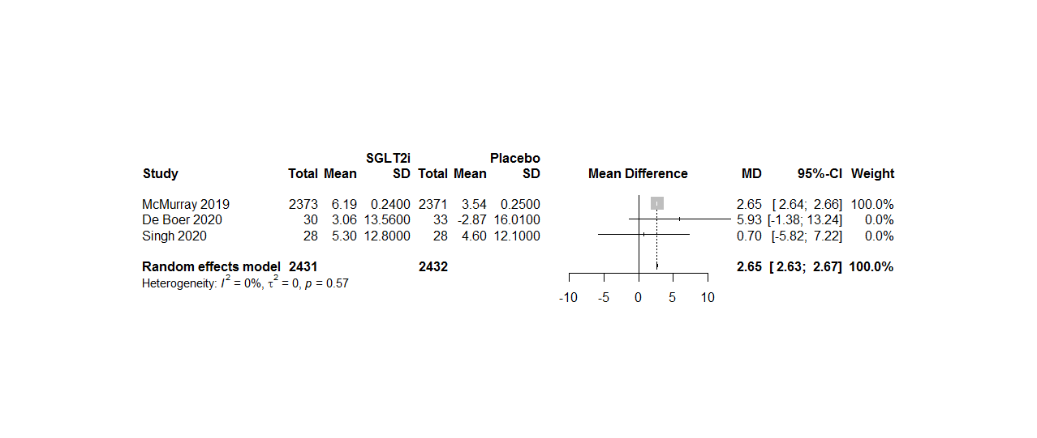
- Systolic blood pressure
- Diastolic blood pressure
- Volume depletion
- Discontinuation due to adverse events

- Estimated glomerular filtration rate

- Fracture

- Glycated hemoglobin

- Hematocrit
- Hypoglycemia
- Hypotension
- Indexed left atrial volume
- Infection

- Left ventricular ejection fraction
- Weight
SGLT2i: sodium/glucose cotransporter-2 inhibitors. CI: confidence interval. RR: risk ratio. MD: mean difference. SD: standard deviation. SMD: standardized mean difference. CI: confidence interval. HF: heart failure. KCCQ: Kansas City Cardiomyopathy Questionnaire.

