Supplementary Material
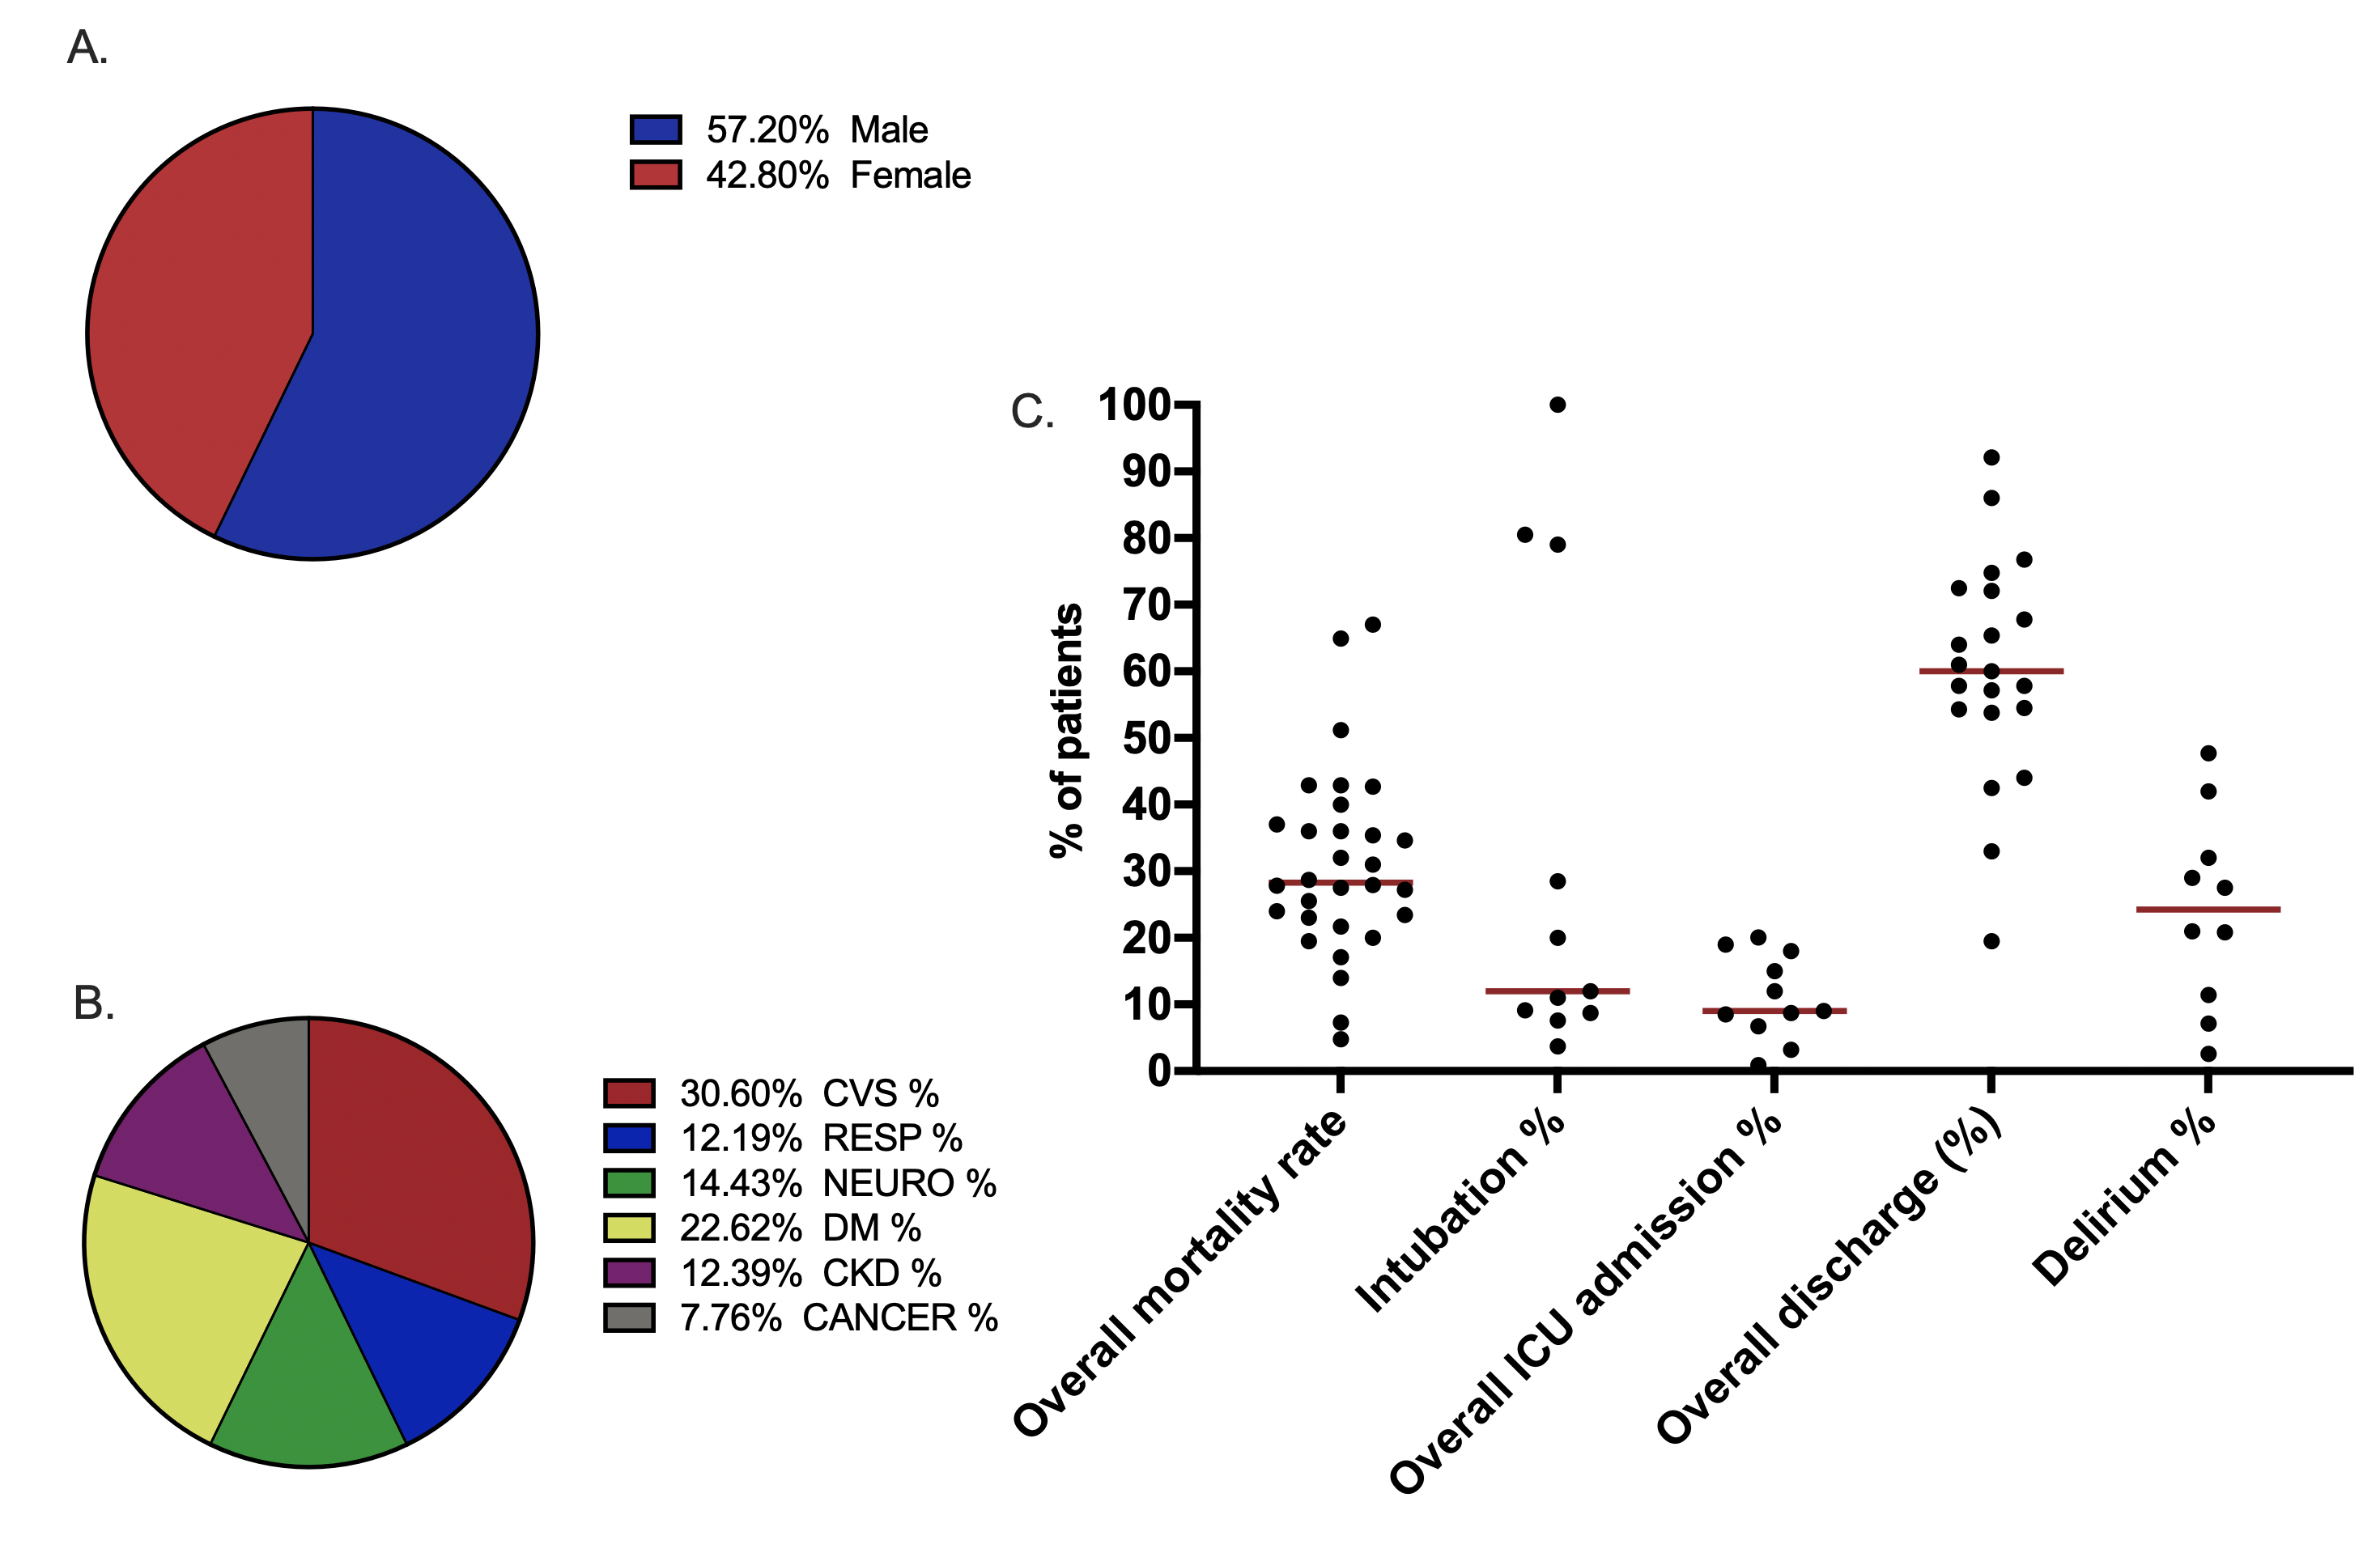
Fig. S1. Overall observational study collective characteristics. COVID-19 positive patient gender pie chart (A), COVID-19 positive patient comorbidities pie chart (B), overall mortality rate, intubation %, ICU admission %, discharge %, delirium incidence %. (C) Graphs were designed using GraphPad Prism V 9.0

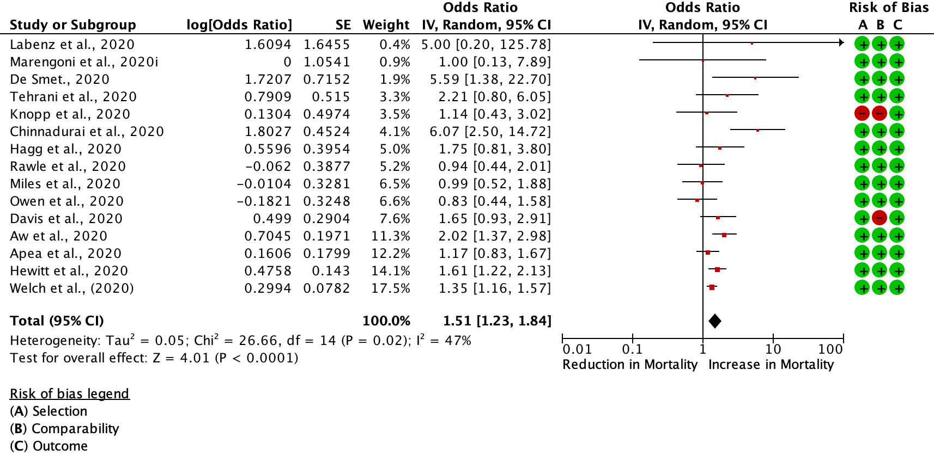
Fig. S2. DerSimonian and Laird statistical method with random effects analysis model and odds ratio as output only for included observational studies. Forrest plot of included observational studies of the meta-analysis (patients with CFS 4-5 COVID-19 mortality vs. patients with CFS 6-9 COVID-19 mortality), representing respective reduction or increase in mortality in the frailest population, random effects odds ratio 1.51 (1.23, 1.84; I² 47% Forrest and funnel plots (Fig. S3) were generated with Review Manager V. 5.4 Cochrane Tool for meta-analysis.
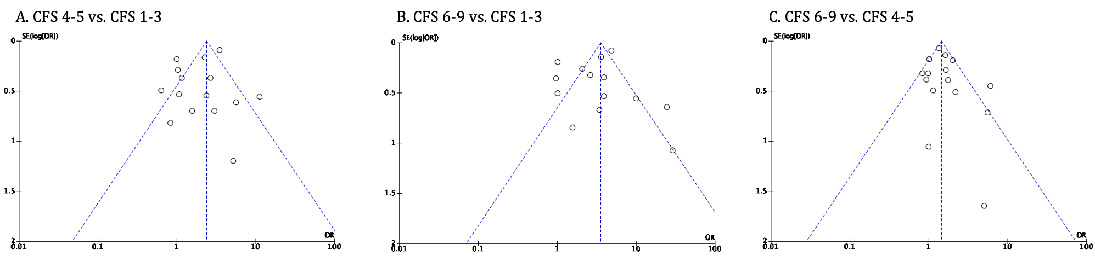Fig. S3. Publication bias plots for Fig. 2 (A), Fig.3 (B) and Fig. S2 (C)

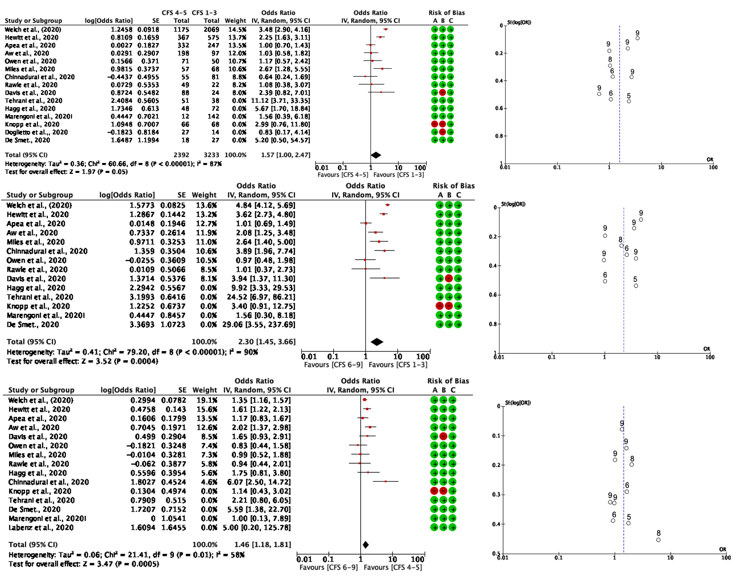
Fig. S4. DerSimonian and Laird statistical method and odds ratio as output only for included observational studies. Forrest plot of included observational studies of the meta-analysis (patients with CFS 4-5 COVID-19 mortality vs. patients with CFS 6-9 COVID-19 mortality) controlled for SE log (OR) 0-0.6 and mapped to respective total NOS scale score. Forest and funnel plots were generated with Review Manager V. 5.4 Cochrane Tool for meta-analysis.
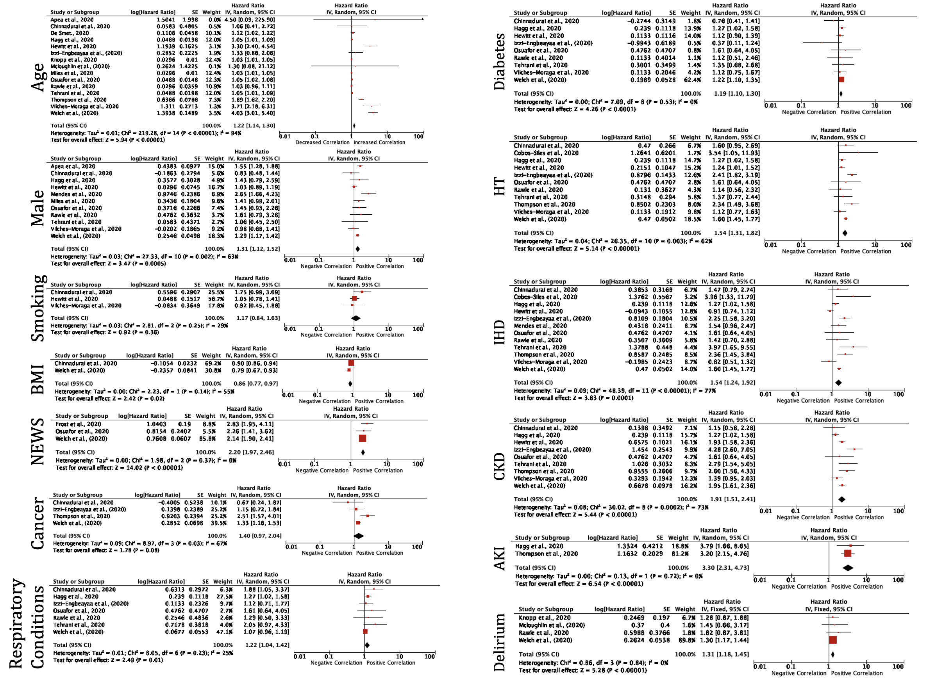
Fig. S5. Generic Inverse Variance analysis of crude (unadjusted) hazard ratio (95% CI) as reported in each study. NEWS: National Early Warning Score; HT: Hypertension; IHD: Ischaemic Heart Disease; CKD: Chronic Kidney Disease. Image was generated with Review Manager V. 5.4 Cochrane Tool for meta-analysis.
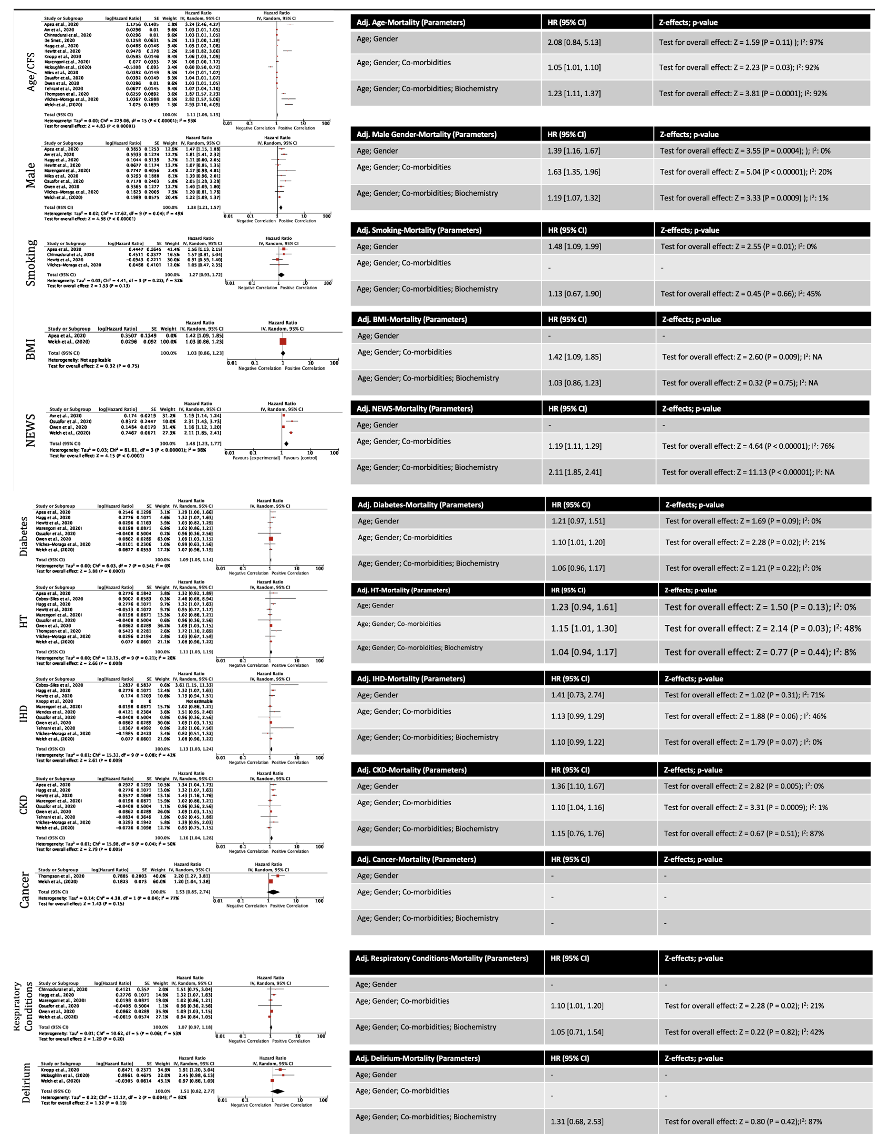Fig. S6. Generic Inverse Variance analysis of adjusted hazard ratio (95% CI) as reported in each study. Associated tables with Model 1: Adjusted for Gender; Model 2: Adjusted for Gender; Co-morbidities; Model 3: Adjusted for Gender; Co-morbidities; Biochemical findings. NEWS: National Early Warning Score; HT: Hypertension; IHD: Ischaemic Heart Disease; CKD: Chronic Kidney Disease. Image was generated with Review Manager V. 5.4 Cochrane Tool for meta-analysis.
Fig. S7. Mortality scatter plot per CFS groups with best-fit line and SD. Descriptive statistics are provided in a tabular format. Simple linear regression (Best-fit values, SD, 95% CI, Goodness of Fit) tabular results. R² 0.9882 and p-value: 0.0005.

 | Author, year | Type of study | Country | Timing of study (duration of data collection) | Total sample size (n) | Sex (% male) | Mean age (years) | Method of COVID-19 diagnosis | Median CFS | Overall mortality rate (%)
Systematic review | Baker et al., 2020 | Retrospective | UK | Between 8 January and 16 April 2020 | 316 | 55 | 75* | PCR | 7 | 28
Systematic review | Brill et al., 2020 | Retrospective | UK | Between 10 March and 8 April 2020 | 450 | 60 | 72* | PCR | 5 in >65 years old | 38
Systematic review | Cobos-Siles et al., 2020 | Retrospective | Spain | Between 18 March and 21 April 2020 | 128 | 57 | 82.7 | PCR | X | 20
Systematic review | Conway et al., 2020 | Prospective | UK | Between 23 March and 4 April 2020 | 71 | 58 | 70.7 | PCR | 4* | 14
Systematic review | Hoek et al., 2020 | Retrospective | Netherlands | Between 12 March and 30 April 2020 | 23 | 78 | 59.0 | PCR | 6* | 22
Systematic review | Izzi-Engbeayaa et al., 2020 | Retrospective | UK | Between 6 March 2020 and 22 April 2020 | 889 | 60 | 65.8 | PCR | 3-4 | 36
Systematic review | Knights et al., 2020 | Retrospective | UK | Between 1 March and 31 March 2020 | 108 | 58 | 68.7 | PCR | 5 | 31
Systematic review | Kokoszka et al., 2020 | Retrospective | Poland | Between 10 March and 10 June 2020 | 32 | 69 | 62.4 | PCR | 5 | 67
Systematic review | Maguire et al., 2020 | Retrospective | UK | Between 17 March to 1 May 2020 | 224 | 55 | X | PCR | >3 | 23
Systematic Review | Marengoni et al., 2020i | Retrospective | Italy | Between 8 March and 17 April 2020 | 91 | 62 | 79.5 | PCR | 3 | 43
Systematic review | McLoughlin et al., 2020 | Point-prevalence study | UK | 21 April 2020 | 71 | 72 | 61.0 | PCR | 2 | 28
Systematic review | Mendes et al., 2020 | Retrospective | Switzerland | Between 13 March and 14 April 14 2020 | 235 | 43 | 86.0 | PCR | 6 | 32
Systematic review | Osuafor et al., 2020 | Retrospective | UK | Between 1 March 2020 to 15 May 2020 | 214 | 57 | 80.3 | PCR | 6 | 35
Systematic review | Poco et al., 2020 | Retrospective | Brazil | Between 30 March and 20 May 2020 | 711 | 57 | 66.0 | PCR | X | 37
Systematic review | Thompson et al., 2020 | Retrospective | UK | Between 12 March and 19 May 2020 | 470 | 54 | 68.7 | PCR | 4 | 36
Systematic review | Vallecillo et al., 2020 | Retrospective | Spain | Between 14 March to 21 June 2020 | 51 | 45 | 80.2 | PCR | X | 7.8
Systematic review | Vilches-Moraga et al., 2020 | Retrospective | UK/Italy | Between 27 February and 10 June 2020 | 831 | 56 | 71.0* | PCR | 6 | 31
Systematic review and meta-analysis | Apea et al., 2020 | Prospective | UK | Between 1 March and 13 May 2020 | 1996 | 62 | 62.2 | PCR | 4 | 29
Systematic review and meta-analysis | Aw et al., 2020 | Retrospective | UK | Between 1 March and 30 April 2020 | 677 | 54 | 81.1 | PCR | 5 | 35
Systematic review and meta-analysis | Chinnadurai et al., 2020 | Retrospective | UK | Between 23 March and 30 April 2020 | 215 | 62 | 72.0 | PCR | 5 | 40
Systematic review and meta-analysis | Davis et al., 2020 | Retrospective | UK | Between 18 March and 20 April 2020 | 222 | 33 | 82.0 | PCR | 6 | 43
Systematic review and meta-analysis | De Smet et al., 2020 | Retrospective | Belgium | Between 12 March and 30 April 2020 | 81 | 41 | 70.3 | PCR | 7 | 24
Systematic review and meta-analysis | Doglietto et al., 2020 | Retrospective | Italy | Between 23 February and 1 April 2020 | 123 | 44 | 82.7 | PCR | 4 | 20
Systematic review and meta-analysis | Frost et al., 2020 | Prospective | UK | Between 1 April and 14 April 2020 | 830 | 61 | 70* | PCR | 4 | 36.1
Systematic review and meta-analysis | Hagg et al., 2020 | Prospective | Sweden | Between 1 March and 11 June 2020 | 250 | 4 | 81.0 | PCR | 6 | 24
Systematic review and meta-analysis | Hewitt et al., 2020 | Prospective | UK/Italy | Between 27 February and 28 April 2020 | 1707 | 58 | 76.0 | PCR | 5 | 27
Systematic review and meta-analysis | Knopp et al., 2020 | Prospective | UK | Up until 23 April 2020 | 217 | 62 | 80.0 | PCR | X | 7
Systematic review and meta-analysis | Labenz et al., 2020 | Retrospective | Germany | Between 3 March and 15 April 2020 | 42 | 75 | 67.5* | X | 3 | 5
Systematic review and meta-analysis | Marengoni et al., 2020 ii | Retrospective | Italy | Between 8 March and 17 April 2020 | 165 | 61 | 69.3 | PCR | 2 | 26
Systematic review and meta-analysis | Miles et al., 2020 | Case-control study | UK | Patients admitted up until 23 April, data collected until 13 May 2020 | 217 | 62 | 59.0 | PCR | 5 | 51
Systematic review and meta-analysis | Owen et al., 2020 | Retrospective | UK | Between 29 February and 16 April 2020 | 285 | 49 | 68.7 | PCR | 6 | 43
Systematic review and meta-analysis | Rawle et al., 2020 | Retrospective | UK | Between 10 March and 29 April 2020 | 134 | 57 | 80.0 | PCR | 5-6 | 65
Systematic review and meta-analysis | Tehrani et al., 2020 | Retrospective | Sweden | Between 5 March and 28 April 2020 | 255 | 59 | 66.0 | PCR | 5 | 28
Systematic review and meta-analysis | Welch et al., 2020 | Prospective | 12 countries | X | 5711 | 55 | X | X | 5 | 28
Table S1. Study Characteristics. Abbreviations: CFS = clinical frailty scale; X = missing data

 | Selection |  |  |  |  |  |  | Comparability |  | Outcome |  |  |  | Max of 9
Study | Representativeness of the exposed cohort | Selection of the non-exposed cohort |  | Ascertainment of exposure |  | Demonstration that outcome of interest was not present at start of study |  | Comparability of cohorts on the basis of the design or analysis controlled for confounders |  | Assessment of outcome | Was follow-up long enough for outcomes to occur | Adequacy of follow-up of cohorts
Apea et al., (2020) | * | * |  | * |  | * |  | ** |  | * | * | * |  | 9
Aw et al., (2020) |  | * |  | * |  | * |  | ** |  | * | * | * |  | 8
Baker et al., (2020) | * | * |  | * |  |  |  |  |  | * | * | * |  | 6
Brill et al., (2020) | * | * |  | * |  |  |  |  |  | * | * | * |  | 6
Chinnadurai et al., (2020) | * | * |  | * |  | * |  | ** |  | * | * | * |  | 9
Cobos-Siles et al., (2020) |  | * |  | * |  |  |  |  |  | * | * |  |  | 4
Conway et al., (2020) | * | * |  | * |  | * |  |  |  | * | * |  |  | 6
Davis et al., (2020) | * | * |  | * |  |  |  |  |  | * | * | * |  | 5
De Smet et al., (2020) | * | * |  | * |  |  |  | ** |  | * | * |  |  | 7
Doglietto et al., (2020) |  | * |  | * |  |  |  | ** |  | * | * | * |  | 7
Frost et al., (2020) | * |  |  | * |  | * |  | ** |  | * | * | * |  | 8
Hägg et al., (2020) | * | * |  | * |  | * |  | ** |  | * | * |  |  | 8
Hewitt et al., (2020) | * | * |  | * |  | * |  | * |  | * | * | * |  | 8
Hoek et al., (2020) |  |  |  | * |  |  |  |  |  | * | * |  |  | 3
Izzi-Engbeayaa et al., (2020) | * | * |  | * |  |  |  | ** |  | * | * | * |  | 8
Knights et al., (2020) | * | * |  | * |  |  |  |  |  | * | * | * |  | 6
Knopp et al., (2020) | * |  |  | * |  | * |  |  |  | * | * | * |  | 6
Kokoszka et al., (2020) | * | * |  | * |  |  |  |  |  | * | * | * |  | 6
Labenz et al., (2020) | * | * |  | * |  |  |  | * |  | * | * | * |  | 7
Maguire et al., (2020) | * | * |  | * |  |  |  | * |  | * | * | * |  | 7
Marengoni et al., (2020) i | * |  |  | * |  | * |  | * |  | * | * |  |  | 6
Marengoni et al., (2020) ii | * | * |  | * |  |  |  | ** |  | * | * |  |  | 7
Mcloughlin et al., (2020) | * | * |  | * |  | * |  | * |  | * | * | * |  | 8
Mendes et al., (2020) |  | * |  | * |  |  |  | * |  | * | * |  |  | 5
Miles et al., (2020) | * | * |  |  |  | * |  | ** |  | * | * | * |  | 9
Osuafor et al., (2020) | * | * |  | * |  | * |  | ** |  | * | * | * |  | 9
Owen et al., (2020) | * |  |  | * |  |  |  | * |  | * | * | * |  | 6
Poco et al., (2020) | * | * |  | * |  | * |  | ** |  | * | * | * |  | 9
Rawle et al., (2020) | * | * |  | * |  |  |  | * |  | * | * |  |  | 6
Tehrani et al., (2020) | * | * |  | * |  |  |  | ** |  | * | * | * |  | 8
Thompson et al., (2020) | * | * |  | * |  |  |  | * |  | * | * | * |  | 7
Vallecillo et al., (2020) | * |  |  | * |  |  |  |  |  | * | * |  |  | 4
Vilches-Moraga et al., (2020) | * | * |  |  |  | * |  | * |  | * | * | * |  | 7
Welch et al., (2020) | * | * |  | * |  | * |  | ** |  | * | * | * |  | 9
Good quality: 3 or 4 stars in selection domain AND 1 or 2 stars in comparability domain AND 2 or 3 stars in outcome/exposure domain
Fair quality: 2 stars in selection domain AND 1 or 2 stars in comparability domain AND 2 or 3 stars in outcome/exposure domain
Poor quality: 0 or 1 star in selection domain OR 0 stars in comparability domain OR 0 or 1 stars in outcome/exposure domain
Table S2. Critical Appraisal using Newcastle-Ottawa Score (NOS)

Comments | Justification of exclusion from meta-analysis | Author, year | Citation
Include in meta-analysis |  | Apea et al., (2020) | As in manuscript reference list
Include in meta-analysis |  | Aw et al., (2020) | As in manuscript reference list
Include in systematic review | live/deceased patient numbers not stated in increments of CFS | Baker et al., (2020) | As in manuscript reference list
Include in systematic review | live/deceased patient numbers not stated in increments of CFS | Brill et al., (2020) | As in manuscript reference list
Include in meta-analysis |  | Chinnadurai et al., (2020) | As in manuscript reference list
Excluded: No confirmed COVID cases |  | Chui et al., (2020) | Chui, K., Thakrar, A., & Shankar, S. (2020). Evaluating the efficacy of a two-site (‘COVID-19’and ‘COVID-19-free’) trauma and orthopaedic service for the management of hip fractures during the COVID-19 pandemic in the UK. Bone & Joint Open, 1(6), 190-197.
Include in systematic review | live/deceased patient numbers not stated in increments of CFS | Cobos-Siles et al., (2020) | As in manuscript reference list
Include in systematic review | live/deceased patient numbers not stated in increments of CFS | Conway et al., (2020) | As in manuscript reference list
Include in meta-analysis |  | Welch et al., (2020) | As in manuscript reference list
Excluded: Using FRAIL Scale for frailty assessment |  | Ma et al., (2020) | Ma, L. (2020). COVID-19 Prevention: Use of Self-Reported Tools to Screen Frail Older Adults. The journal of nutrition, health & aging, 24(10), 1152-1152.
Excluded: COVID negative patients included |  | Thakrar et al., (2020) | Thakrar, A., Chui, K., Kapoor, A., & Hambidge, J. (2020). Thirty-day mortality rate of patients with hip fractures during the COVID-19 pandemic: a single centre prospective study in the United Kingdom. Journal of orthopaedic trauma.
Include in systematic review | Not assessing mortality; focus on functional outcomes | Vilches-Moraga et al., (2020) | As in manuscript reference list
Include in systematic review | live/deceased patient numbers not stated in increments of CFS | Thompson et al., (2020) | As in manuscript reference list
Include in meta-analysis |  | Hagg et al., (2020) | As in manuscript reference list
Include in meta-analysis |  | Davis et al., 2020 | As in manuscript reference list
Include in meta-analysis (CFS 4-9) |  | De Smet., 2020 | As in manuscript reference list
Include in meta-analysis (CFS 3-6) |  | Doglietto, 2020 | As in manuscript reference list
Include in meta-analysis (CFS 3-6) |  | Frost et al., 2020 | As in manuscript reference list
Include in meta-analysis |  | Hewitt et al., 2020 | As in manuscript reference list
Include in systematic review | live/deceased patient numbers not stated in increments of CFS | Hoek et al., 2020 | As in manuscript reference list
Include in systematic review | live/deceased patient numbers not stated in increments of CFS | Knights et al., 2020 | As in manuscript reference list
Include in meta-analysis |  | Knopp et al., 2020 | As in manuscript reference list
Include in Systematic review | live/deceased patient numbers not stated in increments of CFS | Kokoszka et al., 2020 | As in manuscript reference list
Excluded: Uses HFRS Scale for frailty assessment |  | Kundi et al., 2020 | As in manuscript reference list
Include in meta-analysis |  | Labenz et al., 2020 | As in manuscript reference list
Include in systematic review | live/deceased patient numbers not stated in increments of CFS | Maguire et al., 2020 | As in manuscript reference list
Include in meta-analysis |  | Marengoni et al., 2020 | As in manuscript reference list
Include in systematic review | live/deceased patient numbers not stated in increments of CFS | Mendes et al., 2020 | As in manuscript reference list
Include in meta-analysis |  | Miles et al., 2020 | As in manuscript reference list
Include in systematic review | HR reported in CFS 1-4, 5-6, 7-9 but no raw patient numbers. | Osuafor et al., 2020 | As in manuscript reference list
Include in meta-analysis |  | Owen et al., 2020 | As in manuscript reference list
Include in Systematic review | live/deceased patient numbers not stated in increments of CFS | Poco et al., 2020 | As in manuscript reference list
Include in meta-analysis |  | Rawle et al., 2020 | As in manuscript reference list
Excluded : Not reporting CFS as score of frailty |  | Steinmeyer et al., 2020 | Steinmeyer, Z., Vienne-Noyes, S., Bernard, M., Steinmeyer, A., Balardy, L., Piau, A., & Sourdet, S. (2020). Acute Care of Older Patients with COVID-19: Clinical Characteristics and Outcomes. Geriatrics, 5(4), 65.
Include in meta-analysis |  | Tehrani et al., 2020 | As in manuscript reference list
Excluded : Only deceased patients included in study |  | Turner et al., 2020 | Turner, J., Hodgson, L. E., Leckie, T., Eade, L., & Ford-Dunn, S. (2020). A dual-center observational review of hospital-based palliative care in patients dying with COVID-19. Journal of pain and symptom management, 60(2), e75-e78.
Include in Systematic review | live/deceased patient numbers not stated in increments of CFS | Vallecillo et al., 2020 | As in manuscript reference list
Include in Systematic review | live/deceased patient numbers not stated in increments of CFS | Izzi-Engbeayaa et al., 2020 | As in manuscript reference list
Excluded : CFS+ Caregiver association; not primary outcome |  | Liu et al., 2020 | Liu, L., Goodarzi, Z., Jones, A., Posno, R., Straus, S., & Watt, J. (2020). Factors associated with access to virtual care in older adults: A cross-sectional study. medRxiv.
Include in Systematic review | live/deceased patient numbers not stated in increments of CFS | McLoughlin et al., 2020 | As in manuscript reference list
Excluded : Assesses fatique, not mortality |  | Townsend et al., 2020 | Townsend, L., Dyer, A. H., Jones, K., Dunne, J., Mooney, A., Gaffney, F., ... & Conlon, N. (2020). Persistent fatigue following SARS-CoV-2 infection is common and independent of severity of initial infection. Plos one, 15(11), e0240784.
Excluded : CFS only > 5 reported |  | Zazzara et al., 202 | Zazzara, M. B., Penfold, R. S., Roberts, A. L., Lee, K. A., Dooley, H., Sudre, C. H., ... & Lochlainn, M. N. (2021). Probable delirium is a presenting symptom of COVID-19 in frail, older adults: a cohort study of 322 hospitalised and 535 community-based older adults. Age and ageing, 50(1), 40-48.
Table S3. Included and excluded studies with justification provided.

 |  | Overall Mortality (%) | Intubation (%) | Overall ICU Admission (%) | Delirium (%) | Male (%) | CFS | CVS (%) | RESP (%) | NEURO (%) | DM (%) | CKD (%) | Cancer (%)
Included in MA | Apea et al., (2020) ³³ | 28.7 | 79 | 20.06 |  | 62 | 4 | 24.3 | 20.32 | 0 | 37.42 | 19.28 | 4.94
Included in MA | Aw et al., (2020) ³⁴ | 35.4 |  |  |  | 54 | 5
Included in SR | Baker et al., (2020) ¹⁶ | 27.8 | 7.6 | 8.5 |  | 55 | 7 | 32.2 | 25.6 | 17.4 | 26.6 | 24.4 | 10.4
Included in SR | Brill et al., (2020) ¹⁷ | 36 | 11 | 19 |  | 60 | 5 | 37 | 19 |  | 30
Included in MA | Chinnadurai et al., (2020) ³⁵ | 40 | 3.7 |  |  | 62 | 5 | 33.8 | 30.2 |  | 30.2 | 19.5 | 8.8
Included in SR | Cobos-Siles et al., (2020) ¹⁸ | 20 | 20 |  |  | 57 | 4 | 30 | 7 | 17 | 31 | 16 | 15
Included in SR | Conway et al., (2020) ¹⁹ | 14 |  |  |  | 58 | 4 | 39.5 | 33 | 14 | 23 | 12.6
Include in MA | Welch et al., (2020) ⁴⁷ | 27.9 |  |  | 21 | 55 | 5 | 49.9 | 25.6 | 12.2 | 29.2 |  | 11
Included in MA (only hospital stay length; mortality not assessed) | Vilches-Moraga et al., (2020) ³² | 31.1 |  |  |  | 56 | 6 | 28 |  |  | 24.4
Included in SR | Thompson et al., (2020) ³⁰ | 36 | 9.1 |  |  | 53 | 5 | 24.5 | 13.5 | 26.1 | 30.4 | 16.1 | 18.5
Included in MA | Hagg et al., (2020) ⁴⁰ | 24 |  |  |  | 48 | 6 | 33 | 12.5 | 15 | 31 | 14
Included in MA | Davis et al., (2020) ³⁶ | 42.7 |  |  | 32 | 33 | 6 | 53.5 | 22 | 39 | 22
Included in MA (CFS between 4-9) | De Smet., (2020) ³⁷ | 23.45 |  |  | 42 | 41 | 7 |  |  | 44
Included in MA (CFS between 3-6) | Doglietto et al., (2020) ³⁸ | 19.5 | 80.49 | 0.9 | 2.6 | 44 | 4 | 39 | 2.44 |  | 14.63 | 0 | 4.88
Included in MA (CFS between 3-6) | Bradley and Frost et al., (2020) ³⁹ | 17.1 |  | 15 |  | 61 | 4
Included in MA | Hewitt et al., (2020) ⁵ | 27.2 |  |  |  | 58 | 5 | 36.75 |  |  | 16.5 | 36.4
Included in SR | Hoek et al., (2020) ²⁰ | 21.7 | 8.7 |  |  | 78 | 6 | 83 |  |  | 43
Included in SR | Knights et al., (2020) ²² | 31 |  | 8.7 | 21 | 58 | 5 | 45 |  | 15 | 23
Included in MA | Knopp et al., (2020) ⁴¹ | 7.3 |  |  | 29 | 62 |  |  |  | 33
Included in SR | Kokoszka et al., (2020) ²³ | 67 | 100 |  |  | 69 | 4.7 | 37.83 | 9 | 14 | 53 | 19 | 13
Included in MA | Labenz et al., (2020) ⁴ | 4.76 | 28.5 |  |  | 75 | 3 | 26.2 | 14.2 |  | 19 |  | 9.5
Included in SR | Maguire et al., (2020) ²⁴ | 23 |  |  | 7.1 | 55 |  | 27.8 | 16.8 | 9.3 | 22.6 | 10.4 | 3.4
Included in MA | Marengoni et al., (2020)ii ⁴² | 25.5 |  | 6.7 |  | 61 | 2 | 31.2 | 2.4 | 8.5 | 30.9
Included in SR | Mendes et al., (2020) ²⁷ | 32 |  |  | 11 | 43 | 5.8 | 26.95 | 10.6 | 27.05 | 23 | 26.5 | 9.4
Included in MA | Miles et al., (2020) ⁴³ | 51.2 |  |  |  | 62 | 5
Included in SR | Osuafor et al., (2020) ²⁸ | 34.6 |  |  | 48 | 57 | 6
Included in MA | Owen et al., (2020) ⁴⁴ | 42.9 |  | 18 |  | 49 | 6
Included in SR | Poco et al., (2020) ²⁹ | 37 |  | 9 |  | 56 |  | 30.45 | 5.1 | 4.5 | 42.5 |  | 14.9
Included in MA | Rawle et al., (2020) ⁴⁵ | 64.9 |  |  |  | 57 |  | 55.95 | 17.2 | 26.1 | 29.1
Included in MA | Tehrani et al., (2020) ⁴⁶ | 27.5 | 12 | 12 |  | 59 | 5 | 22 | 9 | 9 | 31 | 19 | 5
Included in SR | Marengoni et al., (2020)i²⁵ | 42.9 |  | 3.2 | 28 | 55 | 4
Included in SR | Izzi-Engbeayaa et al., (2020)²¹ | 36 | 11.4 |  |  | 60 |  | 35.3
Included in SR | McLoughlin et al., (2020) ²⁶ | 28 |  |  |  | 72
 | Vallecillo et al., (2020) ³¹ | 7.8% |  |  |  | 45 |  | 48.85 | 19.6% |  | 29.4 | 27.5% | 7.8%
Table S4. Patient demographics in % as per each study. Abbreviations: SR: systematic review, MA: meta-analysis, ICU: intensive care unit, CFS: clinical frailty scale, CVS: cardiovascular, RESP: respiratory, DM: diabetes mellitus, CKD: chronic kidney disease.

