The formulas used for conversion
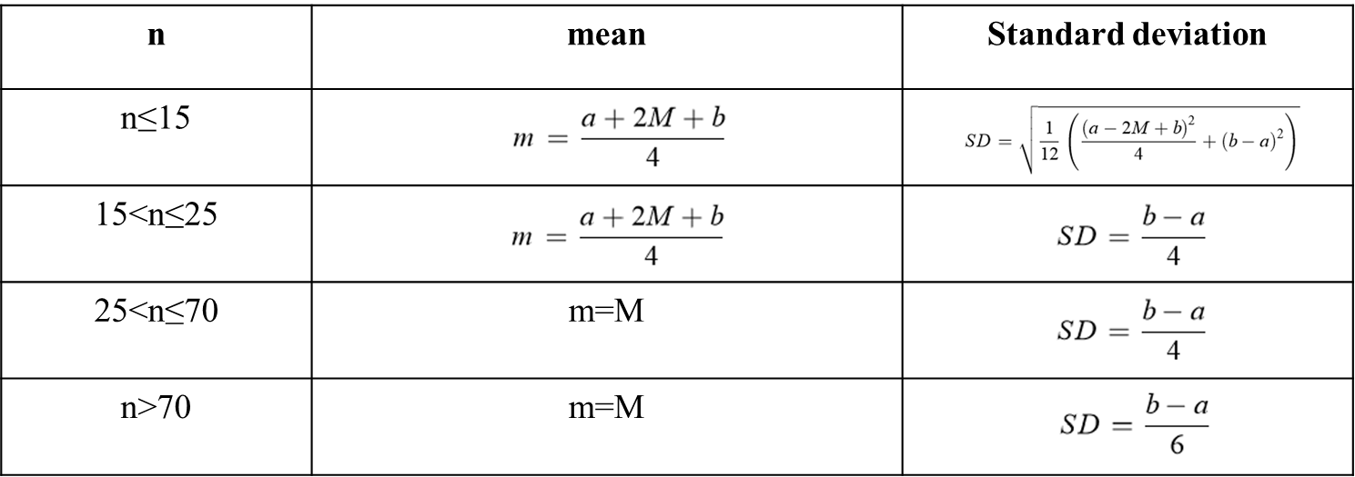
n, number of samples; m, mean; M, median; SD, standard deviation; a, minimum; b, maximum.

